Road safety investigations for government

PaveLedger connects road observations to accountable action.
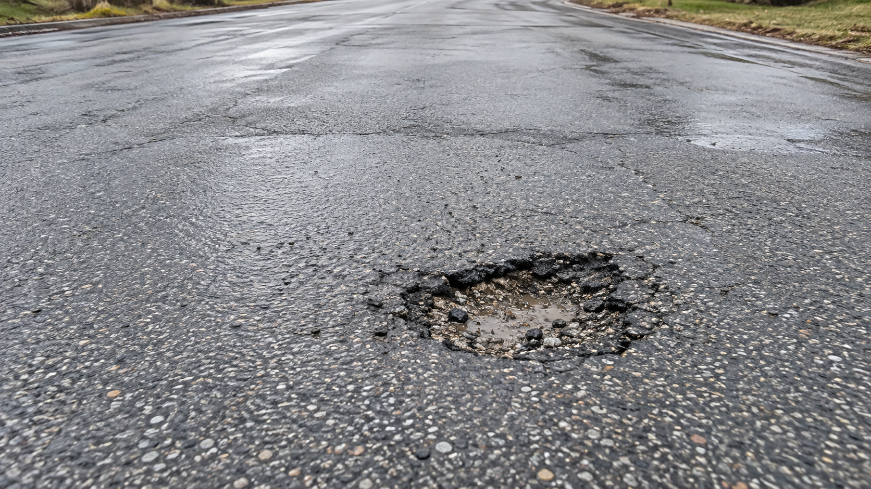
Illustrative generated road image

A clear record from defect to repair
Cameras on approved buses, service vehicles and volunteer routes can provide repeat observations of the roads you manage. PaveLedger is designed to turn those observations into assigned investigations with image evidence, GPS context and a tracked next action.
Observe | Investigate | Verify
Find possible potholes on existing routes | Review urgency and connect the case to its repair contract | Confirm the completed repair or reopen the case

Give analysts a focused queue, give managers a clear view of outstanding work, and give contractors a scoped channel to acknowledge and update assigned repairs.

A measurable pilot before a wider rollout

Proposed ninety day pilot
CAD 18,000 before tax | Up to 5 vehicles | Up to 100 managed lane-km
Start with one road authority, a defined route network and a bounded set of repair contracts. Agree what success means before cameras begin collecting. Hardware and connectivity are separate.
Your team receives | What the pilot measures
Evidence-linked investigations | Precision, missed defects and review effort
Team and analyst assignments | Time from observation to an accountable action
Contract-aware repair requests | Accuracy of warranty candidates and contact records
Verification and reopening | Whether a clear repeat view confirms the repair
Role-scoped management reporting | Coverage gaps, backlog and repeat failures

Proposed software plans
Municipal from CAD 2,500/month. City from CAD 6,500/month. Regional from CAD 15,000/month. Annual commitment; setup, devices, cellular and extra integrations are separate. Prices and capacity limits are proposed and subject to pilot validation.

Designed for municipal responsibility
Customer-owned records, role-based access, an auditable investigation history and planned integration with GIS and work-order systems. Urgent safety action remains separate from warranty recovery. A failed or unclear camera view never proves that a road is safe.

Next step
Choose a pilot area and review your current inspection workflow, contract records and fleet routes with the PaveLedger project team. Agree a baseline, privacy controls and acceptance criteria before committing to rollout.
Concept offer | September 2026. Live capture AI and external messaging require integration. No government affiliation, deployed customer or guaranteed savings is claimed.

