Analysis of similar systems:

An analysis of the most popular similar systems, including Elevate, Peak, Lumosity, Memorado (Brain-Training apps) and Duolingo (language-learning app), returned the following common features:

- Tracking user progress: The user would be able to see how much they have improved since using the app - indication of progress & increased proficiency is typically a visualisation of data metrics e.g. bar chart, pie chart, radar graph - this feature is usually made feasible by mapping data to an account. It could be beneficial for users to see their “score” and how they compete with others around the world?

- Giving the user a choice of disciplines to train: The most popular applications will give the user the choice to choose between disciplines such as arithmetic, memory, language, spelling, problem solving etc.

- Establish baseline: It is common for users to be prompted to complete an initial test upon using the app for the first time - this is useful in establishing a baseline to show how much the users will/have improved, and in suggesting which skills the user should work at improving.

- Incentives/Notifications: Users are commonly sent reminders or notifications that encourage them to continue using the app. In Duolingo for example, users will achieve “streaks” upon continuous daily use - streaks in turn assist the user in unlocking further material to study.

- Difficulty levels: Users are often met with increasingly difficult tasks as they improve their skills/knowledge – It is worthwhile discussing whether this is truly a necessity in achieving the project aims.

- Training goals: Users are given (or are able to define) a schedule that will encourage them to use the app - this often ties in with incentives/receiving reminders.

Questionnaire:
From the discussion of similar systems, a questionnaire was made to gauge the opinion of potential features from mock-users.
Below are the questions & responses

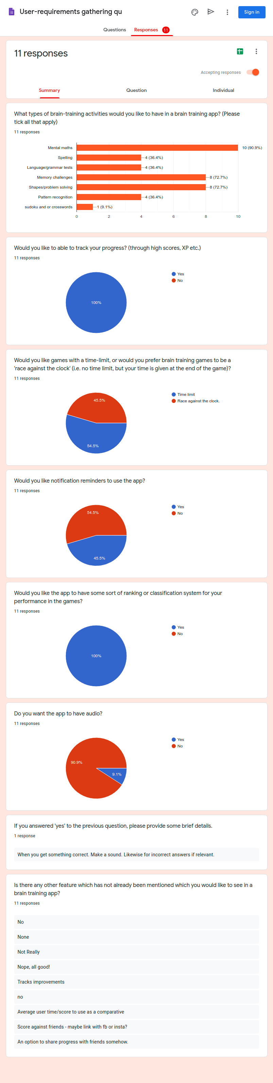

Discussion of Questionnaire/System Analysis:
As a group, based on the above, we decided that the following requirements were worthy of pursuing:

Must have features:
- The app will initially deal with “mental maths”
- We will establish a baseline of the user’s abilities when they open the app for the first time
- We will allow the user to track their progress
- We will allow the users to see how they compare against other users i.e. leaderboards

Could have features:
- Could explore having problem solving and/or memory challenges
- Could explore having a reminder/notifications system
- Could have a way of sharing content e.g. Facebook, Whatsapp, text, export to pdf/jpg etc.

Wont have:
- Audio (Accessibility may still be of worth researching)
- Won’t worry about “time-limit” vs “ race against the clock” at this stage – seems trivial and is polarizing to users

