**Link:**

Gemchain Token: <https://thirdweb.com/mumbai/0xc4372a95396d578d7c8d898aB4c3f9079CD34D7e>

NFT Characters:

<https://thirdweb.com/mumbai/0xd6ea454e9c1bCDd142DDBcB2b53D96A7a66343B2>

Setup Unity:

- **Download Unity:** https://unity.com/download

- **SetUp Unity**: add **personal license** and install version **2021.3.33f1** and install **WebGL**.

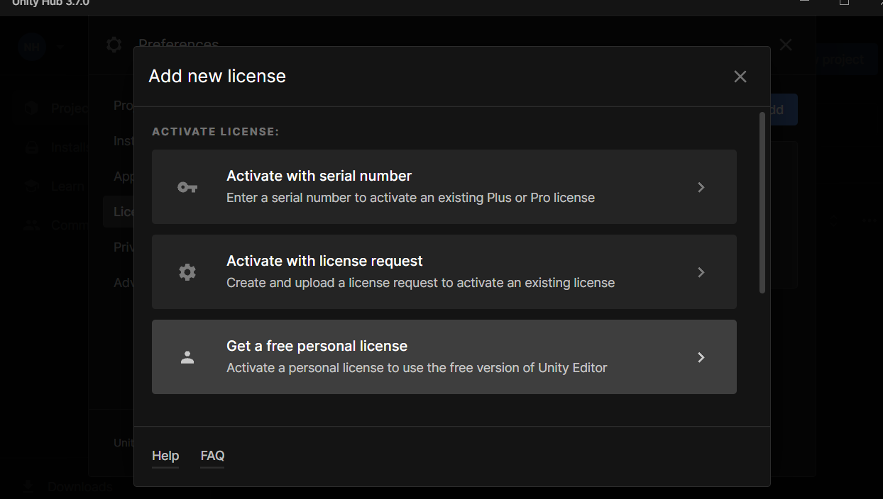

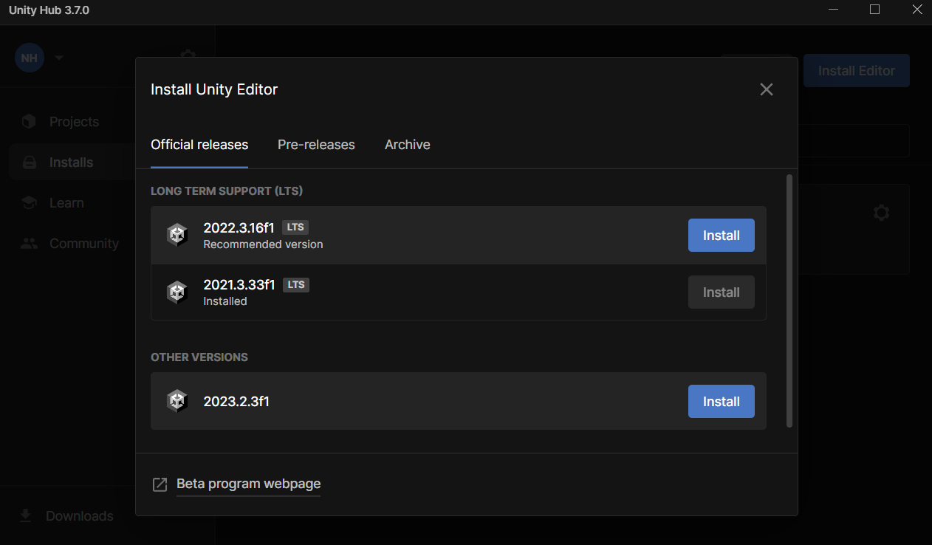

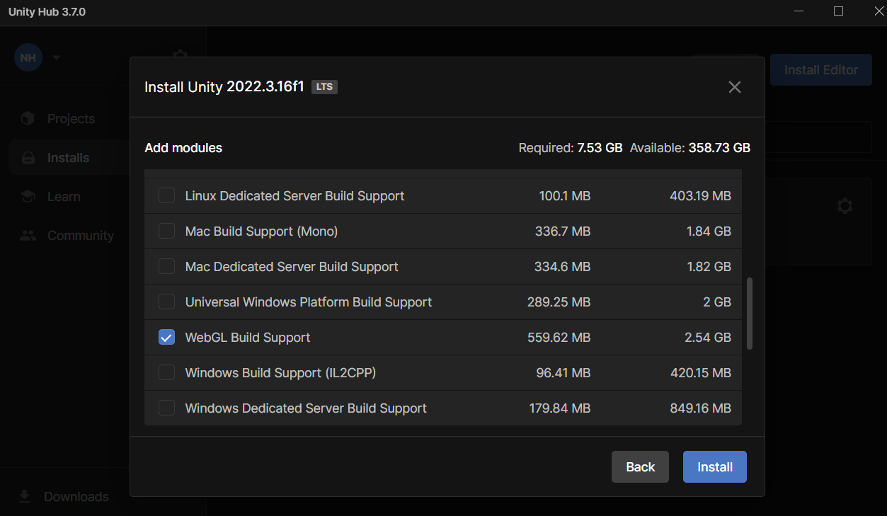

**Open Game**: Click Scenes -> Game

Open **Assets**-> **Import Package**. Add file **GameBlockchain.unitypackage** in **SourceCodeGameBlockchain** in Github**.**

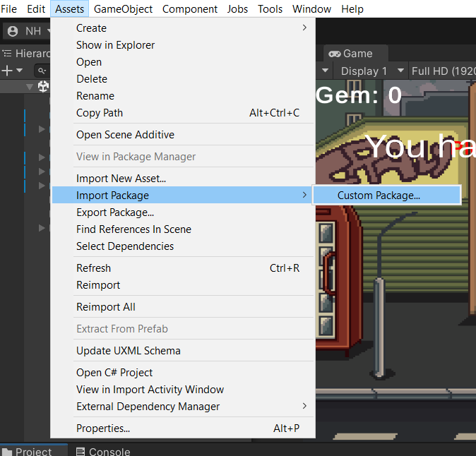

**Download InputSystem:** Window -> Package Manager -> Unity Reristry-> Input System

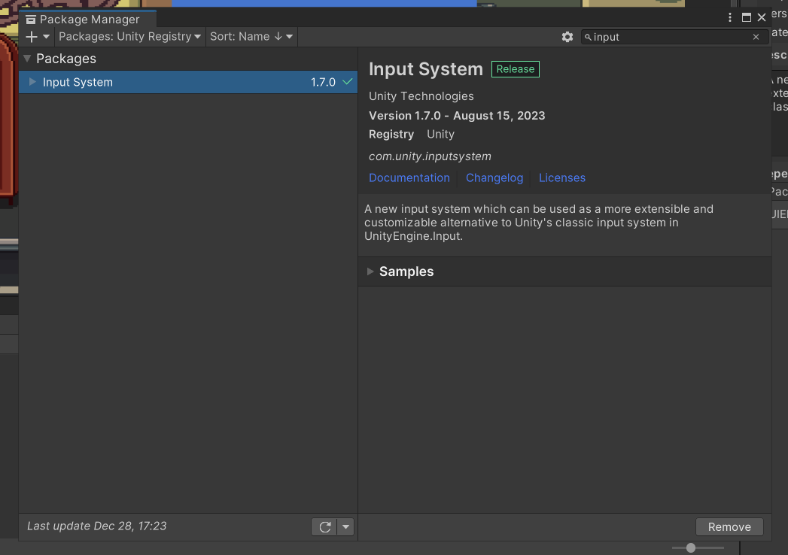

**Switch platform:** File->Buildsetting -> WebGl -> Switching

**Run project:** File -> Build and Run

**Remember:**

* Create and connect metamask.
* Create and connect web3.
* Buy character first before play game.