**Zhen Tong**

Tel：5102298110

Email：120090694@link.cuhk.edu.cn

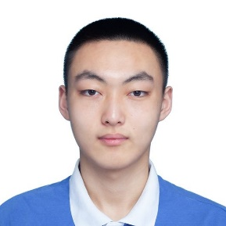**Education**

Chinese University of Hong Kong (Shenzhen)

September 2020 - present (Expected to graduate in June 2024.06)

Junior in computer science

* Dean's Honor of the School of Data Science for the 2020-2021 academic year2020-2021
* College Scholarship for the 2020-2021 academic year
* Core courses: linear algebra, Calculus, discrete Mathematics, optimization, probability statistics, data structure, digital circuit, database, computer composition principle, Algorithm, deep learning, computer vision, computer security

­­­­­­­­­­­­­­­­­**Projects**

**Hybrid Image Inpainting**

<https://github.com/ECE-Img-Inpainting/Examplar-based>

* Poisson Image Blending
* Exemplar based image inpainting.

**Database Development of a Music Application**

<https://github.com/3170-musk-cattle>

* MySQL for data
* Python django
* JS and VUE front-end

**Verilog Simulation of MIPS Architecture CPU**

<https://github.com/58191554/CSC3050_P4>

* Verilog implemented
* Simple computer function achieved

**Sound classification based on Hidden Markov model and EM algorithm**

<https://github.com/58191554/HMM-EM>

* Python code
* Without EM library

_______________________________________________________________________________________________

**Experience of competition**

2022 American Mathematical Modeling Competition H Award (top 18%)

<https://github.com/58191554/MCM_ICM-2022_ICM_E-topic>

**Research Experience**

Distributed RL Solving Combinatorial Problem

* Solve VRP and TSP in Distributed RL.

**Tools and Techniques**

Python, Java, C++, Verilog, SQL

**Research areas of interest:**

Reinforcement learning