**Perficient Employee Persona**

## Features

1. Login

**Acceptance Criteria:**

* 1. User name need to be Perficient domain name, such as "jack.yang"
  2. Acceptable password is "Password666"
  3. Display error message while pattern is incorrect, such as "no dot inside of username”, “password is empty".
  4. Prompt login failed message while username or password is incorrect.

TextlnputLayout 
weddings 
G*A9Exi 
weddtfffx 
wedding 
a 
S 
z 
weddings 
m 
a 

1. Toast display "Login successful" after login.

**Advanced:**

use "last known location" - GPS latitude, longitude to instead of static message) (**lower priority**)

1. Employee Summary (Home Page)

**Acceptance Criteria:**

* 1. By default, current user is based on login user name.
  2. Four categories should display as below (Linear Layout)
     1. Assignment
     2. Blogs
     3. Training
     4. Library
  3. Each category should display sub-category by using **card view** (**Advanced**: swipe can be supported to switch cards)

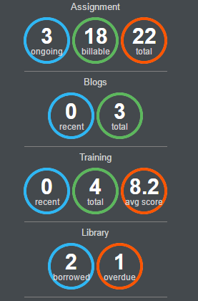

1. Implement Menu and NavigationView, show the avatar of current employee and basic profile at top of navigationview, refer to below,

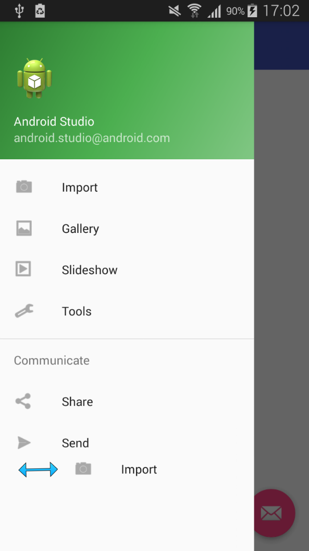

1. EmployeeID need to be saved in shared preferences.
2. Floating Action Button should be displayed and able to show EmployeeID (read from shared preferences) via snackbar
3. **Advanced**: ToolBar is needed and able to trigger search function to switch to another employee

1. Assignment

**Acceptance Criteria:**

* 1. RecyclerView display each record
  2. Each item can be click and display dialog for short period

1. Library

**Acceptance Criteria:**

* 1. Using TabLayout and ViewPager to separately display "borrowed" and "overdue" data
  2. **Advanced:** highlight the tab if "overdue" record is more than 1.

**Foundation requirement**

1. MVP pattern is required
2. Material Design
3. Using Retrofit for Restful service call
4. Shadow style is required for button and edit text
5. All codes need to be covered by unit test (Robolectric)
6. Unit test needs to be created and reviewed internally (Eason, Bin, Jack and Kent) before feature implementation. (TDD)
7. Advanced: Refactoring is needed to use Dagger, Glide and RxJava when features implemented.

Restful Services

1. Get Perficient Employee data by screen name

[http://10.2.7.140/dashboard/etl/api/common/find?dbName=stage&collectionName=stg_employee&filter={is_active:true,screen_name:"Kent.Jiang"}](http://10.2.7.140/dashboard/etl/api/common/find?dbName=stage&collectionName=stg_employee&filter=%7bis_active:true,screen_name:%22Kent.Jiang%22%7d)

* Screen name must be capitalized (首字母大写)
* If no result/result is empty, then login failed.