# git config

<https://help.github.com/en/github/using-git/getting-changes-from-a-remote-repository>

<http://www.yiibai.com/git/git_clone_operation.html>

<https://www.tutorialspoint.com/git/git_environment.htm>

<https://www.yiibai.com/git/git_update_operation.html>

$ git config –global user.email “[yjf66@qq.com](mailto:yjf66@qq.com)” ---- when you first clone

$git config –global user.name “yjf”

[jerry@CentOS project]$ git config --global core.editor vim

Git does not provide a default merge tool for integrating conflicting changes into your working tree. We can set default merge tool by enabling following settings.

[jerry@CentOS project]$ git config --global merge.tool vimdiff

[jerry@CentOS ~]$ git config --list

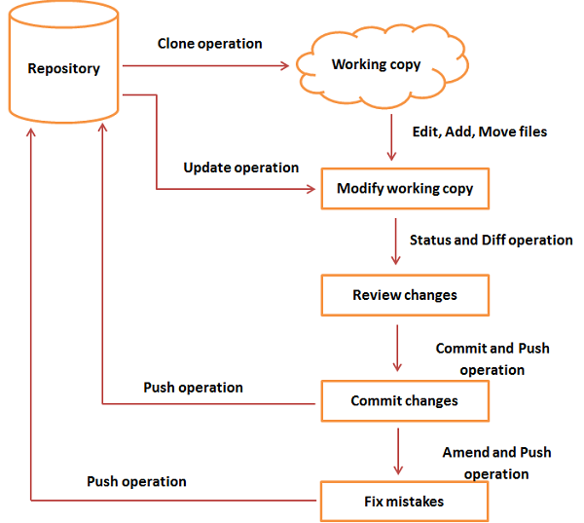

# add .gitignore file

jianfei@jianfei-wk:~/XPshared/gitDocs$ git add .

jianfei@jianfei-wk:~/XPshared/gitDocs$ git commit -m "add .gitignore"

[master 01d5515] add .gitignore

1 file changed, 145 insertions(+)

create mode 100644 .gitignore

jianfei@jianfei-wk:~/XPshared/gitDocs$ git push

# Clone

jianfei@jianfei-wk:~/Documents$ git clone https://github.com/xiterator/gitDocs.git

正克隆到 'gitDocs'...

Copy all docs into the dir “gitDocs”, then run

jianfei@jianfei-wk:~/Documents/gitDocs$ git add *.*

jianfei@jianfei-wk:~/XPshared/gitDocs$ git add ./* add all files and dirs

jianfei@jianfei-wk:~/Documents/gitDocs$ git commit -m "init build"

jianfei@jianfei-wk:~/Documents/gitDocs$ git push origin master

---- when you first clone a remote repository to local, and you want to

commit a change, git will need you do the following two steps:

$ git config –global user.email “[yjf66@qq.com](mailto:yjf66@qq.com)”

$git config –global user.name “yjf”

# update local repository after clone

jianfei@jianfei-wk:~/XPshared/gitDocs$ git pull

Username for 'https://github.com': ...

# fetch remote and check diff

jianfei@jianfei-wk:~/XPshared/gitDocs$ **git fetch origin master**

...

* branch master -> FETCH_HEAD

01e4326..6f54819 master -> origin/master

jianfei@jianfei-wk:~/XPshared/gitDocs$ **git diff**

diff --git a/Fintech/VaR/delivery.php b/Fintech/VaR/delivery.php

index d6b671a..03d528c 100644

Binary files a/Fintech/VaR/delivery.php and b/Fintech/VaR/delivery.php differ

diff --git a/Fintech/VaR/delivery.php.aria2 b/Fintech/VaR/delivery.php.aria2

deleted file mode 100644

index e7af712..0000000

Binary files a/Fintech/VaR/delivery.php.aria2 and /dev/null differ

diff --git a/LearningDoc/.~lock.LinuxDocDB.docx# b/LearningDoc/.~lock.LinuxDocDB.docx#

deleted file mode 100644

index 189a58c..0000000

--- a/LearningDoc/.~lock.LinuxDocDB.docx#

+++ /dev/null

@@ -1 +0,0 @@

jianfei@jianfei-wk:~/Documents/gitDocs$ git diff

diff --git a/LinuxDocDB.docx b/LinuxDocDB.docx

index 4ebe05b..dbe9c9e 100644

Binary files a/LinuxDocDB.docx and b/LinuxDocDB.docx differ

* 1. jianfei@jianfei-wk:~/Documents/gitDocs$ git status
  2. 位于分支 master
  3. 您的分支与上游分支 'origin/master' 一致。
  4. 尚未暂存以备提交的变更：
  5. （使用 "git add <文件>..." 更新要提交的内容）
  6. （使用 "git checkout -- <文件>..." 丢弃工作区的改动）
  7. 修改： LinuxDocDB.docx
  8. 未跟踪的文件:
  9. （使用 "git add <文件>..." 以包含要提交的内容）
  10. .~lock.LinuxDocDB.docx#
  11. 修改尚未加入提交（使用 "git add" 和/或 "git commit -a"）

# [Merging changes into your local branch](https://help.github.com/en/github/using-git/getting-changes-from-a-remote-repository" \l "merging-changes-into-your-local-branch)

jianfei@jianfei-wk:~/XPshared/gitDocs$ git merge origin master

更新 01e4326..6f54819

Fast-forward

LearningDoc/.~lock.LinuxDocDB.docx# | 1 -

LearningDoc/LinuxDocDB.docx | Bin 187354 -> 187991 bytes

2 files changed, 1 deletion(-)

delete mode 100644 LearningDoc/.~lock.LinuxDocDB.docx#

### **[Pulling changes from a remote repository](https://help.github.com/en/github/using-git/getting-changes-from-a-remote-repository" \l "pulling-changes-from-a-remote-repository)**

git pull is a convenient shortcut for completing both git fetch and git mergein the same command:

$ git pull remotename branchname

# Grabs online updates and merges them with your local work

Because pull performs a merge on the retrieved changes, you should ensure that your local work is committed before running the pull command. If you run into [a merge conflict](https://help.github.com/en/articles/resolving-a-merge-conflict-using-the-command-line) you cannot resolve, or if you decide to quit the merge, you can use git merge --abort to take the branch back to where it was in before you pulled.

# push failed: local version is out of date from the remote one

提示：更新被拒绝，因为您当前分支的最新提交落后于其对应的远程分支。  
提示：再次推送前，先与远程变更合并（如 'git pull ...'）。详见  
提示：'git push --help' 中的 'Note about fast-forwards' 小节。

引起这个问题是远程仓库和本地不同步引起的

解决方案：需要**先获取远端更新并与本地合并**,再git push  
具体操作如下:

git remote add origin https:*//github.com/miaoihan/weibo.git*

$git fetch origin *//获取远程更新*

$git merge origin/master *//把更新的内容合并到本地分支*

1、git pull origin master --allow-unrelated-histories

2、重新add和commit相应文件

3、git push origin master --force

4、此时就能够上传成功了

如果git报告不知道参数 allow-unrelated-histories，则更新git版本。

sudo add-apt-repository ppa:git-core/ppa

sudo apt-get update

sudo apt install git

jianfei@jianfei-wk:~/XPshared/gitDocs$ git revert b290a25d04e51aab5533353dcc0ed1c2bff0f400

error: Your local changes to the following files would be overwritten by merge:

inice/nlmShared/.idea/workspace.xml

Please, commit your changes or stash them before you can merge.

Aborting

jianfei@jianfei-wk:~/XPshared/gitDocs$ git stash

Saved working directory and index state WIP on master: b290a25 .

HEAD 现在位于 b290a25 .

jianfei@jianfei-wk:~/XPshared/gitDocs$ git clean -d -fx ""

正删除 Fintech/Prob/

正删除 Writing/ACM_TKDD/refs/blockTrading/

正删除 inice/.~lock.compile_comments.odt#

正删除 inice/compile_comments2.odt

正删除 inice/mixtools.pdf