# LTFSArchiver 1.0 Web User Interface

Summary

LTFSArchiver 1.0 Web User Interface 1

Pending jobs 4

Active jobs 5

Tape management 6

Make Tape Available 8

Device monitoring 9

This document describes in detail the Web User Interface used to manage LTFSArchiver’s operation involving external tapes.

It is also explained how to manage tapes, pools and devices.

This web interface allows to monitor both automatic and manual operations, to manage tapes and tape pools and finally to control the stable tape mount operations (makeavailable).

The home page appears as reported in the following picture:

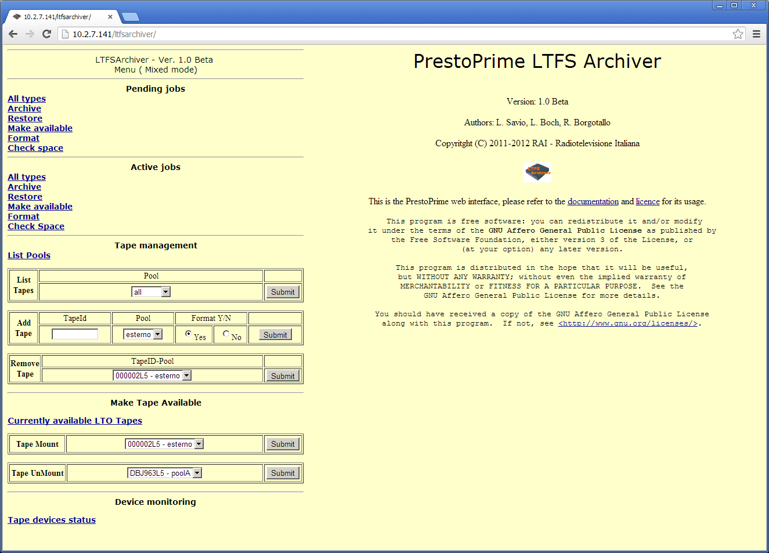

Figure 1 - LTFSArchiver web interface

In the upper left corner is shown the operational mode which can be one of:

* “Mixed mode” means that LTFSArchiver runs managing both external manual (desktop model) and internal automated (library connected) LTO drives.
* “Manual mode” means that LTFSArchiver runs managing only external manual LTO drives.
* “Changer mode” means that LTFSArchiver runs managing only internal automated LTO drives. If mode has been set to “Changer mode”, the “Pending job” section will not be shown.

In mixed and manual modes a human operator must be in charge for loading and unloading the tapes. The Manual mode can be suitable for very small archives not wishing to deal with a robotic library. From the client application perspective the behaviour of LTFS Archiver is exactly the same, although the operations will be unavoidably slower. Requests of manual tape exchange are proposed to the operator through the web interface, and also with this interface he has to confirm after completion.

In the Mixed configuration both automated and not automated LTO drives are connected to the system. In this case the service ***WriteToLTO*** tries first to use a tape located in a library with enough free space and belonging to the required pool. If this first attempt fails a “on the shelf tape” with the same requirements is asked to be used when available.

Basically all the operations allowed through this interface are also feasible using the API described in detail in the *LTFSArchiverAPI* document. The execution of all the operations, require that a system service daemon called ltfarchiver is up and running on the server. For this reason **only if it is down** an alert is shown (Figure 2) on the interface saying “ltfsarchiver daemon is DOWN !”, in this case please call the server administrator and ask him to start the service (the command to be issued as root user is “*service ltfsarchiver start”*).

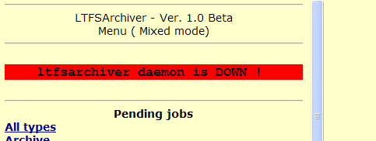

Figure 2 - System service down warning

The following chapters describe in detail all the relevant features of the interface.

### Pending jobs

This section appears in the top left part of the screen **only when the system configuration is Manual or Mixed mode**. Here are listed the pending requests that are waiting for a tape to be manually loaded. For each request, a line like that in Figure is shown.



Figure 3 - Listing pendind jobs sample

In this sample, a Makeavailable request was issued and the required tape is the ZZ04020B, therefore LTFSArchiver waits for that specific tape to be manually loaded into the free drive indicated in the 5th column.

The column “Req. Action” reports what the operator is expected to do.

After having inserted the requested LTO tape in the Assigned drive, the operator must click on “confirm load”.

A message will confirm the acknowledgement, and LTFSArchiver will be able to proceed:

The following uuids have been sent to ready status:

d6f462e7-200e-45b0-9d47-cb1d13b8b794

And the job will not be further swhon in this menu.

When the activity has been completed, the tape will be automatically eject from drive

### Active jobs

This section lists the currently active jobs that is the requests previously accepted and actually in charge to the system.

For each job, a line looking like in Figure 5 is shown, where the column status can assume different values.



Figure 4 - Active jobs list sample

The above samples is about the status of the Makeavailable request discussed in the previous paragraph.

The operator has loaded the tape and confirmed; the LTFSArchiver agent will be able to complete the job.

The Status and note fields may have the following values, showed in the correct sequence they should occur:

|  |  |
| --- | --- |
| Satus | Note |
| Wait | Waiting to be dispatched |
| Dispatched, waiting for tape device |
| Dispatched, waiting for tape loading |
| Starting | Tape being loaded o positiong |
| Tape loaded and ready |
| Running | Running |

Note that the jobs that have been completed are not shown, regardless if they’ve been successfully completed or have failed.

Use this section as a queue monitor.

### Tape management

This section of the main menu has been designed to provide a web interface for the **TapeManager** and **QueryKnownTapes** API (see “LTFSArchiverAPI” document), enabling user to manage tape and pools.

**List pools**

This function will simply list (5) the existing configured pools in the system and the total number of tapes under each of them.

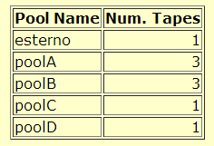

Figure 5 - List Pools output

#### List Tapes

This function lists the tapes owned by pools. You can select a single pool from the dropdown box or get information about all pools selecting “all”.

The output will show also the amount of the free space available on each tape.

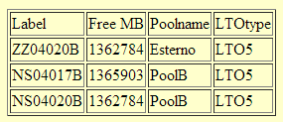

Figure 6 - List Tapes output

#### Add Tape

This function allows to add a new tape to an existing pool or to create a new one while adding the first tape to it.

To add a new tape to an existing pool:

* Fill in the “TapeID” field (according to the barcode label is present);
* select the poolname from the “Pool” combo
* check “Yes” or “No” radio button for asking or not the tape format (see notes at the end of this paragraph);
* Click “Submit”

If everything goes ok, a similar message will appear:

200<TAB>*uuid*<TAB>LTO with label: NEWTAPE added to system and assigned to pool: CHOOSENPOOL

To simultaneously create a new pool:

* Fill the “TapeID” field (according to the barcode label is present);
* Click on the word “Pool” over the combo box, a text input field will appear in place of the combo
* Fill this textbox with the name of the new pool you can decide freely
* check “Yes” or “No” radio button for asking or not the tape format (see notes at the end of this paragraph);
* Click “Submit”

If everything goes ok, a similar message will appear:

200<TAB>uuid<TAB>LTO with label: NEWTAPE added to system and assigned to pool: NEWPOOL

In case of error (i.e. trying to add a tape already managed by LTFSArchiver), a similar message will be returned:

400<TAB>LTO with label NEWTAPE was already in use by the system

Notes about Yes/No format option.

If you need to add a tape that already contains an LTFS file system, choose “No”.

As soon as possible, the tape will be mounted to:

* Check mechanical unprotection
* Evaluate actual available space (in case it has data in it)

If you need to add a blank tape, choose “Yes”. As soon as possible, the tape will be mounted to:

* Check mechanical unprotection
* Create an LTFS file system on it according to the configuration parameter PPRIMELTO_LTFSRULE (see LTFSArchiverConfiguration documentation)

If the tape already contains an LTFS file system and you choose “yes”, the format will fail: as a security feature indeed, the creation of the LTFS is executed in a “non force” mode, to avoid loss of pre-existing data.

If you want to use a previously LTFS formatted tape, please run offline the *unltfs* command line utility to clear it before adding the tape to the system.

#### Remove tape

Allows the user to remove a tape from a pool. Simply select the tape to be removed from the combo box (for each tape is shown the pool owning it) and click “Submit”.

Please note that withdrawing a tape that is currently in use or that has been booked for further use is not allowed (a message error will be returned).

### Make Tape Available

This section of the main menu has been designed to provide a web interface for the **MakeAvailable** API (see “LTFSArchiverAPI” document), enabling the user to manually ask for a MakeAvailable (Mount or Unmount) job.

#### Currently available LTO tapes

This option will show which tape(s) has/have been put in the “make available” mode.

As the Makeavailable access mode locks access to both tape and device in use, it is useful to check if some tape has been “forgotten” in this situation.

The table in Figure 7 reports in the Runtime column how long the tape has been made available through this modality.



Figure 7 - LTFSArchiver tapes made available

#### Tape mount

This section provides a web interface for the **MakeAvailable** (mountcommand) API.

Simply select the TapeID (the owning pool is also shown near the label) from the dropdown menu and click on “Submit”. The mount process will follow the same procedure as it was submittet through the API.

#### Tape Unmount

This section provides a web interface for the **MakeAvailable** (unmountcommand) API. Simply select the TapeID (the owning pool is also shown near the label) from the dropdown menu (only mounted tapes are shown) and click on “Submit”. The unmount process will follow the same procedure as it was submitted through the API.

Please note that the unmount procedure will fail (and it will be automatically re-quested) if some process is still accessing the data.

### Device monitoring

**Tape devices status command** has been designed to :

* Get a quick report about the current use of tape devices
* Enable or disable one or more tape devices

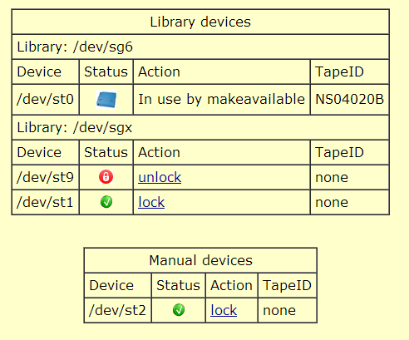

Figure 8 - Tape device status sample output

Selecting “lock” or “unlock” link the operator can disable o enable a single tape device.

A tape cannot change his status when a tape is loaded in it.

Please refer to LTFSARCHIVER_LOCK_LABEL variable in “LTFSArchiverConfiguration” to more information about locking devices.