Health Record Management System

**A PROJECT REPORT**

**for**

**Mini Project (KCA353) Session (2024-25)**

**Submitted by Pooja**

**(2300290140117 )**

**RitikaVerma**

**(2300290140146 )**

**Submitted in partial fulfilment of the Requirements for the Degree of**

MASTER OF COMPUTER APPLICATION

**Under the Supervision of Ms. Divya Singhal Assistant Professor**



**Submitted to**

**Department Of Computer Applications**

**KIET Group of Institutions, Ghaziabad Uttar Pradesh-201206**

**(December 2024)**

# CERTIFICATE

Certified that **Pooja ( 2300290140117) , RitikaVerma ( 2300290140146)** have carried out the project work having “**Health Record Management System**”**(Mini ProjectKCA353) for Master of Computer Application** from Dr. A.P.J. Abdul Kalam Technical University (AKTU) (formerly UPTU), Lucknow under my supervision. The project report embodies original work, and studies are carried out by the student himself/herself and the contents of the project report do not form the basis for the award of any other degree to the candidate or to anybody else from this or any other University/Institution.

**Date:**

**Ms. Divya Singhal Dr. Arun Kumar Tripathi**

**Assistant Professor Dean and Professor**

**Department of Computer Applications Department of Computer Applications KIET Group of Institutions, Ghaziabad KIET Group of Institutions, Ghaziabad**

**Health Record Management System Pooja**

**RitikaVerma**

**ABSTRACT**

In the rapidly evolving healthcare landscape, the need for efficient and secure management of patient health records has become increasingly critical. The **Health Record Management System** (HRMS) aims to address these challenges by providing a web-based Application that streamlines the process of storing, managing, and retrieving patient health records digitally. This system is designed to enhance the quality of care by offering healthcare providers quick and secure access to patient information, improving data security, and simplifying the management of medical data.

At the core of this Health Record Management System is a robust backend built using Node.js and Express.js. which facilitates secure and seamless data management. The system utilizes MongoDB to store patient Medical History with Doctor appointment.The application provides an intuitive and user-friendly interface for healthcare providers, allowing them to create, update, and access patient records with ease and also Improve Quality of Care.

The system prioritizes data security by implementing encryption, role-based access control, and secure user authentication mechanisms, ensuring that only authorized personnel can access sensitive patient information. It also adheres to healthcare regulations like HIPAA (Health Insurance Portability and Accountability Act), ensuring compliance with industry standards for data protection and privacy.

In addition, the system enhances healthcare decision-making by integrating data analytics tools that allow healthcare providers to analyze patient records and gain actionable insights. These insights support informed medical decisions, improving patient care outcomes and overall healthcare delivery.

## 

## ACKNOWLEDGEMENTS

Success in life is never attained single-handedly. My deepest gratitude goes to my project supervisor, **Ms. Divya Singhal** for her guidance, help, and encouragement throughout my project work. Their enlightening ideas, comments, and suggestions.

Words are not enough to express my gratitude to Dr. Arun Kumar Tripathi, Professor and Head, Department of Computer Applications, for his insightful comments and administrative help on various occasions.

Fortunately, I have many understanding friends, who have helped me a lot on many critical conditions.

Finally, my sincere thanks go to my family members and all those who have directly and indirectly provided me with moral support and other kind of help. Without their support, completion of this work would not have been possible in time. They keep my life filled with enjoyment and happiness.

**Pooja RitikaVerma**

# TABLE OF CONTENTS

|  |  |  |  |
| --- | --- | --- | --- |
| Certificate | | | ii |
|  | Abstract | | iii |
|  | Acknowledgements | | iv |
|  | Table of Contents | | v - vi |
|  | List of Figures | | vii |
| 1 | Introduction | | 1-7 |
|  | 1.1 | Overview | 8 |
|  | 1.2 | Motivation | 9 |
|  | 1.3 | Problem Statement | 10 |
|  | 1.4 | Expected Outcome | 11 |
| 2 | Literature Survey | | 12 |
| 3 | Design | | 13-17 |
|  | 3.1 | Data Flow Diagram | 13 |
|  |  | 3.1.1 Level 0 DFD | 13 |
|  |  | 3.1.2 Level 1 DFD | 14 |
|  | 3.2 | ER Diagram | 15 |
|  | 3.3 | Use Case Diagram | 16-17 |
| 4 | Proposed Work | | 18 |
|  | 4.1 | Technology Description | 18 |
|  | 4.2 | Approach Used | 19 |
|  | 4.3 | Implementation Details | 20 |
|  | 4.4 | Challenges Faced | 21 |
| 5 | Results | | 22-27 |
|  | 5.1 | Home Page | 22-23 |
|  | 5.2 | Registration Page | 25 |
|  | 5.3 | Login Page | 26 |

|  |  |  |  |
| --- | --- | --- | --- |
|  | 5.4 | Patient Data | 27 |
|  | 5.5 | Report | **29** |
| 6. | Discussions | | 28-29 |
|  | 6.1 | Performance | 28 |
| 7. | Conclusion | | 30 |
| 8. | References | | 31 |

**LIST OF FIGURES**

|  |  |  |
| --- | --- | --- |
| **Figure No.** | **Name of Figure** | **Page No.** |
| 3.1 | Data Flow Diagram | 13 |
| 3.2 | ER Diagram | 15 |
| 3.3 | Use Case Diagram | 16 |
| 5.1 | Home Page | 23 |
| 5.2 | Registration Page | 25 |
| 5.3 | Login Page | 26 |
| 5.4 | Patient Data | 27 |

## CHAPTER 1 INTRODUCTION

### Overview:

The Health Record Management System is a comprehensive web based application meticulously

designed to revolutionize the management of patient health records by transitioning from

traditional paper-based methods to a fully digital and streamlined approach. In an era where the

complexity and volume of medical data are growing exponentially, the conventional systems for record-keeping are proving to be increasingly inefficient, cumbersome, and prone to errors. This innovative project seeks to address these challenges by offering a robust solution that digitizes patient records, ensuring healthcare providers have quick, secure, and seamless access to critical patient information.

By leveraging this system, healthcare providers can efficiently create, update, and manage patient data in a highly secure manner, ultimately enhancing the overall quality of care. The digitization process not only reduces the risk of errors but also enables healthcare facilities to focus more on patient care rather than administrative burdens. Furthermore, the system employs a powerful backend architecture built using Node.js and Express.js, paired with a dynamic front-end developed with JavaScript, ensuring an intuitive and user-friendly interface.

The application utilizes a robust database, optimized for handling large volumes of unstructured data, making it ideal for storing diverse types of medical records, from diagnostic reports and treatment histories to prescriptions and billing details. This approach not only improves the organization and retrieval of data but also significantly bolsters data security, ensuring compliance with healthcare regulations and protecting patient privacy.

Ultimately, the Health Record Management System aims to modernize healthcare operations, reduce administrative overheads, and create a seamless experience for both providers and patients, laying the groundwork for a more efficient and patient-centric healthcare ecosystem.

### Motivation:

The motivation behind the development of the **Health Record Management** stems from the urgent need to modernize healthcare record management to address evolving challenges in the healthcare sector. Traditional record-keeping systems often face limitations such as inefficiency, lack of accessibility, and potential for errors, which can hinder the delivery of quality care. As technology advances and patient-centric care becomes a priority, there is a growing need for secure, efficient, and adaptable solutions to manage health records effectively.

One key driver of this project is the demand for accessible healthcare data. In today’s interconnected world, patients and providers require instant, anytime-anywhere access to medical records to ensure timely and accurate care. Traditional systems often present barriers like physical storage constraints and restricted availability. eliminates these barriers by providing a digital, cloud-based platform that ensures seamless access to records while maintaining the highest standards of data security.

Another significant motivation is the need for real-time insights and analytics. Healthcare providers require tools that go beyond static data storage to deliver actionable insights about patient progress and outcomes. By integrating advanced analytics and interactive dashboards, **Health Record Management** enables practitioners to make informed decisions, improving care quality and efficiency.

The platform also addresses the critical need for compliance and credibility. With strict adherence to healthcare standards and certification frameworks, **Health Record Management** ensures that all processes meet regulatory requirements, building trust among users. Industry-recognized certifications further validate the platform’s reliability and value, establishing it as a benchmark for excellence in health record management.

**Health Record Management** embodies the principle of democratizing healthcare technology. Access to efficient and secure healthcare record systems should not be limited by geographic or economic constraints. By leveraging advanced technology, the platform aims to empower healthcare providers and patients alike, ensuring equitable access to vital health information and enhancing overall healthcare outcomes.

The motivation behind the **Health Record Management** lies in addressing the challenges of traditional healthcare record systems, Reduce Paper work, the need for secure and accessible data management, the importance of real-time insights for effective decision-making, the demand for compliance and credibility, and the commitment to democratizing healthcare technology. Through this project, we aim to revolutionize the way health records are managed, ensuring improved outcomes, efficiency, and accessibility in an increasingly dynamic and interconnected healthcare environment.

### Problem Statement:

In traditional healthcare record management, several critical challenges hinder the accessibility, efficiency, and reliability of medical information. These issues highlight the urgent need for a transformative solution to address the following key problems:

* **Limited Accessibility:** Traditional healthcare record systems often rely on physical documentation and on-premises access, restricting the availability of vital information. Geographical barriers and the lack of centralized systems further hinder efficient healthcare delivery, particularly in rural or underserved areas. Patients and providers face delays in accessing critical health data, impacting timely and effective care.
* **Data Accuracy and Security:** Paper-based or outdated digital systems are prone to errors, duplication, and loss of information. Moreover, ensuring the security and confidentiality of sensitive health data remains a significant challenge, exposing patients and providers to potential breaches and misuse of information.
* **Inefficient Workflows:** Healthcare professionals often encounter fragmented systems that complicate patient record retrieval, updates, and sharing. This inefficiency can result in delayed diagnoses, miscommunication among providers, and compromised patient outcomes.

**Compliance and Standardization:** Traditional systems struggle to meet the stringent compliance requirements of healthcare standards such as HIPAA and GDPR. The lack of standardization across platforms creates inconsistencies and reduces trust among stakeholders.

**Exclusionary Practices and Inequities:** Marginalized populations, including those in low-income communities and rural areas, often face limited access to quality healthcare and secure record management systems. These disparities exacerbate health inequities and hinder efforts to ensure equitable healthcare for all.

Addressing these multifaceted challenges requires a holistic approach that leverages technology, innovation, and collaboration across various stakeholders. By developing an e- learning platform that prioritizes accessibility, engagement, credibility, relevance, and inclusivity, we can pave the way for a more equitable, effective, and responsive educational ecosystem.

### Expected Outcome:

The envisioned outcome of the **Health Record Management** is a solution that addresses the challenges of traditional healthcare record systems and delivers significant benefits to patients, healthcare providers, and administrators. The anticipated outcomes include:

* **Enhanced Accessibility:** The platform will enable secure, anytime, anywhere access to patient records and medical information, eliminating geographical and logistical barriers. This will empower healthcare providers to deliver timely, effective care and allow patients to stay informed and engaged in their health management, regardless of location.

**Improved Efficiency and Outcomes:** Through streamlined workflows, centralized data management, and real-time access to critical insights, the platform will enhance operational efficiency for healthcare providers. By reducing delays and errors, it will contribute to better patient outcomes and improved healthcare experiences.

**Data Security and Compliance:** With robust security protocols and adherence to industry standards like HIPAA, the platform will ensure the confidentiality and integrity of sensitive health data. Patients and providers will benefit from a secure and trustworthy system for managing medical records.

**Alignment with Evolving Healthcare Needs:** The platform will be designed to adapt to emerging healthcare trends, technological advancements, and regulatory requirements. This will ensure that it remains relevant and capable of meeting the dynamic needs of the healthcare sector while supporting the delivery of modern, patient-centered care.

**Promotion of Equity in Healthcare:** By providing accessible and inclusive healthcare record management solutions, the platform will help bridge the gap for underserved and marginalized populations. This commitment to equity will contribute to more inclusive healthcare services and better health outcomes for all.

**Health Record Management** is designed to be highly scalable and accessible, enabling its adoption by healthcare providers and institutions worldwide, regardless of their size, location, or resources. By leveraging advanced technology and digital connectivity, the platform has the potential to revolutionize healthcare record management on a global scale, fostering improved health outcomes and empowering communities to access better, more equitable healthcare services.

## CHAPTER 2 LITERATURE SURVEY

A Literature Review of Health Record Management Systems (HRMS) typically focuses on analyzing various systems used to manage, store, and share patient information within healthcare organizations. It involves understanding different aspects, including technical frameworks, security protocols, efficiency, interoperability, and compliance with health regulations like HIPAA (Health Insurance Portability and Accountability Act).

### Impact on Healthcare Outcomes:

Literature reviews assess how Electronic Health Record/ HRMS contribute to better patient care, reduced medical errors, and improved decision-making.

### Usability and User Experience:

Successful adoption of HRMS depends on its usability for clinicians, nurses, and administrative staff.

Common issues include complex interfaces, data entry burden, and lack of training, which hinder system adoption.

Studies focus on designing more user-friendly systems with intuitive interfaces and automation of routine tasks.

## CHAPTER 3

**DESIGN**

### Data Flow Diagram:

* + 1. **Level 0 Data Flow Diagram:**

Level 0 Data Flow Diagram of Health Record Management System

Fig. 3.1 illustrates the basic interaction between the user and the health record management system.

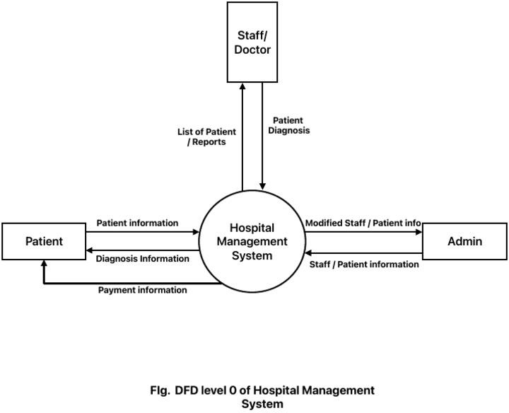

### Level 1 Data Flow Diagram:

The Level 1 Data Flow Diagram for the Health Record Management System elaborates on the detailed interactions between the user and various system processes. It depicts how both new and existing users engage with different functionalities within the system.

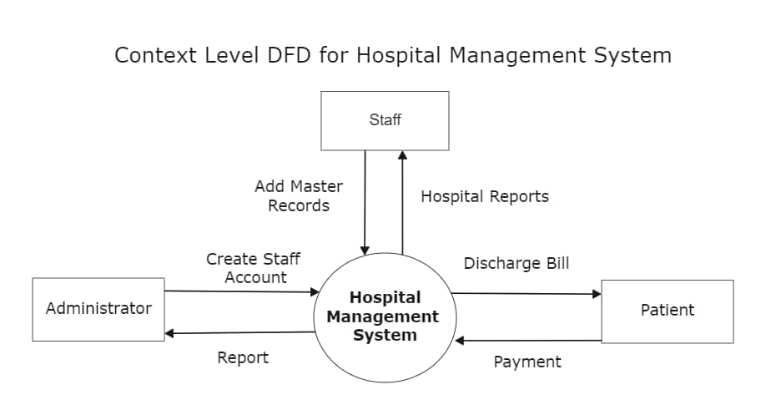

### Fig. 3.2 Level 1 DFD

**Fig. 3.2 Flow of Data of user and system**

If the user is new to the system, they register by providing details such as name, email, and password. These details are securely stored in the database. For existing users, they log in with their email and password, which the system validates against the database.

### ER Diagram:

An Entity Relationship (ER) Diagram is a visual representation of the entities within the **Health Record Management System** and the relationships among them.

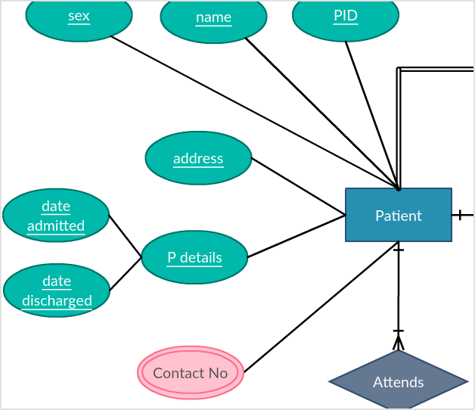

### Fig.3.3 ER Diagram - 2

**Relationships:**

* A **User** can manage multiple **Patients**.
* A **Patient** can have multiple **Health Records**.

The ER Diagram ensures a clear structure for the database, promoting efficient data management, retrieval, and scalability within the Health Record Management System.

* 1. **Use Case Diagram:**

In the **Health Record Management System**, the Use Case Diagram elaborates on the system's interactions between actors and the use cases involved. The purpose of the Use Case Diagram is to illustrate how users interact with the system, ensuring that all necessary conditions are met to achieve specific tasks.

### In this system, there are two primary actors:

**User (Healthcare Provider/Doctor)**: Interacts with the system to manage and access health records, update patient information, schedule appointments, and review medical histories.

**1.Admin**: Manages user accounts, oversees the system’s overall functioning, and has higher-level

### Key Use Cases:

1. Register User (Admin)
2. Login to the System
3. Manage Patient Health Records (User)
4. Schedule Appointments (User)
5. Manage System Configuration (Admin)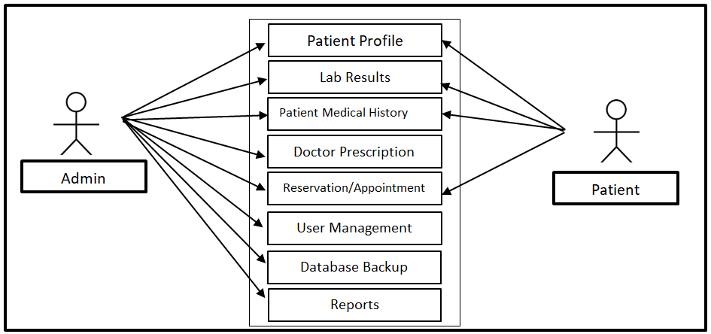

**Fig.3.4 Use Case Diagram**

## CHAPTER 4

**PROPOSED WORK**

### 4.1 Technology Description:

* + - Selection of Operating System:
    - Our website is platform independent, so it does not depend on the operating system.
    - **Selection of Software:** Visual Studio is used to create our software.
    - **Frontend Used**: for fronted HTML , CSS , EJS are used.
    - **Languages Used:** Development Software **Node.js:**

npm (Node Package Manager)

### Backend Software: Express.js:

A web application framework for Node.js used to build the API by install it using npm.

### MongoDB:

* + - **Database:** The database to store Patient’s health records.

### Approach Used

The **Health Record Management System** is designed to streamline the storage, retrieval, and management of patient health records. The system ensures secure, efficient, and user-friendly operations to cater to healthcare providers and administrators.

### Objectives:

* + - * Improve Data Centralize Patient Information:
      * Deve Accessibility and Efficiency:
      * Ensure easy and secure access to health records for authorized medical.
      * Enhance Data Security and Privacy:
      * Implement robust security measures
      * Improve Healthcare Decision-Making:
      * Integrate data analytics tools to analyze patient records, providing healthcare ,Provide User-Friendly Interfaces:

### Technologies Used:

* + - * **Frontend:** Ejs, CSS.
      * **Backend:** node.js,Express.js, MongoDB --Database

### Implementation Details:

1. **Authentication and Authorization Module:**

Description: Manages login, sign-up, and authorization, ensuring secure access to sensitive patient data.

### Key Features:

* + Handle User login and registration.
  + Password and Username handled.
  + Role-based access to different features (e.g., doctors, administrators, User).

### Patient Record Management Module:

**Description:** Manages the entire lifecycle of patient records, including creation, updating, retrieval, and deletion of patient data.

### Key Features:

* Patient registration (add new patients with details like name, age, gender, address, medical history).
* Edit/update patient information.
* View patient medical history.
* Delete patient records if needed.

### 4.4 Challenges Faced:

**Scalability**: Ensuring the **Health Record Management System** can accommodate an increasing number of patient records and healthcare providers without compromising

performance.

**Security**: Implementing robust authentication and authorization mechanisms to safeguard sensitive patient health data and maintain confidentiality.

**Performance Optimization**: Optimizing frontend and backend code to ensure quick data retrieval, seamless navigation, and a smooth user experience for healthcare providers and administrators.

### 

**Flow of Information:**

* **User** → Node.js Server (Express) → MongoDB (Data) → Response to User.
* Step 1: MongoDB , and Node.js setup.
* Step 2: Create RESTful API endpoints for patient records.
* Step 3: Implement Mongoose schemas for patient data.
* Step 4: Build the front-end interface and style using CSS.
* Step 5: Test and validate API routes using Postman.
* Step 6: Secure and deploy the application.

## CHAPTER 5

## RESULTS

### 5.1 Home Page

* + - **Header Section:**

### A title at the top: "Health Record Management."

* + - Navigation links (e.g., About, Admin, Dashboard, and Login).
    - A "Login" option with an icon, likely for user authentication.
    - A main image featuring a doctor holding a clipboard, symbolizing healthcare services.
    - Icons representing various health-related features, such as:
    - A computer monitor (possibly indicating digital records).
    - A lab building icon (indicating lab services).
    - A phone with a cross symbol (indicating emergency or support services).
    - Motivational text: "Stay Safe, Stay healthy, Care for you."

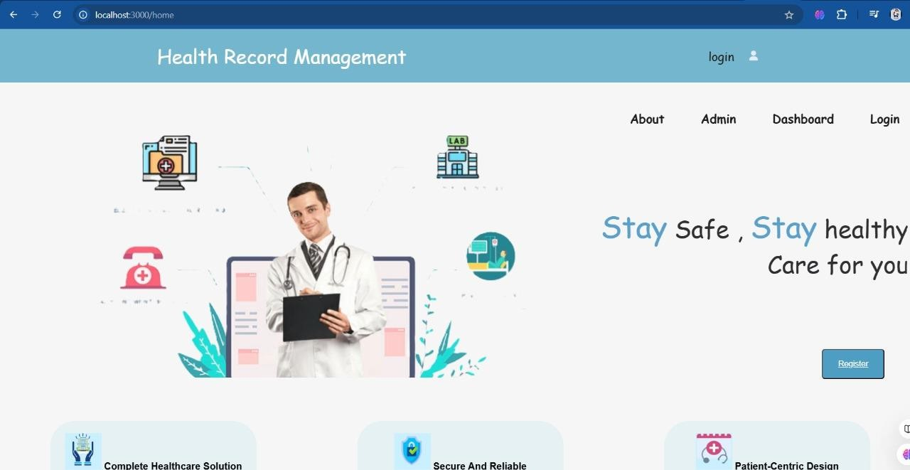

Fig. 5.1 Home Page

A Register button for users to create an account or sign up. Feature Highlights :

### Cards or sections emphasizing the system's key attributes:

* + - "Complete Healthcare Solution."
    - "Secure and Reliable."
    - "Patient-Centric Design."
    - A main image featuring a doctor holding a clipboard, symbolizing healthcare services.
    - Icons representing various health-related features, such as:
    - A computer monitor (possibly indicating digital records).
    - A lab building icon (indicating lab services.

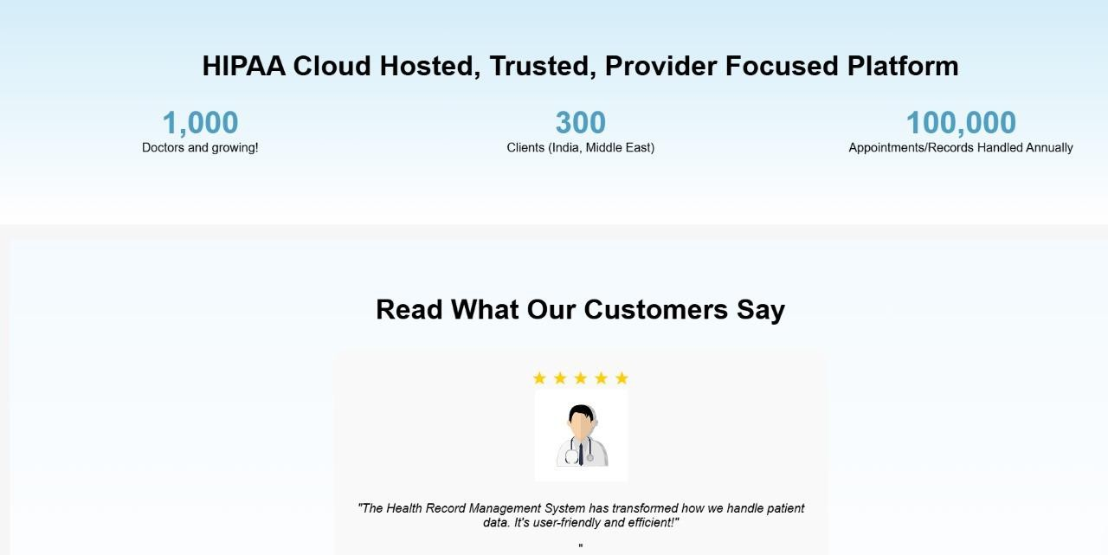

Fig. 5.1 Home Page

### 5.2 Registration Page

This page is a registration form designed for new users to create an account in the Health Record Management system. At the top, the title "Register" clearly indicates the purpose of the form. It features input fields for users to enter their username, phone number, and password, ensuring all essential information is collected for account creation. Below the input fields, there is a prominent "Register" button that allows users to submit their details and complete the registration process.

Additionally, a helpful note at the bottom provides an option for existing users to log in, with a clickable "Login here" link for easy navigation. The background features a clean and professional wavy gradient design in shades of blue, adding visual appeal and enhancing the user experience.

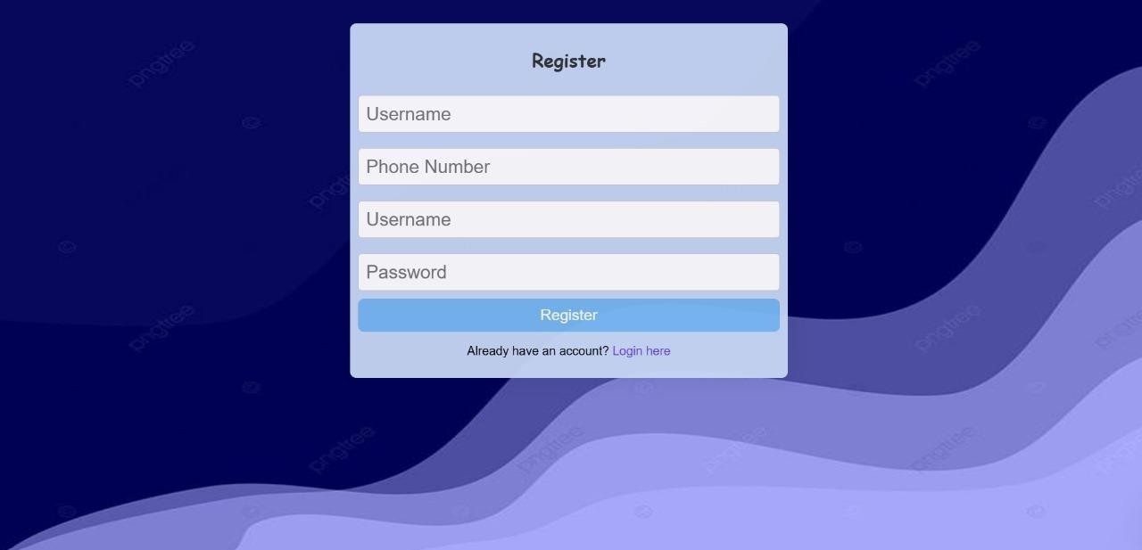

Fig. 5.2 Login and Registration Screen

## 5.3 Login Page

The page features a login interface set against a soft, light blue background. Centralized on the page is a rectangular login box with the title "Login" prominently displayed at the top.

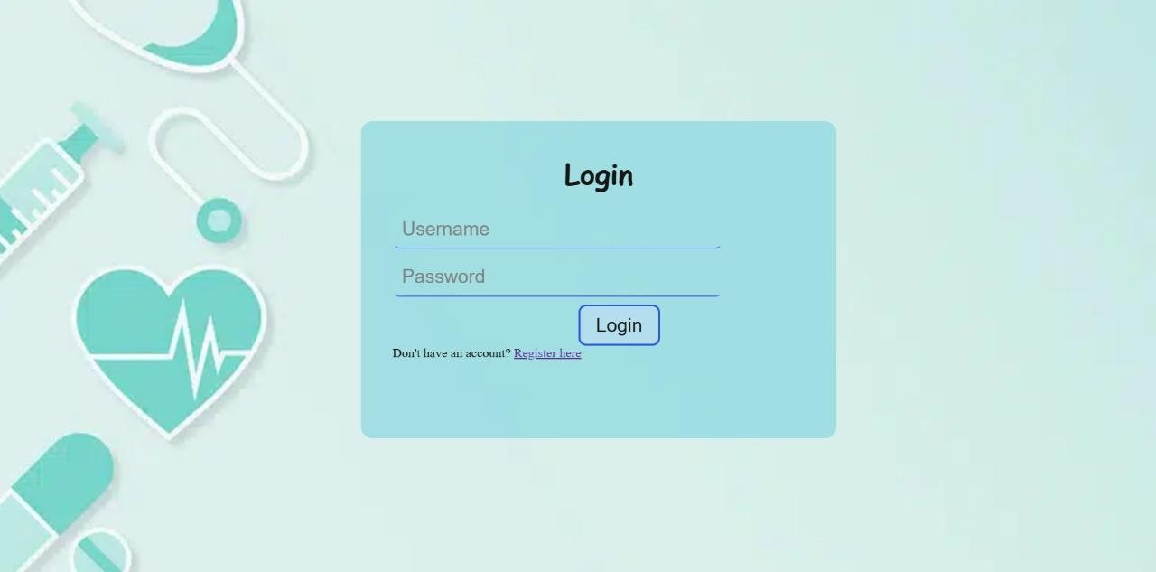

5.3 Login Page

Below it, there are fields for users to enter their "Username" and "Password," both clearly labeled . this login page for hospital staff which record the patient detail after check from the doctor .

### 5.4 Patient Data:

The dashboard page for the Health Record Management system presents a user- friendly overview of the patient list. Set against a calming light blue background, the layout is clean and easy to navigate. The page features a prominent header titled "Patient List," indicating the main focus of the dashboard.

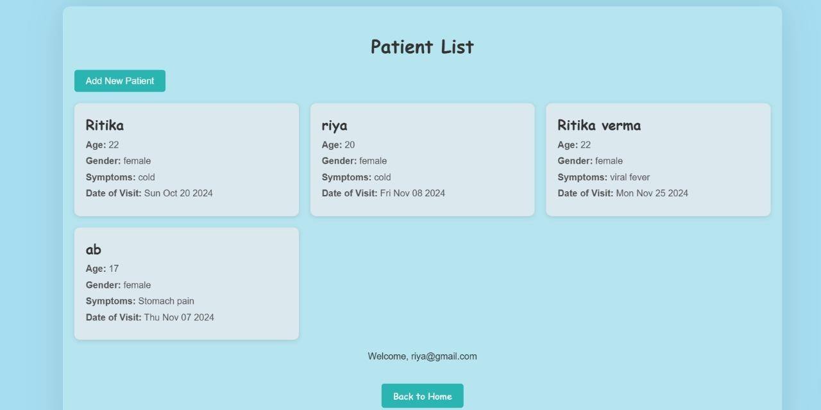

Fig. 5.4 Patient’s Record

On the left, an "Add New Patient" button is clearly visible, allowing users to quickly add new entries to the patient records. Below this button, a series of patient cards displays essential information for each individual. Each card includes the patient’s name, age, gender, symptoms, and the date of their last visit, making it convenient for users to access key details at a glance. The patient cards are well- organized, creating a visually appealing grid format that enhances readability. Towards the bottom of the page, a welcome message a personalized experience for the user. Additionally, a "Back to Home" button provides easy navigation, ensuring an intuitive user experience throughout the health record management process.

**5.5 Reports**

**1. Patient Medical Report.**

**Description:** Provides an overview of patient Medical History, including age, gender, location, and other relevant details.

**Use Case:** Helps healthcare providers analyze patient population characteristics and tailor services accordingly.

1. **Patient History Report.**

**Description:** Summarizes a given patient's medical history, including past diagnoses, treatments, medications, and hospital visits.

**Use Case:** Assists healthcare providers in understanding the health background of patients for better care planning.

1. **Treatment Outcome Report.**

**Description:** Analyzes the outcomes of treatments administered to patients, including success rates and complications.

**Use Case:** Helps in evaluating the effectiveness of various treatment methods and improving clinical practices.

**Authentication and Authorization .**

Authentication and authorization are two critical concepts in any secure system, including patient health record management systems. Although these terms are often used interchangeably, they represent distinct processes that play unique roles in ensuring the security and integrity of information.

1. Authentication: Authentication is the process of verifying the identity of a user, device, or application attempting to access a system. The goal of authentication is to ensure that the entity requesting access is who or what it claims to be.

**2**. Authorization : Authorization determines what resources and data a verified user can access and what actions they are permitted to perform. While authentication identifies who the user is, authorization controls their level of access based on predefined policies.

The workflow typically involves:

1. Login Phase: The user authenticates themselves through a secure process.
2. Access Control Phase: The system verifies the user’s authorization level and grants access accordingly.

For example,

when a hospital staff member logs into the system, their identity is authenticated using a password and an OTP. Once authenticated, the system checks their role (e.g., Doctor) and grants access to patient records relevant to their department.

## CHAPTER 6

**DISCUSSIONS**

The Discussions section of this report delves into crucial aspects of the **Health Record Management System**, shedding light on the strategic choices and their implications for user experience, scalability, and future developments. The technological integration emphasizes flexibility, scalability, and real-time interactions, ensuring the system meets the dynamic needs of healthcare providers and administrators.

### 6.1 Performance

The success of the **Health Record Management System** is contingent upon the effectiveness and efficiency of the technologies responsible for managing patient records, generating medical reports, and providing seamless access to sensitive health information.

1. **Node.js** enhances backend operations, enabling fast data processing and seamless communication between the server and client.
2. **Firebase's scalable architecture** accommodates a growing database of patient records and user access without compromising performance.
3. **Firebase's real-time database capabilities** ensure instant updates, allowing healthcare

## CHAPTER 7 CONCLUSION

The Health Record Management System (HRMS) is a web-based application that revolutionizes the management of patient health records by transitioning from outdated paper-based systems to a secure, efficient, and digital solution.

Health record management systems are essential components of modern healthcare infrastructure. They offer a centralized platform for storing, managing, and retrieving patient data, ensuring that healthcare professionals can deliver timely and informed care. Through robust authentication and authorization mechanisms, these systems protect sensitive information against breaches and unauthorized access, fostering a secure environment.

By leveraging technologies such as Node.js, Express.js and MongoDB, this system ensures the streamlined storage, management, and retrieval of large volumes of unstructured medical data. Its user-friendly design provides healthcare providers with seamless access to patient information, enhancing the quality of care and operational efficiency in healthcare facilities.

Robust security features, including encryption and role-based access control, safeguard sensitive patient data and ensure compliance with healthcare regulations such as HIPAA. Additionally, the integration of data analytics tools supports informed decision-making, enabling healthcare professionals to deliver personalized and timely care.

Through intuitive interfaces and scalable architecture, the HRMS fosters widespread adoption and adaptability to growing healthcare demands, ultimately driving improved patient outcomes and setting a benchmark for modern healthcare data management systems.

In the broader scope of healthcare, these systems are instrumental in driving a shift toward value-based care. By enabling data-driven insights, they empower healthcare providers to optimize treatment plans, minimize errors, and improve patient outcomes. As technology advances, the potential of health record management systems will continue to grow, paving the way for a more efficient, patient-centred, and innovative healthcare ecosystem.

**REFERENCES**

* [MDN Web Docs](https://developer.mozilla.org/)

Comprehensive documentation and tutorials on HTML, CSS, JavaScript.

* [W3Schools](https://www.w3schools.com/)

Easy-to-follow tutorials on HTML, CSS, JavaScript, and MongoDB.

### Node.js Official Documentation

Essential for understanding the core modules and features of Node.js.

* [Express.js Guide](https://expressjs.com/)

Official documentation for Express.js, covering routing, middleware, and more

.

* https://docpulse.com/