**Design Inspirations**

# Nike+ Run Club

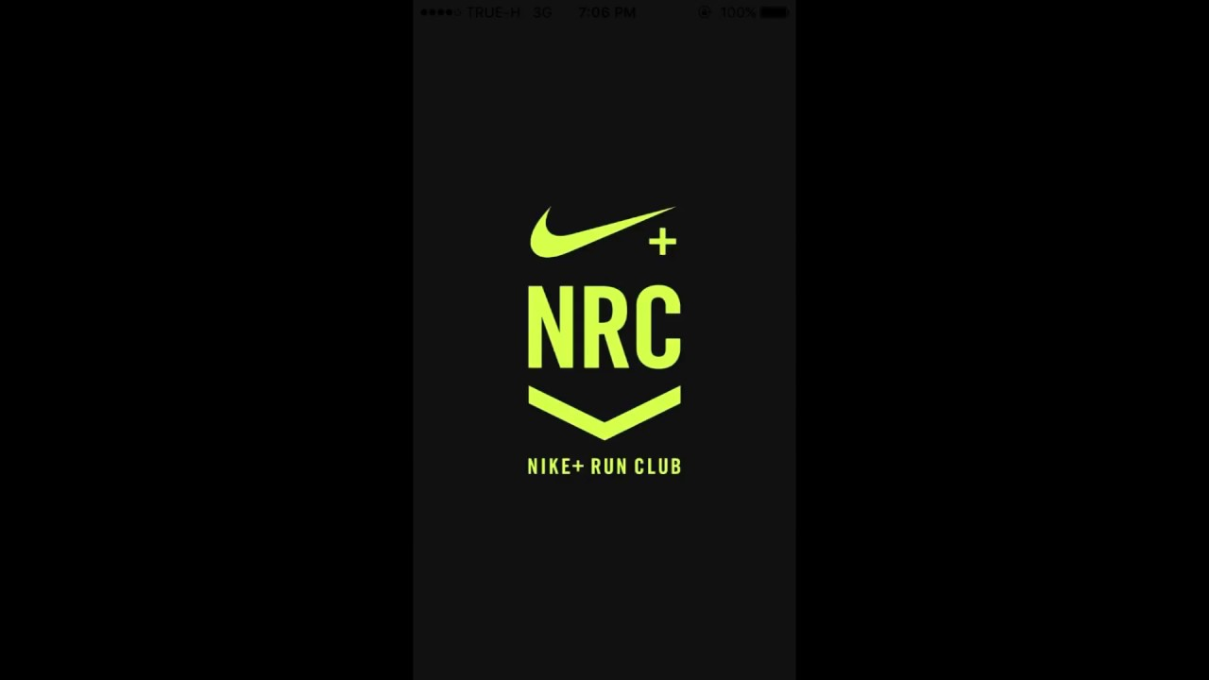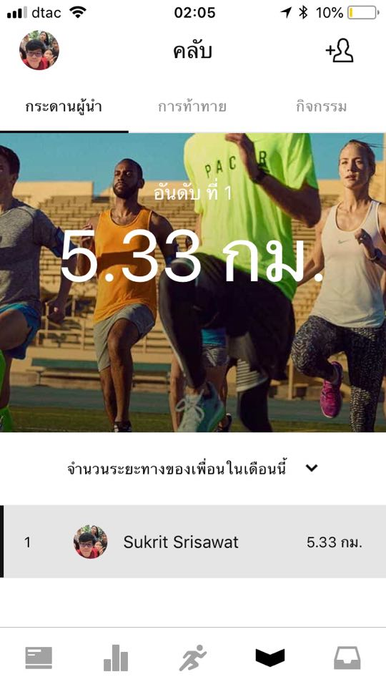

https://itunes.apple.com/us/app/nike-run-club/id387771637?mt=8

# ผลการค้นหารูปภาพสำหรับ Moment – Screen Time TrackerMoment – Screen Time Tracker



https://itunes.apple.com/th/app/moment-screen-time-tracker/id771541926?l=th&mt=8

# QualityTime - My Digital Diet

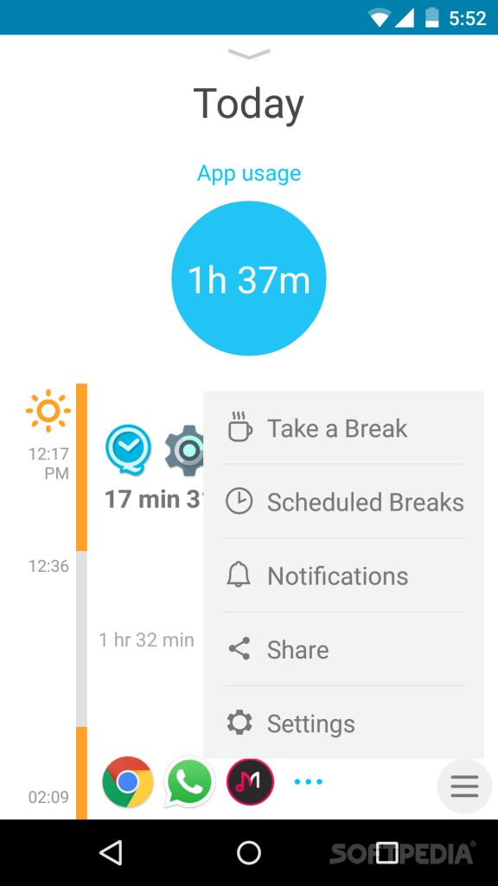

https://play.google.com/store/apps/details?id=com.zerodesktop.appdetox.qualitytime

# SPACE - Break phone addiction

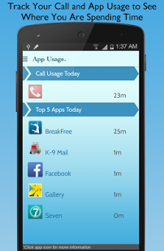

<https://play.google.com/store/apps/details?id=mrigapps.andriod.breakfree.deux>

# Forest - Stay focused

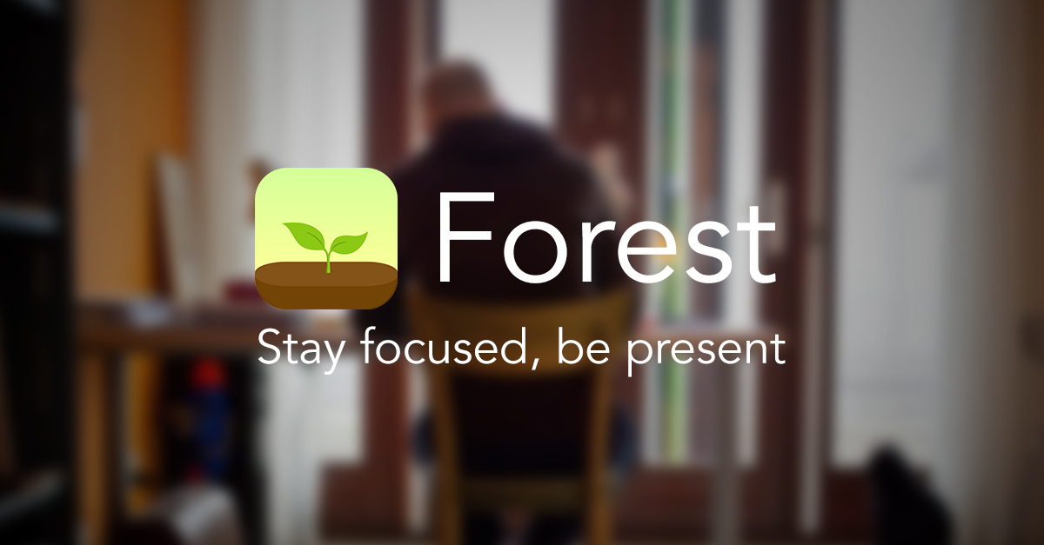

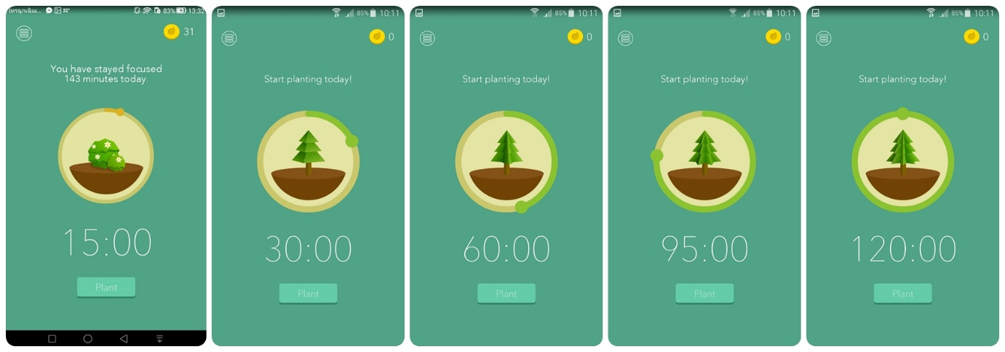

<https://itunes.apple.com/us/app/forest-stay-focused/id866450515?mt=8>