Lab1: Object, Class, JUnit (Worksheet)

Section______2________ Date_________27 August 2017_________________________

Student ID ___________5930486521______________ Name_____Sirawit Tantiphuwanart____________

# Part A: Implementation

1. Summarize the step to export your project into jar file.

File -> Export -> Java -> jar file -> next -> select destination & name the jar file

-> next -> next -> select the main class

1. Create a UML diagram of the program using eclipse and tell us the name of software/eclipse extension you are using.

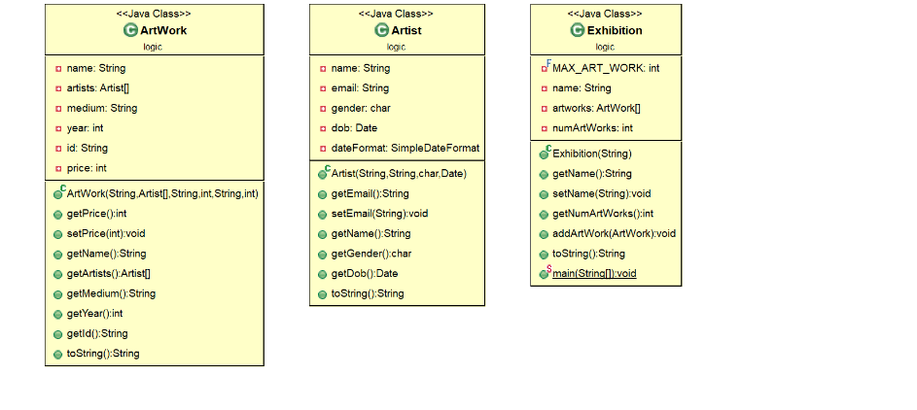

Using ObjectAid UML diagram

1. Capture the screen of JUnit Test Cases.

