Exercise 1

**\*the assignment is finished using Python version 3.6.1, with PyCharm.**

**\*\* the data set is cut to 1/10 of original size for faster testing, and iterations are limited to 1 except for Q2.**

2. (CNN.py)

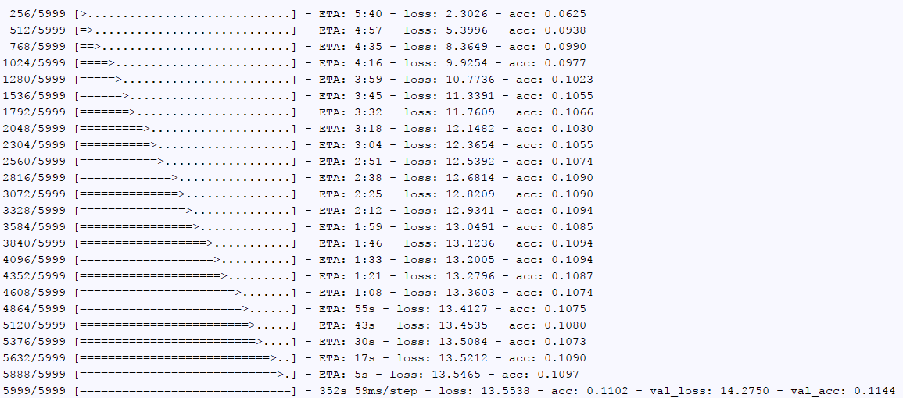

(because of limit of space, only result for 1 iteration is listed)

a) Testing test accuracy against iteration:

1 iterations: 0.875

2 iterations: 0.918

5 iterations: 0.955

b) Testing training accuracy against iteration:

1 iterations: 0.89

2 iterations: 0.916

5 iterations: 0.971

c) Testing test loss against iteration:

1 iterations: 0.423

2 iterations: 0.283

5 iterations: 0.149

d) Testing training loss against iteration:

1 iterations: 0.390

2 iterations: 0.281

5 iterations: 0.109

Conclusion: both training and test accuracy increases as loss decreases as the number of iterations increases. Changes in training sets increases faster.

3e). (CNN_rotate.py)

**\*(The result is obtained with a rotation of -45 degree)**

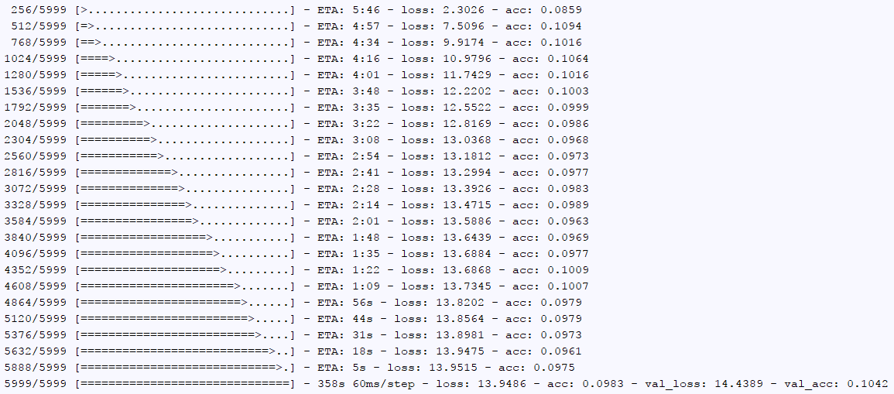

3f). (CNN_blur.py)

**\*(The result is obtained by adding a Gaussian blur of 4)**

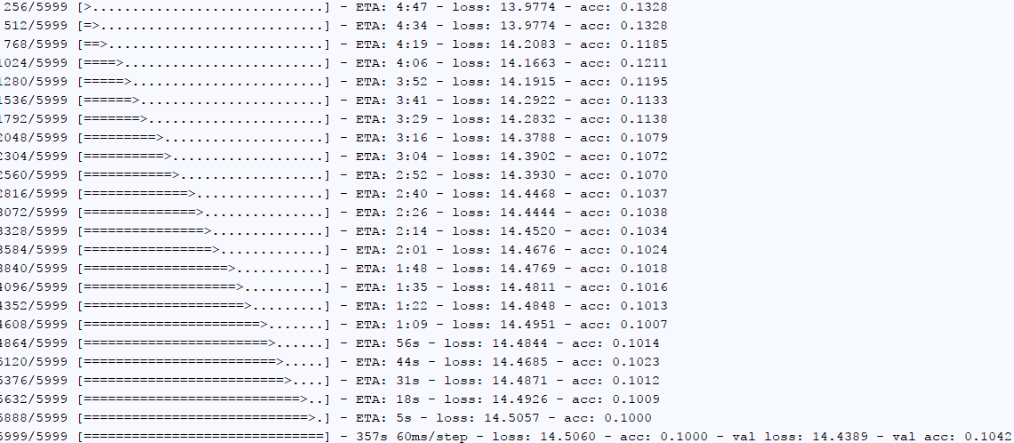

Conclusion: According to the results, rotations and blurring decreases accuracy as they are able to prevent overfitting.

4g). (CNN_regularization.py)

Original



Rotation



Blur



As the results comparing to all answers from question 2 and 3, regularizing still takes effect but when it is used in combination with either blurring or rotating, regularizing takes less effect.

4f). (CNN_dataAug.py)

Original



Rotation



Blur



As the results comparing to all answers from question 2 and 3, data augmenting decreases accuracy of the data. However, this depends on the data we generated, and it will be a less likely event when we use a larger data set. However, testing with all 60k elements is limited by computational capability.