作业二

10172100212 顾炤天

第一题答案为：

DROP TABLE IF EXISTS `customer2`;

CREATE TABLE `customer2` (

`customer_id` int NOT NULL,

`address` varchar(255) DEFAULT NULL,

`city` varchar(40) DEFAULT NULL,

`type` varchar(1) DEFAULT NULL,

`province` varchar(40) CHARACTER SET utf8 COLLATE utf8_general_ci DEFAULT NULL,

`zipcode` varchar(6) DEFAULT NULL,

`credit` int DEFAULT NULL,

PRIMARY KEY (`customer_id`)

) ENGINE=InnoDB DEFAULT CHARSET=utf8;

第二题答案为：

UPDATE `customer2`

SET `province`=NULL;

第三题答案为：

UPDATE `customer2`

SET `province`='上海市'

WHERE `city`='上海市';

第四题答案为：

UPDATE `customer2`

SET `province`=CASE

WHEN `city`='南京市' THEN '江苏省'

WHEN `city`='杭州市' THEN '浙江省'

ELSE '上海市'

END;

第五题答案为：

ALTER TABLE `customer2` ADD `rank` varchar(1) DEFAULT NULL;

UPDATE `customer2`

SET `rank`=CASE

WHEN `credit`<2000 THEN 'J'

WHEN (`credit`>=2000 AND `credit`<4000) THEN 'E'

WHEN `credit`>=4000 THEN 'S'

END;

第六题答案为：

UPDATE `customer2`

SET `credit`=CASE

WHEN (`credit`>=0 AND `credit`<1500) THEN `credit`*1.2

WHEN (`credit`>=1500 AND `credit`<2000) THEN `credit`*1.1

WHEN (`credit`>=2000 AND `credit`<3000) THEN `credit`*1.05

ELSE `credit`

END;

第七题答案为：

SELECT `credit`

FROM `customer2`

WHERE `city`='上海市';

第八题答案为：

SELECT *

FROM `customer2`

WHERE `rank`='E' AND `credit`<3000;

第九题答案为：

SELECT `city`

FROM `customer2`

WHERE `credit`>=1000 AND `credit`<=2500;

第十题答案为：

1. E-R图如下所示

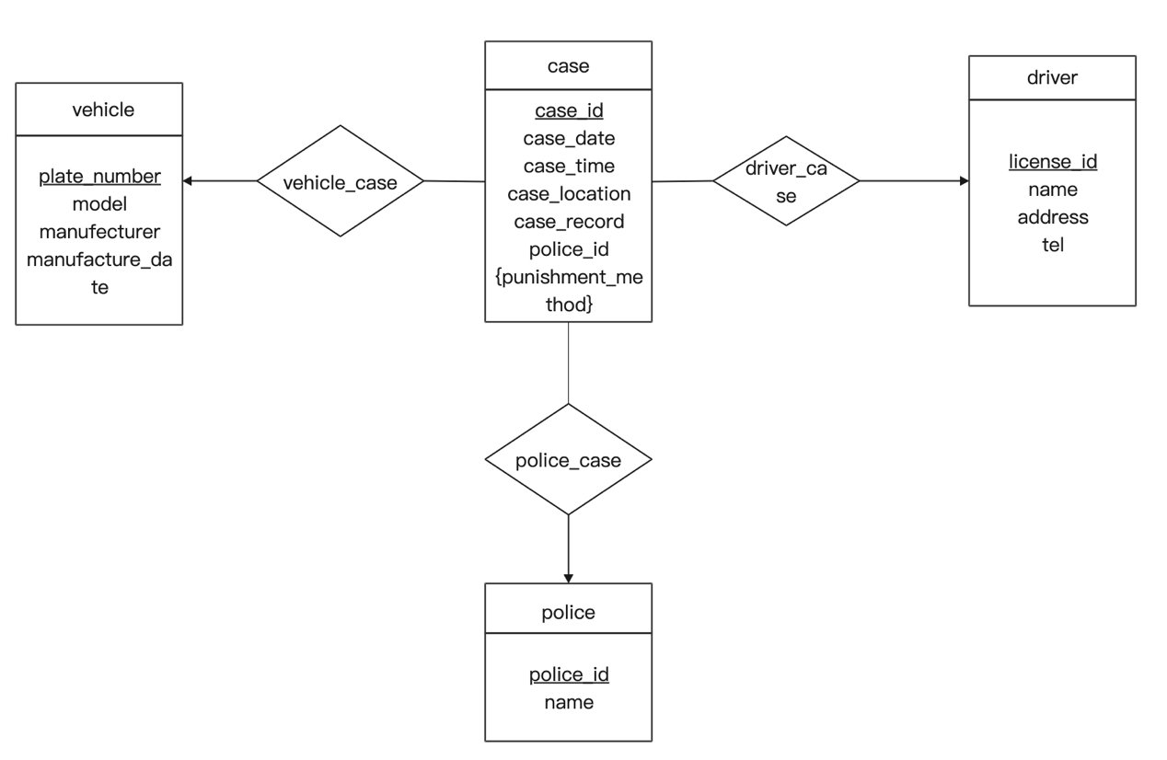

1. 转化为表如下所示

driver(license_id, name, address, tel)，license_id为主键

vehicle(plate_number, model, manufacturer, manufecture_date)，plate_number为主键

police(police_id, name)，police_id为主键

case(case_id, license_id, plate_number, case_date, case_time, case_location, case_record, police_id)，case_id为主键，外键license_id引用driver表的license_id，外键plate_number引用vehicle表的plate_number，外键police_id引用police表的police_id。

punishment(case_id, punishment_method)，外键case_id引用case表的case_id。

表的模式图如下所示

