1. **定义视图v_customeInfo，要求可以替换同名视图，列出所有客户相关信息，输出属性包括客户编号（CUST_ID）、完整联系地址（PROVICIAL_REGION、CITY与ADDRESS三个字段拼接）、邮政编码（POSTAL_CODE）、客户名称（类型为I的客户输出在Individual表中对应的姓名，使用LAST_NA ME与FIRST_NAME拼接；类型为B的客户输出在business表中对应的NAME）**

DROP VIEW IF EXISTS v_customeInfo;

CREATE VIEW v_customeInfo AS

SELECT c1.CUST_ID , CONCAT(c1.PROVICIAL_REGION,c1.CITY,c1.ADDRESS) AS accommadation,c1.POSTAL_CODE,NAME AS whole_name

FROM customer AS c1,business AS b

WHERE c1.CUST_TYPE_CD = 'B' AND c1.CUST_ID = b.CUST_ID

UNION

SELECT c.CUST_ID , CONCAT(c.PROVICIAL_REGION,c.CITY,c.ADDRESS) AS accommadation,c.POSTAL_CODE,CONCAT(i.LAST_NAME,i.FIRST_NAME)AS whole_name

FROM customer AS c,individual AS i

WHERE c.CUST_TYPE_CD = 'I' AND c.CUST_ID = i.CUST_ID;

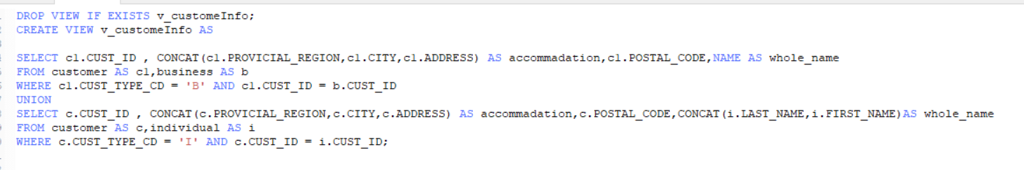

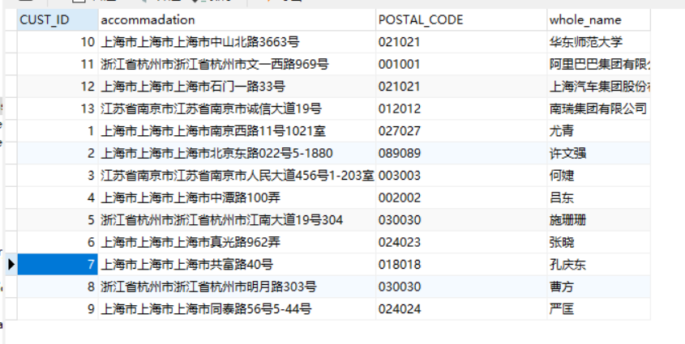

**（2）定义视图v_transInfo，从acc_transaction中查出不在其开户行进行的交易记录信息（即EXECUTION_BRANCH_ID不为该账户对应的OPEN_BRANCH_ID），输出属性包括交易金额（AMOUNT）、交易时间（TXN_DATE）、交易类型（CD显示为现金存入，CW显示为现金取出，TF显示为汇款转出，TT显示为汇款转入，IC显示为利息计入，LI显示为贷款拨入）、执行交易的分支机构名称（EXECUTION_BRANCH_NAME）、开户分支银行名称（OPEN_BRANCH_NAME）**

DROP VIEW IF EXISTS v_transInfo;

CREATE VIEW v_transInfo AS

SELECT a1.AMOUNT , a1.TXN_DATE ,a1.TXN_TYPE_CD,b.NAME AS EXECUTION_BRANCH_NAME,b.NAME AS OPEN_BRANCH_NAME

FROM acc_transaction AS a1,account AS a2,branch as b

WHERE a1.EXECUTION_BRANCH_ID = b.BRANCH_ID AND a2.OPEN_BRANCH_ID =b.BRANCH_ID AND a1.EXECUTION_BRANCH_ID <> a2.OPEN_BRANCH_ID

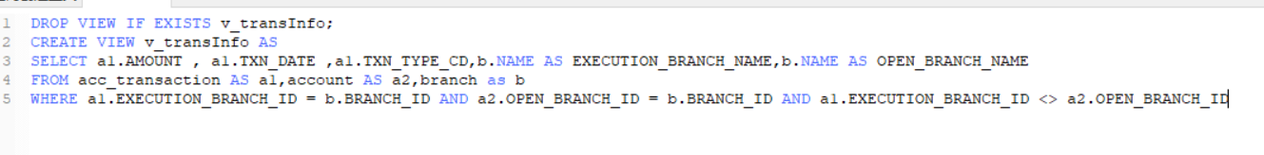



**（3）为了备份数据或复制生产数据进行测试，经常会需要把数据从现有的表复制到新的（临时）表中，可以用CREATE TABLE ... AS ...子句进行表的复制。创建存储过程（copyTransactionFrom），该存储过程接收一个参数：起始日期（fDATE），功能是将acc_transaction表中交易日期（TXN_DATE）晚于等于起始日期的记录全部信息复制到新表（acc_transactionNew）中（该表如存在应先删除）。提示：在存储过程中执行DDL语句需要特殊处理。**

DROP PROCEDURE IF EXISTS copyTransactionFrom;

CREATE PROCEDURE copyTransactionFrom(in fDATE datetime)

BEGIN

DROP TABLE IF EXISTS acc_transactionNew;

CREATE TABLE acc_transactionNew AS

SELECT *

FROM acc_transaction

WHERE TXN_DATE >= fDATE;

END;

CALL copyTransactionFrom('2015-12-28 00:00:00')

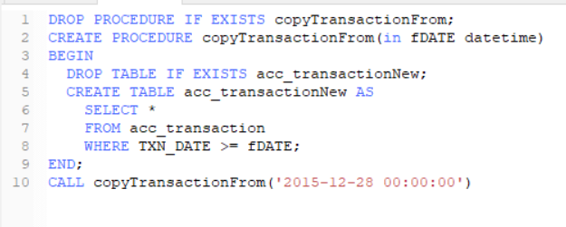



**（4）编写函数func_vipid，接收输入参数after_date，返回开户日期（OPEN_DATE）晚于after_date的、且可用余额最多的账户对应的客户编号（CUST_ID）。**

**（5）编写函数func_rand_email，随机生成合法的邮箱地址，@之前为长度不超过50的字符串，字符串中符号可包括a-z、A-Z、0-9；@之后为163.com、hotmail.com或ecnu.edu.cn。**

**（6）编写函数func_rand_telnum，可随机生成长度为11为的手机号，开头为130 131 132 133 134 135 136 137 138 139 186 187 189 151 157。**