作业七

10172100212 顾炤天

第一题答案为：

CREATE TRIGGER d_newTransaction AFTER INSERT

ON acc_transaction FOR EACH ROW

BEGIN

UPDATE account

SET STATUS='正常'

WHERE account.ACCOUNT_ID=NEW.ACCOUNT_ID AND account.STATUS='不活跃';

END;

第二题答案为：

CREATE TRIGGER e_newTransaction AFTER INSERT

ON acc_transaction FOR EACH ROW

BEGIN

DECLARE employeeId INT;

SET employeeId=NEW.TELLER_EMP_ID;

WHILE employeeId IS NOT NULL DO

UPDATE employee

SET SIMPLE_KPI=SIMPLE_KPI+1

WHERE employee.EMP_ID=employeeId;

SELECT employee.SUPERIOR_EMP_ID INTO employeeId

FROM employee

WHERE employee.EMP_ID=employeeId;

END WHILE;

END;

第三题答案为：

(1)

UPDATE instructor

SET salary=10000

WHERE ID=12121 AND name='Wu';

(2)

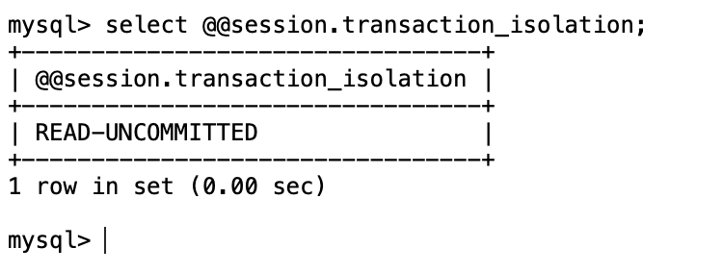

说明设定成功。

(3)

信息如下所示

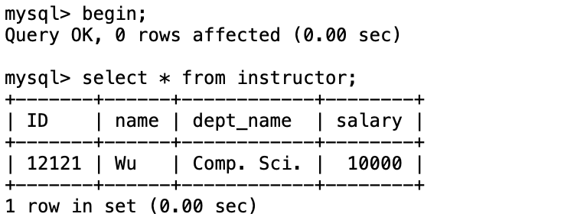

(4)

信息如下所示

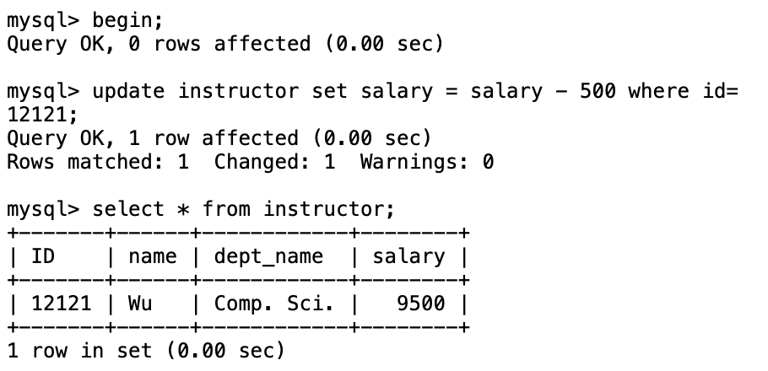

(5)

Q1：是

Q2：脏读

(6)

如下所示



(7)

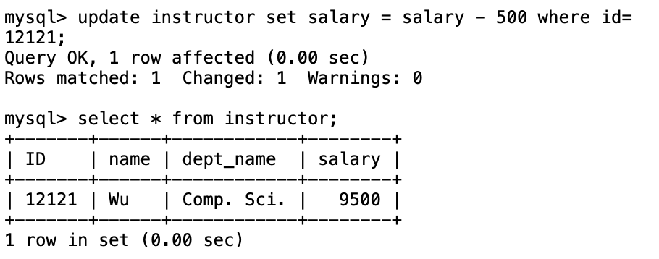

值为9500.

(8)

如下所示

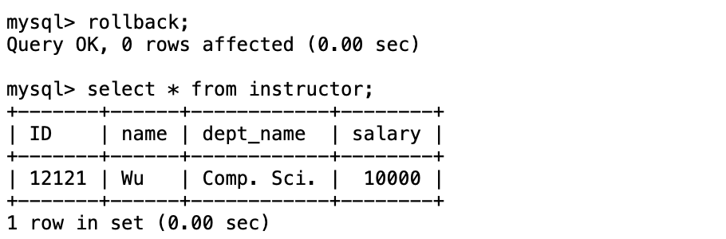

(9)

如下所示

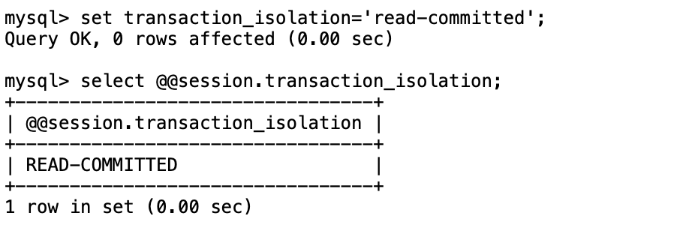

(10)

如下所示

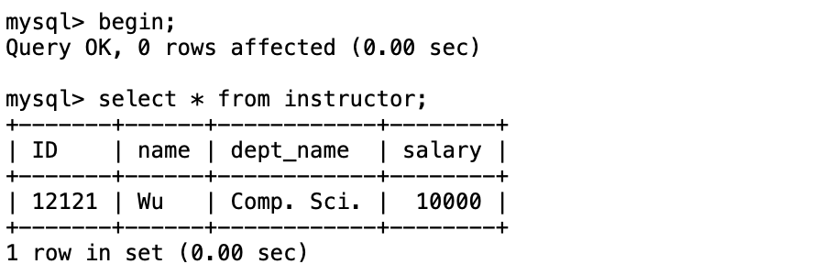

(11)

如下所示

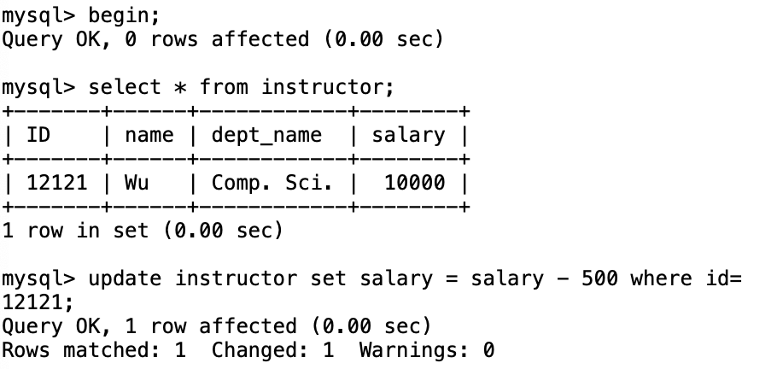

(12)

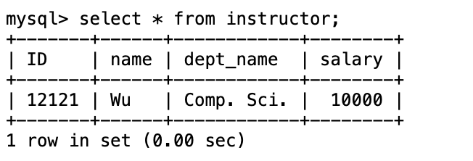

Q1：salary值为10000

Q2：否

(13)

如下所示

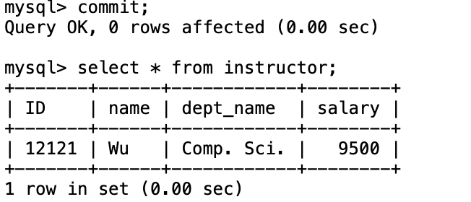

(14)

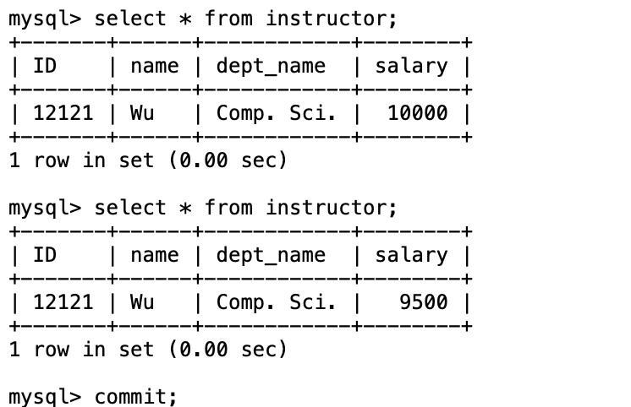

Q1：值为9500

Q2：是

Q3：不一致

Q4：不可重复读

(15)

如下所示

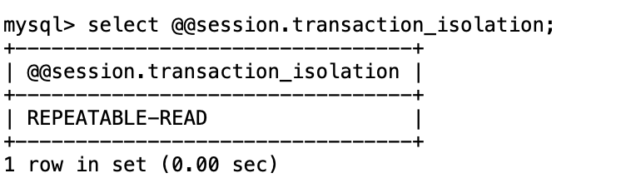

(16-1)

如下所示

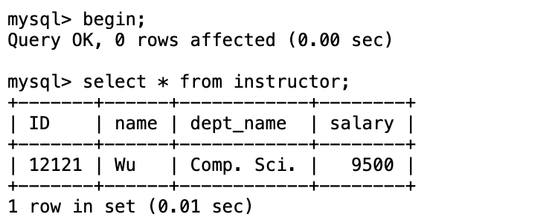

(16-2)

如下所示

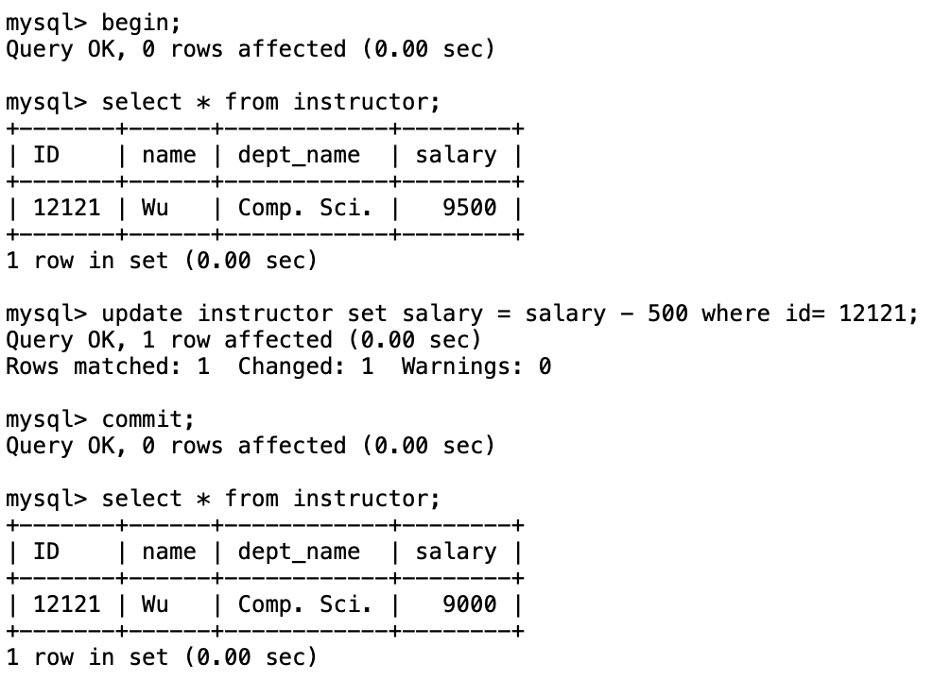

(17)

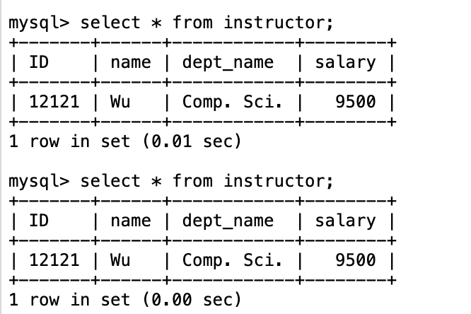

Q1：值为9500

Q2：否

Q3：一致

(18)

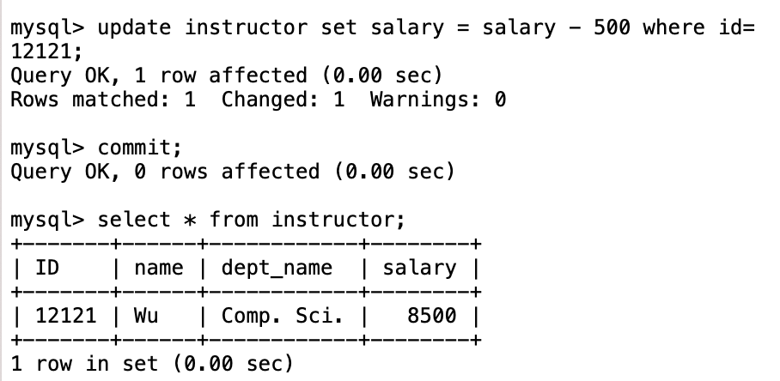

Q1：值为8500

(19)

如下所示

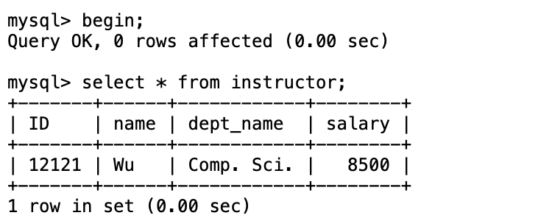

(20)

如下所示

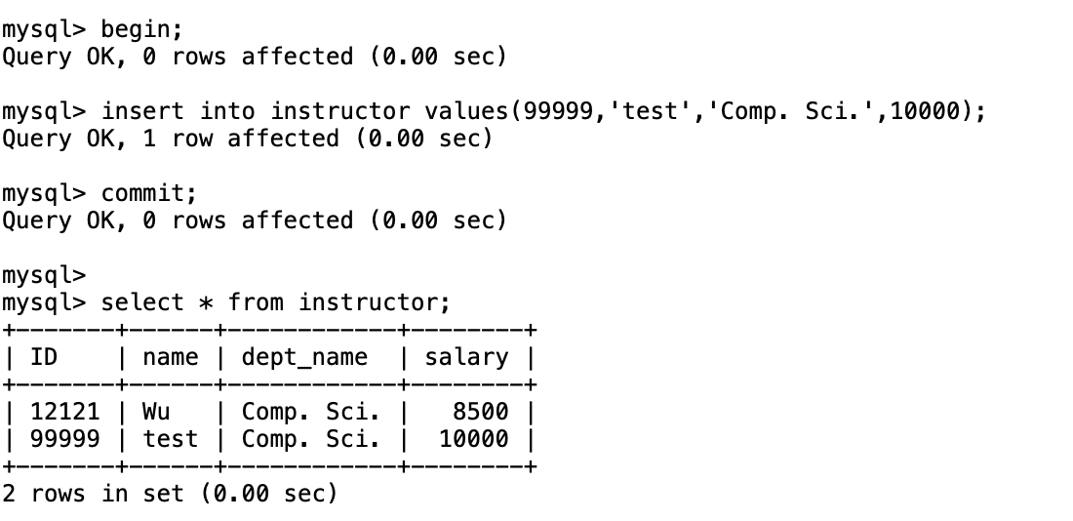

(21)

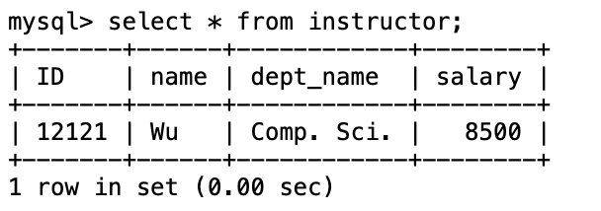

Q1：否

(22)

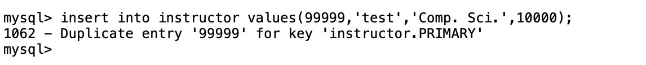

Q1：否

Q2：幻读

(23)

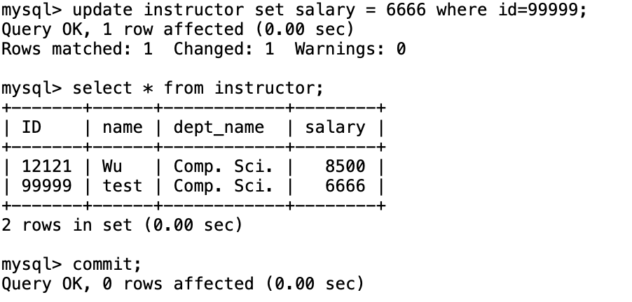

Q1：是

第四题答案为：

import java.sql.*;

public class **Main** {

public static void **main**(String[] args) {

try{

Class.**forName**("com.mysql.jdbc.Driver");

} catch (ClassNotFoundException e){

System.out.**println**("抛出异常");

e.**printStackTrace**();

}

try {

String url = "jdbc:mysql://localhost:3306/bank";

String user = "root";

String pass = "mysql";

Connection connection = DriverManager.**getConnection**(url, user, pass);

System.out.**println**("连接成功！");

String sql1="insert into customer values(?,?,?,?,?,?)";

PreparedStatement preparedStatement=connection.**prepareStatement**(sql1);

preparedStatement.**setInt**(1,1);

preparedStatement.**setString**(2,"上海市南京西路11号1021室");

preparedStatement.**setString**(3,"上海市");

preparedStatement.**setString**(4,"I");

preparedStatement.**setString**(5,"上海市");

preparedStatement.**setString**(6,"027027");

int temp=preparedStatement.**executeUpdate**();

if(temp!=0){

System.out.**println**("记录添加成功");

}

else{

System.out.**println**("记录添加失败");

}

Statement statement=connection.**createStatement**();

String sql2="update customer set cust_type_cd='B' where address='上海市南京西路11号1021室'";

temp=statement.**executeUpdate**(sql2);

if(temp!=0){

System.out.**println**("记录更新成功");

}

else{

System.out.**println**("记录更新失败");

}

} catch (SQLException e) {

System.out.**println**("连接数据库失败");

e.**printStackTrace**();

}

}

}