<https://blog.csdn.net/weixin_26738395/article/details/108924823?ops_request_misc=&request_id=&biz_id=102&utm_term=%E5%85%AC%E5%B9%B3%20%E6%9C%BA%E5%99%A8%E5%AD%A6%E4%B9%A0%E9%A1%B9%E7%9B%AE&utm_medium=distribute.pc_search_result.none-task-blog-2~all~sobaiduweb~default-0-108924823.pc_search_result_before_js>

<https://blog.csdn.net/weixin_42137700/article/details/104214345?utm_medium=distribute.pc_relevant_download.none-task-blog-baidujs-6.nonecase&depth_1-utm_source=distribute.pc_relevant_download.none-task-blog-baidujs-6.nonecase>

<https://download.csdn.net/download/weixin_42099151/16265840?utm_medium=distribute.pc_relevant.none-task-download-2%7Edefault%7EOPENSEARCH%7Edefault-6.control&dist_request_id=&depth_1-utm_source=distribute.pc_relevant.none-task-download-2%7Edefault%7EOPENSEARCH%7Edefault-6.control>

1、从某一方面（隐私、公平、对抗攻击、可解释等）入手，自行实现一个简单的可信机器学习算法（如基于SVM、决策树、神经网路、概率图模型等），课堂展示并简要介绍算法原理

2、每位同学时间不超过10分钟（请严格控制时间）

3、评分细则

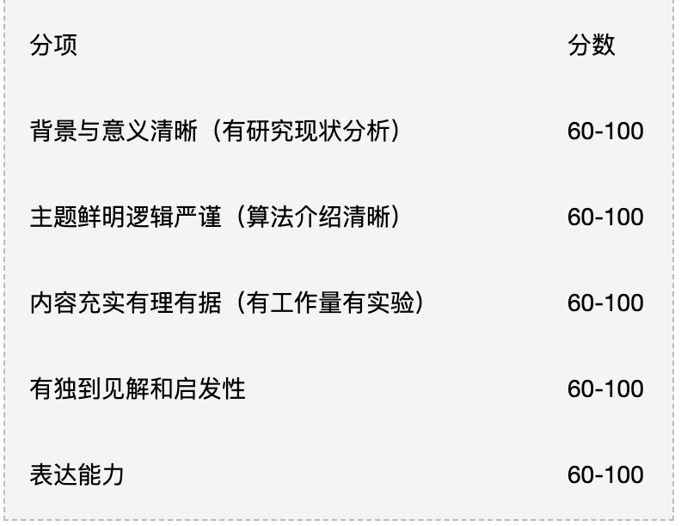

<https://www.baidu.com/s?ie=UTF-8&wd=billamt>