**MODULE: 1 (HTML)**

1. **Are the HTML tags and elements the same thing?**

**Ans:**

* HTML tags and elements are not the same thing, Tags are the starting and ending parts of an HTML element. They begin with < symbol and end with > symbol. Whatever written inside < and > are called tags. A HTML tag is like a container for either content or other HTML tags. An example of tag is: <p> </p>
* Where, the elements generally consist starting tag, content and an end tag.
* An example of an element is: <p>This is the content. </p>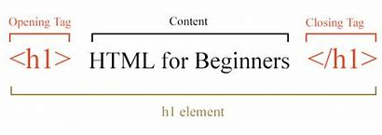

**2.What are tags and attributes in HTML?**

**Ans:**

* Tags are used to mark up the start of an HTML element and they are usually enclosed in angle brackets. An example of a tag is <h1>. Most tags must be opened <h1> and closed </h1> in order to function. Attributes contain additional pieces of information. Attributes take the form of an opening tag and additional info is placed inside.
* An example of an attribute is: <img src="mydog.jpg" alt="A photo of my dog.">

**3.What are void elements in HTML?**

**Ans:**

* Most of the HTML elements starts with the opening tag and ends with the ending tag but, There is a group of tags that only 11have start tag And doesn’t contain any content within it, these elements are known as Void element. Void elements doesn’t contain content but can have attributes. These elements can not be nested. Example of such elements are <br>, <hr>, <img>, <input>, <link>, <meta>etc.

**4.What are HTML Entities?**

**Ans:**

* An HTML entity is used to display invisible characters and reserved characters that would otherwise be interpreted as HTML code. It is a piece of text, or string, that begins with an ampersand (&) and ends with a semicolon (;).
* An example of entities is: &lt for (<), &gt for (>) , &nbsp for (non-breaking space) etc...

**5.What are different types of lists in HTML?**

**Ans:** There are three list types in HTML

* unordered list — used to group a set of related items in no particular order
* ordered list — used to group a set of related items in a specific order
* description list — used to display name/value pairs such as terms and definitions

**6.What is the ‘class’ attribute in HTML?**

**Ans:**

* The HTML class attribute is used to specify a single or multiple class names for an HTML element. The class name can be used by CSS and JavaScript to do some tasks for HTML elements.
* A class attribute can be defined within <style> tag or in separate file using the (.) character. In an HTML document, we can use the same class attribute name with different elements.
* It can also be used by a JavaScript (via the HTML DOM) to make changes to HTML elements with a specified class.

**7.What are the various formatting tags in HTML?**

**Ans**:

* HTML Formatting is a process of formatting text for better look and feel. HTML provides us ability to format text without using CSS. There are many formatting tags in HTML. These tags are used to make text bold, italicized, or underlined.
* In HTML the formatting tags are divided into two categories:
* Physical tag: These tags are used to provide the visual appearance to the text.
* Logical tag: These tags are used to add some logical or semantic value to the text.
* Here are some examples:

1. <b>: This is a physical tag, which is used to bold the text written between it.
2. <strong>: This is a logical tag, which tells the browser that the text is important.
3. <i>: This is a physical tag which is used to make text italic.
4. <em>: This is a logical tag which is used to display content in italic.
5. <sub>: It displays the content slightly below the normal line.
6. <sup>: It displays the content slightly above the normal line.
7. <big>: This tag is used to increase the font size by one conventional unit.
8. <small>: This tag is used to decrease the font size by one unit from base font size.

**8.What is the difference between the ‘id’ attribute and the ‘class’ attribute of HTML elements?**

**Ans**:

* The only difference between them is that “id” is unique in a page and can only apply to at most one element, while “class” selector can apply to multiple elements.

**9.** **How is Cell Padding different from Cell Spacing?**

**Ans:**

* Cellpadding and Cell spacing are the attributes used in table formatting.
* Cellpadding is used to specify the distance between a cell content and its boundaries.
* Cell spacing is an important attribute of <Table> tag the property which increases the space between the cells of the table.

**10.** **How can we club two or more rows or columns into a single row or column in an HTML table?**

**Ans:**

* You can merge cells in HTML by using the colspan and rowpan attributes. The rowspan attribute is for the number of rows that a cell should span, while the colspan attribute is for the number of columns that a cell should span.

**11.** **What is the difference between a block-level element and an inline element?**

**Ans:**

* Block-level element takes up the width available, and has a line break before and after it.
* Examples of block-level element:
* <p>
* <div>
* <h1> to <h6>
* <ul>
* <table>
* <ol>
* <li>
* Inline elements take only as much width as necessary, and does not force line breaks after it.
* Example of inline elements
* <a>
* <span>
* <img>

**12.** **How to create a Hyperlink in HTML?**

**Ans:**

* We can create hyperlink using anchor tag <a>.
* Syntax of <a> tag is:

<a href="url">link text</a>

* The most important attribute of the <a> element is the href attribute, which indicates the link's destination.
* The link text is the part that will be visible to the reader.
* Clicking on the link text, will send the reader to the specified URL address.
* This example shows how to create a link to W3Schools.com:

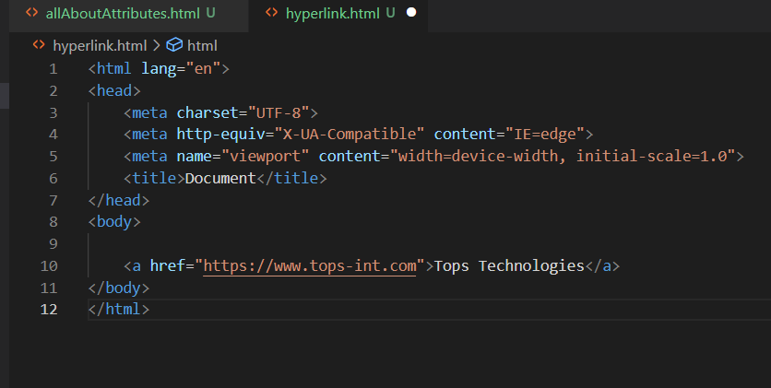

* Output:

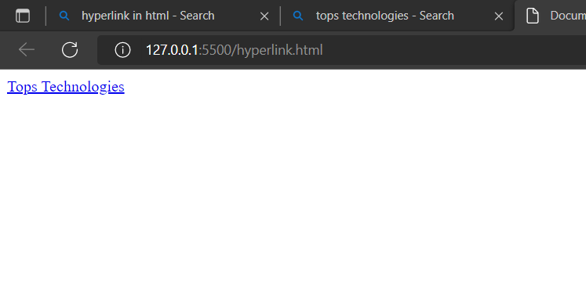

**13.** **What is the use of an iframe tag?**

**Ans:**

* To display a web page within a web page or a nested web page, the HTML <iframe> Tag are used. HTML Iframes are also known as Inline frames. As the name itself suggests, it defines an inline frame.
* Syntax of this tag is:

<iframe src="URL"></iframe>

* src: It is an attribute used to specify the URL.
* URL: It is used to define the web address of the inline frampage
* Example:

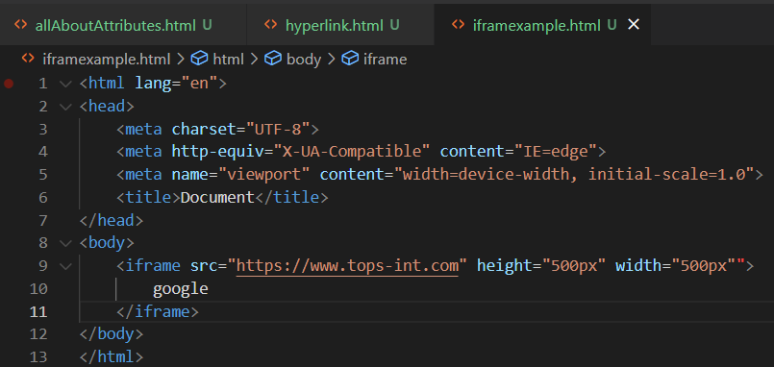

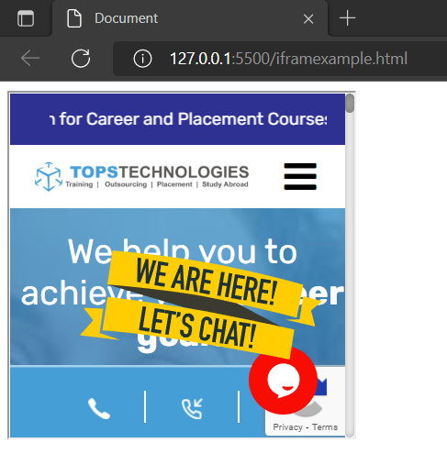

**14.** **What is the use of a span tag? Explain with example?**

**Ans:**

* The <span> tag is an inline container used to mark up a part of a text, or a part of a document.
* The <span> tag is easily styled by CSS or manipulated with JavaScript using the class or id attribute.
* The <span> tag is much like the <div> element, but <div> is a block-level element and <span> is an inline element.

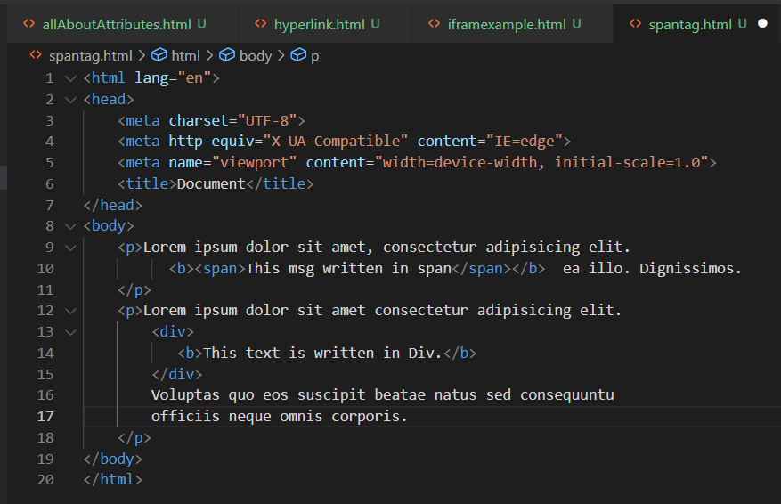

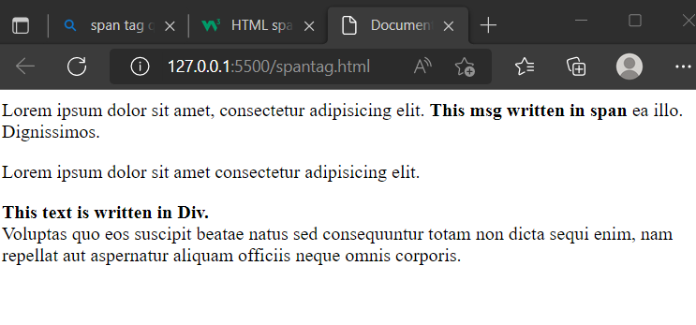

**15.** **How to insert a picture into a background image of a web page?**

**Ans.**

* There are two methods for setting background image in an HTML file:

1.By using background attribute in the tag in HTML.

Example:

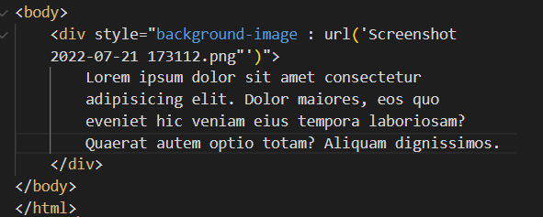

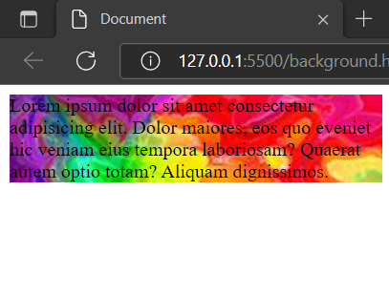

2.BY specifying the Background image in the <style>

Example:

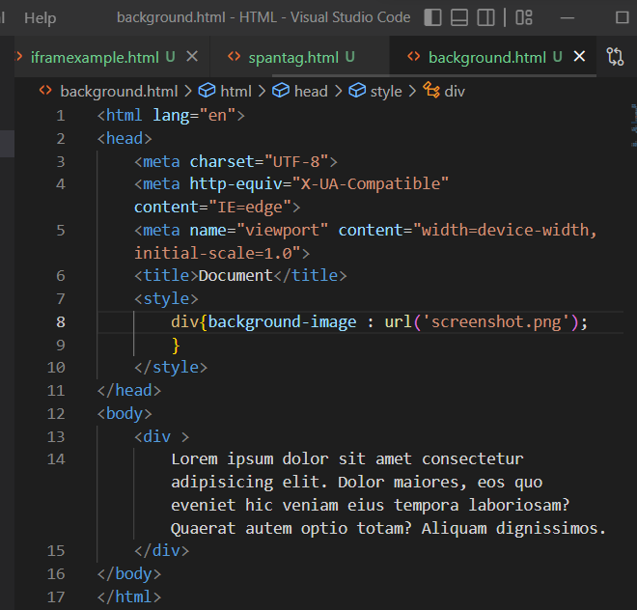



**16.** **How are active links different from normal links?**

**Ans:**

* Normal links are links which are there on the page and have not been clicked yet. Active links are those links, which have just been clicked at that instant. The default colour for normal and active links is blue.
* The following example shows the basic example for Normal Link (Unvisited Link).

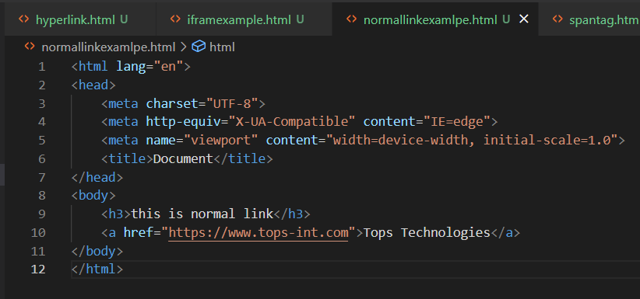

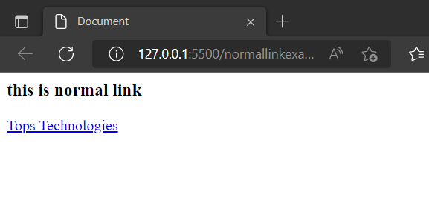

* If you click on the link shown above and again go back to the link page, you can now see the link is in purple colour and underlined.

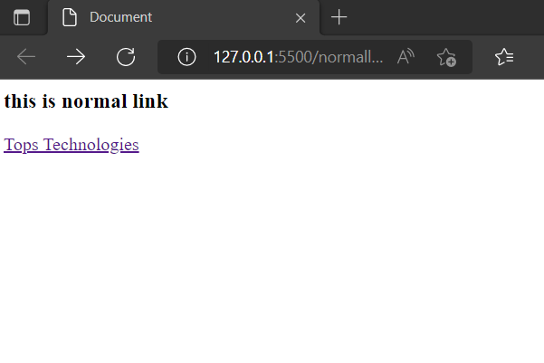

**17.** **What are the different tags to separate sections of text?**

**Ans:** There are **three** tags used to separate the texts.

* <br> tag - Usually <br> tag is used to separate the line of text. It breaks the current line and conveys the flow to the next line
* <p> tag - The <p> tag contains the text in the form of a new paragraph.
* <blockquote> tag - It is used to define a large quoted section. If you have a large quotation, then put the entire text within <blockquote>.............</blockquote> tag.
* Following example shows all the three tags:

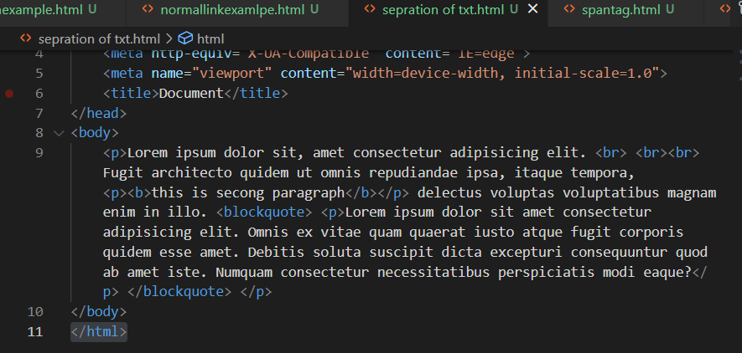

* Output:

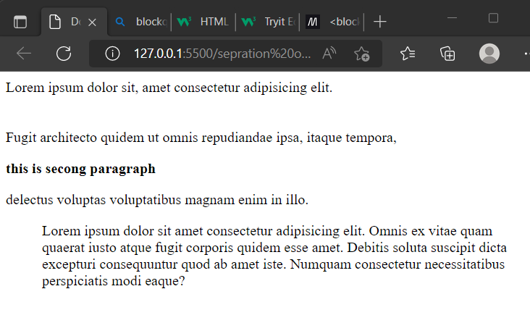

**18.** **What are logical and physical tags in HTML?**

**Ans:**

Physical tags are used to indicate exactly how specific characters are to be formatted.

* For example: <B> ---</B>

Indicates that the text should be bold.

Here are some useful Physical tag lists:

* <sup>: Superscript is usually used for showing elements above base-line
* <sub>: The subscript is used for alternate baseline.
* <i>: An Italic tag is used to define a text with a special meaning.
* <big>: Big tag increase the font size by 1 (Note: You cannot use the big tag in HTML 5)
* <small>: A small tag defines the small text, and it is used while writing copyright.
* <b>: Bold increases the importance of the text because bold tag covert the text into bold size.
* <u>: It is used to underline the text.
* <tt>: Teletype text gives the default font-family which is monospace.
* <strike>: It is an editing markup that tells the reader to ignore the text passage.

Logical tags are used to tell the browser what kind of text is written inside the tags. Logical tags are also known as Structural tags because they specify the structure of the document. Logical tags are used to indicate to the visually impaired person that there is something more important in the text or to emphasize the text ie, logical tags can be used for styling purposes as well as to give special importance to text content.

Here are some useful Logical tags list:

* <abbr>: Defines the abbreviation of text.
* <acronym>: Defines the acronym.
* <address>: Contact information of a person or an organization.
* <cite>: Defines citation. It displays the text in italic format.
* <code>: Defines the piece of computer code.
* <blockquote>: Defines a long quotation.
* <del>: Defines the deleted text and is used to mark a portion of text which has been deleted from the document.
* <pre>: Defines the block of preformatted text which preserves the text spaces, line breaks, tabs, and other formatting characters which are ignored by web browsers.
* <q>: Defines the short quotation.
* <strong>: Defines strong text i.e. show the importance of the text.
* <var>: Defines the variable in a mathematical equation or in the computer program.

**19.** **What is SVG?**

**Ans:**

* SVG stands for Scalable Vector Graphics.
* SVG is used to define graphics for the Web.
* Scalable Vector Graphics (SVG) are an XML-based markup language for describing two-dimensional based vector graphics
* As such, it's a text-based, open Web standard for describing images that can be rendered cleanly at any size and are designed specifically to work well with other web standards including CSS, DOM, JavaScript, and SMIL. SVG is, essentially, to graphics what HTML is to text.
* SVG is mostly useful for vector type diagrams like Pie charts, Two-dimensional graphs in an X, Y coordinate system etc.
* Most of the web browsers can display SVG just like they can display PNG, GIF, and JPG.

**20.** **What is difference between HTML and XHTML?**

**Ans:**

* XHTML (Extensible Hypertext Markup Language) is the more extended version of the popular HTML. It is the same HTML but defined as an XML application, which combines the advantages of both HTML and XML.
* XHTML retains all the features of HTML but introduced more strict rules for creating pages, which allows you to make sites independent of the display device and browser. It means that the site will be correctly displayed in all modern browsers and platforms like computers, smartphones.

Difference between HTML and XHTML:

* You should always use <!DOCTYPE ....>
* An XHTML document must include an XHTML Doctype Declaration. Other required elements are the <html>, <head>, <title>, and <body> tags.

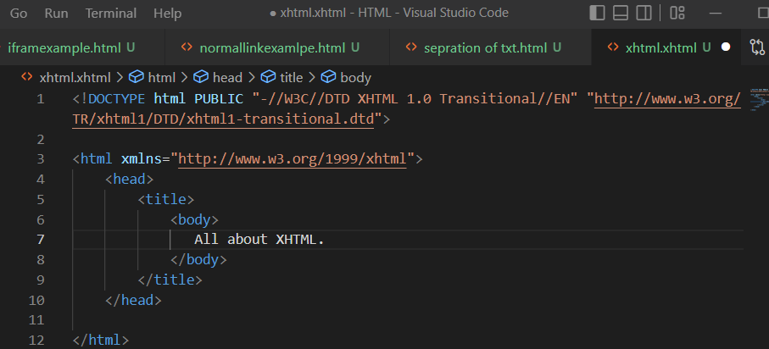

* Lowercase and uppercase tags are distinguished in XHTML. To avoid confusion, all tags, as well as their attributes must be typed in lowercase.
* In XHTML, elements must always be properly nested within each other.
* In XHTML, elements must always be closed.
* In XHTML, empty elements must always be closed.
* You must put the attribute values in quotes.
* In XHTML, attribute minimization is forbidden.