G1 Perception Capability Map and Collision Attribution
Adrián Lendínez Ibáñez — meta-reasoning payload campaign, University of Bedfordshire. 21 July 2026.
Purpose. Following the supervisor’s request to make the robot’s perceptual capabilities explicit, this note answers three questions from logged evidence: what the G1 can and cannot see; why it keeps clipping its shoulder/arm on the door frame and on the sofa arm; and whether each cause is hardware or software. Every one of the 10 collisions recorded across the two real-lab sessions (8 and 14 July) is attributed to a mechanism, and each mechanism now has a shipped mitigation.
1. What the robot can see — and what it structurally cannot
Channel | What it provides | Blind spots
SLAM LiDAR → obstacle map | Occupancy cells (0.2 m) from laser returns in a height band of ≈0.7–1.8 m above the floor; K-of-N persistence filter; high-confidence "hard" subset for the wall guard | Anything BELOW ≈0.7 m: sofa arm (≈0.6 m), seat edges, low cabinets. The band is necessary: gait pitch floods the map with floor hits if lowered. Thin jambs at grazing incidence return too few points for the persistence filter
Camera (floor-colour channel) | Projected obstacle scan + "clamp" columns = tall obstruction dead ahead within ≈0.7 m (central ±30° only). Design rule (RQ, 2 Jul): the LiDAR decides, vision supports — clamps must only moderate speed | No range beyond the clamp floor, no height, forward FOV only. Until this week the moderation half of the rule was never implemented — the channel was logged and ignored
IMU | Contact detection | Fires AFTER the impact — it is the coroner, not the guard
Self-model | DWA plans the body as a circle of r = 0.22 m (0.24 aggressive) | Physical half-width is 0.22 m at the shoulders and ≈0.28–0.30 m with arm swing (supervisor’s own July-2 observation) — the robot plans thinner than it walks

2. Forensic attribution of all 10 real collisions
Method: for each IMU collision event, join the recorded obstacle-map neighbourhood (was the obstacle in the map?), the planner’s believed clearance c0/c0_hard in the 3 s before impact, and the camera clamp count. Three mechanisms explain all 10 events with no residue.
# | Mechanism | Evidence | Collisions | Nature
A | Body-model margin: map HAD the jamb, planner advanced at c0 ≈ its own radius (0.20–0.38 m) | All six door-loop hits of run 104520 at (−3.7, 1.2–1.4); two in aggressive phases with the radius shrunk to squeeze | 6 / 10 | Software (parameter)
B | Below the laser height band: map empty ≥0.87 m around, believed clearance 0.9–2.5, camera clamp columns 30+ the whole approach | Start-pocket cabinet (1.03, 0.48) and sofa/cabinet (−1.10, 0.42), session 1 | 2–3 / 10 | Hardware (sensor geometry); the on-board camera info existed and was unused
C | Jamb dropout: persistent-map clearance flapped 0.7↔2.5 m in the final 3 s (thin jamb, grazing incidence, near-field discard during the crossing itself) | Door-frame hit of run 174051 (fig. 2 left); first hit of 104520 | 1–2 / 10 | Software (filtering)

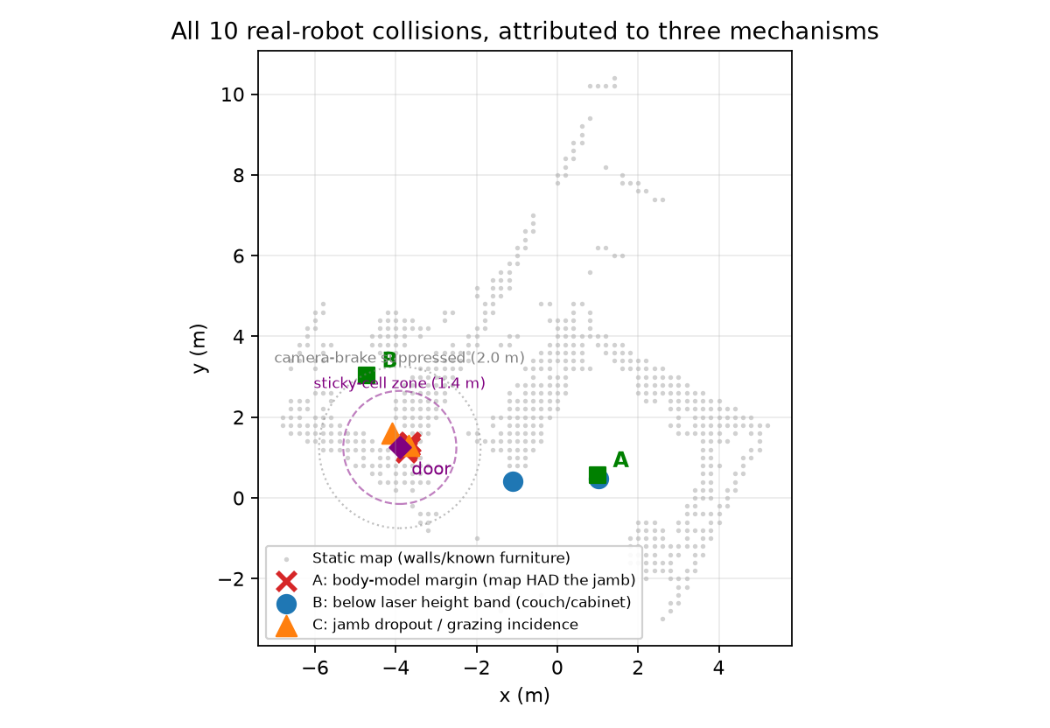
Figure 1 — All 10 real collisions on the lab map, coloured by mechanism. Green squares: waypoints A/B; purple diamond: door centre with the two new protection zones (sticky cells 1.4 m, camera-brake suppression 2.0 m).
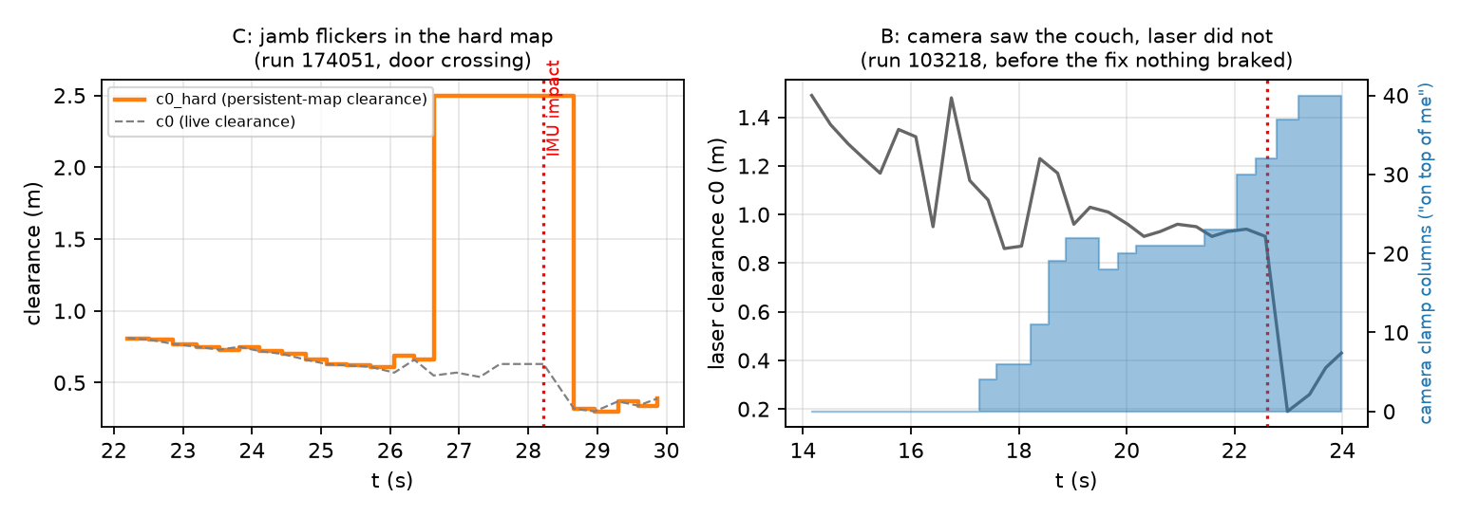
Figure 2 — The two smoking guns. Left (mechanism C): the persistent map drops and recovers the jamb (c0_hard 0.7↔2.5) seconds before the impact of run 174051. Right (mechanism B): during the sofa approach of run 103218 the camera clamp count climbs to 20–40 ("it is on top of me") while laser clearance stays ≥0.9 m; nothing braked — the moderation half of the vision rule was missing.
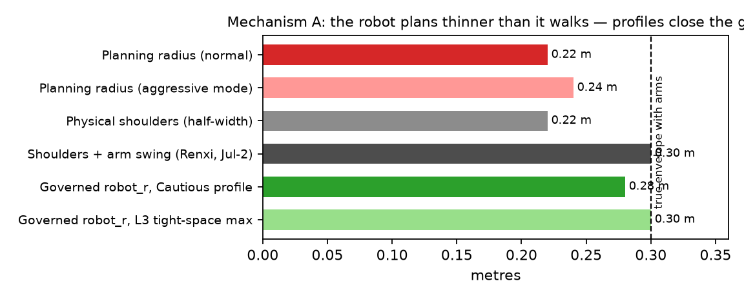
Figure 3 — Mechanism A in one picture: planning radius vs. the true walking envelope. The governed profiles close the gap (0.28–0.30 m) exactly at the supervisor’s measured number.
3. Answers to the direct questions
• Is it hardware or software? Both, cleanly separated: the sofa arm is a hardware sensing limit (below the laser band — the laser never sees it); the door frame is software twice over (body model thinner than the walking envelope, and the persistence filter dropping a thin jamb seen edge-on).
• Is it our laser filtering? For the sofa — no: filtering never had the points to reject. For the jamb — partly yes: the K-of-N persistence gate plus the near-field discard made a real, static obstacle flicker in the hard map during the crossing (fig. 2, left).
• Did the robot have enough information to avoid the hits? In 9 of 10, yes, somewhere on board: 6× the map knew (A), 3× the camera knew (B). Only the very first jamb touch of 104520 approached with every channel believing clear. The gap was never raw sensing — it was calibration of the self-model and unused cross-channel evidence.
4. Mitigations shipped (merged to main, each reversible by env switch)
Mechanism | Fix | Status / evidence
A | Governed multi-parameter profiles: robot_r 0.28–0.30 by analogy + environment layer; retires the heuristic radius shrink; door-approach analogy library with lateral bias | Validated in the digital twin A/B (32 runs): 8/8 clean crossings, 0 collisions with all extensions on; formal Fisher p=0.020 vs control
B | COLOR-BRAKE (G1_COLORBRAKE): the missing moderation half of the July-2 rule. Camera-only (fires only when laser says open), suppressed within 2 m of the door (ghost-wall lesson), creep 0.10 m/s on sustained warning, full stop only when the camera is saturated (≥24 columns) | Replayed over all 60 real runs: acts BEFORE both furniture collisions, zero false stops, cost 1–6 s of creep alongside the sofa in clean runs
C | DOORSTICKY (G1_DOORSTICKY): a door-zone cell confirmed in ≥2 fresh scans stays fixed for the rest of the run and bypasses the near-field discard — the frame is static by definition | v3, hardened by the twin itself: v1 could freeze live noise (a smoke run accumulated 6 phantom cells in the door mouth → 9-collision loop); v3 only lets cells already present in the static map stick — it cannot invent obstacles. Validated: 4/4 clean twin crossings, 94–95 s, 0 collisions
(context) | G1_M2_REALCAL: fragility thresholds and DST attribution recalibrated from the twin’s spill statistics (0.5/run) to the real platform’s (≈12/run) | First governed completions of the campaign (4 runs reached, 0 collisions, 59 g/round-trip vs 130–169 g baseline)

Still open (needs a lab session, no code): survey the sofa and low cabinet into the static furniture layer (nav_map.json) so the planner routes around them proactively — the camera brake is the safety net, not the planner. Procedure: slow manual waypoint sweep facing each item; the accumulation tooling already exists.
5. Why this matters beyond the fixes
The meta-reasoner arbitrates policies from evidence, but a policy is only as safe as the capability model underneath it: the campaign showed the same lesson twice in one week — the task model carried the simulator’s physics (fragility thresholds), and the self-model carried the wrong body width. Making capability boundaries explicit (this note) is what lets Layer 3 judge WHERE an analogy is relevant and lets the deployment veto stay monotone in risk. The next governed session runs with the full stack: profiles + door library + graded spill-speed coupling + platform calibration + camera brake + sticky frame.

