
The SCReAM BW test tool is built as a wrapper around the SCReAM congestion control algorithm to benchmark networks for performance when subject to video-like streaming. The SCReAM BW does
not stream real video, instead it mimics a video encoder that generates fake RTP packets

Introduction
SCReAM is short for Self Clocked Rate Adaptation for Multimedia. The brief outline is that SCReAM adjusts a video encoder target bitrate and applies a transmission scheduler that has the objective to keep e2e delay low. For this purpose, it reacts to congestion feedback, carried over RCTP.

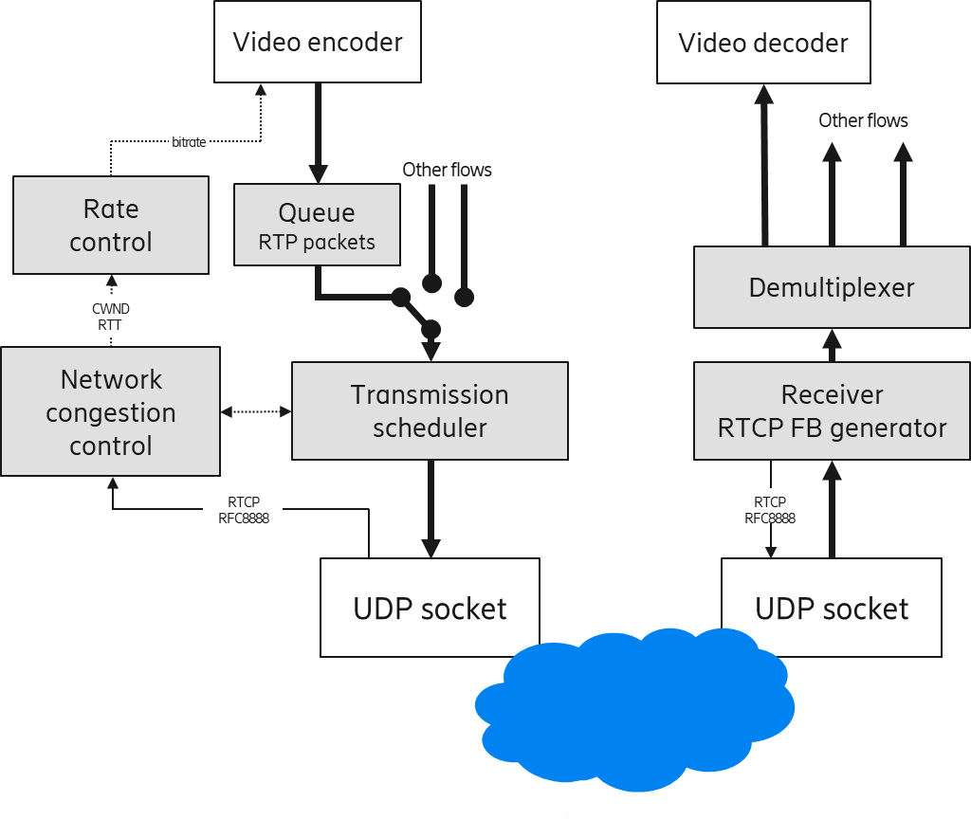
Figure 1 SCReAM congestion control overview

The congestion signals that SCReAM reacts to are:
- Packet loss
- Estimated queue build-up
- ECN marking in ECN capable network nodes
- L4S marking in L4S capable network nodes.
For more details the interested reader is recommended to read the latest IETF draft.
The SCReAM BW test tool can operate at bitrates ranging from a few 100 kbps up to about 500Mbps. As mentioned before the tool does not generate any meaningful video, it does however mimic video encoder with optionally varying frames sizes and I-frames.

Installation
The SCReAM BW test tool is contained at https://github.com/EricssonResearch/scream
The repository contains code that does not directly apply to the SCReAM BW test tool. This manual will only cover the specifics for the test tool.
The test tool is easiest to install on Linux platforms, the steps are
> git clone https://github.com/EricssonResearch/scream.git
> cd scream
> cmake .
> make
The binaries are found in the ./bin folder as
- scream-bw-test-tx: the sender side application.
- scream-bw-test-rx: the receiver side application.
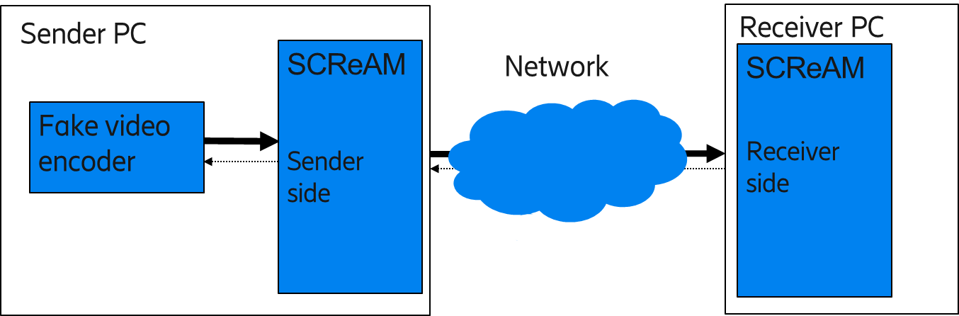
Figure 2 SCReAM BW test tool, sender and receiver side

As seen in Figure 2, the SCReAM BW test tool is installed on both a sender PC and a receiver PC.

SCReAM BW test tool on Android
Cellular phones can be connected via USB or optionally tethered via WiFi. This however comes with issues such as increased latency. An option with android OS is to install the BW test tool in the phones directly.
The steps are below, note that line numbers may change as the SCReAM code is modified.
- Download TERMUX APK from Termux | F-Droid - Free and Open Source Android App Repository, I chose com.termux_118.apk
- Use adb shell to push it to /sdcard/Download
>adb root
>adb push com.termux_118.apk /sdcard/Download
- From UE UI, choose files->internal storage->Download, com.termux_118.apk should show up there. Click on it, you should see the install from unknown source notice, click on setting to allow installing from unknown source. Then it is installed.
- Launch Termux through APP window.
- Make sure the UE has Wi-fi connection to internet.
- >pkg clean (Sometimes, issues with the package lists can cause problems)
- >pkg update (Answer Y for all the prompt)
- >pkg install cmake
- >pkg install vim (or nano)
- >pkg install git
- >git clone https://github.com/EricssonResearch/scream.git
In file: ./scream/code/scream_sender.cpp (Edit line 554 and 573 , change "bind(" to "::bind("
In file: ./scream/code/scream_receiver.cpp (Edit line 229, change "bind(" to "::bind("
In file: ./scream/multicam/sender/scream/code/scream_sender.cpp (Edit line 914 and 993 , change "bind(" to "::bind("
In file: ./scream/multicam/receiver/scream/code/scream_receiver.cpp (Edit line 293 and 344 , change "bind(" to "::bind("
- >cd ./scream
In file: CMakeLists.txt SET(CMAKE_CXX_FLAGS "-fPIC -fpermissive -pthread") to SET(CMAKE_CXX_FLAGS "-fPIC -fpermissive -pthread -DV2")
- >cmake .
- >make
- In directory ./bin/ you should now see file scream_bw_test_rx and scream_bw_test_tx

Running the tool
Running the SCReAM BW test tool is relatively simple.
On sender side:
> scream-bw-test-tx ↵
lists all the options for the sender side of the tool, some of these will be explained later
On receiver side:
> scream-bw-test-rx ↵
lists all the options for the receiver side of the tool, explained later.
The most simple running example is:
On sender side:
> scream-bw-test-tx RX_IP PORT ↵
On receiver side:
> scream-bw-test-rx TX_IP PORT ↵
Where RX_IP is the IP address of the receiver side and TX_IP is the IP address of the sender side. PORT is the UDP port number. Note that the IP and PORT is last.
The sender side will print summary output every 2 seconds, shown in Figure 3, until it is terminated with Ctrl-C.
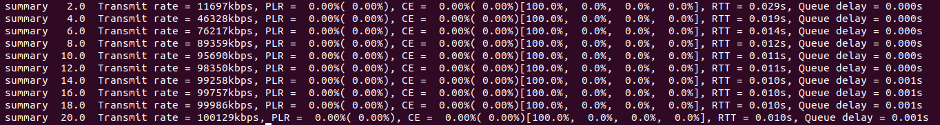
Figure 3 SCReAM BW test sender side summary output
The summary statistics cover:
- Transmit rate [kbps]
- Packet loss rate (PLR), two values
  - Average over a 5s window
  - Long term average (entire test session)
- CE marking rate (CE), two values
  - Average over a 5s window
  - Long term average (entire test session)
- Percent of packets marked for entire session as
[Not-ECT%, ECT(0)%, ECT(1)%, CE%]
- RTT [s]
- Estimated queue delay [s]
The simple example above with only summary output is good for quick benchmarking and to verify that ECN bits in the IP header are handled correctly.
A more advanced example on the sender side:
> scream-bw-test-tx -minrate 1000 -maxrate 30000 -ect 1 -ntp -log logfile.csv RX_IP PORT ↵
will run the tool with L4S support with a min and max bitrate of 1Mbps and 30Mbps and store a detailed log in the file logfile.csv.
A list of options for the SCReAM BW test tool sender is found in Table 1 with the most commonly used parameters first. Some options are not listed, they will be added as users begin to ask about them
Table 1 SCReAM BW test tool sender side options
-minrate value | The minimum bitrate [kbps], default 1000kbps
-maxrate value | The maximum bitrate [kbps] default 200000kbps (200Mbps)
-ect value | Configures ECN or L4S  -ect 0 == Classic ECN, -ect 1 == L4S
-log logfile | Store detailed logs in logfile for later inspection
-itemlist | Add a list that describes the log items in the logfile
-ntp | Store NTP time stamps in log file. This makes it easier to correlate SCReAM logs against network logging
-fixedrate value | Run at a fixed rate [kbps] regardless and keep the bitrate even though the network path becomes congested. Logging may become faulty in extremely congested scenarios with high network queue build-up.
-fps value | Set frames per seconds for the “video encoder”, default 50fps
-mtu values | A list of RTP packet sizes. The values should be in increasing order separated by a ‘,’ without spaces, for instance  200,500,800,1200. Default is only one value 1200 [bytes]
-minpktsinflight | Min desired packets in flight. The packet size is picked to meet at least a min number of packets in flight. This feature may be useful with L4S at low bitrates (< 2Mbps) to get a more stable rate adaptation.
-if name | Define which interface to open
-ipv6 | Use IPv6 istf IPv4
-time value | Run for a specified time [s]
-txrxlog logfile | Store TX and RX timestamps for RTP packets
-nosummary | Silent mode, no summary
-verbose | Print a more extensive data on stdout
The less commonly used options are listed below:
-initrate value | Initial bitrate [kbps]
-detailed | Detailed log to logfile per ACKed RTP. This option makes the logfile larger and can also cost more CPU.
-delaytarget | Trigger point when delay based congestion control should set in. Bitrate is gradually reduced as the estimated queue delay > delaytarget/2, default 0.06 [s]
-nopacing | Disable packet pacing

The receiver side options are listed in Table 2
Table 2 SCReAM BW test tool receiver side options
-if name | Define which interface to open
-ipv6 | Use IPv6 istf IPv4
-ackdiff | The max distance in received RTPs to send an ACK, this is default 16. Which means that an RTCP feedback is transmitted no more seldom than evert 16 RTP packets. For at low bitrates it can in some cases be beneficial to set -ackdiff 1
-nreported | The number of reported RTP packets per ACK, default 64.

Logs
The SCReAM BW test tool provides logs, besides the aforementioned summary logs

Verbose log on stdout, -verbose option
The verbose log on stdout is enabled with -verbose option and produces an output on stdout like Figure 4.
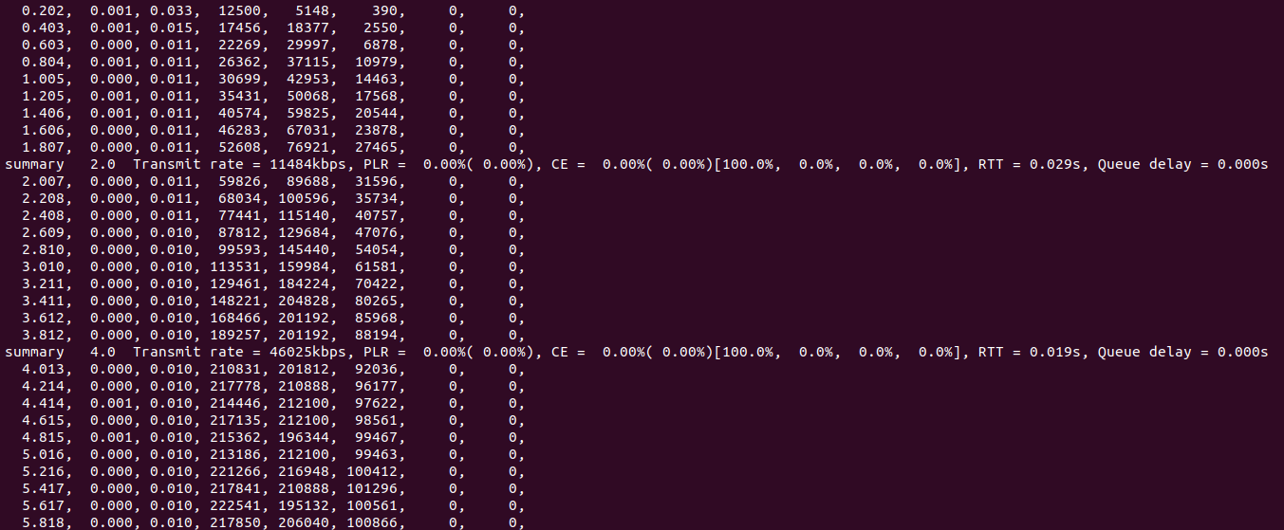
Figure 4 Verbose mode (with summary every 2s) on stdout

The output is in 8 columns representing
- Time [s]
- Estimated queue delay [s]
- Smoothed RTT [s]
- Congestion window [byte]
- Bytes in flight [byte]
- Total transmit bitrate [kbps]
- Lost bitrate [kbps]
- CE marked bitrate [kbps]
The lost and CE marked bitrate is a running average of the calculated bitrate for packets that are lost or CE marked. In a loose sense, the lost or CE marked divided by the transmitted bitrate *100 gives ~the packet loss or marking rate in %.

Log to file, -log option
The logfile gives more detailed information that is useful for instance for presentation of time traces or for statistical analysis.
The logfile is one line per received RTCP feedback, with the additional option -detailed. One line is produced for each acknowledged RTP packet. An example log is seen in Figure 5.
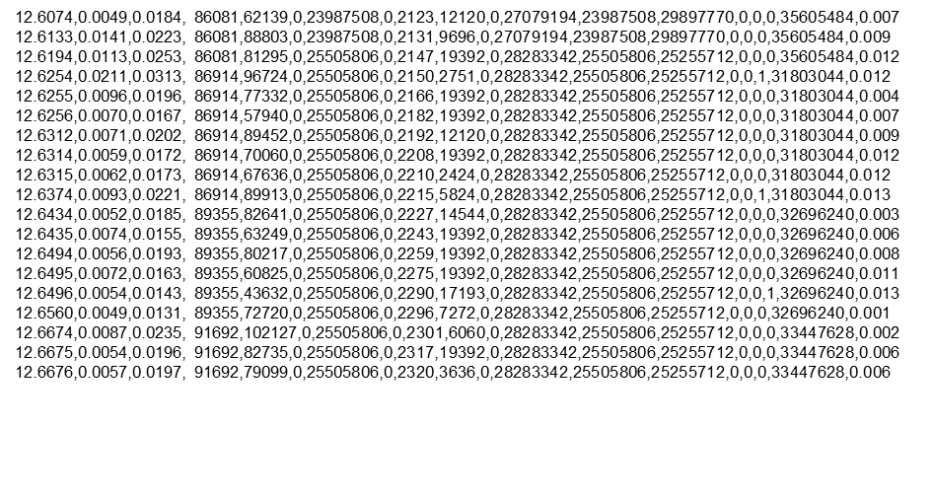
Figure 5 Log file produced with -log option

The output is in 19 columns representing:
    - Time [s]
    - Estimated queue delay [s]
    - RTT [s]
    - Congestion window [byte]
    - Bytes in flight [byte]
    - Fast increase mode (not used, but is still here for backwards compatibility
    - Total transmit bitrate [bps] (same values as col. 13)
    - Stream ID (not relevant for the SCReAM BW test as it is only one media stream)
    - RTP SN
    - Bytes newly ACKed
    - Bytes newly ACKed and CE marked
    - Media coder bitrate [bps]
    - Transmitted bitrate [bps]
    - ACKed bitrate [bps]
    - Lost bitrate [bps]
    - CE Marked bitrate [bps]
    - Marker bit set
    - Target bitrate [bps]
    - RTP queue delay for last ACKed RTP packet [s]

The log file contains some items that are either superfluous or duplicates. The reason is that the same logging is used for multi stream applications.
The total estimated e2e queue delay can be obtained by adding columns 2 and 19. Note that this does not include the physical e2e transport delay.
The most relevant log items for analysis with the SCReAM BW test tool are :
- Col 1:Time [s]
- Col 2:Estimated queue delay [s]
- Col 3: RTT [s]
- Col 4:Congestion window [byte]
- Col 5: Bytes in flight [byte]
- Col 10: Bytes newly ACKed
- Col 11: Bytes newly ACKed and CE marked
- Col 13: Transmitted bitrate [bps]
- Col 14: ACKed bitrate [bps]
- Col 18: Target bitrate [bps]

Examples
The logs can be displayed in matlab or octave. There are a few matlab (.m) scripts available. Example data is found in the ./examples folder. The examples represent a simple test setup with a simple 50Mbps link with DualQ AQM and 20ms RTT. Matlad/octave commands and the graphs are displayed below
> a = load('./examples/trace-dualpi-50Mbps-25ms-nol4s.txt');
> plot_thp_delay(a,0,[0 25],60,0.06);
Figure 6 Example 1, no L4S

> b = load('./examples/trace-dualpi-50Mbps-25ms-l4s.txt');
> plot_thp_delay(b,0,[0 25],60,0.06);
Figure 7 Example 2, L4S
> plot_cdf(a,[0 20],0.06);
Figure 8 Example 3 CDF queue delay and RTT, no L4S

TX/RX log for RTP packets (-txrxlog option)
The -txrxlog option logs transmit and receive times for RTP packets.
This feature may be useful for postprocessing and e.g. evaluation of things like out of sequence delivery of packets.
The data format is one line per RTP packet
time[s] seqNr txTime[s] rxTime[s] rxTime-txTime
If case the packet was lost or just too late to be ACKed properly the line will be
time[s] seqNr txTime[s] -1.0 -1.0
Note 1: rxTime-txTime will have an offset that needs to be subtracted. The simple matlab code below fixes this.
> a = % vector of rxTime-txTime i.e 5th column in tx rx logfile
> ix = find(a > 0.0); % Only entries that that represent successfully transmitted packets
> a_min = min(a(ix));
> a(ix) = a(ix)-a_min;
Note 2: rxTime-txTime may be skewed by clock drift that needs to be corrected for. This clockdrift is mostly monotonically increasing or decreasing and can for instance be resolved with a 1st order least square fit.
Note 3: Given that the RX timestamps are given by the RFC8888 RTCP feedback, the accuracy can never be better than 1.0/1024 seconds.
Note 4: The times are based on a 32 bit unsigned NTP time where the 16 MSB are seconds and the 16 LSB are decimal seconds. This means that the time stamp values can wrap around at 65536 seconds.
Example
> a = load('./examples/trace-dualpi-50Mbps-25ms-l4s-txrx.txt');
> plot_txrx(a,[0 20],0.01);
Figure 9 Example 4 RX-TX delay

Issues

Lost packets, socket overflow
Limited socket buffers can lead to lost packets, this issue is particularly relevant when the SCReAM BW test tool is used to evaluate cellular communication with intermittent scheduling of batches of packets.
To avoid dropped packet due to socket buffer overflow it is recommended to add the following lines to /etc/sysctl.conf in both the sender and receiver PC.
net.core.rmem_default=26214400
net.core.wmem_default=26214400
net.core.rmem_max=26214400
net.core.wmem_max=26214400
The value 26214400 is not mandatory but it should be sufficiently high to avoid socket buffer overflow.

NAT traversal
Network address translators are commonly used with e.g. 5G modems.
The general rule is that the SCReAM BW test tool should be first started on the PC that is on the modem side, regardless if is the scream_bw_test_rx or the scream_bw_test_tx application. This punches a hole in the NAT from the PC on the modem side to the outside world. It also helps to avoid a strange behaviour that port numbers are remapped.
To make it possible to know the public IP address of the modem there are a number of methods. One way is to ping the opposing side that is on a public (fixed) IP address and to a TCP dump on the opposing side to get the IP address. In the example in Figure 10 the receiver PC is connected to the modem. From the receiver PC one ping the sender PC which is on a public (or fixed) IP address. A TCP dump records the ping traffic to get the IP address of the modem.
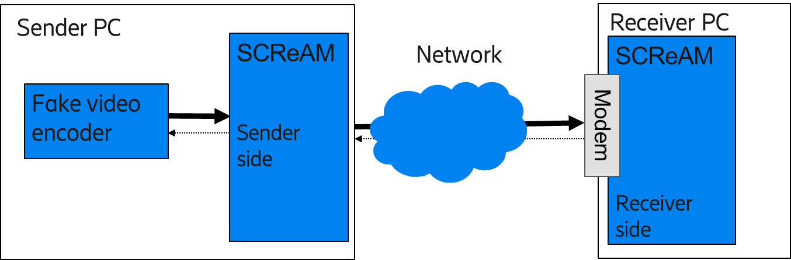
Figure 10 Example case where the receiver PC is connected to the modem, i.e. a downlink test setup

Another, possibly simpler way is to use IP forwarding.

SCReAM IETF draft https://datatracker.ietf.org/doc/draft-johansson-ccwg-rfc8298bis-screamv2/

