|  |  |
| --- | --- |
| Faculty of Computer & Information Sciences  Ain Shams University  Subject: Neural Networks and Deep Learning  Year: 4th-year undergraduate (CS) |  |

**Task 1-Penguins Classification**

|  |  |
| --- | --- |
| 20191700729 | ھادي إیھاب رجاء أحمد |
| 20191700728 | ھادي أحمد عبد السلام عبد الحميد |
| 20191700730 | ھادي عاطف سید محمد |
| 20191700740 | ھیثم محمود السید محمود |
| 20191700732 | ھاني محمد سید أحمد |

Content:

* A Plotted graph for all possible combinations of features.
* Plotted graphs for combinations of two features between test samples of each two classes.
* Confusion matrices for these relations.

Before Training:

We have plotted a graph to show all the possible combination of features and determine which features are discriminative between which classes.

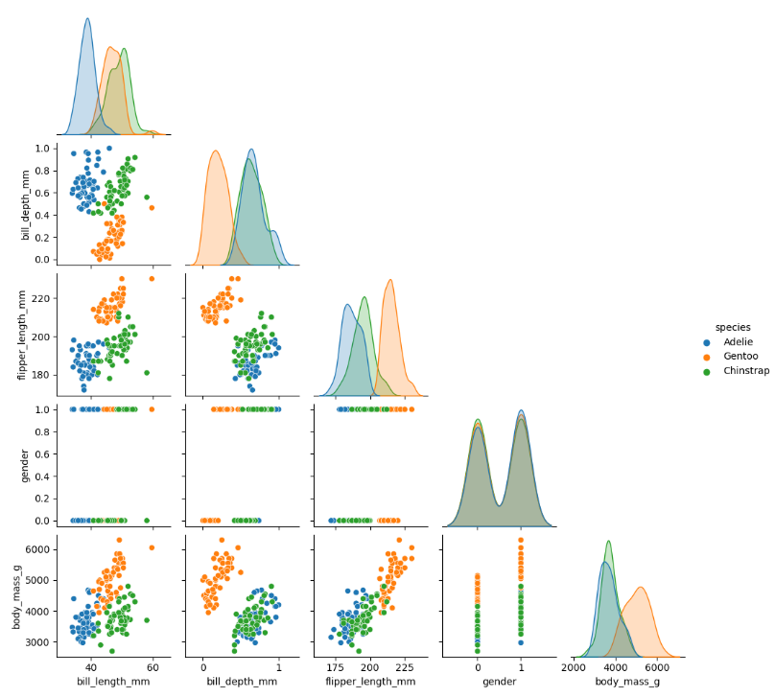

* **Bill_depth_mm & bill_length_mm:**

The relation between the mentioned two features; “bill_depth_mm” and “bill_length_mm” shows that:

* The samples of Adelie & Gentoo classes are linearly separable
* The samples of Adelie & Chinstrap are not linearly separable.
* The samples of Gentoo & Chinstrap are not linearly separable.
* **Flipper_length_mm & bill_length_mm:**

The relation between the mentioned two features; “flipper_length_mm” and “bill_length_mm” shows that:

* The samples of Adelie & Gentoo classes are linearly separable
* The samples of Adelie & Chinstrap are not linearly separable.
* The samples of Gentoo & Chinstrap are not linearly separable.
* **Flipper_length_mm & bill_depth_mm:**

The relation between the mentioned two features; “flipper_length_mm” and “bill_depth_mm” shows that:

* The samples of Adelie & Gentoo classes are linearly separable
* The samples of Adelie & Chinstrap are not linearly separable.
* The samples of Gentoo & Chinstrap are linearly separable.
* **Gender & bill_length_mm:**

The relation between the mentioned two features; “bill_length_mm” and “gender” shows that:

* The samples of Adelie & Gentoo classes are linearly separable
* The samples of Adelie & Chinstrap are not linearly separable.
* The samples of Gentoo & Chinstrap are not linearly separable.
* **Gender & bill_depth_mm:**

The relation between the mentioned two features; “bill_depth_mm” and “gender” shows that:

* The samples of Adelie & Gentoo classes are linearly separable
* The samples of Adelie & Chinstrap are not linearly separable.
* The samples of Gentoo & Chinstrap are not linearly separable.
* **Flipper_length_mm & Gender:**

The relation between the mentioned two features; “flipper_length_mm” and “gender” shows that:

* The samples of Adelie & Gentoo classes are linearly separable
* The samples of Adelie & Chinstrap are not linearly separable.
* The samples of Gentoo & Chinstrap are not linearly separable.
* **Body_mass_g & bill_length_mm:**

The relation between the mentioned two features; “bill_length_mm” and “body_mass_g” shows that:

* The samples of Adelie & Gentoo classes are not linearly separable
* The samples of Adelie & Chinstrap are not linearly separable.
* The samples of Gentoo & Chinstrap are not linearly separable.
* **Body_mass_g & bill_depth_mm:**

The relation between the mentioned two features; “bill_depth_mm” and “body_mass_g” shows that:

* The samples of Adelie & Gentoo classes are linearly separable
* The samples of Adelie & Chinstrap are not linearly separable.
* The samples of Gentoo & Chinstrap are linearly separable.
* **Body_mass_g & flipper_length_mm:**

The relation between the mentioned two features; “flipper_length_mm” and “body_mass_g” shows that:

* The samples of Adelie & Gentoo classes are linearly separable
* The samples of Adelie & Chinstrap are not linearly separable.
* The samples of Gentoo & Chinstrap are not linearly separable.
* **Body_mass_g & gender:**

The relation between the mentioned two features; “gender” and “body_mass_g” shows that:

* The samples of Adelie & Gentoo classes are not linearly separable
* The samples of Adelie & Chinstrap are not linearly separable.
* The samples of Gentoo & Chinstrap are not linearly separable.

**Conclusion:**

* To classify between Gentoo & Chinstrap, the best features to use are “flipper_length_mm” with “bill_depth_mm” or “body_mass_g” with “bill_depth_mm” and in both cases the accuracy is 100%.
* To classify between Adelie & Chinstrap, the best features to use are “gender” and “bill_length_mm” with accuracy 100%.
* To classify between Adelie & Gentoo, the worst features to use together are “bill_length_mm” and “body_mass_g” and all “gender” combinations are not completely accurate. Otherwise, all features’ combinations are accurate 100%.

After training the model we will run the GUI to test the relation between samples when the features at learning rate=0.1, epochs=100, and bias is checked.