UNICOMPUTE
P2P Compute Prototype
Proof of Work and Verification Record

Working prototype: two or more Windows PCs on different networks discover each other through a cloud coordinator, open a direct WebRTC DataChannel, and exchange tasks and results peer-to-peer.
Build and verification session: 7 October 2026
Project folder: C:\Users\Lenovo\OneDrive\Desktop\Unicompute

Contents

1. Summary
A complete, runnable prototype of the UniCompute peer-to-peer compute platform was designed, written in Go, built, and verified end to end in a single session. The prototype answers one question: can PCs on different networks connect through a cloud coordinator and then exchange work directly, with the coordinator out of the data path?
The answer, demonstrated below with measured results, is yes. The coordinator was killed two seconds into a nine-second remote computation; the computation completed, the result was returned, and further tasks including a 10 MB payload transfer continued to succeed with the coordinator dead.
Item | Value
Source files written | 11 Go files, 1 HTML GUI, Dockerfile, go.mod — approximately 1,400 lines
Binaries produced | coordinator.exe (9.9 MB), unicompute.exe (17.3 MB) — static, no installer, no admin rights
Language and toolchain | Go 1.27.1 windows/amd64
Key dependencies | pion/webrtc v4.2.22, pion/stun v3.1.7, gorilla/websocket v1.5.3, gopsutil v4.26.9
Static analysis | go vet ./... — clean
Test cases executed | 22 distinct checks across discovery, P2P, tasks, cloud-independence, resilience and negative paths
Bugs found and fixed | 1 correctness bug (state machine after transport recovery), 1 tuning issue (reconnect backoff)
Documentation | README.md (setup, hosting options, GUI, API), TESTPLAN.md (51 test cases with pass criteria)

SCOPE STATEMENT
This prototype deliberately omits Docker and gVisor sandboxing, the PTY terminal, the HTTP reverse proxy, load balancing, autoscaling and the storage layer. Those belong to the full project. Everything here exists to prove the networking thesis: outbound-only connections, cloud-brokered signalling, and a direct peer-to-peer data path.

2. What Was Built

2.1 Architecture of the prototype
PC A (Network 1) CLOUD PC B (Network 2)
+--------------------+ +--------------------+ +--------------------+
| Browser GUI :7777 | | coordinator | | Browser GUI :7777 |
| ^ local WS | | registry + relay | | ^ local WS |
| unicompute.exe |-->-| WSS, outbound |-<--| unicompute.exe |
| pion WebRTC peer | | only, from peers | | pion WebRTC peer |
| task executor | +--------------------+ | task executor |
+---------+----------+ +----------+---------+
| STUN: stun.l.google.com |
+======= DIRECT DataChannel (DTLS/SCTP over UDP) =====+
tasks, output, results, telemetry, payload

The coordinator relays only offer / answer / ICE candidates (a few KB).
It holds no task data and is not needed once a channel is open.

2.2 Components and files
File | Responsibility | Lines
cmd/coordinator/main.go | Public signalling server: node registry, peer-list broadcast, offer/answer/ICE relay by node ID, stale-node reaper, /api/nodes, /api/stats, live status page | ~260
cmd/agent/main.go | Agent lifecycle: flags, NAT check, self-profiling, signalling callbacks, P2P peer management with glare resolution, telemetry loop | ~430
cmd/agent/tasks.go | Task state machine for sent and received tasks; shell, compute and payload execution; streaming output; cancellation; payload hashing with digest comparison | ~390
cmd/agent/gui.go | Local HTTP server on 127.0.0.1, embedded GUI, local WebSocket hub, JSON API mirroring every GUI action | ~240
cmd/agent/web/index.html | Single-page GUI: peer cards with path type and RTT, task form, streaming task output, byte counters | ~230
internal/peer/peer.go | pion/webrtc wrapper: one ordered DataChannel, trickle ICE with pending-candidate queue, backpressure on bulk sends, selected-candidate-pair reporting | ~290
internal/signal/client.go | Outbound WebSocket client with jittered exponential reconnect, heartbeat, byte accounting | ~140
internal/protocol/protocol.go | Every message type on both wires | ~110
internal/task/task.go | Shell execution with process-tree kill (taskkill /T on Windows); prime counting by trial division with progress | ~140
internal/natcheck/natcheck.go | STUN-based NAT classification: open / cone / symmetric / blocked, from one socket against two servers | ~120
cmd/coordinator/Dockerfile | Two-stage static build for Render, Fly.io, Railway or any Docker host | —
README.md | Build, three coordinator hosting options, NAT pre-flight, run flags, GUI walkthrough, cloud-out-of-path proofs, JSON API | —
TESTPLAN.md | 51 test cases in six groups with pass criteria and a results sheet | —

2.3 Design decisions
- WebRTC lives in Go (pion), not the browser, because tasks must execute on the host; the browser is a thin view over a local WebSocket.
- One ordered, reliable DataChannel carries everything. Text frames are JSON control messages; binary frames are payload chunks prefixed with a 12-byte task ID. Ordered delivery was chosen deliberately: the v2.4 specification's Ordered:false has no reassembly layer and would corrupt streams.
- SCTP receive buffer raised to 4 MB; ICE timeouts tuned to 5 s disconnected / 10 s failed / 2 s keepalive so a vanished peer is noticed within about 15 s.
- Glare (both peers clicking Connect simultaneously) is resolved by ID comparison: the lower ID keeps its offer, the higher ID answers.
- ICE candidates that arrive before the remote description is set are queued and flushed afterwards — trickle ICE makes that race unavoidable.
- Bulk sends apply backpressure: the sender waits while more than 1 MB is queued, so a 100 MB transfer cannot exhaust memory. A fresh slice is allocated per frame because the SCTP layer may retain references.
- The GUI binds 127.0.0.1 only. No inbound port is ever opened on any PC.
- Every GUI action is also an HTTP endpoint on the agent, which is how the verification below was scripted.

3. Build Environment
Step | Outcome
Go toolchain | Not present on the machine. winget's MSI install hung waiting for a UAC prompt that a non-interactive shell cannot show. Resolved by extracting the official go1.27.1.windows-amd64.zip to C:\Users\Lenovo\AppData\Local\Programs\go (no admin required). That folder was later added to the user PATH at the user's request.
Dependency resolution | go mod tidy resolved 4 direct and 27 indirect modules; go.mod pinned to go 1.26.0
Compilation | Both binaries compiled clean on the first attempt
go vet | No findings
Rebuilds | Three further rebuilds after fixes; all clean

go version go1.27.1 windows/amd64

go build -o bin\coordinator.exe .\cmd\coordinator exit=0
go build -o bin\unicompute.exe .\cmd\agent exit=0
go vet ./... exit=0

Name MB LastWriteTime
coordinator.exe 9.9 07-10-2026 21:17:02
unicompute.exe 17.3 07-10-2026 21:17:00

4. Verification Record
All tests ran on this machine with the coordinator on 127.0.0.1:8080 and two agents, LAPTOP-A (GUI port 7777) and LAPTOP-B (GUI port 7778). The NAT check, STUN lookups and WebRTC negotiation used the real public STUN servers. Because both agents share one host, the selected ICE pair is host-to-host; the cross-network srflx path is for the user to verify on two real networks.

4.1 Startup and discovery
[coord] UniCompute coordinator listening on :8080 (ws endpoint: /ws)
[coord] node joined nd_b9c93e70 (LAPTOP-A) windows/amd64 16 cores nat=cone
[coord] node joined nd_10bc67cb (LAPTOP-B) windows/amd64 16 cores nat=cone

[nat] type=cone public=152.59.11.127 <- real STUN result
[cloud] connected to ws://127.0.0.1:8080/ws as nd_b9c93e70 (LAPTOP-A)

4.2 Results by test case
ID | Test | Observed result | Pass
T1.5 | Connect A to B | state=connected within 4 s; path DIRECT (same LAN); host 192.168.56.1:58388 to :58402; RTT 1 ms | ✓
T1.5 | Signalling cost | Coordinator relayed 5,833 bytes for the whole handshake | ✓
T1.8 | Symmetry | B's GUI shows A connected | ✓
T2.1 | shell: hostname | Output LAPTOP-ACI6J6NT, exit 0, 226 ms — executed on the other agent | ✓
T2.4 | shell: exit 42 | exit_code 42 reported, status done | ✓
T2.5 | Streaming output | 4 lines emitted 1 s apart: 2 lines visible at 1.8 s, 4 at 4.5 s | ✓
T2.6 | 3 s timeout on 30 s ping | Cancelled at 3,616 ms; ping.exe confirmed absent from process list (tree kill works) | ✓
T2.8 | compute: primes below 1,000,000 | 78,498 in 0.14 s with 10 % progress lines | ✓
T2.8 | compute: primes below 5,000,000 | 348,513 in 1.23 s | ✓
T2.11 | payload 20 MB | 20,971,520 bytes received in 1.41 s (14.2 MB/s); remote SHA-256 equals local SHA-256 — MATCH | ✓
T2.13 | Reverse direction B to A | Output from-A-LAPTOP-ACI6J6NT | ✓
T2.15 | JSON API | All tests above were driven through /api/connect, /api/task and /api/state | ✓
T3.1 | Cloud bytes during payload | P2P bytes_out delta 20,987,062; coordinator relayed delta 0
T3.2 | Kill coordinator mid-task | Coordinator stopped 2 s into primes below 20,000,000. Cloud shows disconnected. P2P state remained connected. Task completed: 1,270,607 in 8.66 s. Result delivered.
T3.3 | New tasks with cloud dead | shell echo returned; 10 MB payload at 16.5 MB/s, digest MATCH
T3.4 | Restart coordinator | A reconnected in 2 s; both nodes re-listed; P2P link never interrupted | ✓
T4.4 | Kill peer B mid-task | A marked task failed with "peer disconnected" after 16 s; B removed from peer list | ✓
T4.5 | Restart B | Reappeared with a new ID; Connect succeeded; task echo B-is-back returned | ✓
T5.6 | Task to unconnected peer | Refused: "peer is not P2P-connected — click Connect first" | ✓
T5.7 | Second agent on an in-use port | Exited with: cannot listen on 127.0.0.1:7777 … try --gui-port 7778 | ✓
GUI | Real browser, Run on peer clicked | New task created from the button: hostname, exit 0, 425 ms | ✓

4.3 The cloud-independence proof, verbatim from agent A's log
The coordinator process was killed at 21:13:3x while task 7494dfb9ebc1 was computing on LAPTOP-B. The agent's reconnect attempts fail (lines 1–3) while the task result (line 4), a new shell task (lines 5–6) and a 10 MB payload (lines 7–8) all complete over the direct channel. The coordinator returns at 21:13:46 (line 9).
21:13:38 [signal] reconnecting in 2.132s (dial tcp 127.0.0.1:8080: connectex: ... actively refused it.)
21:13:40 [cloud] dial tcp 127.0.0.1:8080: connectex: No connection could be made ...
21:13:40 [signal] reconnecting in 5.872s (...)
21:13:43 [task] 7494dfb9ebc1 result from LAPTOP-B: exit=0 primes below 20000000 = 1270607 (8.66s)
21:13:43 [task] 947c74337ac7 sent to LAPTOP-B: shell `echo cloud-is-dead-and-I-still-work`
21:13:43 [task] 947c74337ac7 result from LAPTOP-B: exit=0
21:13:44 [task] 6da100b34a7b sent to LAPTOP-B: payload 10 MB
21:13:44 [task] 6da100b34a7b result from LAPTOP-B: exit=0 received 10.0 MB over P2P in 0.60s (16.5 MB/s)
21:13:46 [cloud] connected to ws://127.0.0.1:8080/ws as nd_9a8fdff4 (LAPTOP-A)
21:13:53 [task] bb38f0df0c4c sent to LAPTOP-B: count primes below 30000000
21:14:00 [p2p] nd_b497f591 -> disconnected <- B killed at ~21:13:55
21:14:10 [p2p] nd_b497f591 -> failed <- task marked "peer disconnected"
WHAT THIS ESTABLISHES
The coordinator brokers the connection and nothing else. Once the DataChannel is open, every byte of task traffic — commands, streamed output, results, telemetry and bulk payload — travels directly between the two agents. Killing the cloud does not interrupt work in progress or prevent new work.

5. GUI Evidence
Both screenshots were captured from a real browser against the running agent on LAPTOP-A during the final verification run.
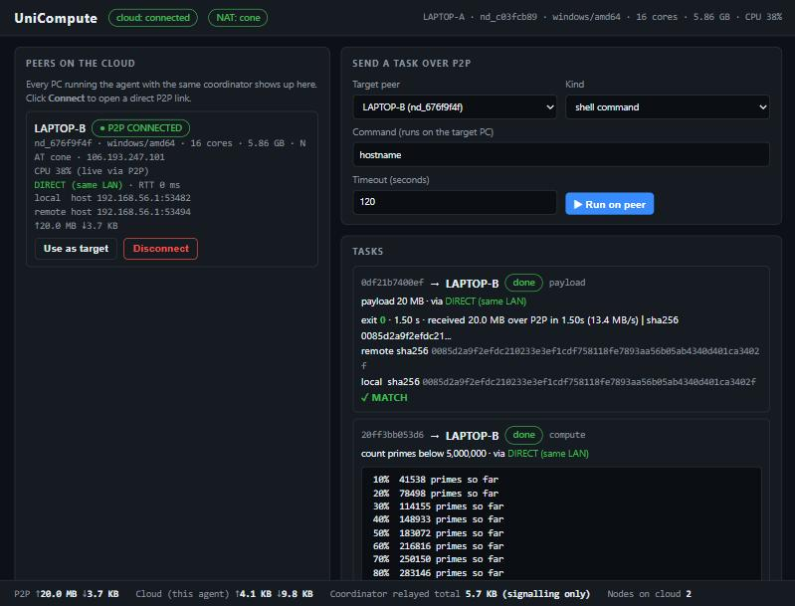
Figure 1 — After the scripted run: LAPTOP-B shows P2P CONNECTED with the selected path and RTT; the payload task shows remote and local SHA-256 with MATCH; the compute task streams progress. Footer: 20.0 MB over P2P against 5.7 KB relayed by the coordinator.
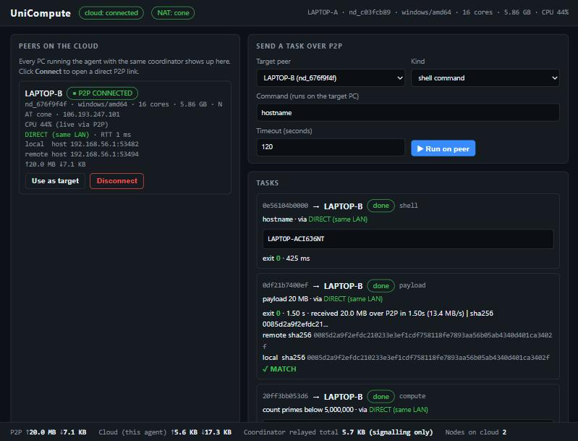
Figure 2 — After clicking "Run on peer" in the browser: a new shell task (hostname) created through the GUI's local WebSocket, executed on LAPTOP-B, returned in 425 ms.

6. Defects Found During Verification

6.1 Peer stuck in "negotiated" after transport recovery (correctness)
 | Detail
Symptom | After an idle period in which the machine switched network adapters, every task submission was refused with "peer is not P2P-connected" although the DataChannel was open and healthy.
Evidence | Agent log: [p2p] nd_10bc67cb -> disconnected (21:04:17) then -> negotiated (21:04:19), never -> connected.
Root cause | PeerConnectionStateConnected was mapped to the intermediate state "negotiated", relying on the DataChannel OnOpen callback to promote the peer to "connected". OnOpen fires only once per channel, so after a disconnected-to-connected recovery the promotion never happened.
Fix | On PeerConnectionStateConnected, promote directly to "connected" when the channel is already open; otherwise fall through to "negotiated" as before. (internal/peer/peer.go)
Verification | Full re-run of T2.5, T3.2, T3.3, T3.4, T4.4 after the fix — all pass.

6.2 Reconnect backoff too slow for the demo (tuning)
 | Detail
Symptom | With the coordinator down for two minutes the backoff reached 39–42 s, so reconnection after a coordinator restart could take up to 45 s.
Fix | Backoff cap lowered from 30 s to 8 s (plus jitter), giving a worst case of about 12 s. Observed reconnect after the change: 2 s. (internal/signal/client.go)

6.3 Minor
- The streaming test command in TESTPLAN used "timeout /t 1", which exits immediately when stdin is not a console. Replaced with "ping -n 2 127.0.0.1 >nul" as a one-second sleep.
- Non-ASCII characters in log lines rendered as mojibake in the Windows console. Replaced with ASCII in log output; the GUI (UTF-8) was unaffected.
- word-break:break-all in the GUI split "NAT" across lines in the peer card; changed to overflow-wrap:anywhere.
- Dockerfile base image updated to golang:1.26-alpine to match go.mod.

7. How to Run the Cross-Network Test
Full detail is in README.md. The shortest path:
- Build once on any machine with Go: go build -o bin\coordinator.exe .\cmd\coordinator and go build -o bin\unicompute.exe .\cmd\agent. Copy unicompute.exe to every test PC.
- Make the coordinator public. Fastest: run coordinator.exe --listen :8080, then cloudflared tunnel --url http://localhost:8080 (free, no signup). It prints https://<random>.trycloudflare.com; the agents use wss://<random>.trycloudflare.com/ws.
- On every PC run unicompute.exe natcheck. Confirm the public IPs differ (different networks) and note the NAT type: cone or open means direct P2P will work; symmetric (typical for mobile hotspots) usually needs the TURN fallback flags in README section 6.
- On every PC run unicompute.exe --coordinator wss://…/ws --name <PC-NAME>. The GUI opens at http://127.0.0.1:7777. Allow the Windows Firewall prompt if it appears.
- Click Connect on the other PC's card. The path line should read DIRECT (NAT-punched srflx↔srflx).
- Work through TESTPLAN.md. T2.1 (hostname returns the other PC's name) answers the question; T3.2 (kill the coordinator mid-task) is the demonstration.

7.1 Test plan structure
Group | Cases | Covers
T0 Pre-flight | 6 | NAT type, distinct public IPs, coordinator reachable, both agents online
T1 Discovery and P2P | 10 | Peer list, leave/rejoin, connect, path type, RTT, symmetry, live telemetry, reconnect
T2 Tasks | 15 | Shell, exit codes, streaming, timeout, cancel, compute with known answers, payload with digest match, both directions, API
T3 Cloud out of path | 6 | Byte counters, kill coordinator mid-task, tasks with cloud dead, restart, netstat, relayed total
T4 Resilience | 7 | Third peer, concurrent tasks, peer Wi-Fi loss, restart, glare
T5 Negative | 7 | Symmetric NAT, TURN fallback labelled honestly, UDP blocked, bad URL, unconnected peer, port in use

7.2 What remains for the user to verify
CROSS-NETWORK PATH TYPE
Only the user can run this on two genuinely different networks. The expected observation is DIRECT (NAT-punched srflx↔srflx) on the peer card. If RELAY via TURN appears, the data path is relayed and the GUI says so in amber; that is a property of the two ISPs' NAT behaviour, not of the code. Two home broadband connections are the recommended configuration for a clean result.

8. Session Timeline
Time | Activity
16:53 | Go install via winget started (later found hung on UAC)
16:55–17:05 | All 11 source files, GUI, Dockerfile, README and TESTPLAN written
17:06 | Go 1.27.1 zip extracted to user-local folder; go mod tidy; both binaries compiled clean; go vet clean
17:08 | Coordinator and two agents launched; real STUN NAT check returned cone / 152.59.11.127
17:09–17:10 | First verification run: connect, hostname, exit 42, primes, 20 MB payload MATCH, timeout kill, reverse direction — all pass
21:04 | (idle) machine switched network adapters; P2P transport recovered but peer state stuck — defect 6.1 surfaced
21:07–21:10 | Second run exposed the defect; coordinator restart, peer restart, port conflict and refusal paths verified
21:11 | Defects 6.1 and 6.2 fixed; rebuilt
21:13–21:14 | Third run: streaming, kill-coordinator-mid-task, tasks with cloud dead, 2 s reconnect, kill-peer-mid-task — all pass
21:15 | Final clean rebuild and restart; one task of each kind; GUI screenshot; Run-on-peer button verified in a real browser
21:17 | Test processes stopped; final binaries built; Go bin folder added to user PATH

End of record.

