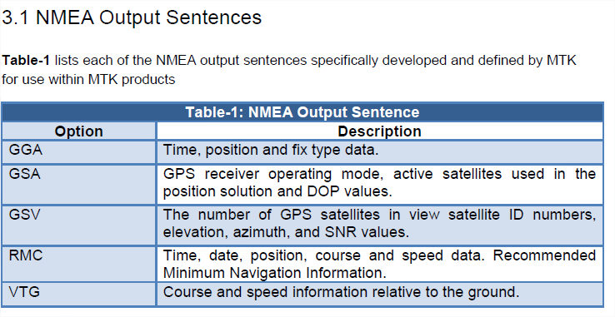

The most commond most pepole use are $GPRMC $GPGGA