
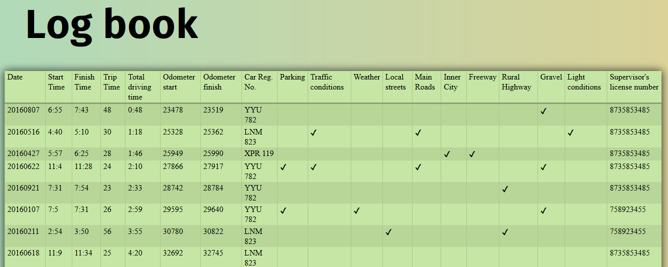
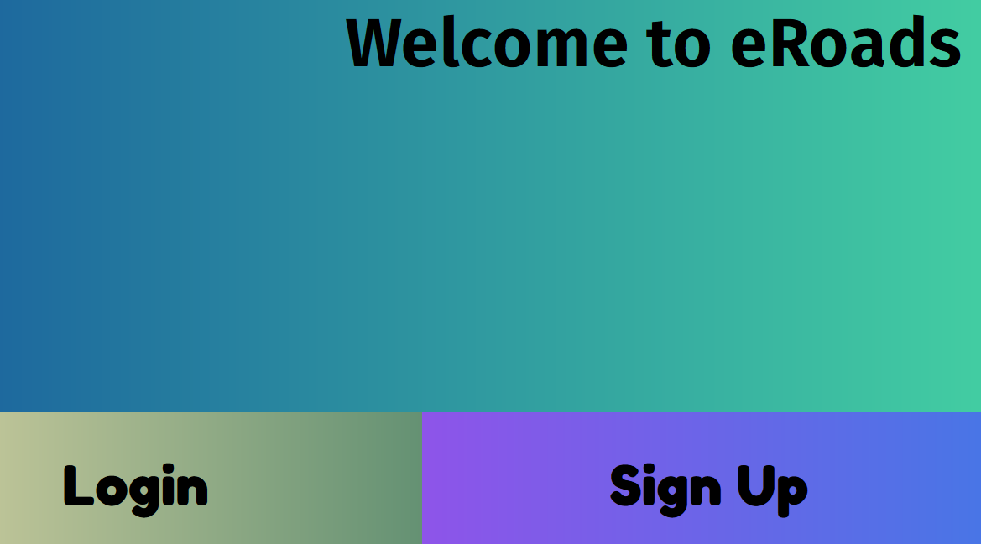
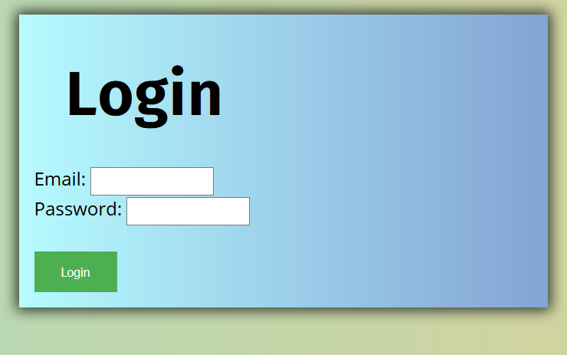
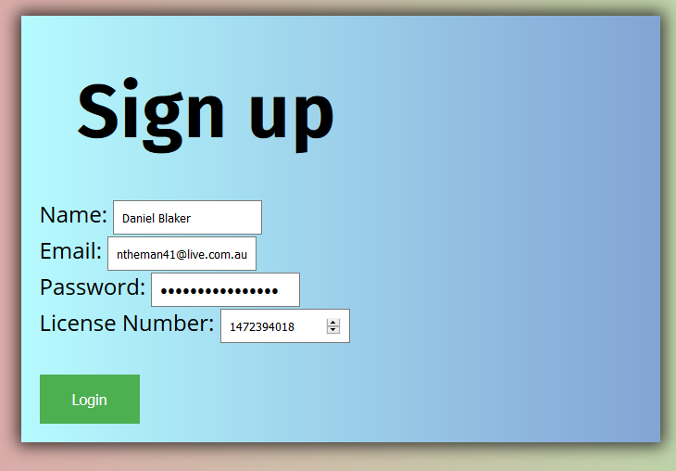

By Daniel Blaker
Year 9
Victoria
Screenshots on the final page.
Introduction
My project for the Young ICT explorers challenge is a website named eRoads, that will be adapted into a mobile app. It is a digital replacement for the learners book which people on L plates have to complete. The learner’s book is used to record the trips they make as they work towards 120 hours on their L plates. I noticed that the book is essentially a database, and has to be tediously filled out. The book has columns for the weather conditions, the type of road being driven on, and more. I saw this as a perfect place for digital technology to replace a manual method. My sister found the book troublesome to complete, easy to make mistakes with, and a general time sink. This prompted the creation of the website, which aims to reduce these annoyances.

Why the book is better online
There are a number of issues with the book being physical. The main issue is that it is very inconvenient. The book must be kept with the driver, moved between cars if more than one car is being used, and not lost in the process. Even if the book does remain with the driver, the book takes considerable time to complete.

Compare this with a small device that is already in the user's pocket, and it’s clear that a virtual application is far more convenient; and with all the data stored in the cloud, losing progress through a broken or lost phone is practically impossible. No calculations (such as trip time) are completed by the user. Another benefit of the app being virtual is it saves repetitive inputs such as the supervising drivers license number, replacing it with a simple drop down for known supervisors.

As well as this, my virtual alternative shows tips to the drivers as for them to actively improve their driving. I have a progress bar and statistics panel that motivates them as they see their progress.

Challenges Faced
The main challenges faced when designing eRoads were technical ones. It was my first time dealing with large database information, and finding an appropriate method of connecting the data for each challenge posed an issue that required research. I used Mongo DB for the database, which interfaced well with Node JS. Mongo is a NoSQL database, meaning that rather than storing data in a predefined, fixed table, objects such as accounts and trips are linked. Another issue posed was writing the code and designing the user interface, as there was a large amount of data to show the user. I used the javascript library Angular JS, which is a MVC (Model, View, Controller) library for binding javascript objects to the actual HTML.

Technical Details
eRoads was created as a web app with the MEAN stack. MEAN stands for Mongo/Mongoose, Express, Angular and Node JS. These are advanced library's used by professionals in real world apps. Mongo DB is my database of choice, it offers fast NoSQL based storage, allowing me to quickly and conveniently store the large numbers of accounts and associated trip data. Express is a server side library that allows Node JS to serve web pages and data. Express is required because a large amount of data needs to be transferred to the client web page. Express keeps server code clean and connects the server to the client. Angular is the client side javascript library which offers a very clean code base based on practices such as MVC, (Model, View, Controller) which separates a user interface into separate components. Angular allows the data from the server to be shown in the user interface. Finally, Node JS is a popular language that allows actual javascript to run on the server in a fast, asynchronous manner. It's become a popular language for creating servers because of its fast nature and large ecosystem of libraries.

Design
The main focus when making eRoads was creating an application that was easy to use without compromising on functionality. I wanted the users to be able to use the app quickly, and making a tedious app would defeat the purpose of the app entirely. So, I chose to keep forms as simple as possible and not to show any information the user doesn’t need to see, like the license number of preregistered supervising drivers.

I aimed for a consistent aesthetic, with vibrant colours and gradients. I wanted to create an aesthetic that was not cliche, choosing fonts that were unique, bold, but still readable. Contrast was kept high with colours, and colours were chosen depending on their meaning. Text and forms are large to keep them readable.

From here - Publishing this app
As of now, eRoads does not have any official ties to any road organisation authority, such as Vicroads. This means that information inputted into eRoads can not be sent to vic roads at a click of the button, which is something I believe would certainly be a great addition. Organizing with them would allow me to send database entries directly to them, or allow authorised accounts to view any drivers records. I also believe that this application can be extended beyond Victoria, to the rest of Australia. Although different locations have different processes for gaining a license, the app is dynamic enough that it could be adjusted based on locations.

Conclusion
eRoads was created to achieve one purpose - innovate and ease the process in which learners record their progress as they drive. I believe that, without getting caught up with unneeded complexities, the app successfully achieves that aim.

Screenshots:
Please note that the visual interface of the application is still being worked on. Some aspects, such as the progress bar and statistics are not shown, and some aspects, such as the large gradients, will be tweaked and modified. I’d love to show you the finished project at the exhibition!

