Car Wash Soap Level Detection System (VL53L1X)
Setup and Upload Guide
1) Download and install Arduino IDE
Download the Arduino IDE and complete the normal installation for your computer. After installation, open the IDE once so it can finish creating its folders and default settings.
2) Open the Boards Manager
In Arduino IDE, go to Tools > Board > Boards Manager. This menu is used to install support packages for additional boards, including the ESP8266 family used by the NodeMCU.
3) Add the ESP8266 board manager URL
Open Arduino IDE Preferences and paste the following link into Additional Boards Manager URLs. If you already have another URL in that field, separate the entries with a comma, then click OK to save your changes.
http://arduino.esp8266.com/stable/package_esp8266com_index.json
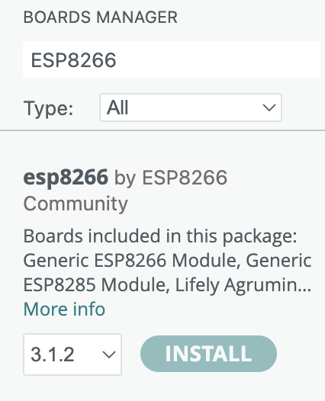
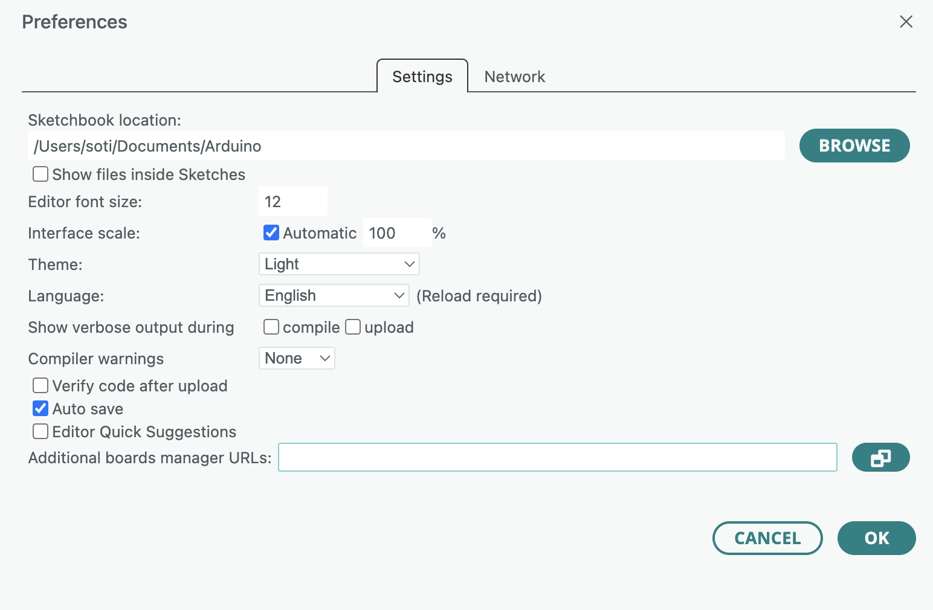
Example screenshots: Arduino Preferences window and the ESP8266 package inside Boards Manager.
4) Install the ESP8266 board package
Open Boards Manager, search for ESP8266, and install the package labeled “ESP8266 by ESP8266 Community.” Let the installation finish completely before moving on.

5) Select the correct board
Go to Tools > Board and choose NodeMCU 1.0 (ESP-12E Module). If the board is connected, also check Tools > Port and confirm the correct port is selected.

6) Paste in the project code
Open the file named “VL53L1X 8266 Code v7 OTA SANITIZED” and paste the full sketch into Arduino IDE. Before uploading, review any values that may need to be customized, such as Wi-Fi credentials, MQTT settings, OTA details, or sensor-related constants.

7) Upload, run, and test
Connect the board, click Upload, and wait for the sketch to compile and finish flashing. After the upload completes, verify that the board boots correctly, the sensor reports expected values, and the device connects to your network or Home Assistant environment as intended.

Helpful notes
The ESP Home add-on in Home Assistant has recently been renamed to Home Assistant Device Builder. On macOS, ESPHome can also be installed through Homebrew if you prefer working from the command line.
brew install esphome
Quick troubleshooting
If the board does not appear in the port list, try a known data-capable USB cable, reconnect the board, and reopen the IDE. If the ESP8266 package does not show up in Boards Manager, double-check the URL in Preferences and restart Arduino IDE before searching again.

