# Quiz Game - Initial Project Documentation

## 1. Introduction

This document outlines the initial concept and user stories for a multiplayer quiz game web application. The game allows users to create game rooms, invite others to join, and compete in answering questions across multiple categories and difficulty levels.

## 2. User Stories

### 2.1 User Story: Creating a New Game

As a game creator,  
I want to fill out a form to configure a new game session with customizable options,  
So that I can create a game room tailored to my preferences and share it with players.

* Acceptance Criteria:
* I can enter a custom name for the game room.
* I can select win points from preset values or choose 'unlimited'.
* I can choose a player count or allow unlimited players.
* I can select multiple question categories using checkboxes.
* I can select a difficulty level (Easy, Medium, Hard).
* I can create the game session by clicking the 'Create' button.

### 2.2 User Story: Joining a Game

As a player,  
I want to select my preferred language and enter my name and the game code,  
So that I can join an existing game session and play with others.

* Acceptance Criteria:
* I can choose from English, Arabic, or German as my language.
* I can enter my name and the game code in the form.
* I can join a game by clicking the 'Join' button.

## 3. Screen Flow Diagram

The following image represents the conceptual flow between different screens of the application as sketched by the project owner:

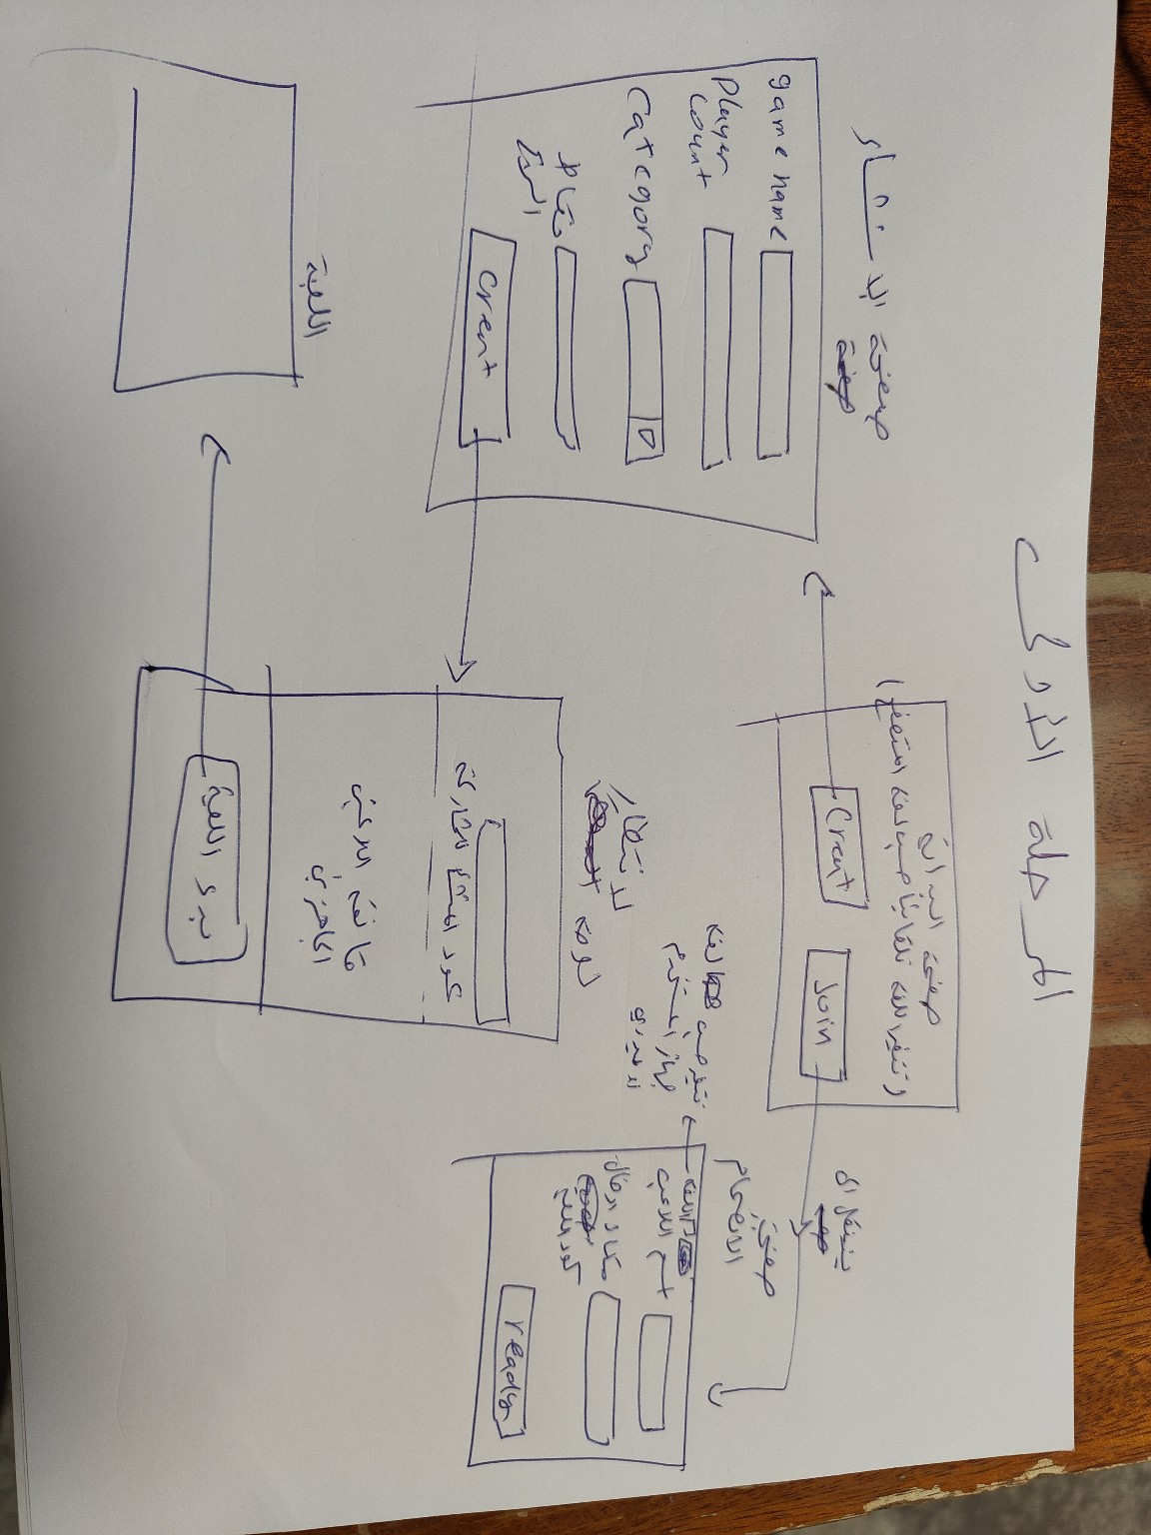

## 4. User Journey Overview

Step 1: User accesses the landing screen with language selection.

Step 2: User selects either 'Create Game' or 'Join Game'.

Step 3A (Create): Creator configures the game and clicks 'Create'.

Step 3B (Join): Player enters name and game code, then clicks 'Join'.

Step 4: Game session starts once players are ready.