Ethical Hacking
1)Execute and display the results for the following commands in Kali Linux Operating Systems:
rm command
users command
tree command
Solution:
Rm command-Used to remove (delete) files or directories in Linux.
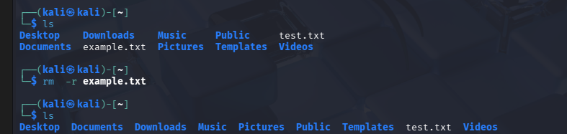

users command-Displays the names of users currently logged into the system.
tree command-Displays directory structure in a tree-like format
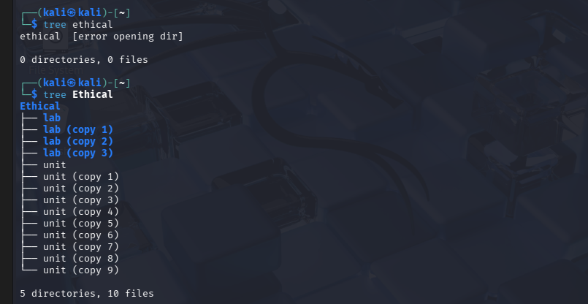

2)Execute and display the results for the following commands in Kali Linux Operating Systems:
less command
more command
vi command
Solution:
less command-Used to view the contents of a file one screen at a time.
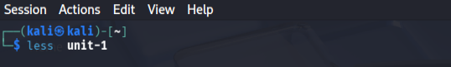
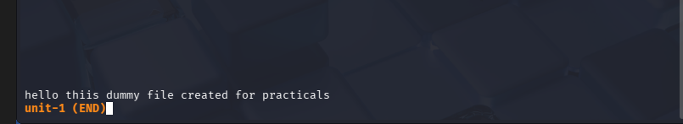
more command-Used to display file contents page by page (forward only).
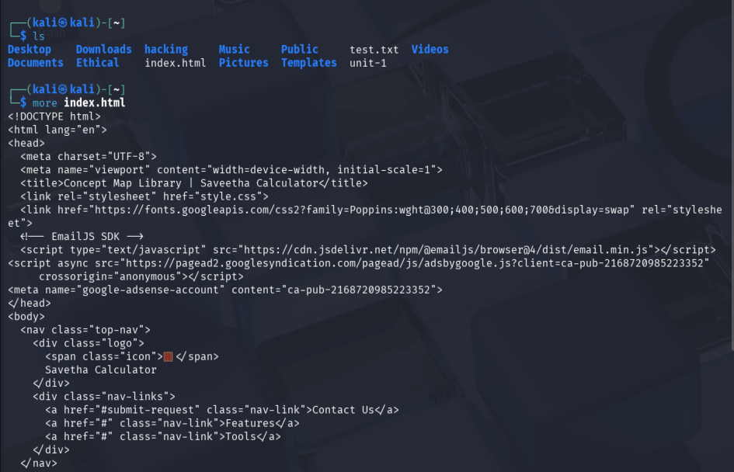
vi command-Used to create, edit, and view files using the VI text editor.
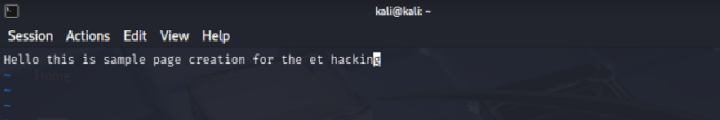

3)Execute and display the results for the following commands in Kali Linux Operating Systems:
Tree
Head
Tail
Solution:
Head-Used to display the first 10 lines of a file by default.
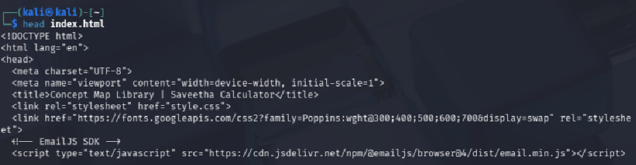
Tail-Used to display the last 10 lines of a file by default.
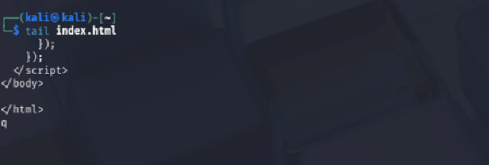
4)Execute and display the results for the following commands in Kali Linux Operating Systems:
i) Ls
ii) Cat
iii) Mkdir
Solution:
i)Ls-Used to list files and directories in the current directory
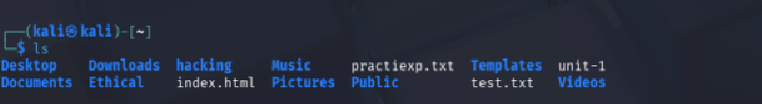
ii) Cat-Used to display the contents of a file on the terminal.
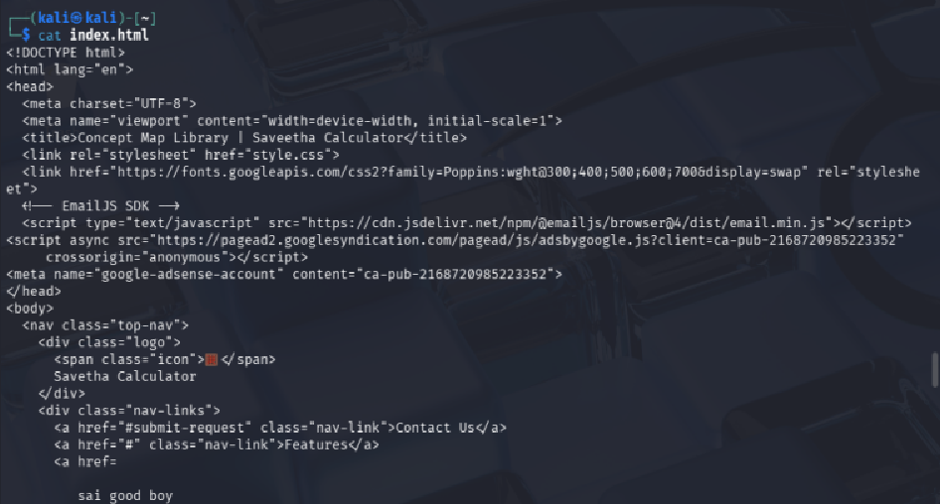
iii) Mkdir-Used to create a new directory.
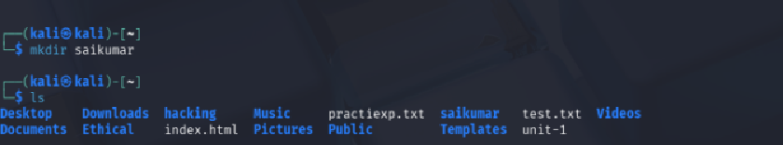

5)Execute and display the results for the following commands in Kali Linux Operating Systems:
i) Uptime
ii) Date
iii) Mv
Solution:
Uptime-Displays how long the system has been running, number of users, and system load.
Date-Displays the current system date and time.

Mv-Used to move or rename files and directories.
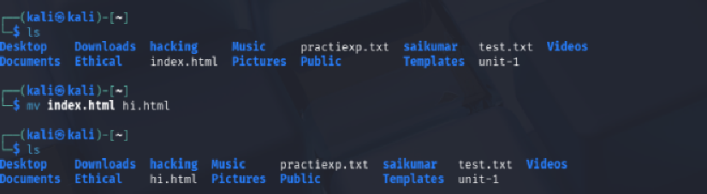
6)Execute and display the results for the following commands in Kali Linux Operating Systems:
i) Touch
ii) Pwd
iii) Wget
Solution:
i)Touch-Used to create an empty file or update the timestamp of a file.

ii) Pwd-Displays the present working directory (current directory path).
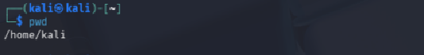
iii) Wget-Used to download files from the internet using a URL.
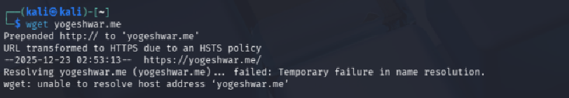

7)Execute and display the results for the following commands in Kali Linux Operating Systems:
Cd
Cp
Ls
Solution:
Cd: Used to change the current working directory.
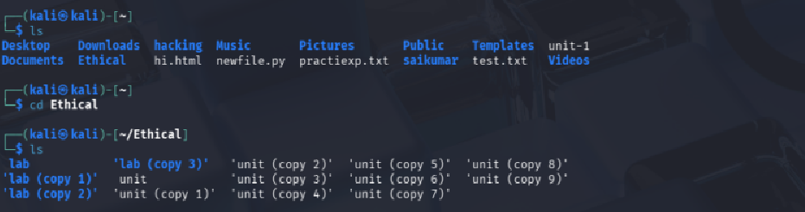
Ls-Lists files and directories in the current directory.
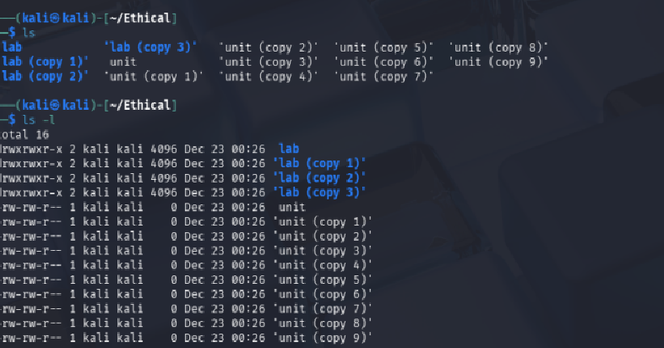
Cp-Used to copy files or directories from one location to another.
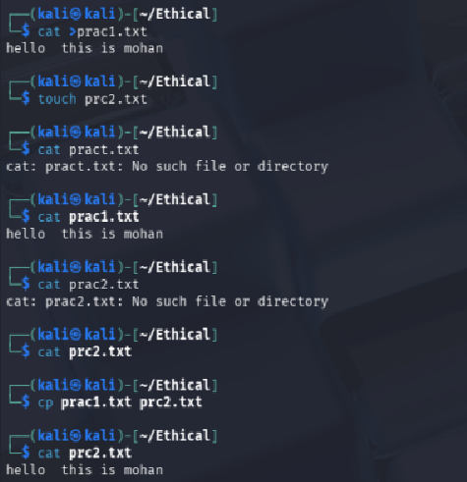

8)Execute and display the results for the following Nmap service version and OS detection commands in Kali Linux operating systems:
i) detect the version of services running
ii) aggressive scan
iii) detect operating system of the target
Solution:
i)detect the version of services running-Used to identify services and their version numbers running on open ports of a target system.
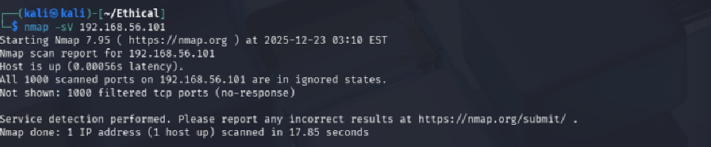
ii) aggressive scan-Performs service detection, OS detection, script scanning, and traceroute in one command.
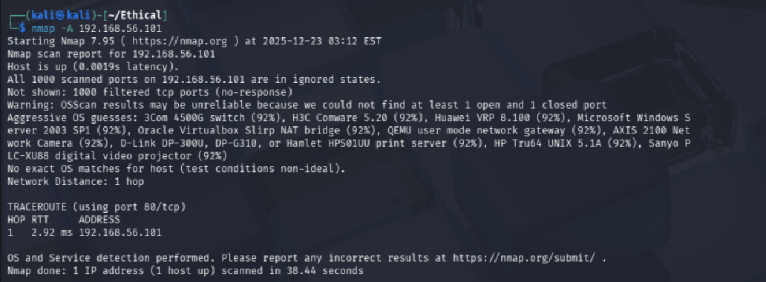
iii) detect operating system of the target-Used to identify the operating system running on the target machine.
