EXP NO 3: Create a simple cloud software application for Car Booking Reservation System using any Cloud Service Provider to demonstrate SaaS include the necessary fields such as search for cabs, from, to, rental , out station, Package type, hours/Days etc.

DATE:

AIM:

To Create a simple cloud software application for Car Booking Reservation System using any Cloud Service Provider to demonstrate SaaS.

PROCEDURE:

Step1: Go to zoho.com.

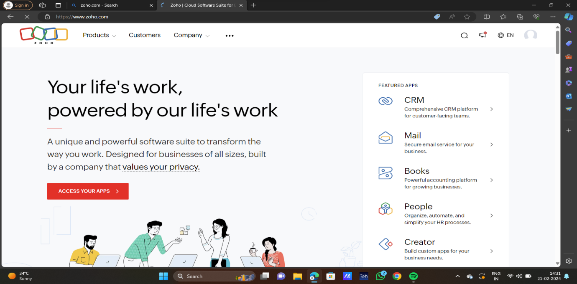

step 2: Log into the zoho.com.

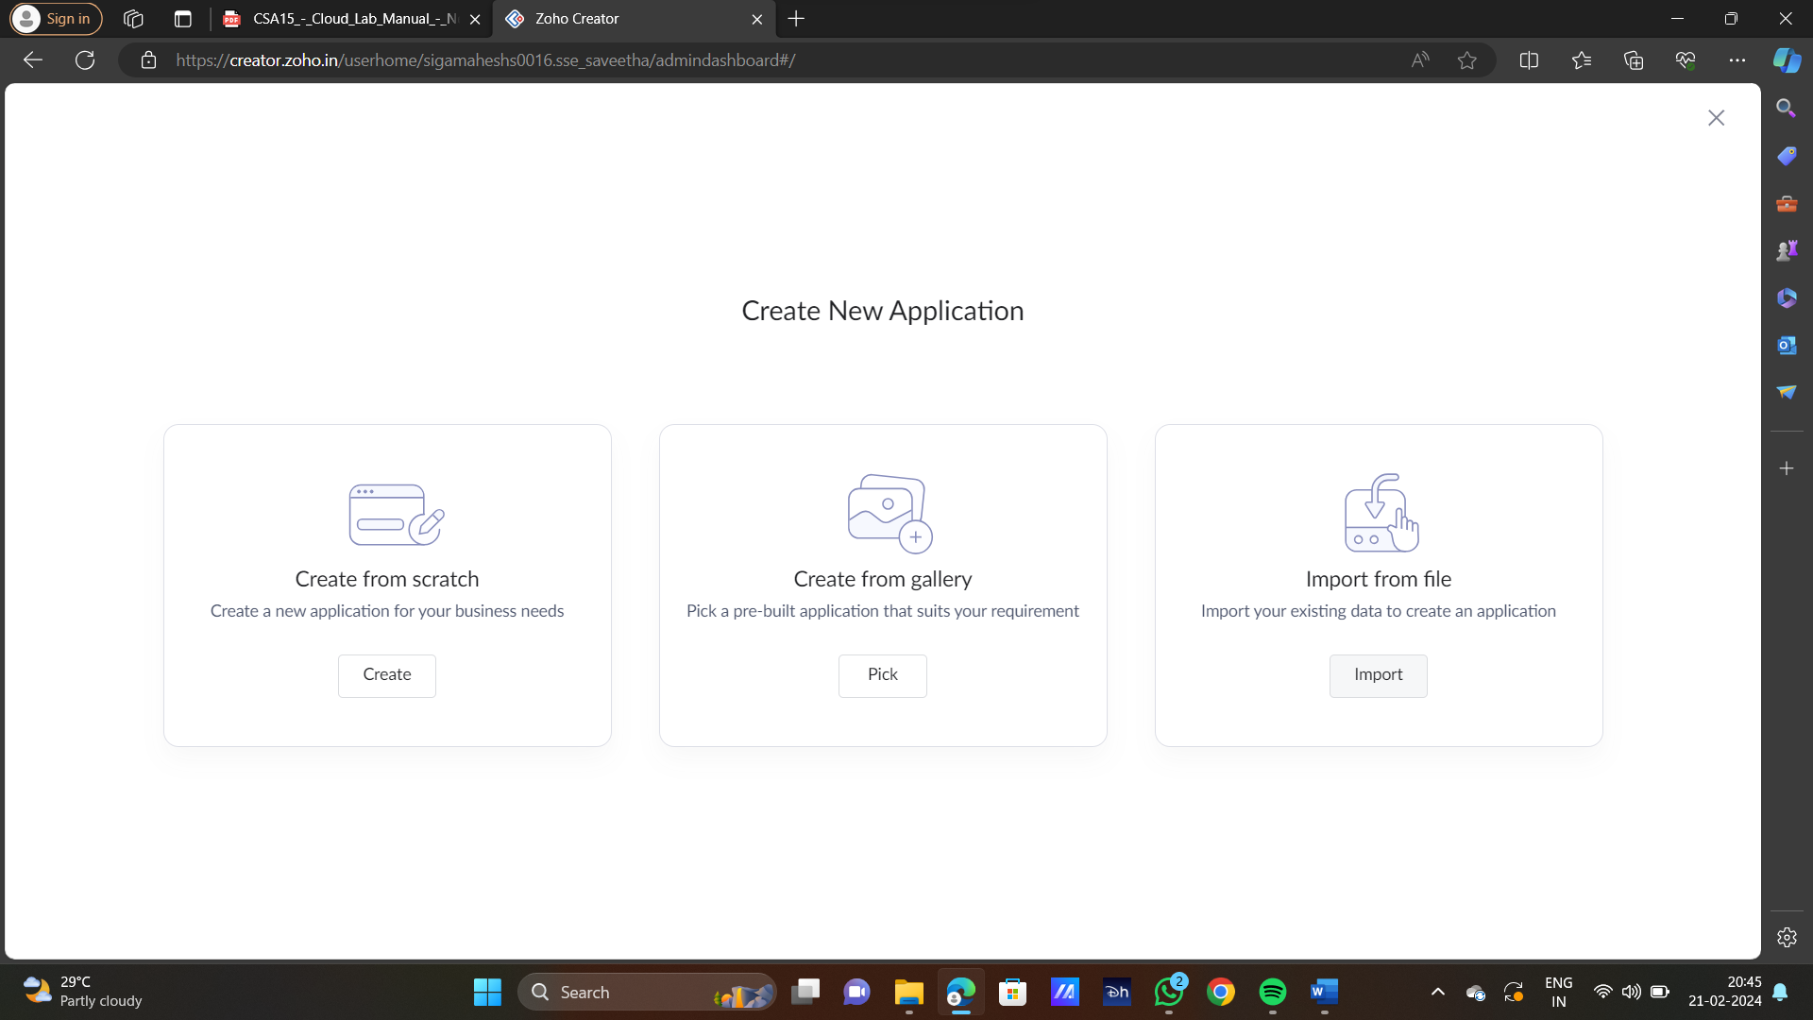

STEP3: SELECT ONE APPLICATION

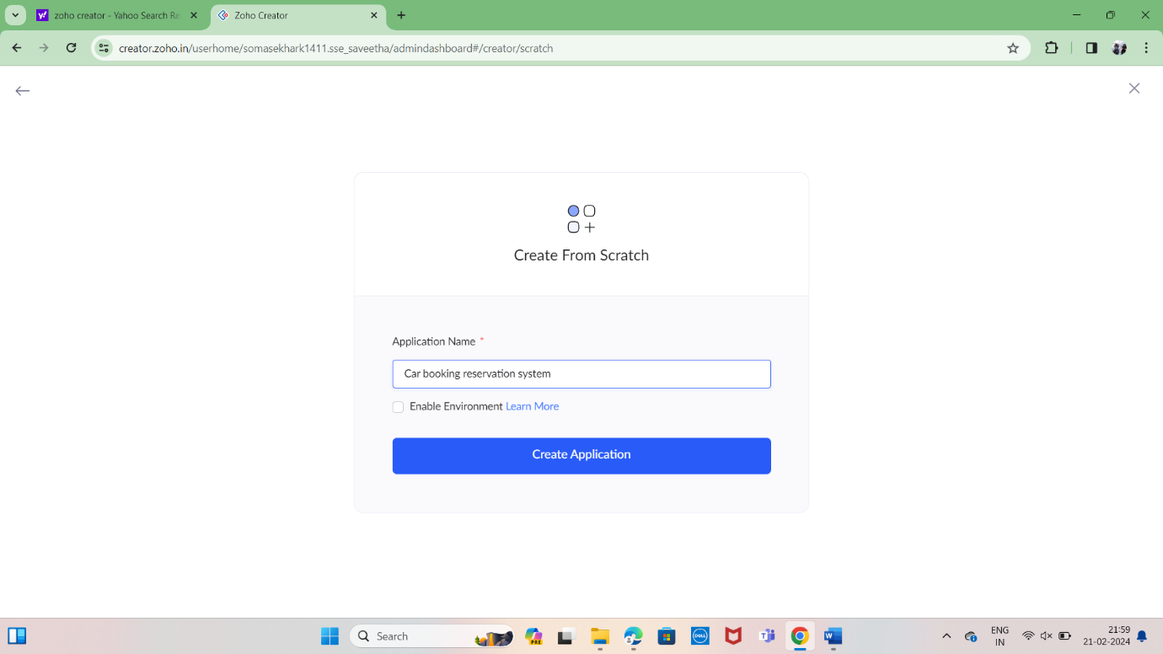

step4: Enter application name as Car Booking Reservation System.



STEP5: CREATED NEW APPLICATION

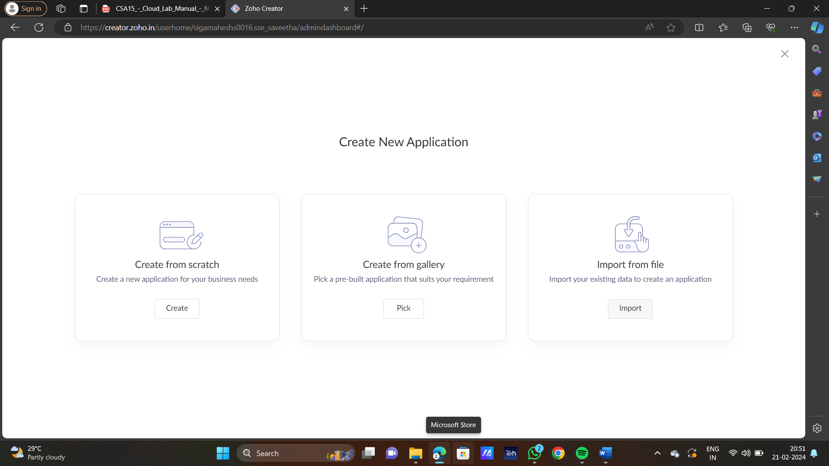

STEP6: SELECT ONE FORM

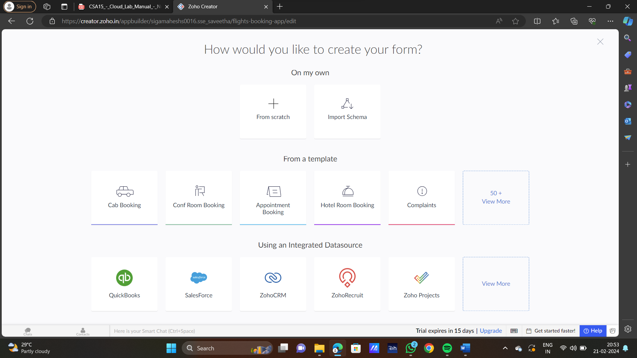

STEP7: THE SOFTWARE HAS BEEN CREATED

