EXP NO 4: Create a simple cloud software application for Library book reservation system for SIMATS library using any Cloud Service Provider to demonstrate SaaS include the necessary fields such as Title of the book, author, publications, Year, edition, no of copies, Rack no, status (taken/returned) etc.

DATE:

AIM:

To Create a simple cloud software application for Library book reservation system for SIMATS library using any Cloud Service Provider to demonstrate SaaS

PROCEDURE:

Step1: Go to zoho.com.

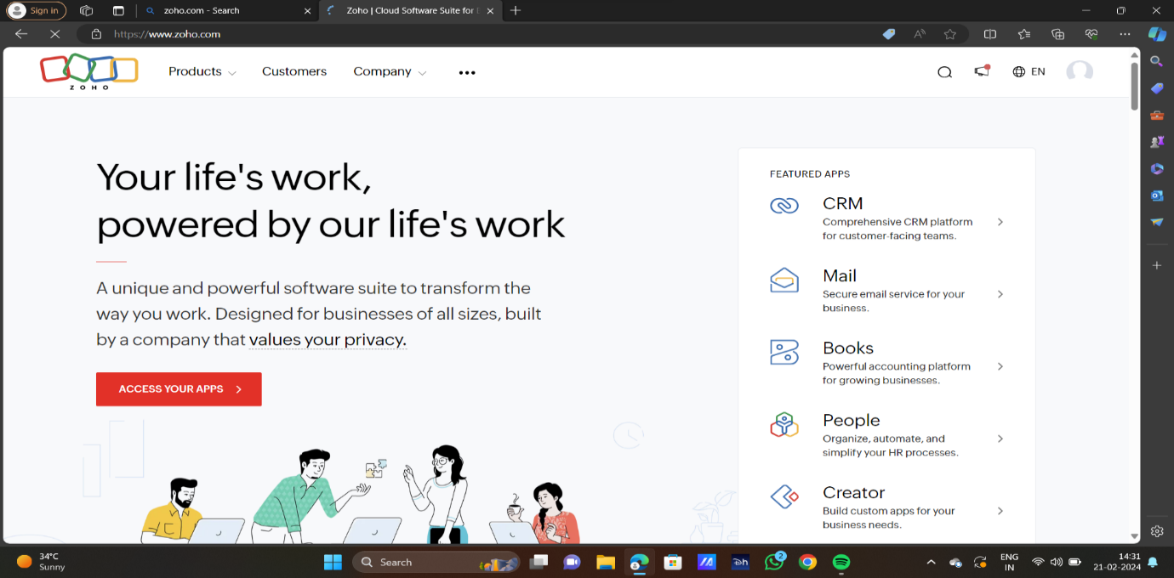

STEP2:LOG INTO THE ZOHO.COM

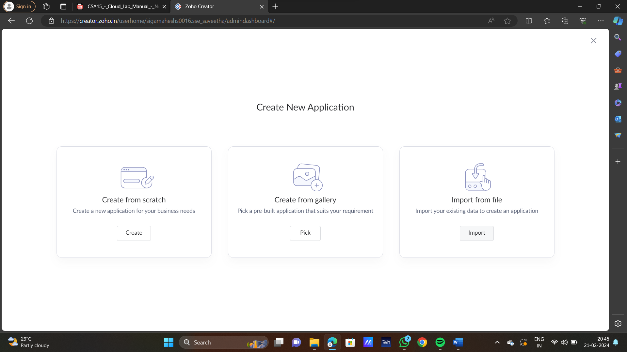

STEP3: SELECT ONE APPLICATION

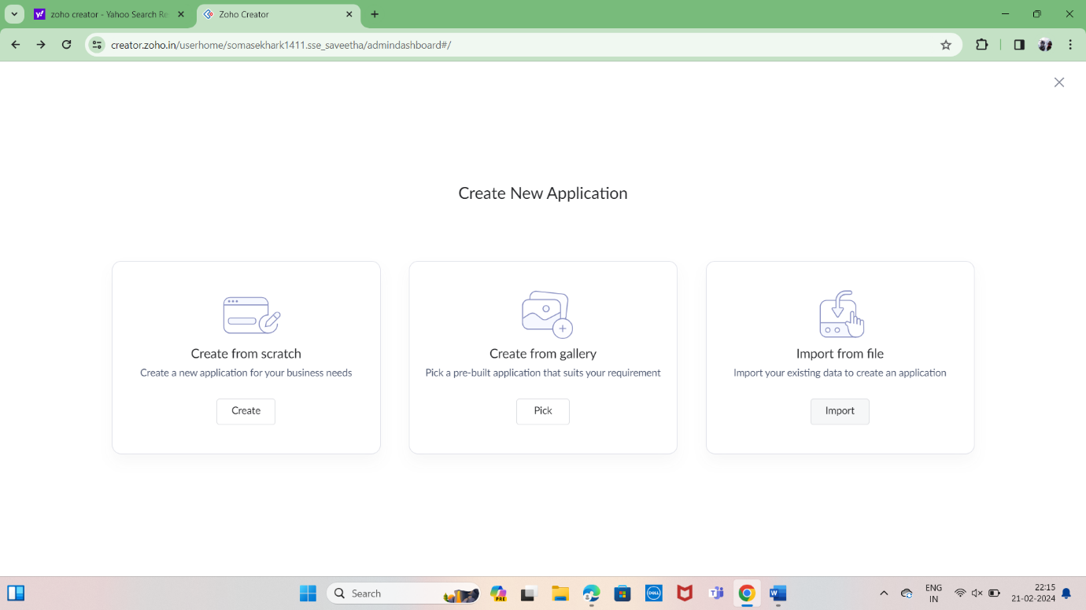

STEP 4: ENTER APPLICATION NAME

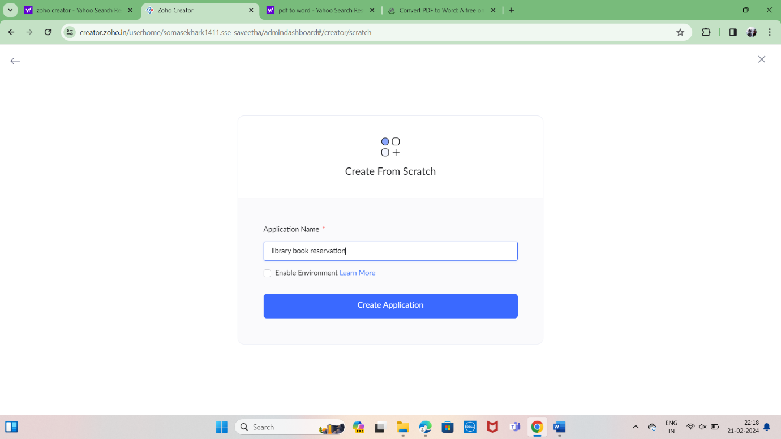

STEP 5: CREATED NEW APPLICATION

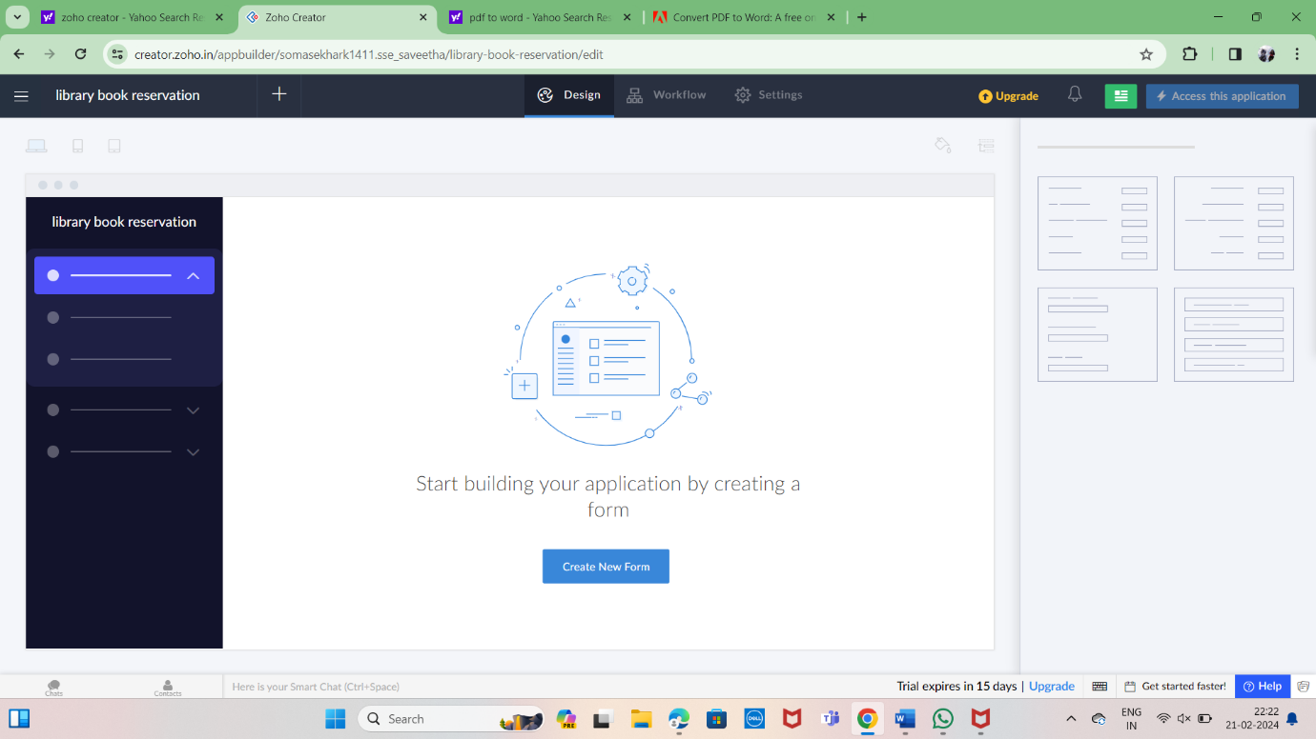

STEP 7: THE SOFTWARE HASE BEEN CREATED.

