EXP NO 5:

Create a simple cloud software application for Mark Sheet Processing System using any Cloud Service Provider to demonstrate SaaS include the necessary fields such as name of the student, Reg no of the student, Subjects, Marks, Average, percentage, rank, overall performance etc.

DATE:

AIM:

To create a simple cloud software application for Mark Sheet Processing system using any cloud service provider to demonstrate SAAS.

PROCEDURE:

STEP1: GOTO ZOHO.COM

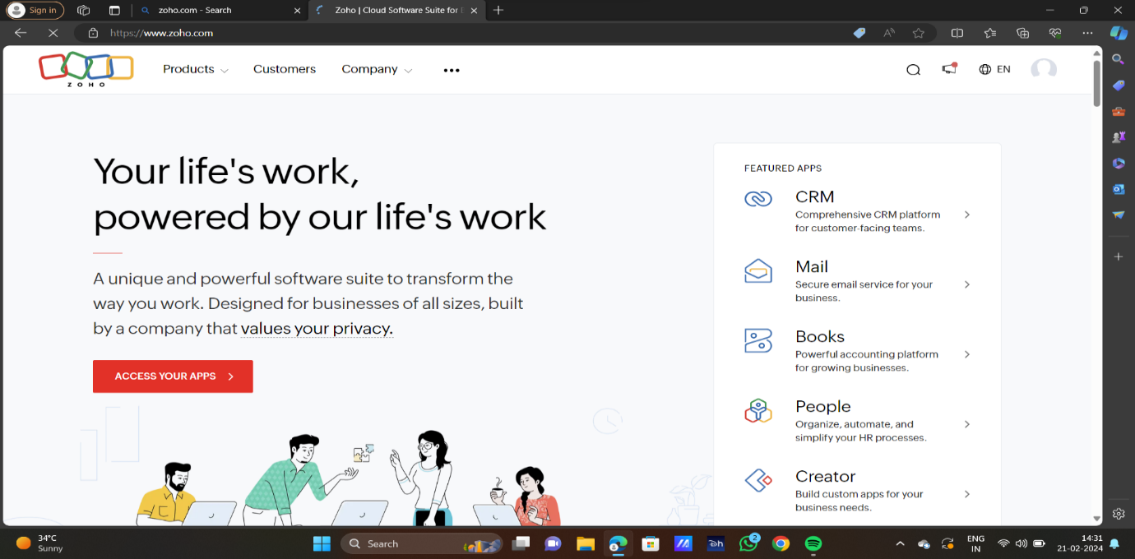

STEP2:LOG INTO THE ZOHO.COM

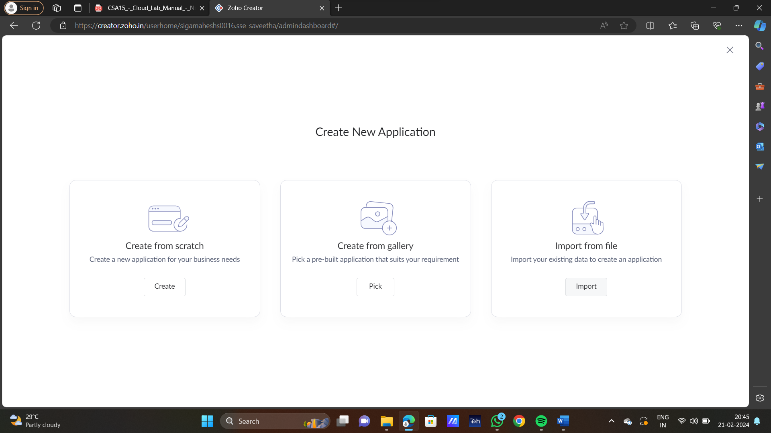

STEP3: SELECT ONE APPLICATION

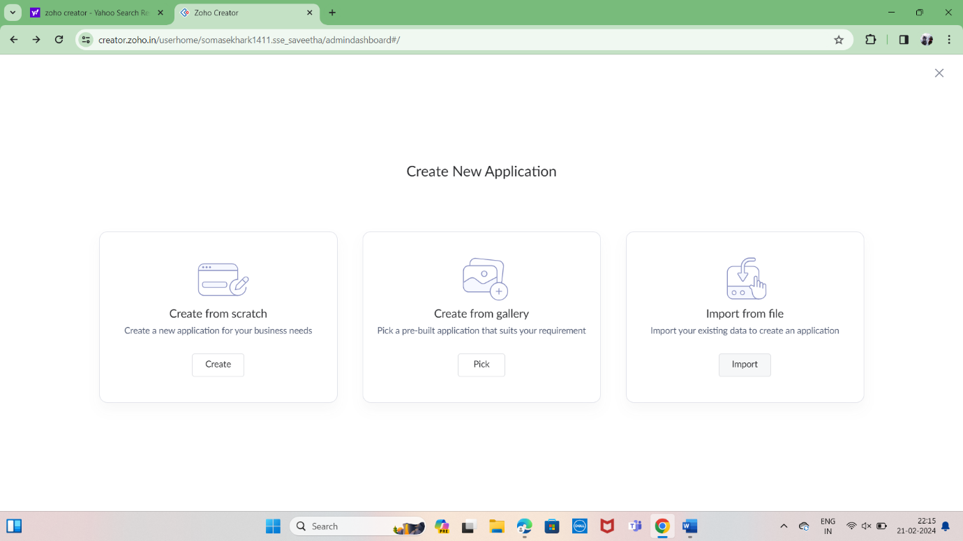

STEP4: ENTER APPLICATION NAME

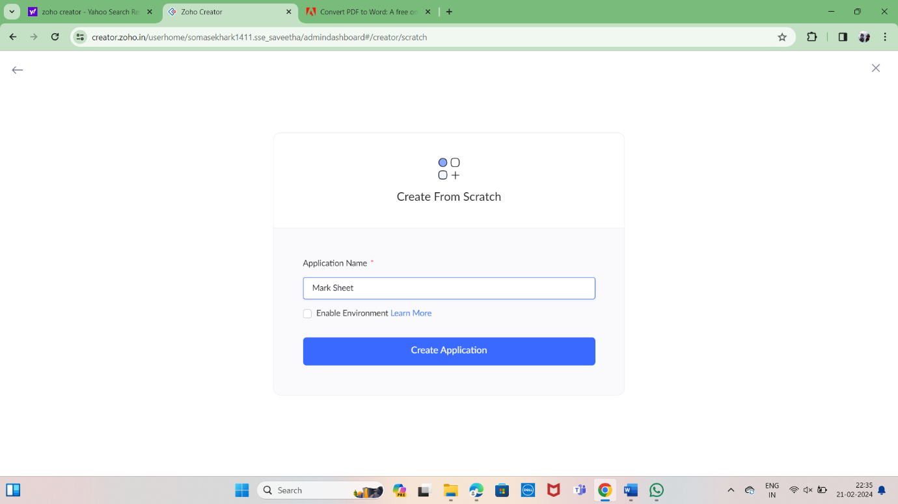

STEP5: CREATED NEW APPLICATION

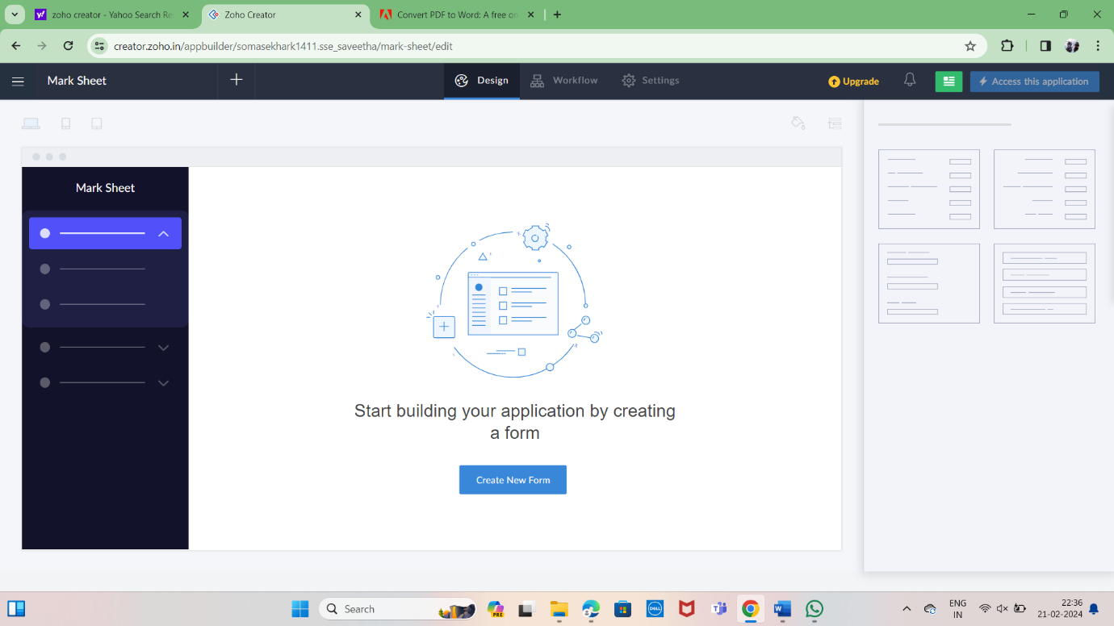

STEP6: SELECT ONE FORM

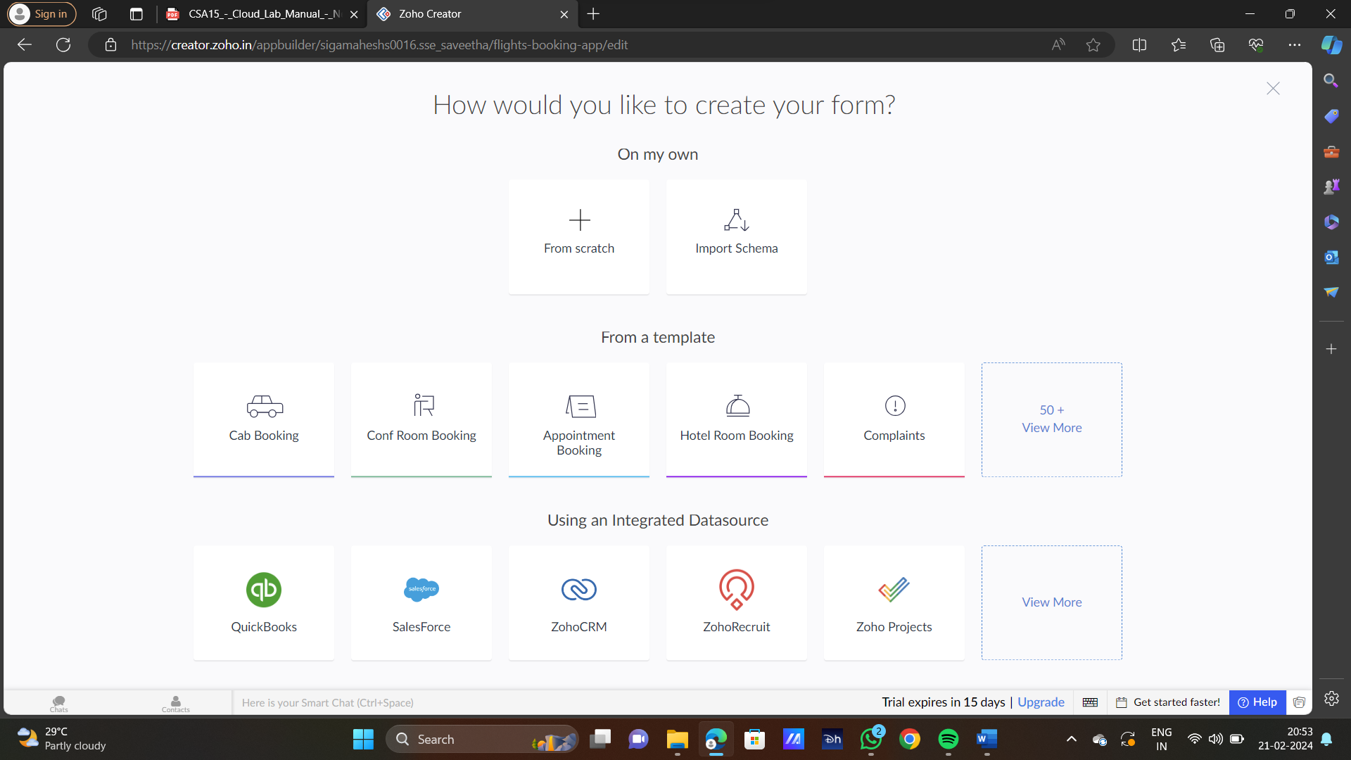

STEP7: THE SOFTWARE HAS BEEN CREATED

