**E-BOOK MANAGEMENT SYSTEM**

**EX.NO:09**

USECASE DIAGRAM:

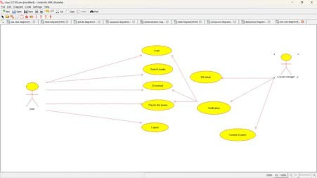

CLASS DIAGRAM:

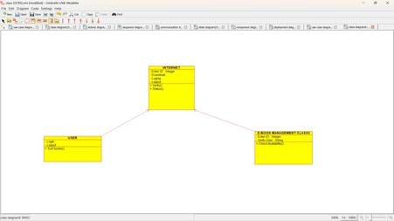

ACTIVITY DIAGRAM:

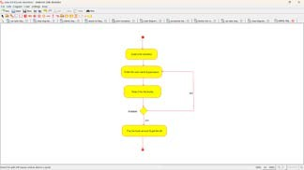

SEQUENCE DIAGRAM:

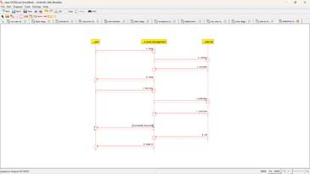

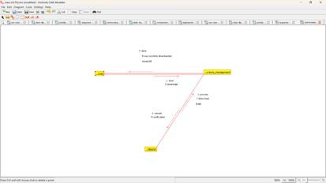COLLABORATION DIAGRAM:

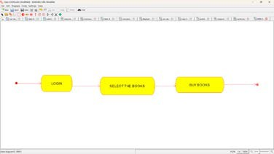STATE DIAGRAM:

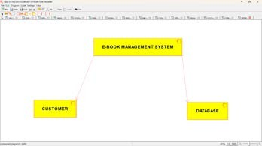COMPONENT DIAGRAM:

DEPLOYMENT DIAGRAM:

