SZABIST AI Chat-Bot

Project Proposal

Supervisor
Dr. Imran Amin

Submitted by

Anas Imran Olia
{1712259}
Izrum Haider
{1712305}

Faculty of Computing and Engineering Sciences
Shaheed Zulfiqar Ali Bhutto Institute of Science and Technology, Karachi.

[Date of Submission]

Introduction
A chat-bot aimed to help the candidates aspiring to get admission in SZABIST with all the admission related queries and ALSO help the students of SZABIST to provide them a one stop solution for all their academic related quires.

Objective

To design a smart chat-bot for SZABIST that will primarily objectify to help the applicants to get info about the admission procedure. The chat-bot will also help the current student’s academic related problems and also help them with their financial queries.

Problem Description
Up until now if any aspiring student who wants to get admission in SZABIST had any query regarding the admission process, they either had to travel or the way to the campus, call the relevant department or go through all the lengthy documents that are present on the website which can be quite a hassle; Similarly if a student (currently in SZABIST) had any query let’s say from the Academics department regarding their class schedule or from the Finance department regarding the fee issues, they had to travel from one campus to other which can be a headache for them. What if we design an intelligent Chabot that can help them with all their queries at one place?

This is where SZABIST AI chat-bot fits in. Our Chabot will first understand the query presented by the user, then it will fetch relevant information based on the query, tailor it and respond the user in the best possible way.

Methodology
In order to build this chat-bot, we have intended to use Python as our choice of language for coding. The chat-bot will either be integrated to the SZABIST official website or it will made a separate stand-alone chat-bot with a separate web page prototype depending on the condition that we are provided access to the SZABIST official website.

Project Scope

- Chat-bot will help the user with his/her admission related queries
- Chat-bot will help the students get a class schedule for his/her day.
- Chat-bot will help the student get his/her financial outstanding and help them with their fee related quires.
- Chat-bot will help the students schedule a meeting with a professor or a SZABIST official body by letting them know their free slots.
- Chat-bot will help the student schedule an appointment with the SZABIST therapist.
- Chat-bot will help the pass out students with their degree clearance procedure
- Chat-bot will help the students get a record of the current books they’ve issued from the library.
- Our chat-bot will also help the faculty members get their class schedule and will also help them reschedule their classes (if required).

Feasibility Study
Risk involved: it is quite possible that we won’t be provided access to the SZABIST official student database as the information may be highly confidential. To overcome this issue we will be creating our own dataset using dummy data.

Also as our project is a research based project so we will be needing time attaining the data, exploring the right algorithms and implementing it to get the accurate response from our Chabot.

Resource Requirements: We would require a PC having at least 8 GB RAM or above. Software requirements would be Python 3 or above and jupyter notebook. Also we would be using FLASK as our PYTHON framework. We will be using NUMPY for working with arrays. We will use Matplotlib to visualize the data through graphical representation of our dataset.

Solution Application Areas
Although our chat-bot can be implemented on any education portal with the right dataset, our main target audience is the students and faculty of SZABIST. Our chat-bot is aimed to provide a one stop solution to help the students at SZABIST.

Tools/Technology
PYTHON, FLASK and different python libraries.

Expertise of the Team Members
All of the team members are pre-equipped with the level of knowledge for successfully making this chat-bot. This project is of interest to all the members.

Milestones

- Our primary task will be making of dataset, we intend to get our required information regarding the admission/academic procedures from SZABIST.
- Our second task will be processing the data for redundancy, we will clean the data and remove all the unnecessary data from our dataset.
- Our fourth task will be exploring different ML algorithms. As this is the first time we will be using ML algorithms, we will spend a good amount of time searching for the right algorithm for our project
- In our next task we will implement the Algorithms, we will analyze the results and find the right algorithm for our Chabot.
- Our next task will be representing the data using different diagrams and chart using matplotlib as a python library.
- Our final task will be creating a GUI prototype for our chatbot. We will either create a separate stand-alone chat-bot or integrate it in the Szabist official website.

Project Schedule
- Task Mode | Task Name | Duration | Start | Finish
Manually Scheduled | Poject idea | 2 days | Mon 28/09/20 | Tue 29/09/20
Manually Scheduled | Gathering Requiement | 21 days | Mon 28/09/20 | Sun 25/10/20
Manually Scheduled | Find Advisor | 3 days | Thu 01/10/20 | Mon 05/10/20
Manually Scheduled | Project Proposal | 8 days | Mon 05/10/20 | Wed 14/10/20
Manually Scheduled | Gantt Chart | 5 days | Thu 08/10/20 | Wed 14/10/20
Manually Scheduled | Project Planning | 9 days | Wed 14/10/20 | Sat 24/10/20
Manually Scheduled | Finding Platform | 5 days | Thu 15/10/20 | Wed 21/10/20
Manually Scheduled | Selecting language | 7 days | Fri 16/10/20 | Mon 26/10/20
Manually Scheduled | Exploring Platform | 5 days | Tue 20/10/20 | Mon 26/10/20
Manually Scheduled | Modelling
Manually Scheduled | Design ERD | 7 days | Sun 01/11/20 | Mon 09/11/20
Manually Scheduled | UCD 50% | 6 days | Mon 09/11/20 | Mon 16/11/20
Manually Scheduled | Use case50% | 5 days | Wed 11/11/20 | Tue 17/11/20
Manually Scheduled | Data set creating or receiving | 15 days | Sun 15/11/20 | Thu 03/12/20
Manually Scheduled | Learning Machine Learning Algorithm | 15 days | Mon 16/11/20 | Fri 04/12/20
Manually Scheduled | implementation of different ML on the project | 10 days | Wed 02/12/20 | Tue 15/12/20
Manually Scheduled | use case100% | 8 days | Wed 09/12/20 | Fri 18/12/20
Manually Scheduled | UCD 100% | 8 days | Wed 09/12/20 | Fri 18/12/20
Manually Scheduled | SDD 50% | 5 days | Fri 11/12/20 | Thu 17/12/20
Manually Scheduled | Create GUI | 10 days | Tue 15/12/20 | Mon 28/12/20
Manually Scheduled | Create SZABIST Web page | 15 days | Sun 20/12/20 | Thu 07/01/21
Manually Scheduled | Integration of chatbot on web page | 20 days | Fri 01/01/21 | Thu 28/01/21
Manually Scheduled | SDD 100% | 5 days | Fri 01/01/21 | Thu 07/01/21
Manually Scheduled | implementation of different ML on the project | 7 days | Thu 25/02/21 | Fri 05/03/21
Manually Scheduled | Analysing the result and finding the right algorithm | 4 days | Fri 05/03/21 | Wed 10/03/21
Manually Scheduled | Data linking with chatbot | 15 days | Thu 25/03/21 | Wed 14/04/21
Manually Scheduled | Unit testing | 6 days | Thu 15/04/21 | Thu 22/04/21
Manually Scheduled | module Testing | 4 days | Mon 19/04/21 | Thu 22/04/21
Manually Scheduled | integration Testing | 5 days | Tue 20/04/21 | Mon 26/04/21
Manually Scheduled | system testing | 5 days | Thu 15/04/21 | Wed 21/04/21
Manually Scheduled | Connection between data and website | 9 days | Wed 28/04/21 | Mon 10/05/21
Manually Scheduled | Testing | 10 days | Sat 01/05/21 | Thu 13/05/21
Manually Scheduled | Adjustment | 6 days | Wed 05/05/21 | Wed 12/05/21
Manually Scheduled | Finalization | 8 days | Tue 01/06/21 | Thu 10/06/21

12. Work Breakdown Structure
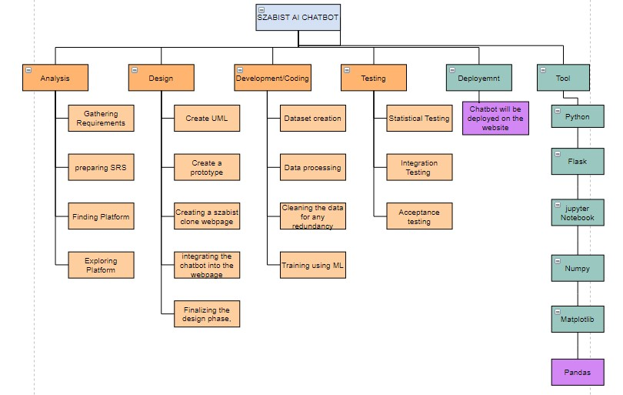

13. References
Enriching Conversation Context in
Retrieval-based Chatbots
Amir Vakili and Azadeh Shakery

Chat-Bot-Kit: A web-based tool to
simulate text-based interactions
between humans and with
computers
Kyoko Sugisaki
Say What I Want: Towards the Dark Side
of Neural Dialogue Models
Haochen Liu
Michigan State University
liuhaoc1@msu.edu
Tyler Derr
Michigan State University

