**Ministerul Educaţiei și Cercetării al Republicii Moldova**

**Universitatea Tehnică a Moldovei**

**Facultatea Calculatoare, Informatică și Microelectronică**



*Laboratory work 3*

Subject: Polyalphabetic script encryption

Done by: Gitlan Gabriel

st. gr. FAF-213

Verified by: Mîțu Cătălin

asist. univ.

Chişinău - 2023

**Description:**

The encryption method known as the "Vigenère cipher" was mistakenly attributed to Blaise de Vigenère in the 19th century and was actually first described by Giovan Battista Bellaso in his 1553 book "La cifra del." Mr. Vigenère created a similar but still different and more powerful cipher in 1586.

**Task:**

To implement the Vigenere algorithm in one of the programming languages for messages in Romanian (31 letters), which are encoded with the numbers 0, 1, ... 30. The values of text characters are between 'A' and 'Z', 'a' and 'z', and no other values are allowed. In case the user enters other values, the correct range of characters will be suggested. The key length must not be less than 7. Encryption and decryption will be carried out according to the formulas in the mathematical model presented above. In the message, spaces must be removed first, then all letters will be transformed into uppercase. The user will be able to choose the operation - encryption or decryption, input the key, the message, or the ciphertext, and obtain the ciphertext or the decrypted message.

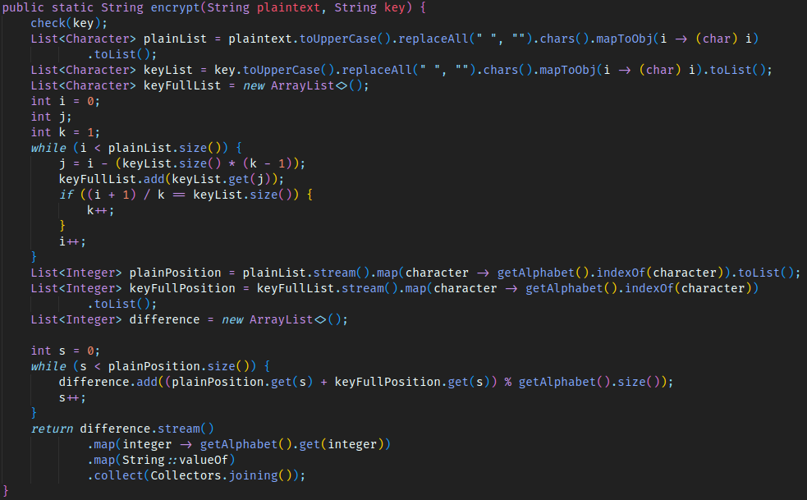Figure 1: Text Encryption

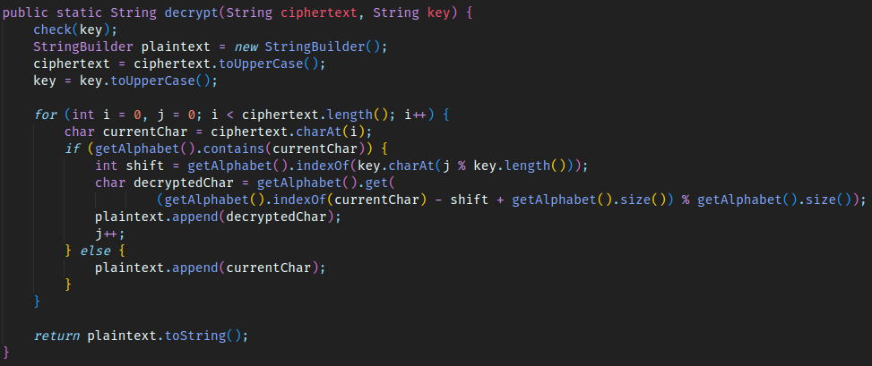Figure 2: Text decryption

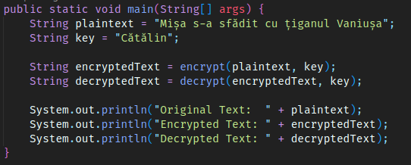

Figure 3: main function

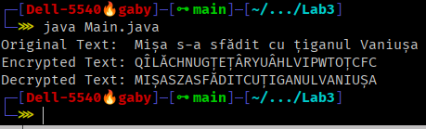

Figure 4: Output

**Conclusion:**

At the current laboratory work I studied how polyalphabetic decryption works and how to implement Vigenere algorithm. It was a real challenge to do it for the Romanian language but it worked. After that, I had found that the text before encryption and that one after decryption is the same.

Link to repo: <https://github.com/5anji/CS_Labs>