GDrive-Test

Rest Services for Google Drive API

# Introduction:

The GDrive-Test API provides rest services to perform operation in Google Drive using java Drive API

Frequently used terminology:

* **file** in the rest service means the file that we are uploading or performing operation on
* **fileId** in the rest service means, in google drive each and every file has unique id and the fileid is used to access the file and perform operation on it
* **folderId** in the rest service means, if we want to access files in subfolder, or upload files to subfolder we use the unique id of the folder

Technologies Used:

* Programming language: Java
* Server: Tomcat 8.0
* Rest Services framework: Spring MVC
* Rest service testing : Postman

# Rest Services:

**/listfiles :**

listfiles is API url to list files in the google drive.

Ex.: http://localhost:8080/GDrive-Test/list

http://395e2231.ngrok.io/GDrive-Test/list

**/folderlist:**

folderlist is API url to list files in a folder, it takes <folderid> as a argument to list files in the given folderid.

Ex.: http://localhost:8080/GDrive-Test/folderlist?folderId=1NvdjiXA-ugvdlhgEcoIfuQvK54mKx3pr

http://395e2231.ngrok.io/GDrive-Test/folderlist?folderId=1NvdjiXA-ugvdlhgEcoIfuQvK54mKx3pr

**/exportdownload:**

exportdownload is API url to export google docs files to required format and download files, it takes file id as argument and file should be a google doc file.

Ex.: http://localhost:8080/GDrive-Test/exportdownload?fileId=1armzz3edlBa16DMtj7Af1atOuMYGJtW1V0_COfPxTG4

http://395e2231.ngrok.io/GDrive-Test/exportdownload?fileId=1armzz3edlBa16DMtj7Af1atOuMYGJtW1V0_COfPxTG4

**/download:**

download is API url to download file from the google drive, it takes <fileId> as argument.

Ex. http://localhost:8080/GDrive-Test/download?fileId=1cJOTpJ6CzMVWKiLLY4hpD5q4uJ6R1sus

http://395e2231.ngrok.io/GDrive-Test/download?fileId=1cJOTpJ6CzMVWKiLLY4hpD5q4uJ6R1sus

**/uploadfile:**

Uploadfile is API url to upload files to root of google drive, it takes <file> as MultiPartfile as input.

Ex. http://localhost:8080/GDrive-Test/uploadfile

http://395e2231.ngrok.io/GDrive-Test/uploadfile

**/uploadtofolder**

Uploadtofolder is API url to upload files to sub folder in google drive, this takes <file>,<folderId> as arguments and uploads file to given folderId

Ex. http://localhost:8080/GDrive-Test/uploadtofolder

http://395e2231.ngrok.io/GDrive-Test/uploadtofolder

**Design issues faced:**

Faced problem in downloading file, uploaded via GDrive-Test API

Reason: The webContentLink value is returning null for uploaded files.

Solution: The file while uploading via API, the set fields should have webContentLink, if we upload with default configuration the webContentLink would remain null

**Rest testing screenshots:**

**Files List:**

http://395e2231.ngrok.io/GDrive-Test/list

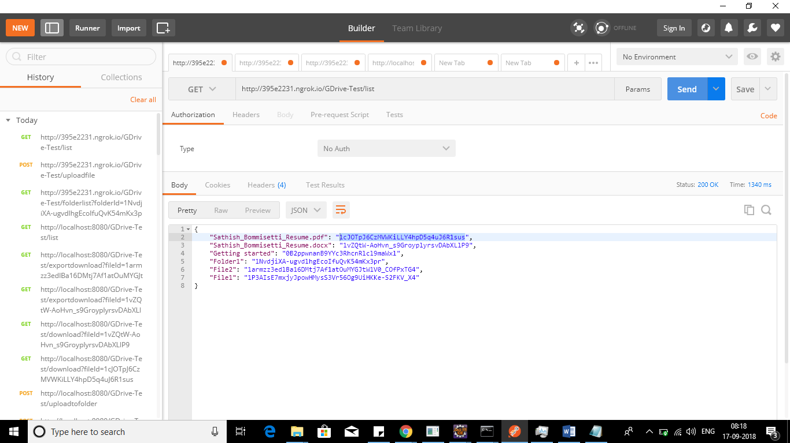

Files in folder:

http://395e2231.ngrok.io/GDrive-Test/folderlist?folderId=1NvdjiXA-ugvdlhgEcoIfuQvK54mKx3pr

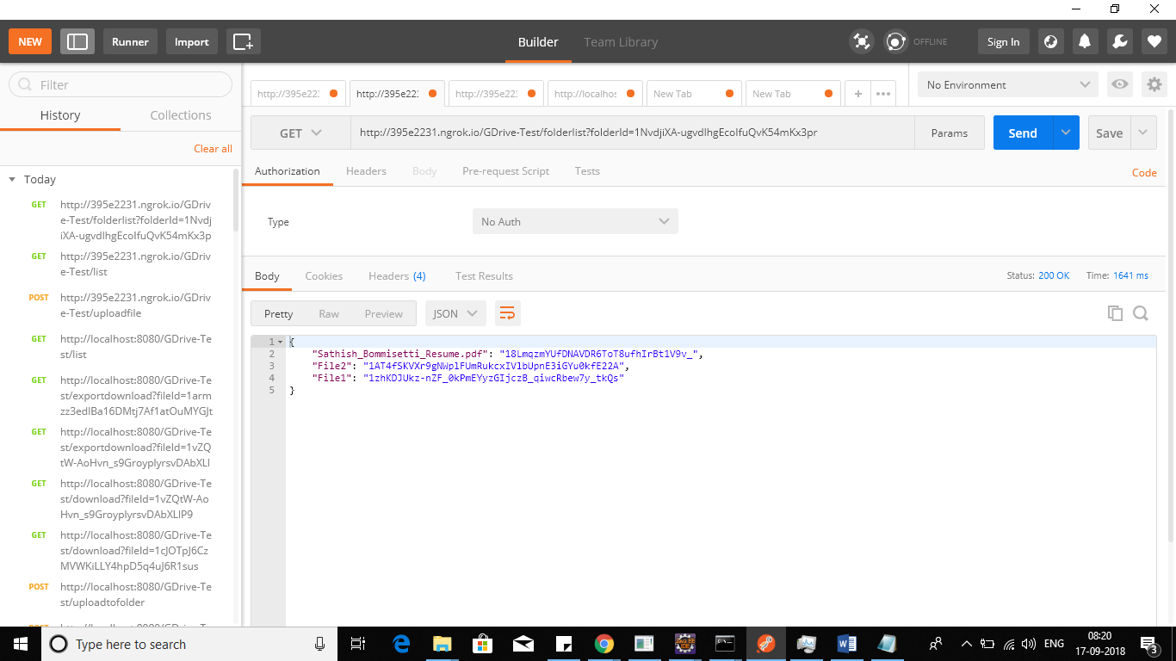

Upload Files:

http://395e2231.ngrok.io/GDrive-Test/uploadfile

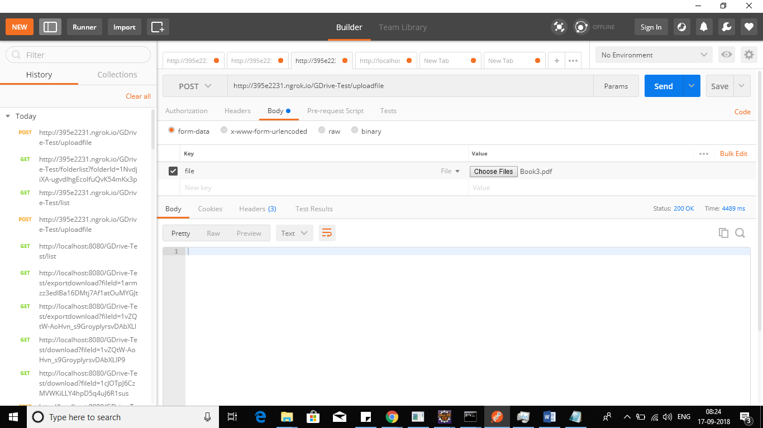

Uploaded file in google drive

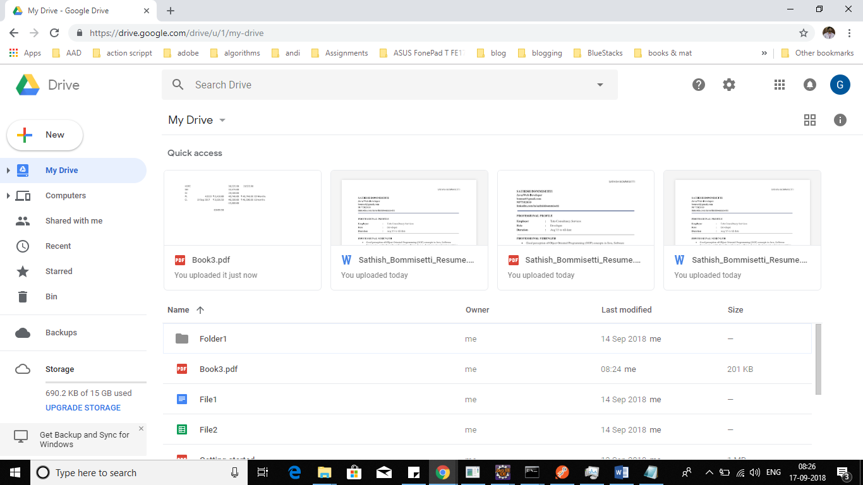

Upload to Folder:

[http://localhost:8080/GDrive-Test/uploadtofolder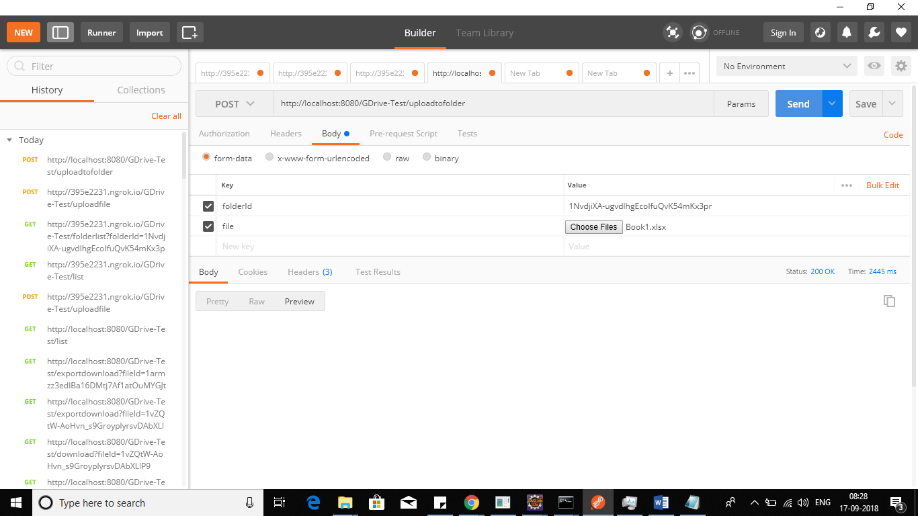](http://localhost:8080/GDrive-Test/uploadtofolder#)

Uploaded file in google drive folder

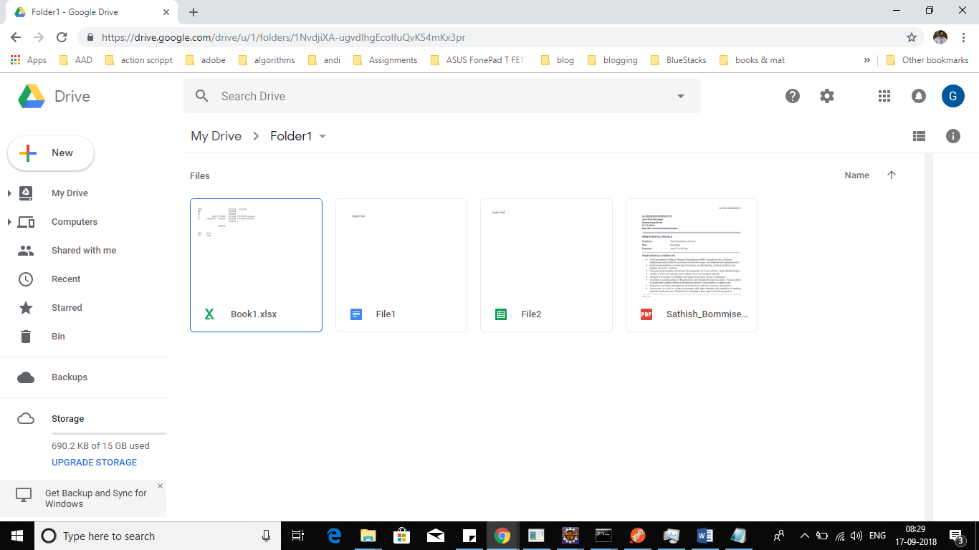

Export Download File:

http://395e2231.ngrok.io/GDrive-Test/exportdownload?fileId=1armzz3edlBa16DMtj7Af1atOuMYGJtW1V0_COfPxTG4

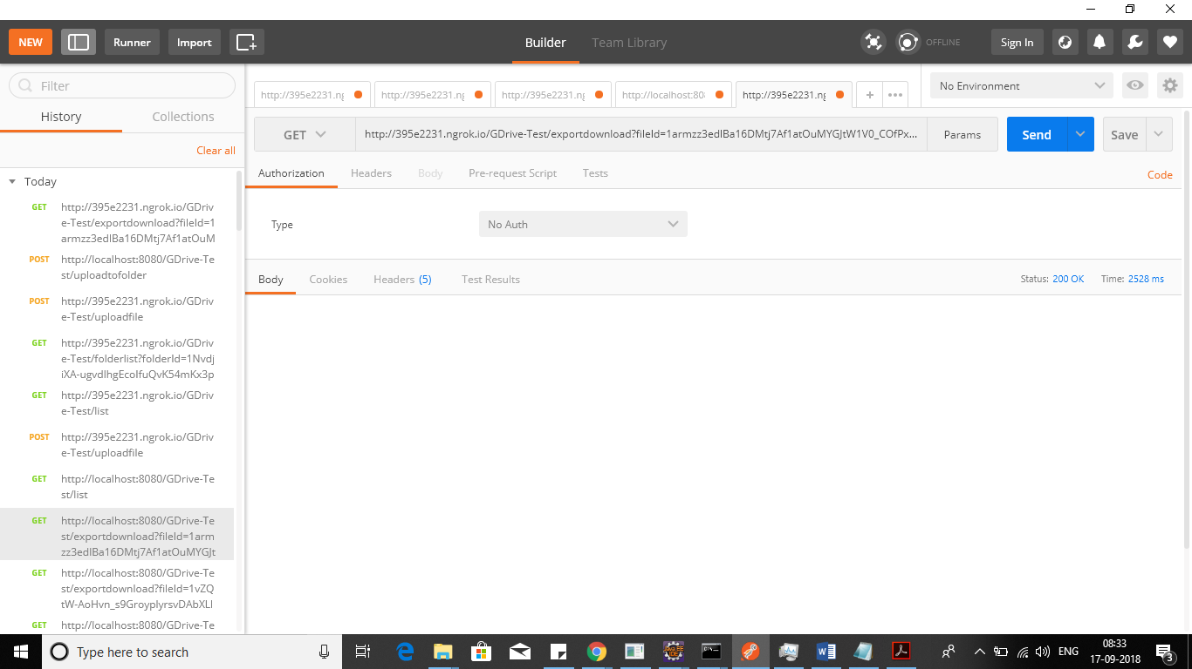

Save file prompt while downloading

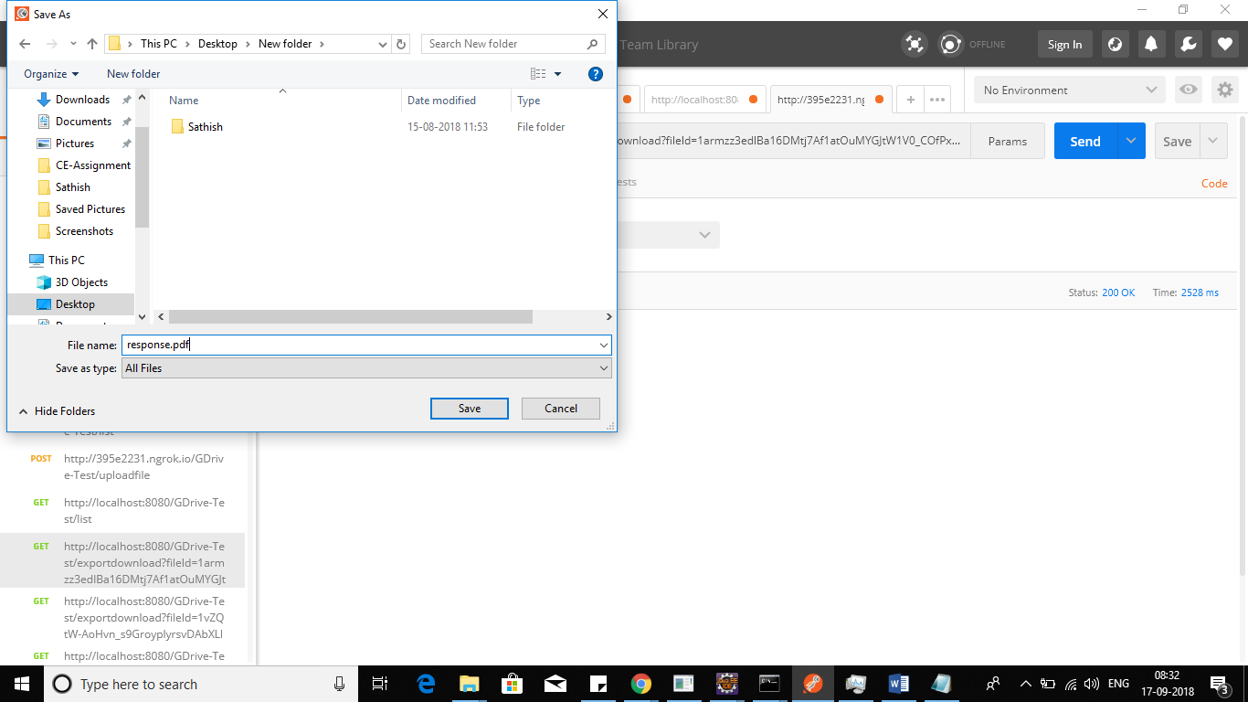

Saved file and contents

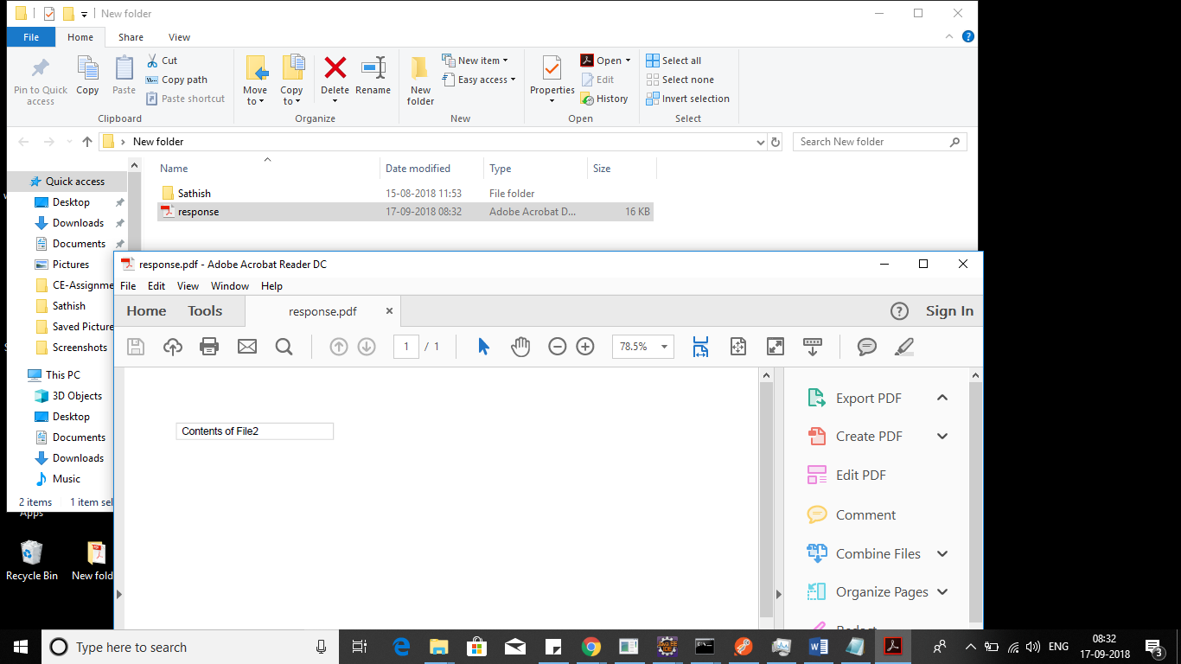

Direct download all files:

http://395e2231.ngrok.io/GDrive-Test/download?fileId=1cJOTpJ6CzMVWKiLLY4hpD5q4uJ6R1sus

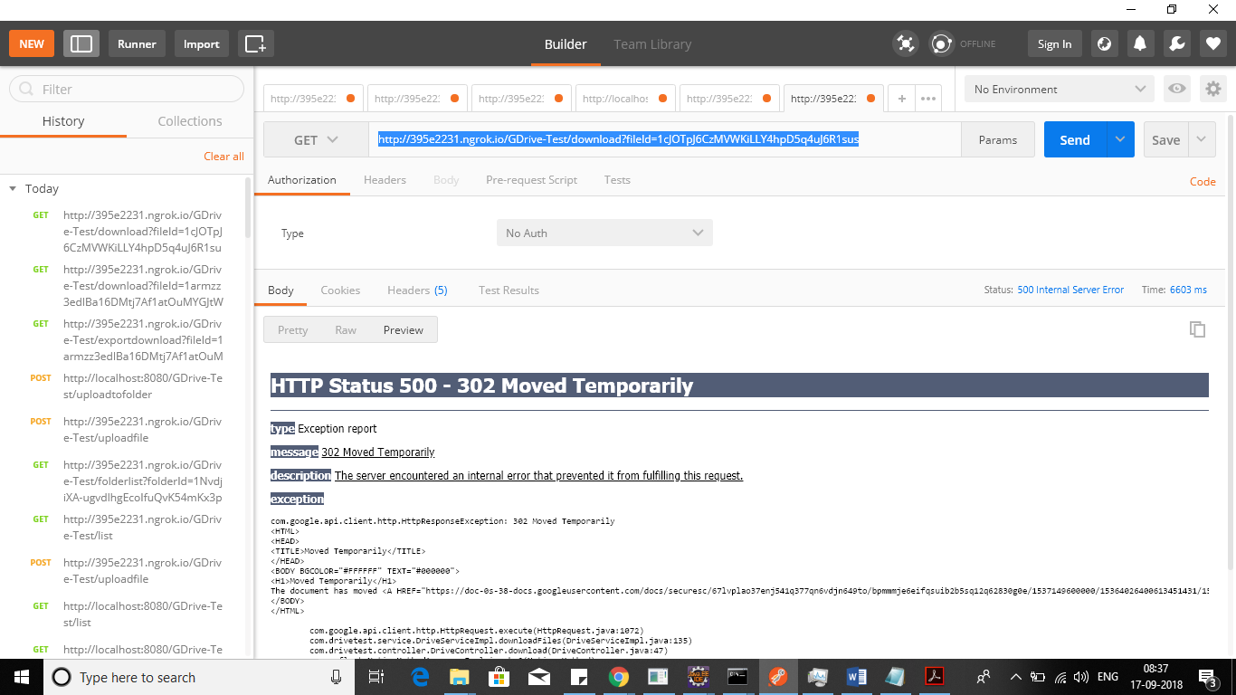

Facing temporarily file moved issue while directly downloading file.