MFS汇报

高可用方案

1.技术选型：keepalived + mfsmetalogger

2.架构图
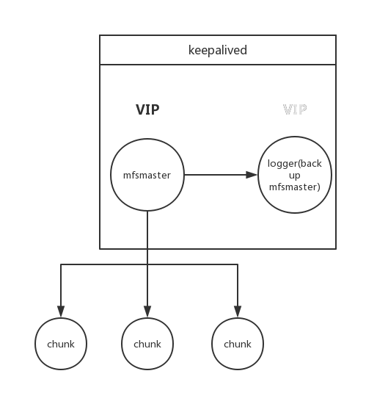

3.切换流程

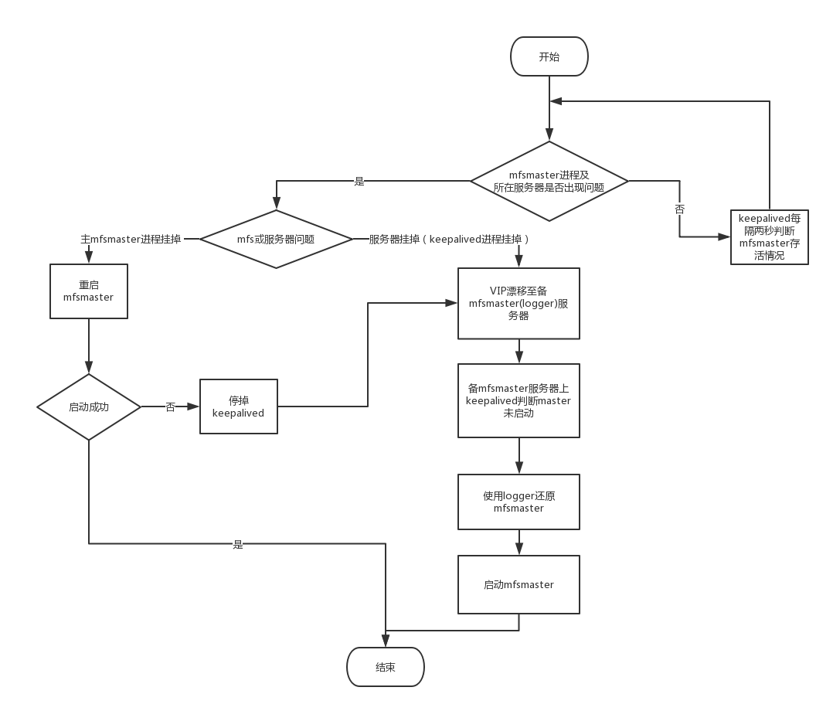

4.为此开发的附属工具及配置文件
setup.sh //MFS HA 初始化
keepalived_check_mfsmaster.sh //mfsmaster 检查切换工具
moosefsha.sh //mfs高可用工具（起,停,重启,恢复）
install_moosefs.sh //mfs自动安装工具
keepalivedha.sh //keepalived 高可用工具
install_keepalived.sh //keepalived 自动安装工具
keepalived.conf.sample.master //keepalived 主实例配置文件
keepalived.conf.sample.backup //keepalived 备实例配置文件

5.部署流程(ubuntu 14.04)
部署keepalived
(1)mfsmaster 服务器上部署 ： keepalived master
./install_keepalived.sh -lp [local_real_ip] -rp [remote_real_ip] -vp [virtaul_ip] --master
(2)mfsmetalogger 服务器上部署 ：keepalived backup
./install_keepalived.sh -lp [local_real_ip] -rp [remote_real_ip] -vp [virtaul_ip] –backup

部署mfs
(1)mfsmaster 服务器上部署 ：mfsmaster, cgiserv
./install_mfs.sh --master_host [master_virtual_ip] --master
./install_mfs.sh --master_host [master_virtual_ip] --cgiserv
(2)mfsmetalogger 服务器上部署 ：mfsmetalogger , mfsmaster
./install_mfs.sh --master_host [master_virtual_ip] --logger
./install_mfs.sh --master_host [master_virtual_ip] --master
(3)mfschunk服务器上部署 ：mfschunk
./install_mfs.sh –master_host [master_virtual_ip ]--chunk
(4)mfsclient服务器上部署 ：mfsclient
./install_mfs.sh --master_host [master_virtual_ip ] --client

6.切换后还原主备结构
(1)找一台合适的服务器作为mfsmetaloger及备mfsmater 服务部署环境
(2)安装mfsmater
./install_mfs.sh --master_host [master_virtual_ip] --master
(3)安装 并 启动mfsmetaloger
./install_mfs.sh --master_host [master_virtual_ip] –logger
service mfsmetalogger start
(4)安装 并 作为备实例启动keepalived
./install_keepalived.sh -lp [local_real_ip] -rp [remote_real_ip] -vp [virtaul_ip] --backup
./keepalivedha.sh -s

7.缺点
由于阿里云服务器网络环境中路由交换层有ARP的广播限制，造成主备无法通过广播方式进行通信，所以当备实例切换成主实例的时候需要更改配置文件的中的unicast_peer参数 ; 而且，备实例切换成主实例的时候，state状态也需要由backup 更改为master ，priority要加大。
因为以上两个原因，所以必须在主备切换稳定之后，重启一次新主实例的keepalived， 理论上会有秒级的断开，实际上不会有明显感知。
理论上自建云以后取消ARP的广播限制，调整配置文件以后不会出现以上问题。

扩容方法
(1)找运维，在要扩容的服务器上再挂上（或者虚拟出）一块硬盘，比如：/dev/sdb
(2)Creating a partition on /dev/sdb
# parted --align optimal /dev/sdb
(parted) mklabel gpt
(parted) mkpart mfschunksdb 0% 100%
(parted) q
(3)Installing xfsprogs
apt-get install xfsprogs
(4) Formatting partitions with 4k
mkfs.xfs -s size=4k /dev/sdb
(5)add appropriate entries into /etc/fstab
echo “/dev/sdb /mnt/mfschunksdb xfs defaults 0 0” >> /etc/fstab
(6) Creating directories 比如 /mnt/mfschunksdb
mkdir /mnt/mfschunksdb
(7) Mounting partitions
mount /mnt/mfschunksdb /dev/sdb
(8) Changing ownership
chown mfs:mfs /mnt/mfschunksdb
chmod 770 /mnt/mfschunksdb
(9)At this point enter mountpoints in mfshdd.cfg
echo “/mnt/mfschunksdb” >> /etc/mfs/mfshdd.cfg

常见问题
(1)安装keepalived 时，
报错：
/usr/sbin/keepalived: /usr/local/openssl/lib/libcrypto.so.1.0.0: no version information available (required by /usr/sbin/keepalived)
/usr/sbin/keepalived: /usr/local/openssl/lib/libssl.so.1.0.0: no version information available (required by /usr/sbin/keepalived)
/usr/sbin/keepalived: /usr/local/openssl/lib/libcrypto.so.1.0.0: no version information available (required by /usr/lib/x86_64-linux-gnu/libnetsnmp.so.30)
解决方法：
cd /usr/local && mv openssl openssl_bak
======================================================================

(2)安装keepalived时，
报错：
找不到 1:1.2.13-1~ubuntu14.04.1 版本的keepalived
解决方法：
下载keepalived-1.2.13.tar.gz，编译安装，
安装 apt-get install libssl-dev
i. tar zxvf keepalived-1.2.13.tar.gz
ii. cd keepalived-1.2.13.tar.gz
iii. ./configure --prefix=/usr/local/keepalived –sbindir=/usr/local/keepalived/sbin
iv. make && make install
v. cp /usr/local/keepalived/sbin/keepalived /usr/sbin/ &&
cp /usr/local/keepalived/etc/rc.d/init.d/keepalived /etc/init.d/
vi. vim /etc/init.d/keepalived -->
#. /etc/rc.d/init.d/functions
. /lib/lsb/init-functions
#. /etc/sysconfig/keepalived
======================================================================

(3)安装moosefs时，
报错：
无法执行 wget -O - http://ppa.moosefs.com/moosefs.key | apt-key add -
解决方法：
mv /etc/apt/apt.conf /etc/apt/apt.conf.bak && touch /etc/apt/apt.conf
======================================================================

监控方案(与监控中心放到一起展开)

预计加入到botasky，监控实例存活情况

1.架构图
