Shy Lee

Costco Wholesale (COST) — | Equity Valuation | July 28, 2026 Draft
Recommendation: BUY COST

Business
The obvious pushback is that it’s expensive (around 48x trailing, ~42x forward), but the quality of the business earns most of a premium, and the membership model makes the earnings a lot more durable than a normal retailer. Plan is to build the position on pullbacks rather than pay all the way up here. Stock is around $935 right now, roughly $420B market cap. Costco ran 914 warehouses as of FY25 (fiscal year ends end of August).

The thing that separates it from every other retailer is that it basically sells merchandise at cost and makes its money on the membership fee instead. Gross margin is only about 11%, tiny next to a normal retailer, and that’s on purpose. Membership fees were $5.3B in FY25 — about half of operating income (~$10.4B) — and those fees are close to 100% margin. Strip the fees out and the actual buying-and-selling business only nets around $5B after SG&A. So really it’s a subscription business wrapped in a store.

Membership stats: about 81M paid members, ~145M cardholders, renewal of 92.3% in US/Canada and 89.8% worldwide. Very sticky. The Executive members (the higher tier, ~38.7M of them) are only about half the base but drive roughly 74% of sales, and that group is still growing ~9% a year. They raised the fee to $65 / $130 in Sept 2024; they only tend to do this every ~7 years, so the next increase is probably around 2030.

A few things that don’t look fully credited by the street. Real estate: they actually own the building on something like 866 of 914 warehouses, carried at old cost on the balance sheet (~$32B net PP&E) — a lot of hidden asset value that doesn’t show up in an earnings multiple. Working capital is negative: they sell inventory before they even pay the supplier for it (payables are actually bigger than inventory), so growth mostly funds itself. Deferred membership fees (~$2.8B) are basically an interest-free loan from members. Limited SKUs (~3,800 items per warehouse) mean huge volume per item, which gets them the best cost from suppliers — that’s the whole flywheel that lets them keep prices low.

Industry
Warehouse clubs are the direct comps — Sam’s Club and BJ’s — and then Walmart / Amazon more broadly. Costco has 60%+ of the US club market. The moat is kind of backwards from how you’d normally think about pricing power: the advantage is the power to NOT raise prices, because the fee already covers the profit. Competitors who live on merchandise margin can’t really match Costco on price without hurting their own P&L.

Tailwinds: trade-down when the consumer gets shaky, Kirkland (private label) taking share, the ancillary businesses (pharmacy, gas, optical, travel), and a lot of international runway still open. Headwinds: labor and healthcare inflation, gas prices (gas is ~10% of sales and swings the reported comps around), tariffs on imported goods, and zoning/permitting issues especially in Europe.

Street View
The street likes the business and doesn’t love the price. Price targets seen so far run roughly $1,000 to $1,160 (RBC initiated Sector Perform at $1,000, JPM around $1,100). The bull case everyone repeats is the recurring fee, ~90% renewal, and rising Executive penetration. The bear case is pretty much just — ~48x is a big premium to staples and to Costco’s own history. Take: the market is already paying for the durability, so from here it’s about the growth continuing to compound, not the multiple going higher.

Catalysts / Thesis
- The membership annuity is durable and under-modeled. ~90% renewal, a growing Executive base, and fee-hike optionality around 2030. It’s half of operating profit at ~100% margin, so the earnings quality looks more like a subscription company than a retailer.
- International is the growth, and it’s the higher-margin part of the business. Canada operating margin is ~5% and Other International ~4.3%, versus the US at ~3.4%. International including Canada is 27% of sales but 34% of operating income, and new openings skew international (China running ahead of plan; Executive membership just launched there). So the growth is actually margin-accretive, not the dilutive thing usually assumed about new stores.
- New warehouses are maturing faster. The FY25 opening class did about $192M per store in its first year, versus ~$150M for the FY23 class. Also getting creative on real estate (multi-story boxes, parking decks, a residential-over-warehouse project near LAX opening in 2027), which lowers the capital per store. Target is 30+ openings a year.
- Digital / AI / retail media is basically free optionality. Digital comps are running 20%+. AI-driven search traffic is growing triple digits and converts better than any other channel, probably because Costco’s all-in pricing (delivery, install, etc. included) shows up well in LLM answers. Retail media is over 1,000 suppliers now.
Near-term catalysts to watch: the monthly comps (June was +10.6% sales / +8.8% comps), the tariff refunds (Section 301 claims filed, lawsuit pending on how the money gets returned to members), and the special dividend question — roughly $45/share of cash sitting on the balance sheet.

Comps (Business Advantage)
Direct comps are Sam’s Club and BJ’s Wholesale, with Walmart and Amazon as the broader competitive set. Costco holds 60%+ of the US warehouse club market. Full side-by-side comps table (WMT / BJ / TGT)
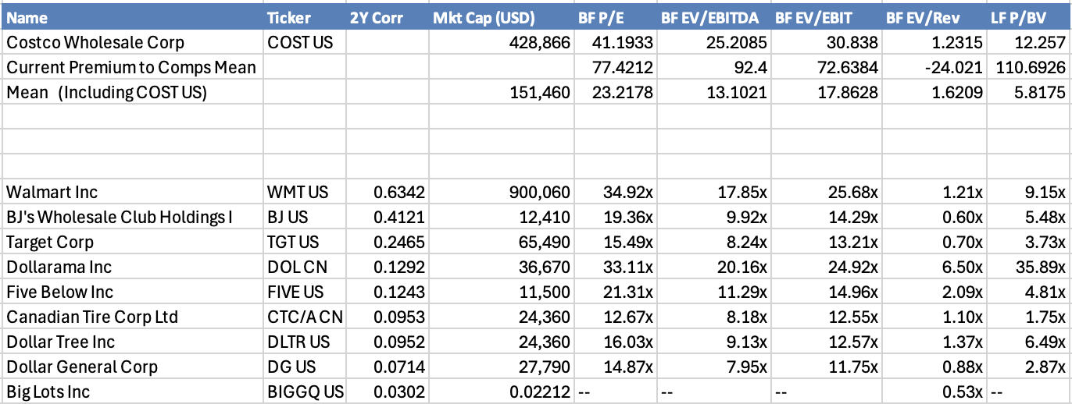

Risks to Thesis
Valuation: ~48x, basically no margin of safety. Most of the downside is just the multiple compressing if growth slips.
Member growth is slowing: it went 5.2%, then 4.8%, then 4.1% over FY26. Existing members are sticky, but new-member growth is decelerating — probably the single most important number to watch.
The moat resists margin expansion: value doesn’t “unlock” the normal way — it only compounds through volume plus the occasional fee increase. This is also why a plain DCF undershoots. (Need to fix mine — split maintenance vs. growth capex.)
Cost inflation: healthcare grew faster than sales for the first time recently, and comps now need to be mid-single-digit just to leverage SG&A.
Concentration / legal: US + Canada is ~86% of sales and profit, and California alone is ~26% of US sales. There’s also the opioid litigation on the pharmacy side.

Conclusion: Great business, arguably one of the best in retail — sticky membership, owns its real estate, growth that funds itself, and a higher-margin international runway. The catch is entirely the price. At ~48x this means paying up for the quality and betting the compounding keeps going. Long, but sizing it carefully and adding on weakness.

Sources: Costco FY2025 10-K, Q1–Q3 FY2026 earnings calls, monthly sales releases, market data as of late July 2026.

