

# ASSIGNMENT 2

**PROG6001**

**Managing Software Development**

**Submitted By:**

### Harinder Kaur (24135850)

Andre Schubert (24096465)

Sayeda Faheem (23229422)

**Task 1**

GitHub link: <https://github.com/5chub1/PROG6001-Assignment-2.git>

Andre created the repository.

Harinder and Sayeda forked it.

Commits:

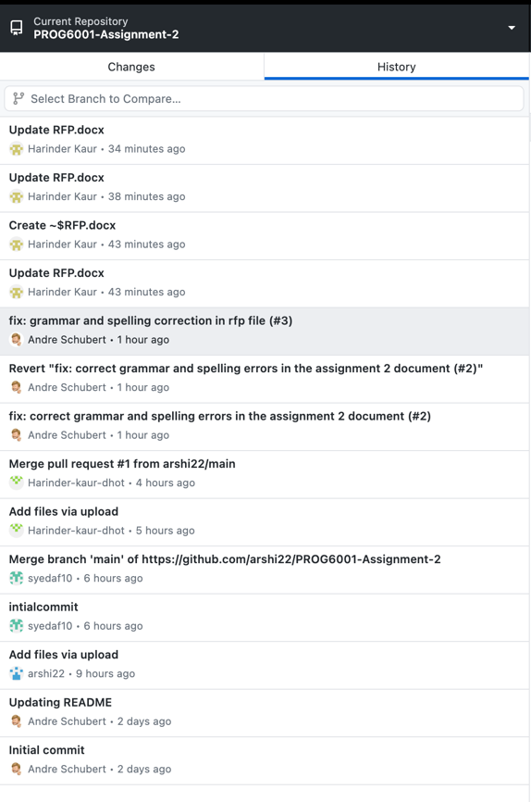

Overall commits

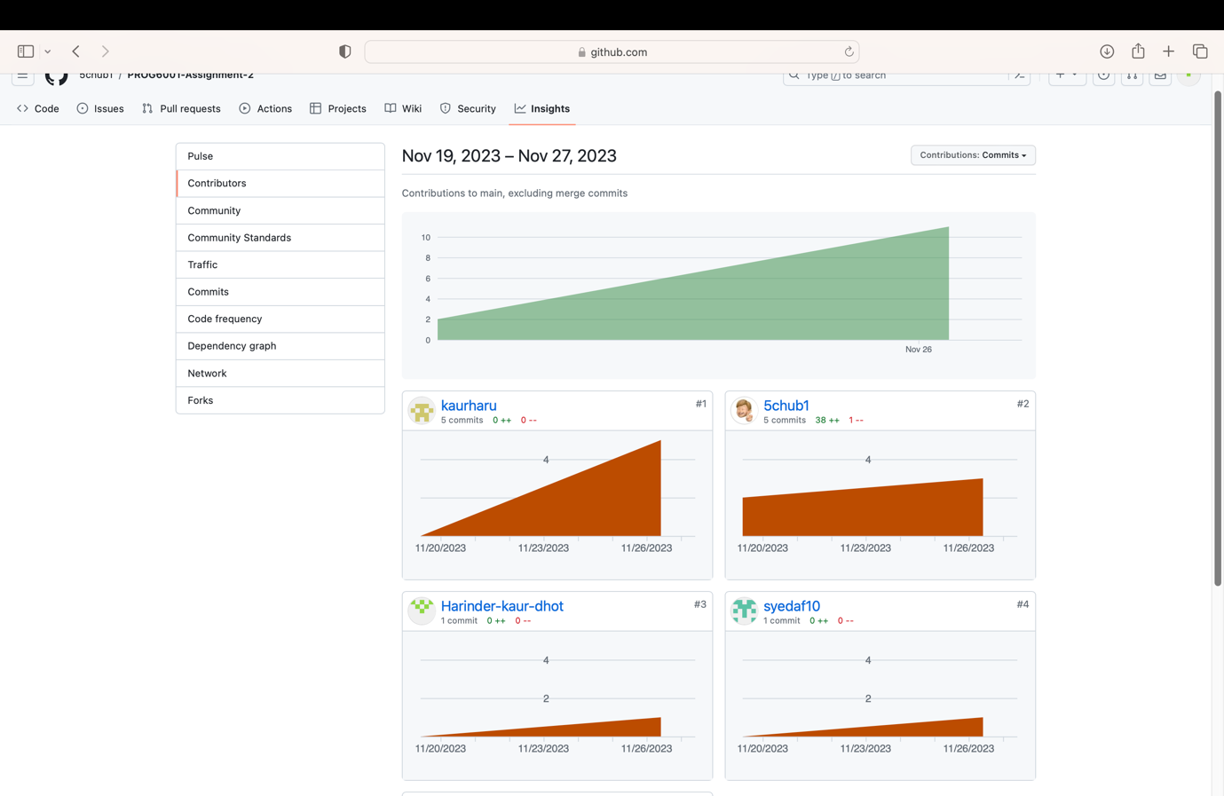

**Commits by Harinder:**

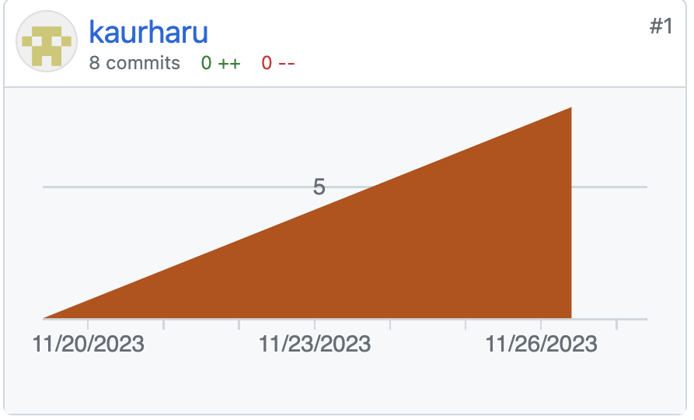

**Commits By Andre:**

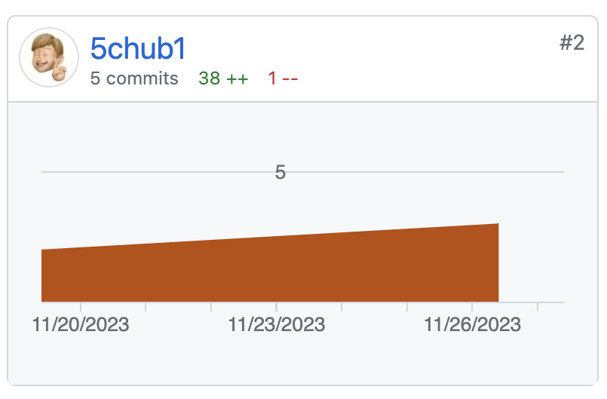

**Commits by Sayeda:**

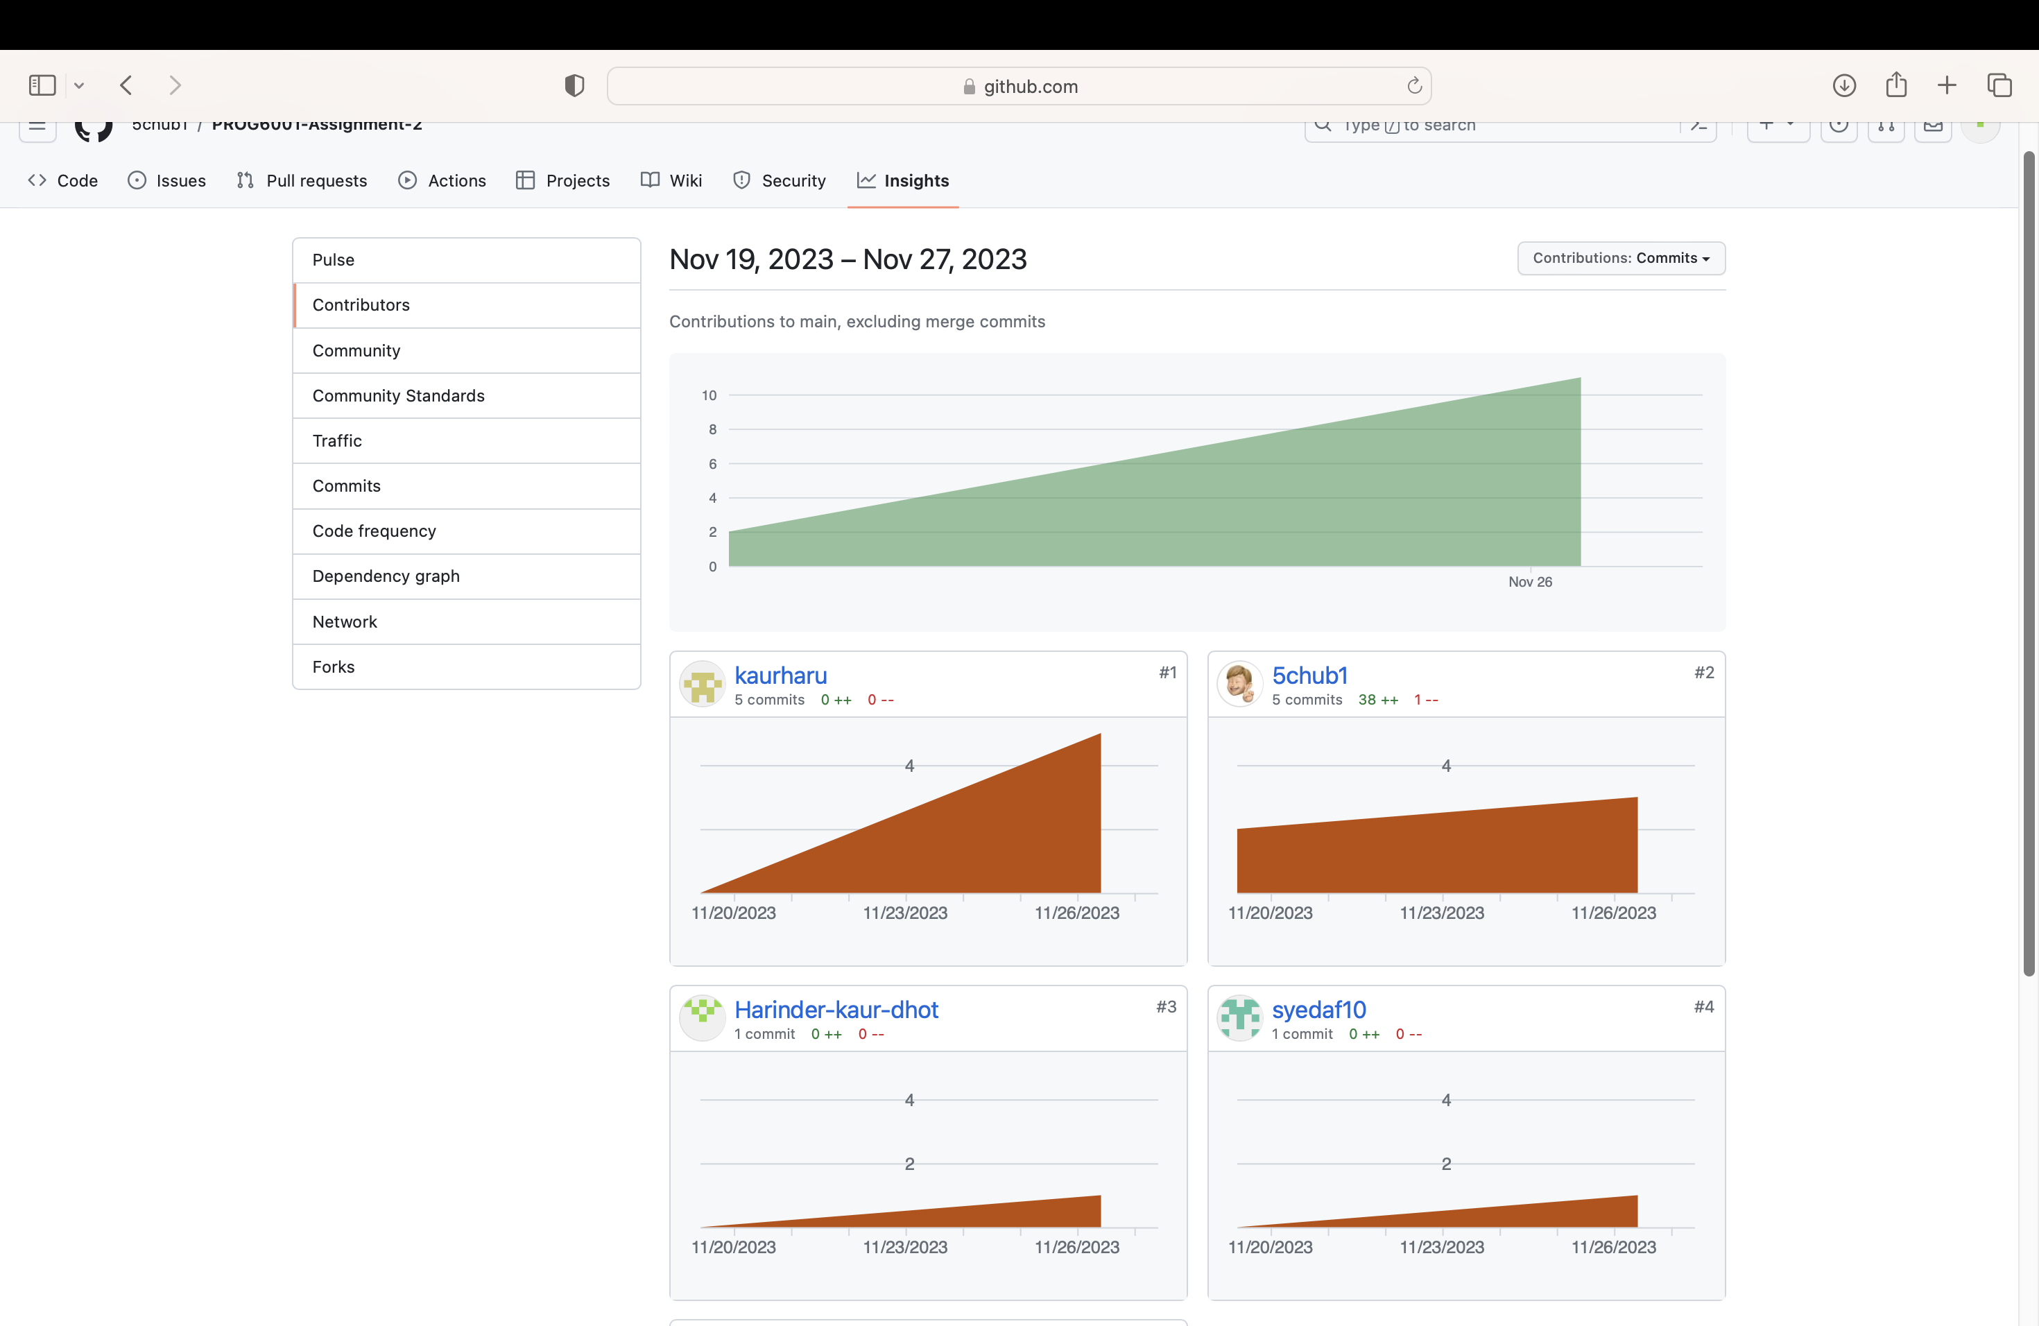

**Task 2**

**Request For Proposal: Business Management System**

**Proposal Due Date: 27 November 2023**

**Company Name: Aussie Business Buzz**

**Introduction**

ABB (Aussie Business Buzz) is a forward-thinking, customer-focused technology retailer and service provider dedicated to providing top-notch goods and services. ABB was founded to lead the IT sector and has progressively expanded to establish itself as a reputable brand. In addition to offering various technological items, such as PCs, laptops, phones, routers, and mobile accessories, ABB also provides excellent device repair services. Adopting a customer-centric strategy consistently aims to surpass customers' expectations, guaranteeing that they obtain high-quality items and a seamless and fulfilling purchasing experience.

**Basic summary of the project**

Aussie Business Buzz (ABB) is about to embark on a revolutionary initiative that will revolutionise company operations across four branch stores and provide scalability for future expansion: the implementation of an Integrated Business Management System. ABB's primary objectives as a top technology retailer and service provider are to improve customer experiences, optimise stock management, and streamline marketing initiatives.

**System description**

A unified and scalable system, the Aussie Business Buzz (ABB) Integrated Business Management System is intended to transform how ABB runs its business entirely. This system will be completely integrated with all ABB facilities, enabling targeted digital marketing, effective customer relations management, and optimised stock management.

**Customer Database:** Functionality: An organised database that holds all the information about a customer's past purchases, interactions, and device repairs.

Features include an all-encompassing perspective of customer contacts, task details, and trouble report handling.

**Marketing System:** Personalised campaigns using customer data through digital marketing abilities. Features include social media outreach, customised email campaigns, and integration with the ABB website to collect information about potential customers.

**Stock Management System:** Automate wholesaler orders, track products for sale, and manage components for maintenance. Provide cross-location product and part lookup functionality to enhance inventory control.

**Supervisory Records**: Create management reports that can be accessed from anywhere to track the state of marketing initiatives, stock management, and customer relations. Encourage making well-informed judgements about hiring employees, placing orders for supplies, and other managerial matters.

**Additional Components**

**Employee management:** This feature allows you to manage employee data, such as jobs, scheduling, and performance reviews. Features for managing employees more effectively, such as time tracking and attendance.

**Financial Management:** Creating financial reports and monitoring sales and expenses through integration with financial systems. Capabilities for billing and invoicing both goods and services.

**Customer Review and feedback:** Include a feature that allows customers to leave comments and reviews about the goods and services they have used. Examine consumer mood to obtain information for ongoing development.

**Primary Goals**

**Setting Up an Integrated Business Management System That Is Scalable and Seamless:**

The main purpose of this request for proposals is to gather ideas for creating, designing, and implementing an all-inclusive integrated business management system for ABB. Thus, ABB hopes to optimise operations across a few sites by combining customer interactions, marketing, stock management, and supervisory records into a single, scalable system. The main objectives are improving managerial decision-making, customer satisfaction, and operational efficiency.

**Secondary Goals**

1. **Promote Future Development and Growth:**

Ensure the suggested system is flexible and scalable to support ABB's planned expansion into new areas. Thus, ABB wants to future-proof its operations by putting in place a system that can expand with the company and handle significant disruptions.

1. **Improve Customer Engagement and Marketing Strategies:**

Boost ABB's marketing initiatives using the integrated system to run individualised and focused digital marketing campaigns. Hence, by employing efficient marketing techniques via the integrated system, ABB hopes to improve its reputation, draw in new clients, and cultivate enduring connections.

**Scope of Work for Aussie Business Buzz**

**1. Initialise the Project:** Organise a meeting for the project to create a clear communication plan and expectations. Create a project plan that details the deliverables, schedule, and important milestones.

**2. Specification and requirement:** Ask ABB stakeholders to conduct a thorough study of the needs of the business. Provide comprehensive requirements in writing for the marketing system, stock management system, supervisory records, and customer relations database.

**3. Design of the System:** While designing the system, make sure it is both scalable and compatible with ABB's current systems. Create user interface and wireframes to demonstrate the suggested design.

**4. Progress:** Execute the stock management system, marketing system, customer relations database, and supervisory records capabilities in accordance with the predetermined guidelines. Create any required linkages between the ABB website and other current systems.

**5. Testing:** Thoroughly test the integrated system to find and fix any flaws or problems.

With ABB stakeholders, do user acceptability testing (UAT) to make sure the system satisfies the requirements.

**6. Execution:** Install the integrated system in every ABB location to minimise disruptions to regular business activities. Keep an eye on any post-implementation problems and take quick action.

**Evaluation of the proposal**

Broad coverage of solution: The degree to which the suggested solution satisfies every condition stated is known as the solution's comprehensiveness. A thorough evaluation of how well the proposal handles reporting, marketing, stock management, and customer relations features.

**Scalability:** The system's capacity to grow along with ABB's intended future expansion. Evaluation of the suggested architecture and the characteristics that allow for scalability without sacrificing efficiency.

**Integration Capability:** The system can work with other systems already in place, particularly the ABB website. Compatibility with ABB's present technological stack, flexibility for future integrations, and examination of the suggested integration mechanisms.

**Innovation:** Adding novel features or methods above and beyond the called-for specifications and finding and evaluating special features, technologies, or development processes suggested by the vendor to improve the system.

**Cost-effectiveness:** Total cost, which considers creation, implementation, and continuing upkeep. A thorough pricing analysis that considers the value provided by the features, scalability, and innovation supplied.

**Experience and Performance History:** The vendor's history of fulfilling customer expectations and their experience in providing comparable solutions. Examination of completed projects, customer endorsements, and the vendor's standing within the sector.

**Cost Analysis**

The cost for this ABB can be evaluated by assuming the budget at different stages of the software development cycle.

**Development Costs:** These comprise costs for the real work of developing the integrated system, such as coding, software development, and customisation. Indicate whether the development expenses include any future upgrades or enhancements or whether they simply cover the original development.

**Costs of Testing:** Budget for testing activities, such as user acceptance testing (UAT), quality assurance, and any necessary software licences or testing equipment. Ensure comprehensive testing is considered to find and fix any problems before system release.

**Implementation Costs:** Expenses related to implementing the integrated system at every ABB site, including installation fees for any required hardware or software.

**Potential Barriers/ challenges and their solutions**

1. **Integration Complexity:** Obstacle: Due to disparities in technologies, data structures, or protocols, integrating the suggested system with the current ABB website and other systems may be difficult. This obstacle can be addressed with the help of comprehensive information about present systems, compatibility requirements, and a commitment to collaborate closely with the current infrastructure.
2. **Difficulties in Data Migration:** Moving data from outdated systems to newly integrated ones can be difficult and involve possible problems with format, consistency, and integrity. Clearly state expectations and requirements for data movement. Work closely with the vendor to create a solid plan for moving the data.
3. **Resistance to User Adoption:** ABB employees' unwillingness to adjust to the new technology, particularly if it materially alters current workflows. To foster support and address concerns, incorporate thorough training programmes, employ transparent communication techniques, and include important stakeholders early in the process.

**ABC XYZ**

**Project Manager**

**Aussie Business Buzz**

**Task 3**

# Overview of the Agile mindset

This is how advocates simply approach a project. Some of these are teamwork, strength, the ability to grow and learn, pride and importance, the ability to consider all options, and the ability to work together. Traditional methods, such as waterfall development, which takes between reasonable billing and final approval, are irrelevant to the customer. Then, when the final framework is delivered to the client, it fails to meet the client's standards in many ways (Ashraf, 2017). As a result, agile development measures have been developed to overcome environmental management challenges. It is crucial for customers to remember to generate leads. The main goal of an agile development process is to improve operational efficiency by encouraging customer collaboration and successful testing. Programming and hierarchical programming are combined using Extreme Programming (XP), the most famous agile programming technique. As these trends change from day to day, so does the management of the program.

## Characteristics of Agile Process

In cooperation with American partners, it was determined that the most important feature of the development plan is to reduce the development length. Time becomes one of the nine characteristics of the fast cycle to show its importance (Paruch, Stray, & Blindheim, 2020):

1. Modality – an essential part of any critical cycle. It divides the cycle into exercises. The product development process shows many ways to implement the product concept.
2. Iterative – Lean programming practice believes in making mistakes before everything is perfect. So, they expect a short cycle. A series of activities are performed in each period.
3. Repetition is the best way to organise products because you are short on time. Each weight can be limited to time (usually a month and a half) and adjusted accordingly.
4. Modesty – Agile cycles offer a new way to measure time constraints in a development program. Tracking conflicting events that cannot be done in a fast-paced environment puts pressure on productivity (Ashraf, 2017). This causes congestion and is not good.
5. Adaptive – During the crisis, new threats appear, requiring some previous actions. The flash changes the circuit to compensate for these new possibilities.
6. The agile cycle does not try to develop the entire system at once. Bring up. At the same time, it divides the non-core building into parts that can be built similarly but at different times and prices.
7. Consolidation – Consolidation means that we have enough to deal with any threat that needs to be addressed. Therefore, the system is close to the reality that we are looking for in all critical factors.

# Agile Mindset vs Waterfall Process

Agile is a management team strategy that involves breaking down sales into small tasks and continuously monitoring and planning for change. The word "water" can refer to a steady flow of water or a stream. A cascade model is developed through the stages of collection, analysis, design, improvement, testing, preparation, and validation (Fagarasan et al., 2021). The concept of creating a tree slide template follows a similar pattern. This method reduces the risk that the plant is complete and has a working process. The project process should be broken down into several steps as separate efforts, and each step should be done once in the SDLC according to the Waterfall definition. However, the agile process can be seen as a collection of activities that only focus on different levels of work, customer feedback, and assurance meetings (Miler and Gaida, 2019).

# Scrum Process and the Waterfall Methodology

Scrum is less robust than XP because it uses different management systems. This makes it easy for large enterprises to adopt and can be very useful for small businesses. It starts with the owner talking to partners and customers (Mora et al., 2021). The owner of the item can add a collection. Manufacturing is a well-designed cycle that includes all the expected functions. Sprints usually last from two weeks to several weeks. In the sprint configuration, there is a sprint that contains the description required for the current sprint. Partners hold small daily meetings to plan their development (Ashraf and Aftab, 2017). The scrum pro monitors all progress and sprint goals. After the competition, the scrum team welcomes the owners and partners to the competition, where they evaluate the results together. Scrum helps customers deliver the best possible user experience.

# Guidelines for Choosing Scrum or XP according to Types of Project

Smart-tech Auto Services (SAS) is a start-up that allows customers to order hardware and software to tag IoT devices. To achieve this, the organisation should adopt the XP process, but it is important that Scrum is suitable for the job. The following factors support the choice of methods for all types of work: The success of an independent company is determined by its presentation and skills. Small business owners look to indoor practices to help them organise their workplace and make it more efficient and effective. Scrum makes them happen. Everyone contributed to this project, and I am thrilled with the project. Scrum helps employees work together and helps achieve this goal by allowing more excellent communication between employees and partners. XP is full of different things that are difficult to access. XP also has essential features that the audience doesn't see. The boats are divided into tasks and teams that finish in the competition. Completing this task shows the gander in action (Mora et al., 2021). The following is true due to common usage. Cooperatives spend a lot of time and money preparing XP. Before getting XP, the company had to prepare all development team members, including only the project manager, to follow Scrum.

# Agile Method Candidate for Adoption

Scrum is the best project management method for projects that need to change over time. Scrum is a change that may be appropriate in this situation. Customers need to change quickly after looking at different models, which makes change scrum important for web development and building flexible applications (Scrum: An Agile Process Reengineering in Software Engineering, 2020). Likewise, agile is ineffective for organisations that don't get the necessary changes. If your job requires you to build chunks or parts daily, Scrum is not the right choice. Therefore, scrum is unsuitable for all projects that cannot be planned. In this case, Kanban is the best project management method.

# Summary

Agile processes are generally more responsive to changing customer needs. Customers get many benefits from XP and Scrum compared to other skills, such as Kanban, Beautiful Stone, XP and Scrum. But looking at XP from the inside has a lot of cost, time, and reliability issues, to name a few. Considering this, Scrum is the most suitable process for both clients. Scrum is designed for highly ambiguous tasks, not highly ambiguous ones.

**Reference:**

Ashraf, S. (2017). IScrum: An Improved Scrum Process Model. *International Journal of Modern Education and Computer Science*, 9(8), pp.16–24. doi:https://doi.org/10.5815/ijmecs.2017.08.03.

Fagarasan, C., Popa, O., Pisla, A. and Cristea, C. (2021). Agile, waterfall and iterative approach in information technology projects. *IOP Conference Series: Materials Science and Engineering*, [online] 1169(1), p.012025. doi:https://doi.org/10.1088/1757-899x/1169/1/012025.

<https://blog.hubspot.com/marketing/rfp-template>

Miler, J. and Gaida, P. (2019). On the Agile Mindset of an Effective Team – An Industrial Opinion Survey. *Proceedings of the 2019 Federated Conference on Computer Science and Information Systems*. doi:https://doi.org/10.15439/2019f198.

Mora, M., Adelakun, O., Galvan-Cruz, S. and Wang, F. (2021). Impacts of IDEF0-Based Models on the Usefulness, Learning, and Value Metrics of Scrum and XP Project Management Guides. *Engineering Management Journal*, pp.1–17. doi:https://doi.org/10.1080/10429247.2021.1958631.

Scrum: An Agile Process Reengineering in Software Engineering. (2020). *International Journal of Innovative Technology and Exploring Engineering*, 9(3), pp.840–848. doi:https://doi.org/10.35940/ijitee.c8545.019320.