**ANGULAR JS – ROUTING**

**Overview:-**

HTML is great for declaring static documents, but it falters when we try to use it for declaring dynamic views in web-applications. AngularJS lets you extend HTML vocabulary for your application. The resulting environment is extraordinarily expressive, readable, and quick to develop.

If you want to navigate to different pages in your application, but you also want the application to be a SPA (Single Page Application), with no page reloading, you can use the ngRoute module.The ngRoute module routes your application to different pages without reloading the entire application.

**Requirements:-**

Browser support:- Angular supports most recent browsers. This includes the following specific versions:

|  |  |
| --- | --- |
| Chrome | latest |
| Firefox | latest and extended support release (ESR) |
| Edge | 2 most recent major versions |
| IE | 11, 10*, 9* ("compatibility view" mode not supported)  *deprecated in v10 |
| IE Mobile* | 11  *deprecated in v10 |
| Safari | 2 most recent major versions |
| iOS | 2 most recent major versions |
| Android | X (10.0), Pie (9.0), Oreo (8.0), Nougat (7.0) |

**Design Structure:-**

For the better understandability in this projects we use some techniques and different tools as follows

**1.Folder structure**

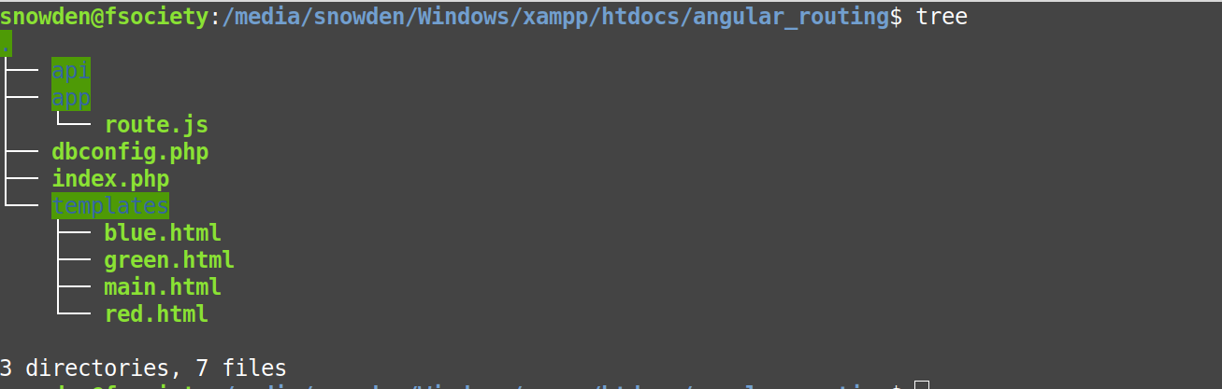

**2.Browser**

* chrome (latest)

* Mozilla Firefox (latest) // recommended

**3.Operating System**

*linux (ubuntu or any)

*windows (8 or above)