Home Page Tabs:

About Us
Invest
-Drop down
->How it works
->Options

Resources
-Drop down
->Why Fractional?
->Why Commercial Real Estate?
->FAQs
->Knowledge Center

Insights

And on the right hand side corner—Sign up/JOIN

Centre of Home Page:

INVEST IN THE NEW WAVE OF REAL ESTATE
ACCESS INSTITUTIONAL LEVEL QUALITY DEALS
InvesAt in a portfolio of professionally-curated commercial real estate in mina

utes.

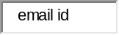
GET STARTED

Below that:
EXPLORE OPPORTUNITIES BEYOND TRADITIONAL.
Diversify with thoroughly vetted commercial real estate, potentially generating income and appreciating assets.
ACCESS
PROPERTIES/OFFERINGS.
INVEST
IN REAL ESTATE FRACTIONAL Ownership assets.

EARN
monthly rentals and capital appreciation.

Below that:

What We Do
A proptech platform that provides users with to institutional quality commercial real estate Investment Options
Access
Thoroughly Vetted commercial real estate with 7-10% yields and 14-20% IRRs
Liquidity
Easy exit option through fractional ownership
Asset Management
Manage Leasing and Selling of assets with thorough market knowledge and network
JOIN NOW

Our Partners / Advisors
We work with some of the most well-known names in the industry.
- Accounting & Structuring Advisor
- Auditor
- Bankers

Testimonials

Footers with the following option

COMPANY
Our StoryContact UsCareersPress
INVEST
Benefits of InvestingHow It WorksInvestment OptionsAuto Invest

RESOURCES

Knowledge CenterWhy Commercial Real EstateWhy REITsWhy Multifamily1031 ExchangeRetirement InvestingDue DiligenceFAQsGlossary

.

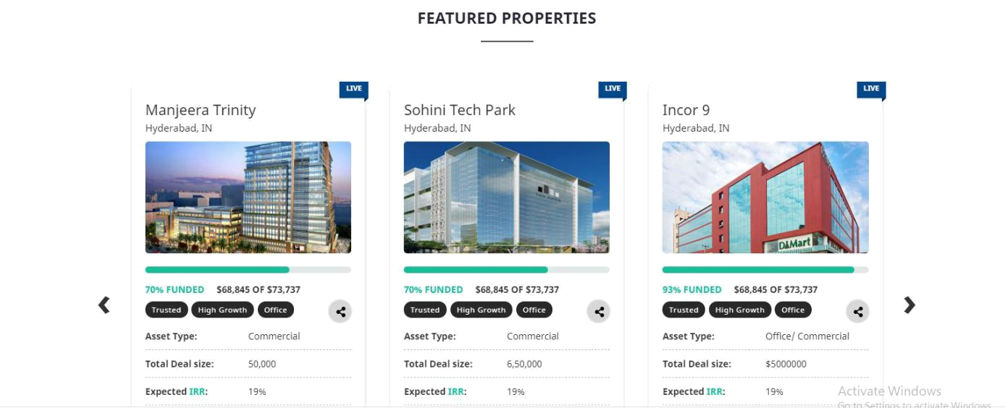

Property Detailed Page :
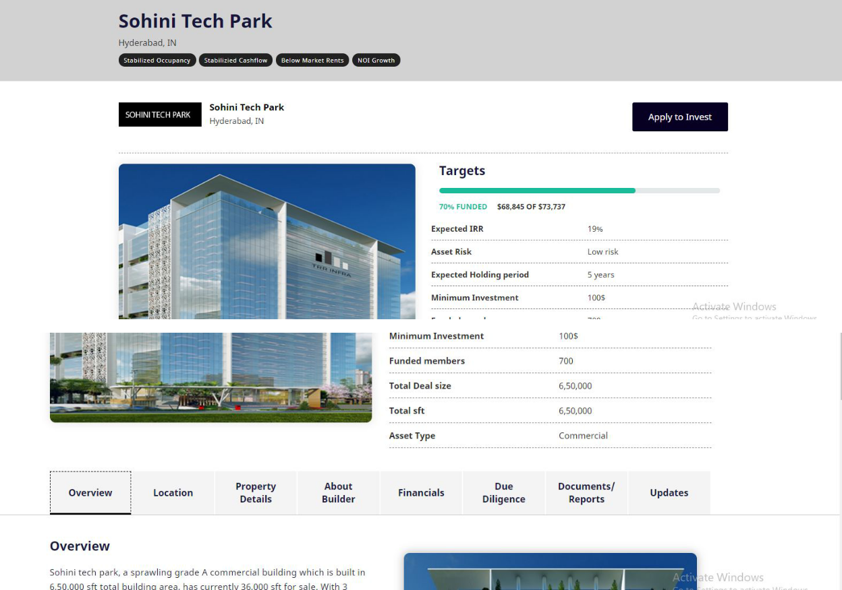

Overview:
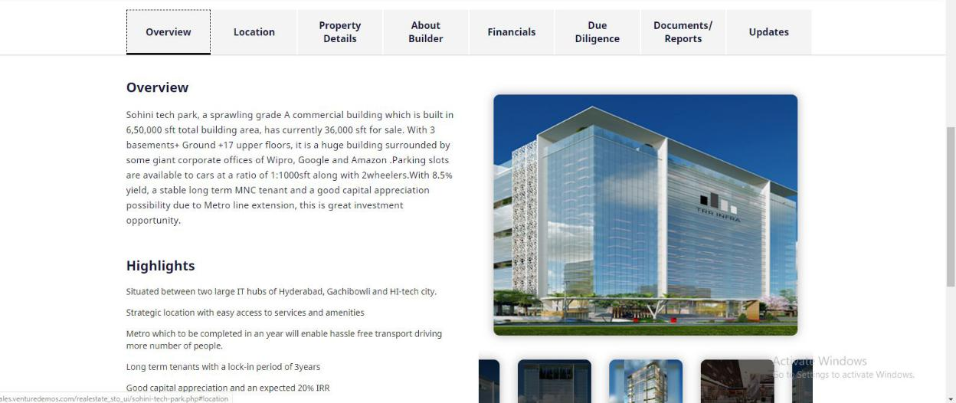

Location:
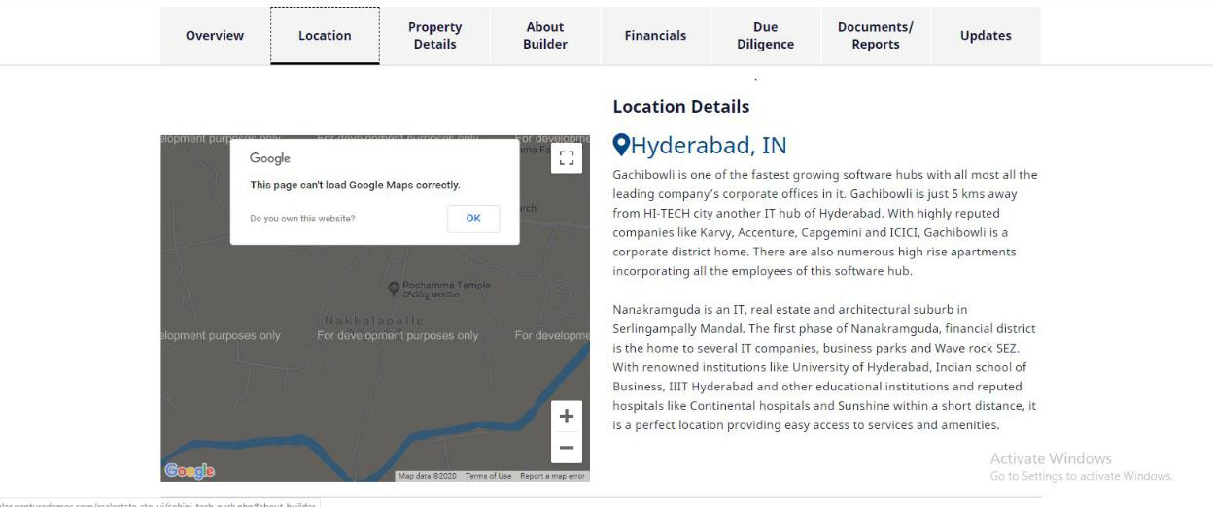

Property Details:
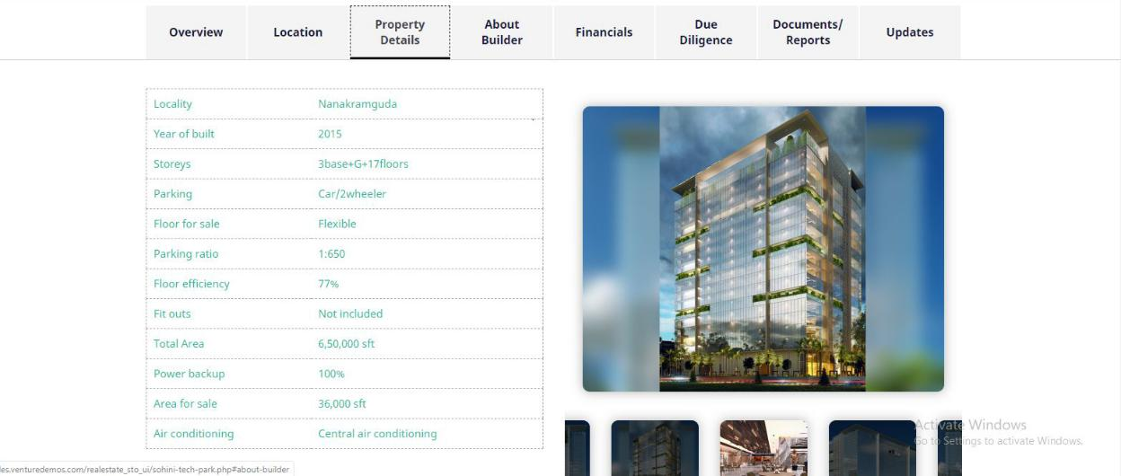

Financials :
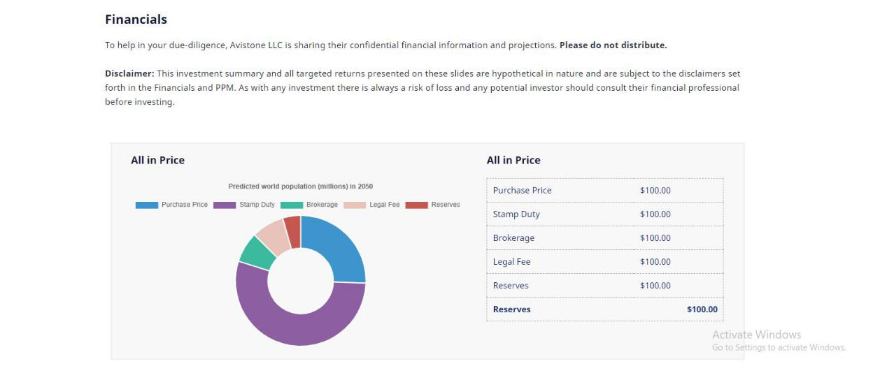
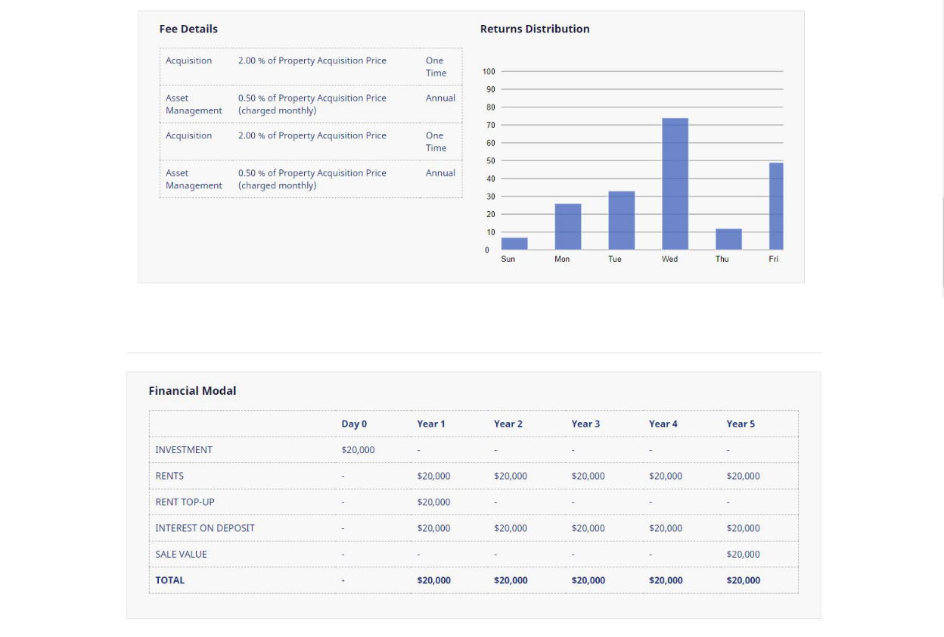

Due Diligence:
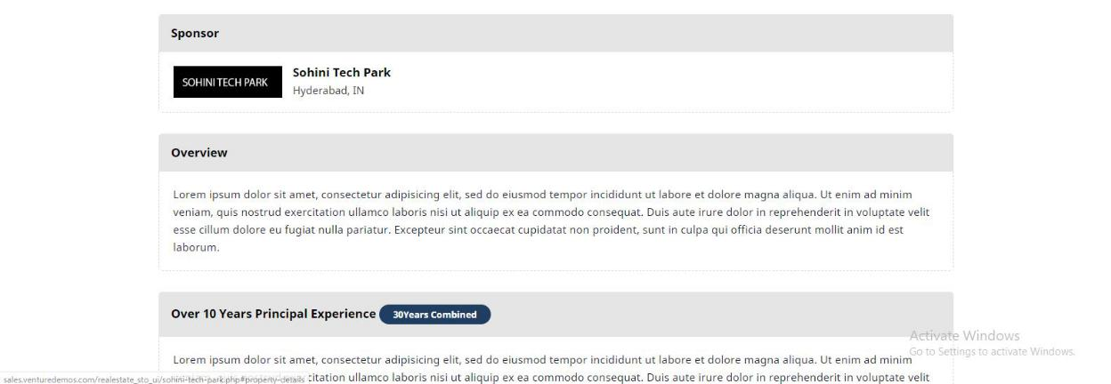
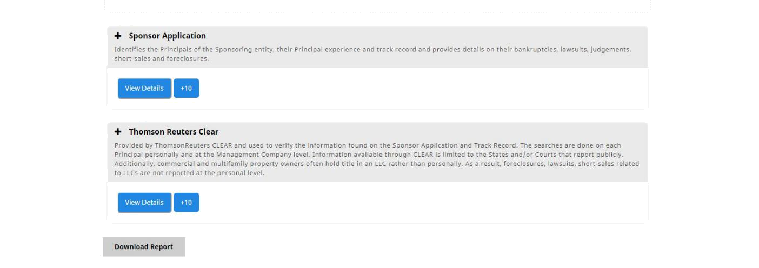

Document Report:
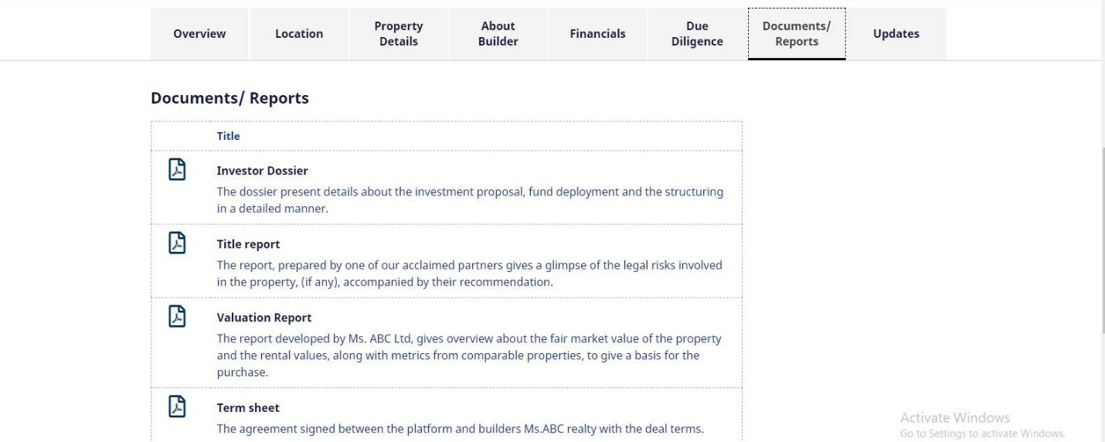
Updates :
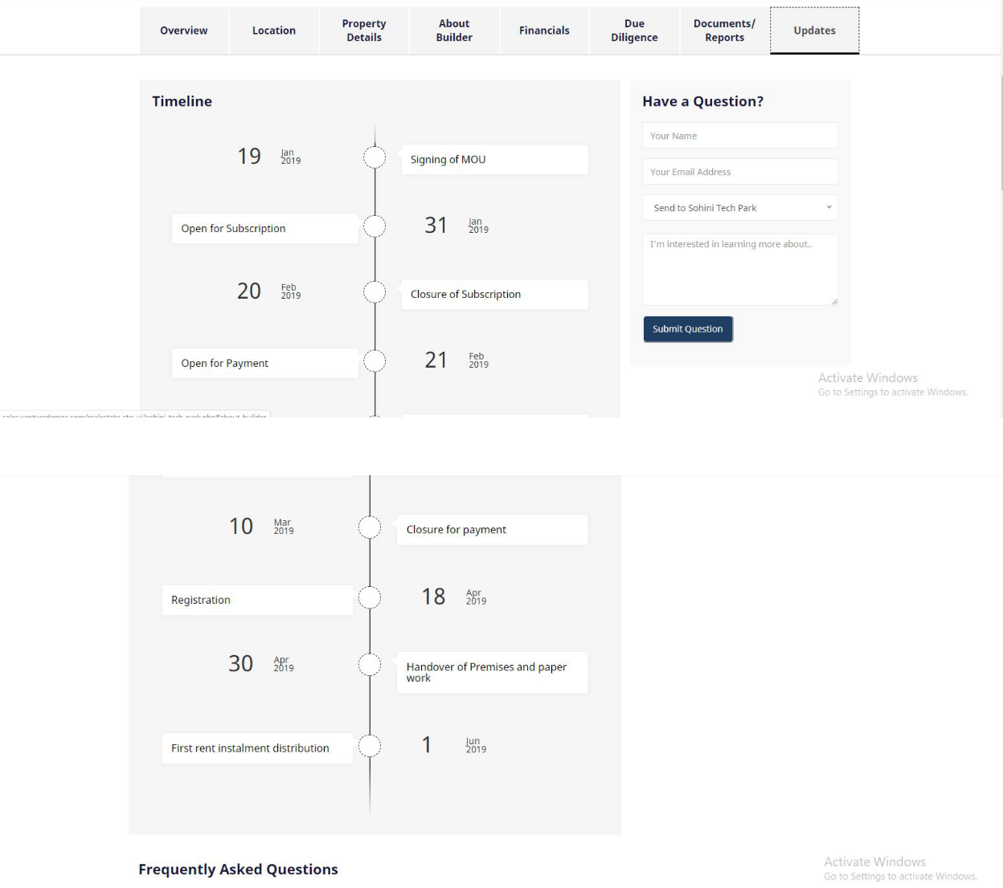

User Profile :
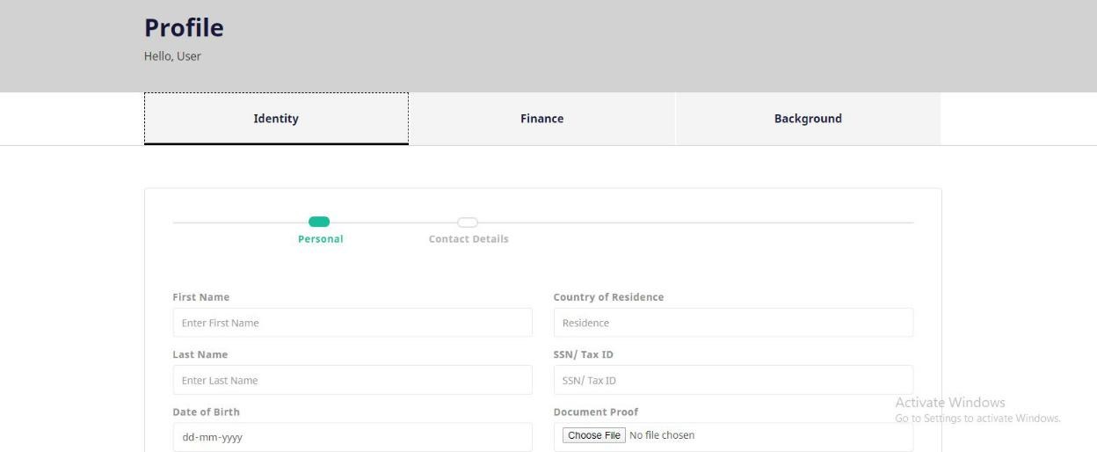
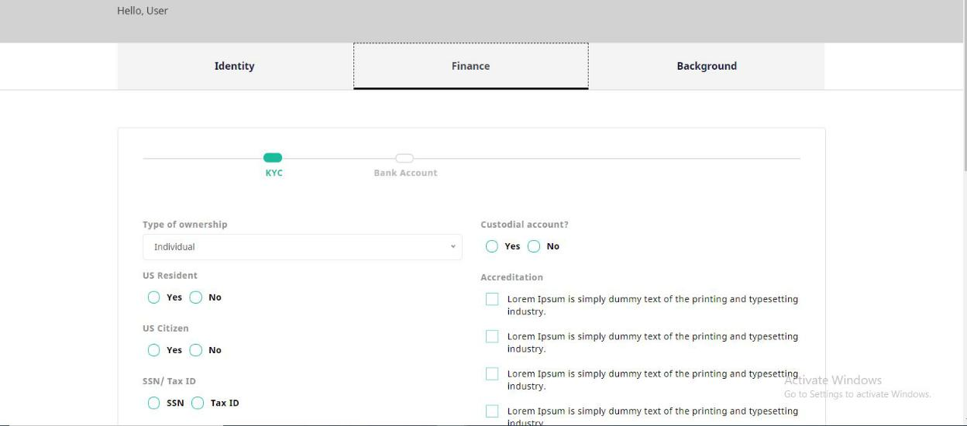
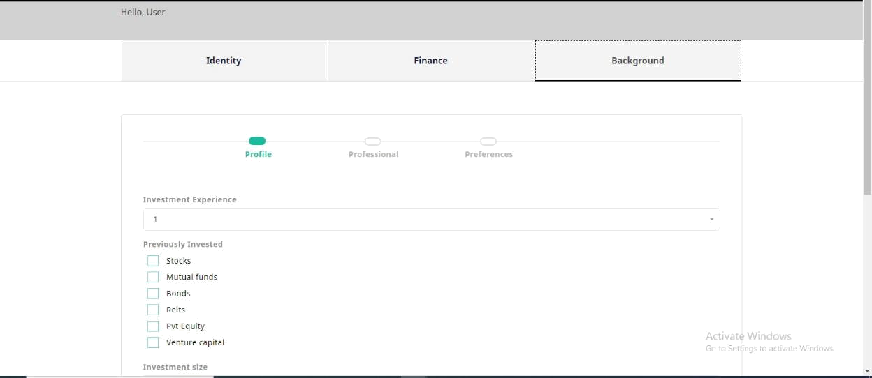

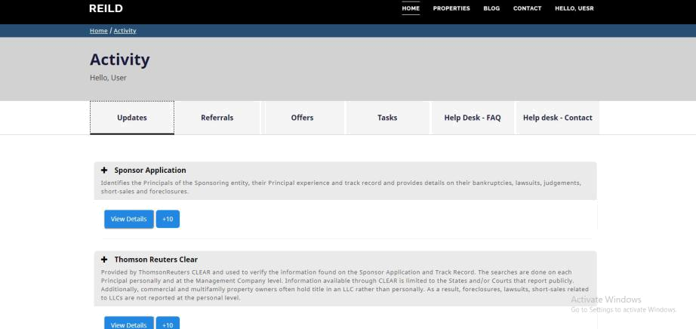

Investor Dashboard

Register/Sign Up
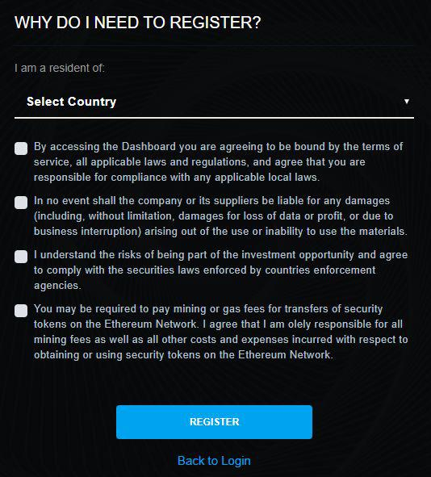

Investors who are interested to register into the platform need to select their country and checkboxes available on the registration page.

All the checkboxes are mandatory as they have legal terms and conditions.

If the user has already registered then he/she can click on the registration button.

Login

- Once the registration process gets over, Investors can sign into the application using their email and password.

- Email and password are mandatory.

- Password restrictions can be customizable. It has mandatory restrictions like Asterisk, capital letter etc

- If the user forget the password, he/she can recover the password using the forgot password button

- On clicking the forgot password button he/she will be redirected to a new screen.

- A password reset link will be sent to their registered email and they can reset the password.
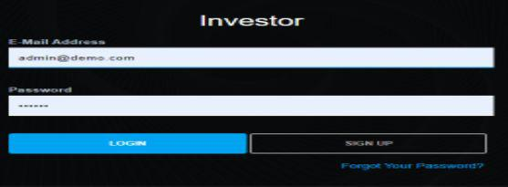

Dashboard
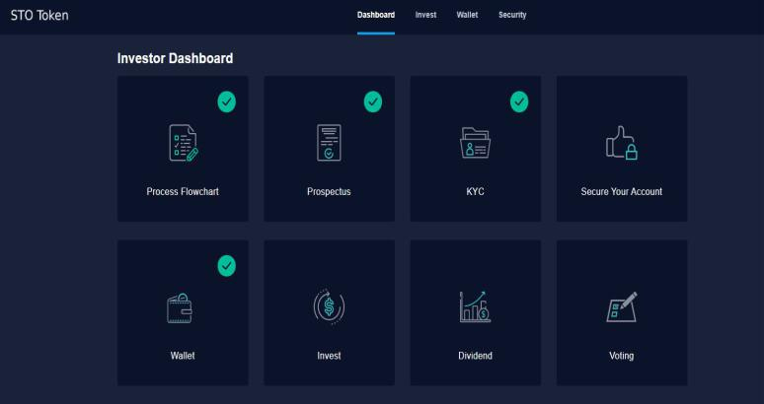

Users can view the dashboard after successfully entering the login credentials. If they fail to enter the correct credentials, they will not be directed to this screen.

The features of an investor dashboard include the following,

- Process Flowchart

- Prospectus

- KYC

- Secure Your Account

- View List of Properties

- Property Details

- My Earnings

- Investments

- Tax

- Invest

- Dividend

Process Flowchart
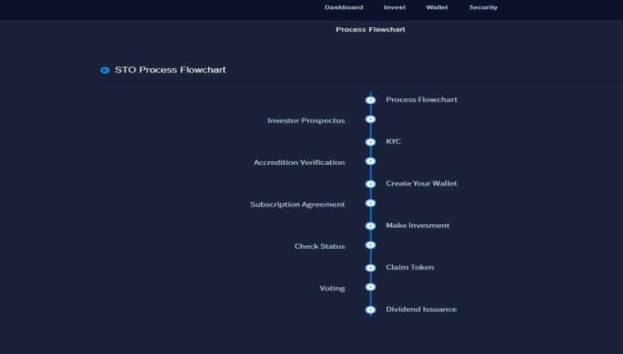

Process Flowchart act as a guide for the users of the platform by providing direction on how to invest in a the properties on this platform

Prospectus
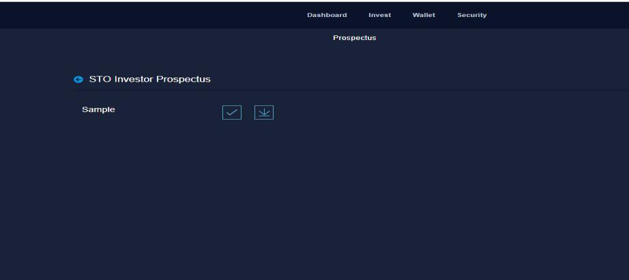

Prospectus contains facts about the Property, management, finances, legal obligations, etc. The platform will show a tick mark once the user has downloaded the prospectus. Previously known as a whitepaper, the owner’s manual will consist of the following:

- Legal Disclaimer
- Letter to Investor

- Executive Summary

- Problem Statement

- Solution

- Team

- Conclusion

Prospectus will be uploaded by the admin in the admin panel.

KYC
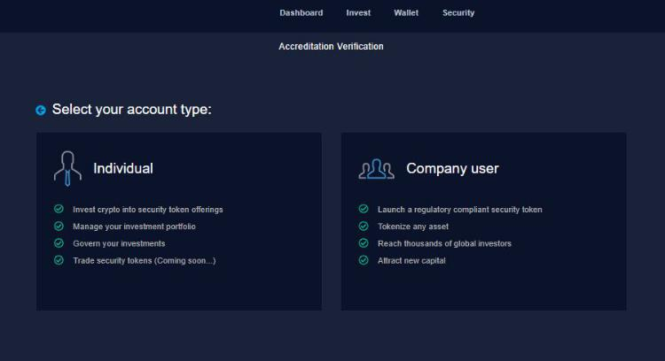

KYC is mandatory for any investor to invest his/her funds in an STO.

KYC will be done to verify the investors of the platform. Investors will be either an individual or a company users.

If the investor is an individual, they need to enter the following details:
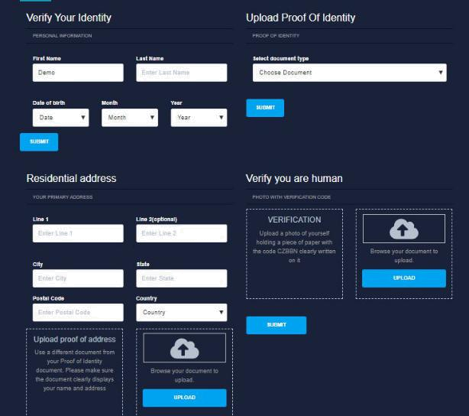

- Personal Information

- Proof of Identity

- Address

- Photo with verification code

- Third party KYC providers to verify the KYC.

- Accredited investor verification documents

If the investor is an company, they need to enter the following details:

- Company user information

- Name and Address

- Source of Funds

- Signing Authority

- Accredited investor verification documents
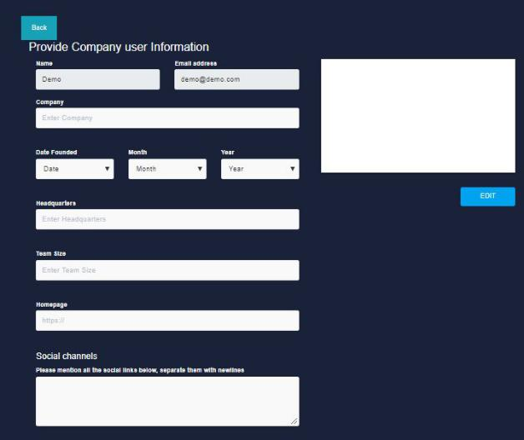

Both the investors and the company need to upload documents based on their jurisdiction.

Admin will be verifying the KYC details provided by the user or company. Only after the admin’s approval, users or companies will be allowed to invest on the platform.

As of now our platform has only manual KYC, If you require the KYC to be automated then you can include any third party KYC providers.

Secure your Account
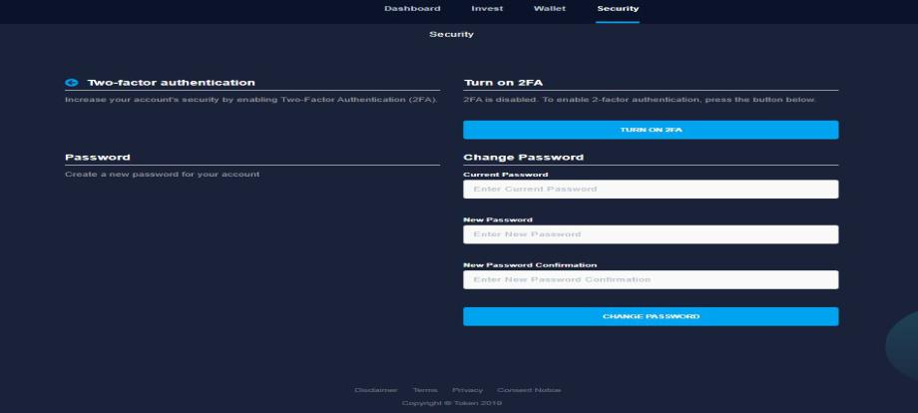

Investors need to download Google two-factor authentication applications on the mobile. It has the steps on how to enable the authentication process. After entering the details, they can choose “Enable Two-factor Authentication” on the platform. It will be redirected to the mobile where they can complete the authentication process.The investor needs to enter the current and new password to complete the authentication process.

By enabling the two factor authentication they can secure their wallets.

Invest
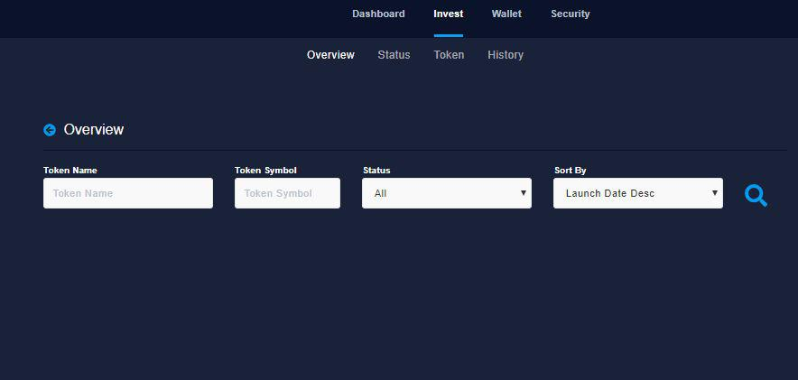

- Once the investors complete the KYC and authentication process, they are allowed to invest in the properties listed on the application.

- Here, the investors can view the list of properties and express inte

In this section, investors can view the details of the digital shares acquired by investing in projects available on the platform.

History

In this section, investors can view the digital share transaction history with details such as digital share price, count, total shares, payment amount, etc.

Withdraw

To withdraw the amount of money from the wallet, investors need to enter the amount and fiat currency type on the platform.

Dividend

In this section, investors can view the dividend received by them at different time periods. They can view the following information,

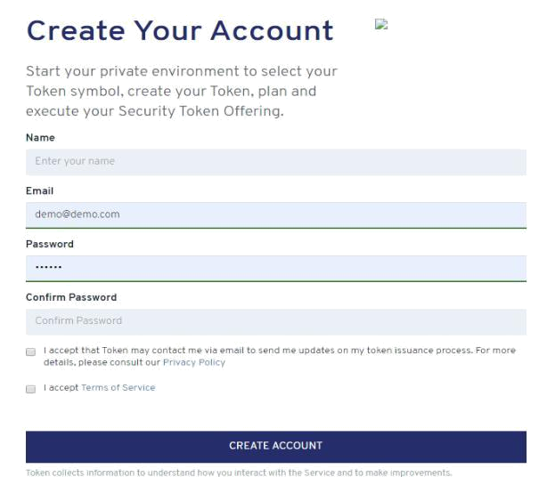

Issuers will be able to enter the following details such as name, email, password, etc., on the platform to complete the registration process.

Sign In
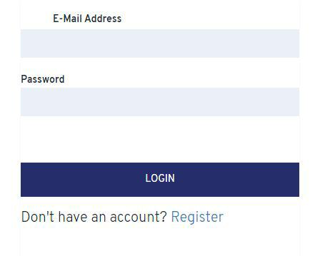

Issuers need to enter their Email address and password to sign into the application.

Dashboard
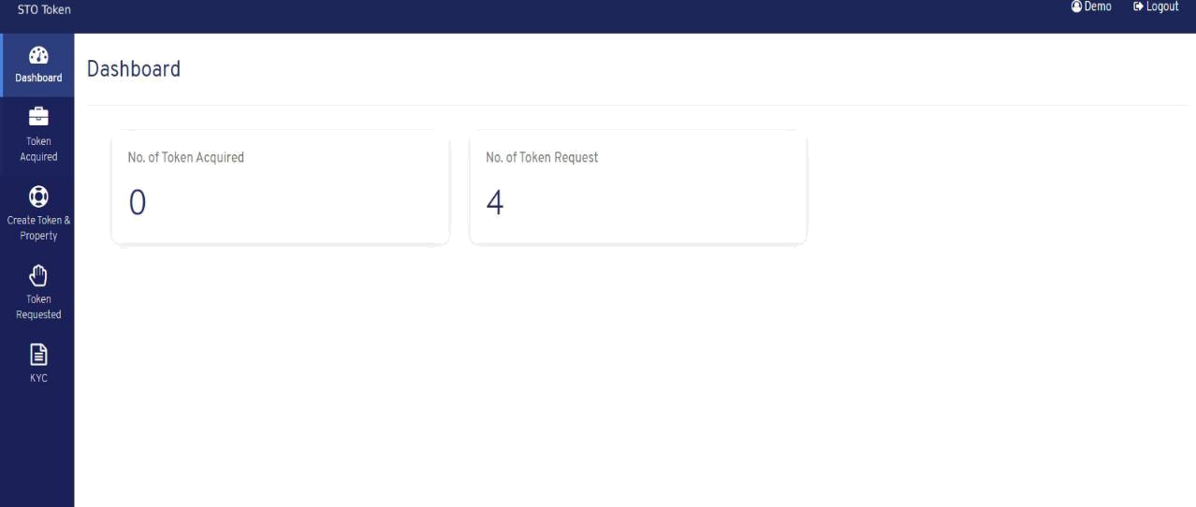

This section contains the list of digital shares acquired for a specific project. It contains details like share name, symbol, value, supply, contact address, action, etc

KYC
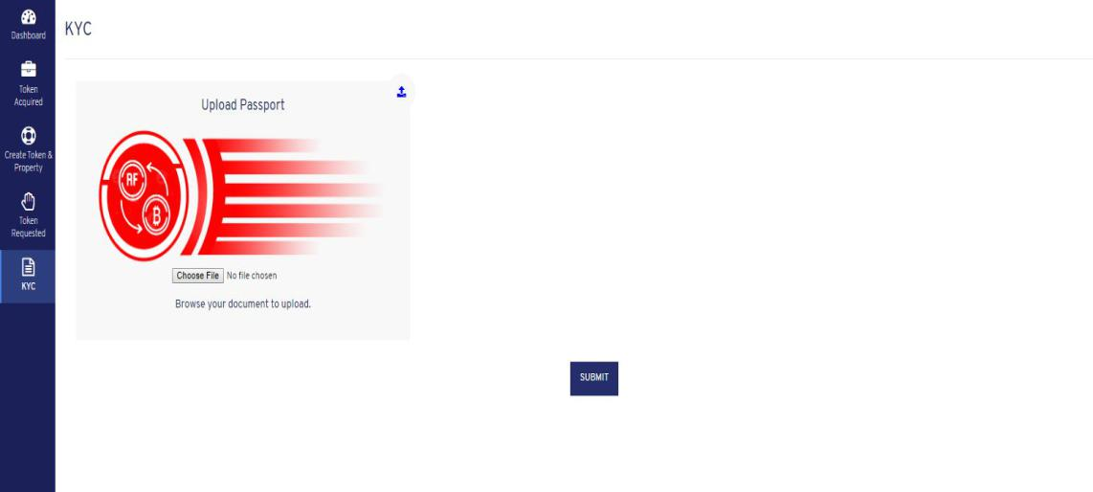

Investors need to upload the necessary KYC documents in the platform to list their securities. It is mandatory for all the issuers to fill their KYC and get it approved from the admin panel.

Admin Dashboard

Login
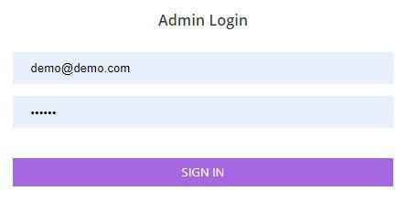

Admin will be able to log into the application using their email and password.

Dashboard

Admin will be able to view the KPIs set by them in the dashboard such as investors, issuers, di, projects, etc.

List Users
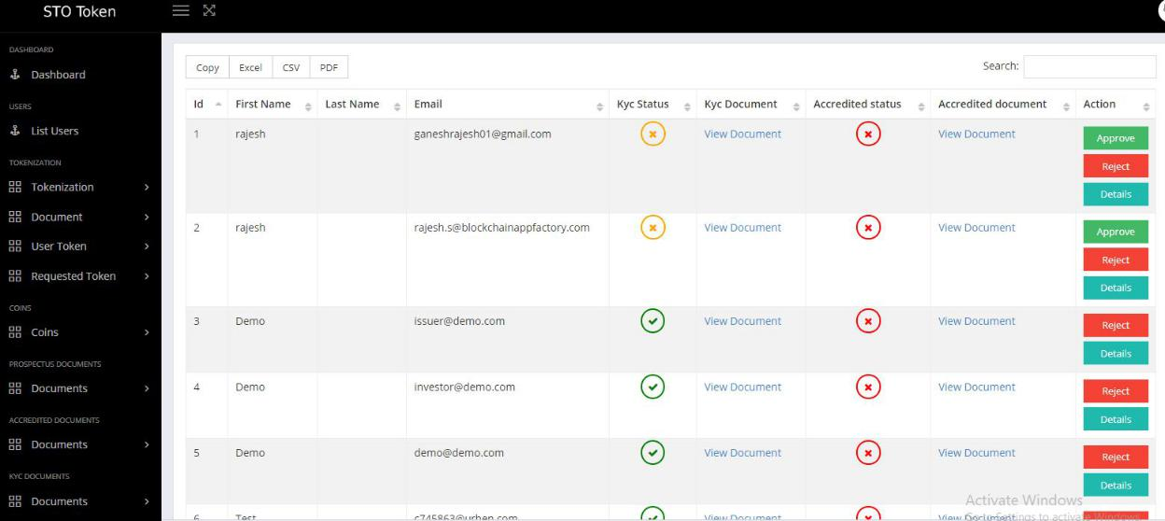

Admin can view the list of users present in the platform. They can check the following details of the platform,

- Name

- Email

- KYC Document

- Accredited Document

Admin can approve/reject the user's request for the platform. The user list can be downloaded as excel/CSV/pdf files.

Admin can view/edit/delete the accredited investor documents available on the platform. They need to enter the document name, document order, document file in order to add a new document in the platform.
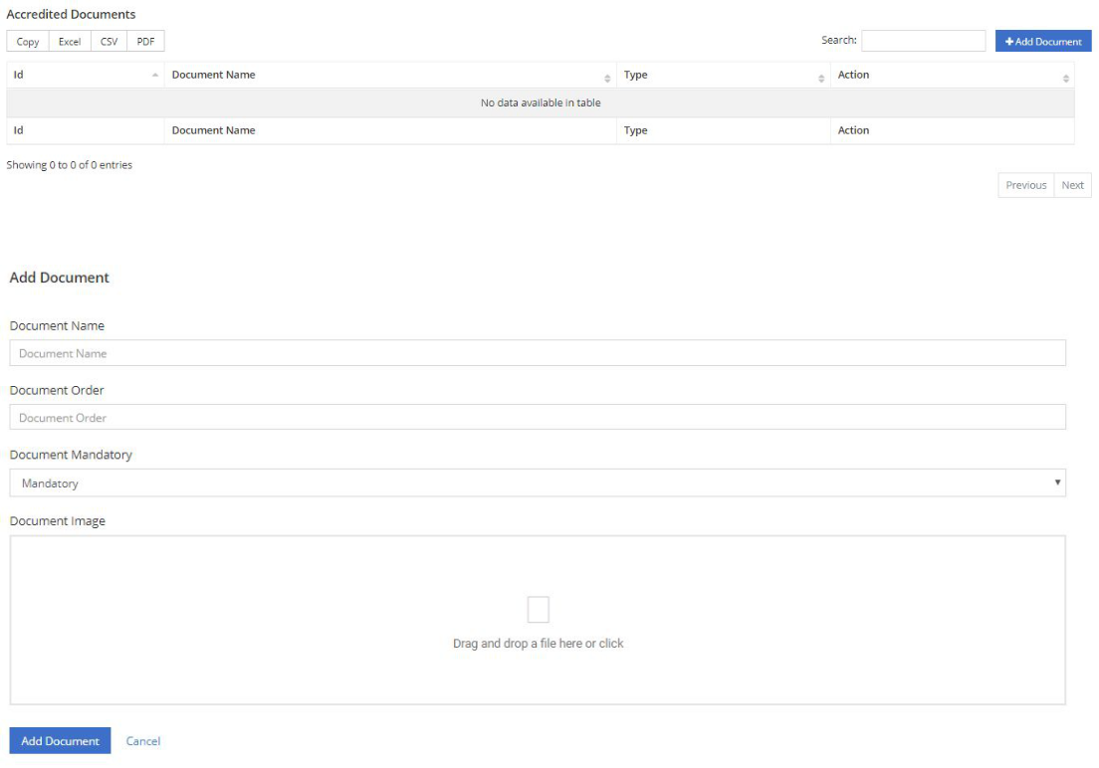

KYC

Admin can view/edit/delete the KYC documents available on the platform. They need to enter the document name, document order, document file in order to add a new document in the platform.
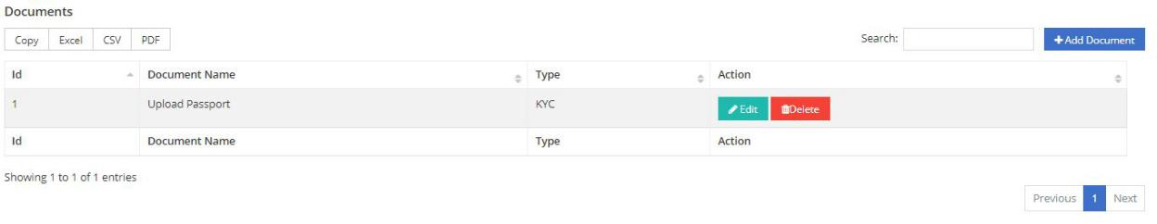
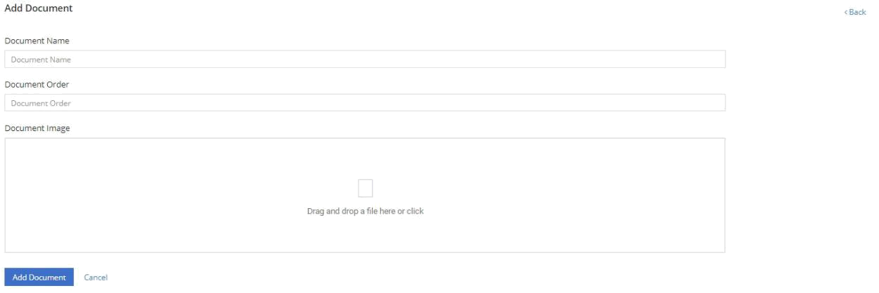

Site Settings

Admin can update the following site settings of the platform,

- Site name

- Site logo

- Site icon

- Copyright content

- Support & inquiry mail address

- Facebook/Twitter/Instagram URL
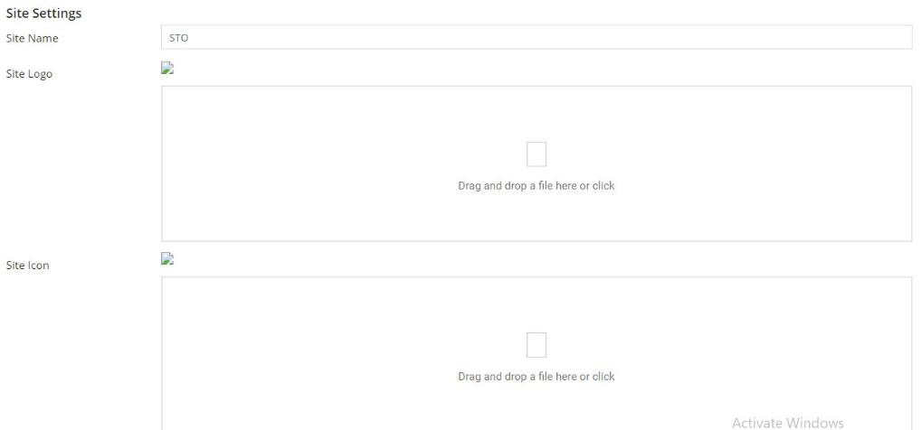

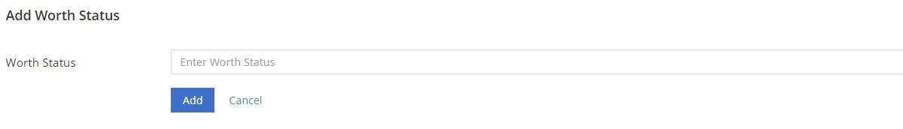

.

Others

Support

Admin will be able to add the support details of the platform. They also view the following details such as Id, email, title, description, status, etc.
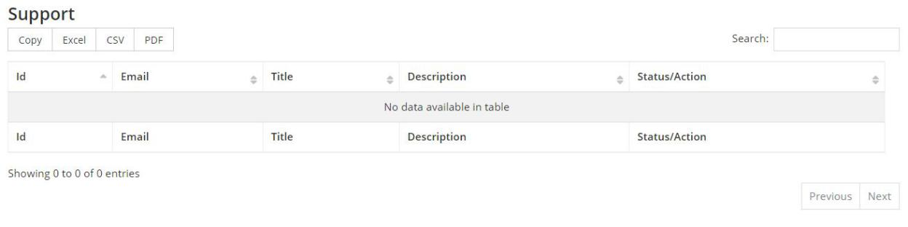

Privacy Policy & Terms and conditions

In this section, admin can add the contents of the privacy policy and terms & conditions on the platform.

Change Password

Admin can view and update the worth status of the projects available on the platform.




