# **SOFTWARE DESIGN DESCRIPTION**

COMPONENT DIAGRAM

[ChatSystem]++->[ChatGUI],

[ChatSystem]++->[ChatController],

[ChatSystem]++->[ChatNI]

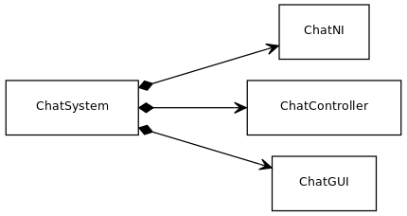

High level Decomposition diagram

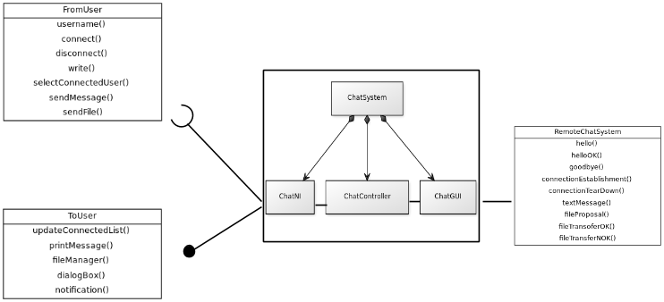

WhiteBOX Sequence Diagram

**LocalUser connecting SDD**

LocalUser->ChatGUI : username(LocalUsername)

LocalUser->ChatGUI : connect()

activate ChatGUI

ChatGUI->ChatController : performConnect(LocalUsername)

activate ChatController

ChatController->ChatNI : sendHello(LocalUsername)

activate ChatNI

ChatNI->RemoteChatSystem : Hello(LocalUsername)

ChatNI->ChatController

deactivate ChatNI

ChatController->ChatGUI

deactivate ChatGUI

deactivate ChatController

RemoteChatSystem->ChatNI : HelloOk(RemoteUsername)

activate ChatNI

ChatNI->ChatController : performHelloOk(RemoteUsername)

activate ChatController

ChatController->ChatGUI : addUser(RemoteUsername)

activate ChatGUI

ChatGUI->LocalUser : updateConnectedList()

ChatGUI->ChatController

deactivate ChatGUI

ChatController->ChatNI

deactivate ChatController

deactivate ChatNI

deactivate RemoteChatSystem

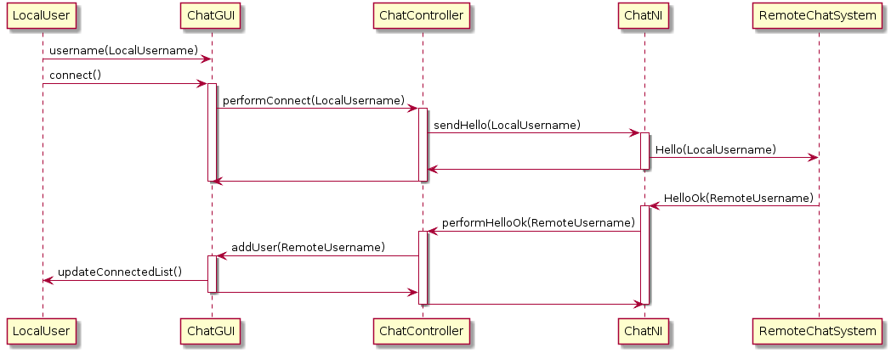

**RemoteUser connecting SDD**

RemoteChatSystem->ChatNI : Hello(RemoteUsername)

activate ChatNI

ChatNI->ChatController : performHello(RemoteUsername)

activate ChatController

ChatController->ChatGUI : addUser(RemoteUsername)

activate ChatGUI

ChatGUI->LocalUser : updateConnectedList()

ChatGUI->ChatController

deactivate ChatGUI

ChatController->ChatNI : sendHelloOk(string:username)

deactivate ChatController

ChatNI->RemoteChatSystem : HelloOk(string:username)

deactivate ChatNI

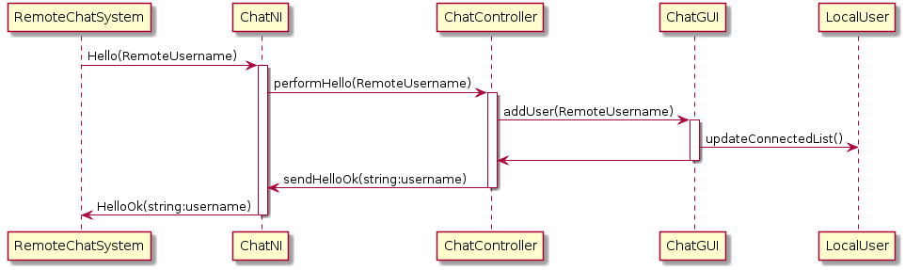

**COMMUNICATION**

**LocalUser sending text message SDD**

LocalUser->ChatGUI : selectConnectedUser(RName)

activate ChatGUI

deactivate ChatController

ChatGUI->LocalUser : DialogBox()

deactivate ChatGUI

LocalUser->ChatGUI : write(message)

activate ChatGUI

LocalUser->ChatGUI : sendMessage(message)

ChatGUI->ChatController : performSendMessage(message)

activate ChatController

ChatController->ChatNI : processTextMessage(message,Lname,Rname)

activate ChatNI

ChatNI->RemoteChatSystem : TextMessage(message,Lname,Rname)

ChatNI->ChatController

deactivate ChatNI

ChatController->ChatGUI

deactivate ChatController

ChatGUI->LocalUser : Notification()

deactivate ChatGUI

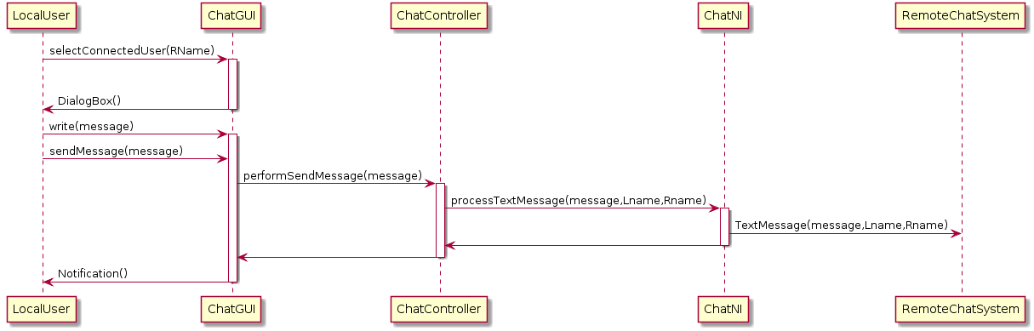

**RemoteUser receiving text message SDD**

RemoteChatSystem->ChatNI : textMessage(message,Rname,Lname)

activate ChatNI

ChatNI->ChatController : performTextMessage(message,Rname,Lname)

activate ChatController

ChatController->ChatGUI : processTextMessage(message,Rname)

activate ChatGUI

ChatGUI->LocalUser : PrintMessage(message,Rname)

ChatGUI->ChatController

deactivate ChatGUI

ChatController->ChatNI

deactivate ChatController

ChatNI->RemoteChatSystem

deactivate ChatNI

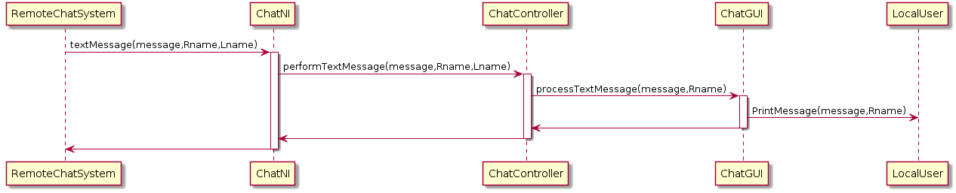

**LocalUser sending file(s) SDD**

LocalUser->ChatGUI : SelectConnectedUser(Rname)

activate ChatGUI

ChatGUI->LocalUser : DialogBox()

deactivate ChatGUI

LocalUser->ChatGUI : SelectFile()

activate ChatGUI

ChatGUI->LocalUser : FileManager()

deactivate ChatGUI

LocalUser->ChatGUI : SendFile(filename)

activate ChatGUI

ChatGUI->ChatController : performSendFile(file)

activate ChatController

ChatController->ChatNI : processSendFile(file,size,Lname,Rname)

ChatController->ChatGUI

deactivate ChatController

deactivate ChatGUI

activate ChatNI

ChatNI->RemoteChatSystem : ConnectionEstablishment()

ChatNI->RemoteChatSystem : FileProposal(filename,size,Lname,Rname)

alt accepted

RemoteChatSystem->ChatNI : FileTransferOK()

ChatNI->RemoteChatSystem : FileTransfer(file)

else

RemoteChatSystem->ChatNI : FileTransferNOK()

end

ChatNI->RemoteChatSystem : ConnectionTearDown()

ChatNI->ChatController : ProcessTransmitted(file,Rname,Transmitted)

activate ChatController

alt Transmitted

ChatController->ChatGUI : NotifyTransmitted(filename,Rname)

activate ChatGUI

else

ChatController->ChatGUI : NotifyNotTransmitted(filename,Rname)

end

ChatGUI->LocalUser : Notification()

ChatGUI->ChatController

deactivate ChatGUI

ChatController->ChatNI

deactivate ChatController

deactivate ChatNI

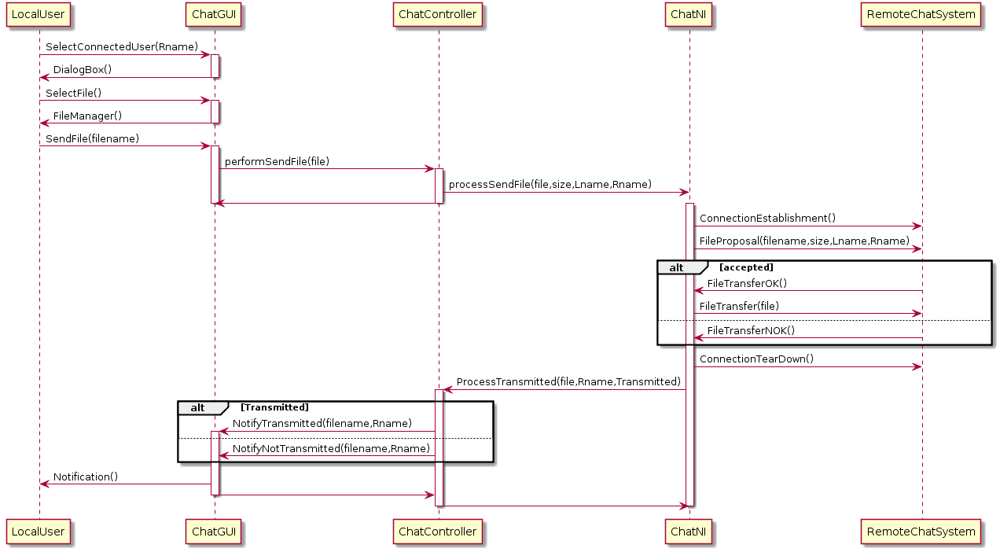

**RemoteUser receiving file(s) SDD**

RemoteChatSystem->ChatNI : ConnectionEstablishment()

activate ChatNI

RemoteChatSystem->ChatNI : FileProposal(filename,size,Rname,Lname)

ChatNI->ChatController : ProcessFileQuery(filename,size,Rname,Lname)

activate ChatController

ChatController->ChatGUI : PerformFileQuery(filename,size,Rname)

activate ChatGUI

ChatGUI->LocalUser : FileDownloadQuery(filename,size,Rname)

alt OK

LocalUser->ChatGUI : FileDownloadOK()

ChatGUI->ChatController : ProcessAcceptTransfer()

ChatController->ChatNI : PerformAcceptTransfer()

ChatNI->RemoteChatSystem : FileTransferOK()

RemoteChatSystem->ChatNI : FileTransfer(file)

else

LocalUser->ChatGUI : FileDownloadNOK()

ChatGUI->ChatController : ProcessRefuseTransfer()

deactivate ChatGUI

ChatController->ChatNI : PerformRefuseTransfer()

deactivate ChatController

ChatNI->RemoteChatSystem : FileTransferNOK()

end

RemoteChatSystem->ChatNI : ConnectionTearDown()

ChatNI->ChatController : ProcessReceipt(file,Rname,Receipt)

activate ChatController

alt Receipt

ChatController->ChatGUI : NotifyReceipt(filename,Rname)

activate ChatGUI

else

ChatController->ChatGUI : NotifyNotReceipt(filename,Rname)

end

ChatGUI->LocalUser : Notification()

ChatGUI->ChatController

deactivate ChatGUI

ChatController->ChatNI

deactivate ChatController

deactivate ChatNI

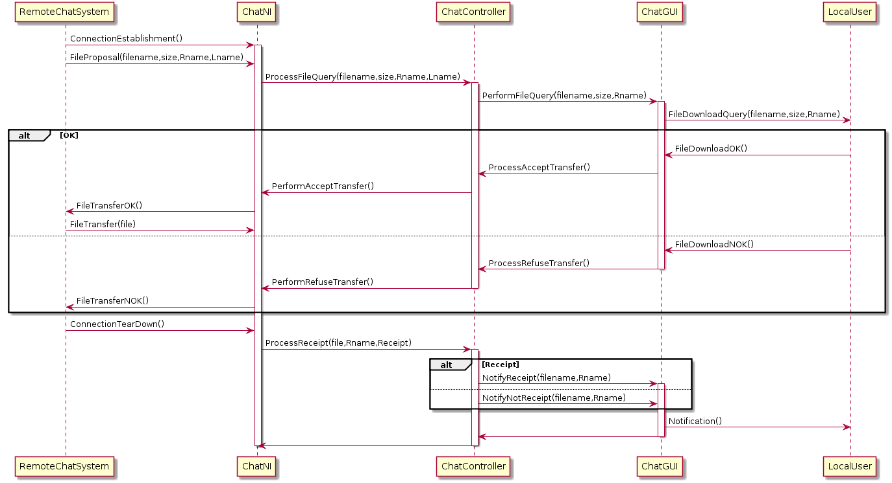

**LocalUser disconnecting SDD**

LocalUser->ChatGUI : disconnect()

activate ChatGUI

ChatGUI->ChatController : performDisconnect()

activate ChatController

ChatController->ChatNI : sendGoodbye(Lname)

activate ChatNI

ChatNI->RemoteChatSystem : Goodbye(Lname)

ChatNI->ChatController

deactivate ChatNI

ChatController->ChatGUI

deactivate ChatController

ChatGUI->LocalUser

deactivate ChatGUI

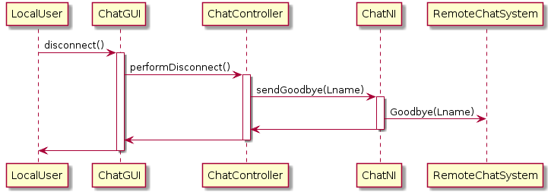

**RemoteUser disconnecting SDD**

RemoteChatSystem->ChatNI : goodbye(RemoteUserName)

activate ChatNI

ChatNI->ChatController : performGoodbye(RemoteUserName)

activate ChatController

ChatController->ChatGUI : DeleteUser(RemoteUserName)

activate ChatGUI

ChatGUI->LocalUser : updateConnectedList()

ChatGUI->ChatController

deactivate ChatGUI

ChatController->ChatNI

deactivate ChatController

ChatNI->RemoteChatSystem

deactivate ChatNI

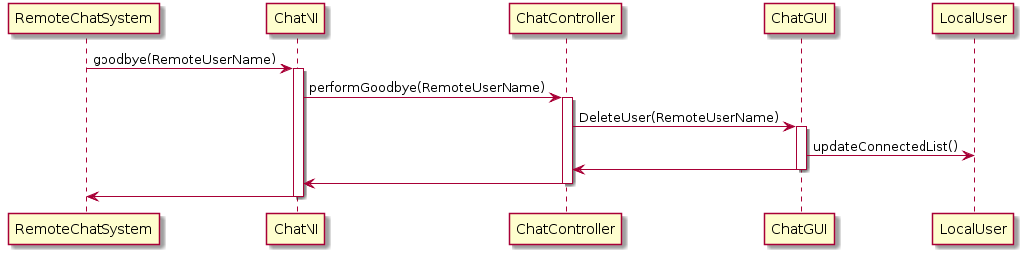

WHITE BOX CLASS DIAGRAM

ChatNI

[FROMChatCtrl | sendHello(); sendHelloOk(); processTextMessage() ; processSendFile() ; performRefusetransfer() ; performAcceptTransfer() ; sendGoodbye() ; ]

[ToChatCtrl | performHelloOk() ; performHello() ; performTextMessage() ; processTransmission() ; processFileQuery() ; processReceipt() ; performGoodbye()]

[RemoteChatSystem | hello() ; helloOk() ; TextMessage() ; connectionEstablishment() ; fileProposal() ; fileTransferOK() ; fileTransferNOK() ; fileTransfer() ; connectionTearDown() ; goodBye() ]

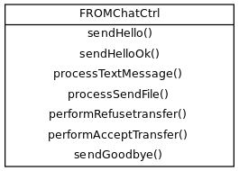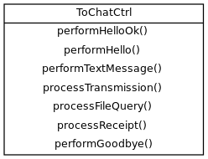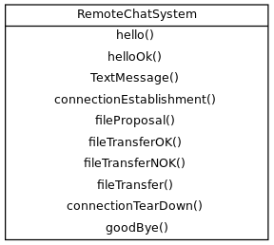

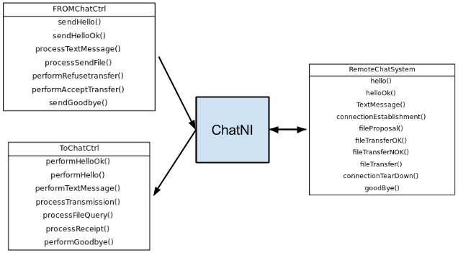

ChatGUI

[FromChatCTRL | addUser() ; processTextMEssage() ; NotifyTransmitted() ; NotifyNotTransmitted() ; performFileQuery() ; notifyReceipt() ; notifyNotReceipt() ; deleteUser(); ]

[TOChatCTRL | performConnect() ; performSendMessage() ; performSendFile(); processAcceptTransfer() ; processRefuseTransfer() ; performDisconnect() ]

[FROMuser | username() ; connect() ; selectConnectedUser ; write() ; sendMessage() ; SelectFile() ; sendFile() ; fileDownloadOk() ; fileDownloadNOk() ; Disconnect()]

[TOuser | UpdateConnectedList() ; dialogBox() ; notification() ; printMessage() ; fileManager() ; fileDownloadQuery()]

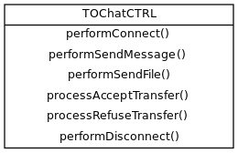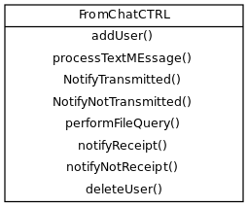

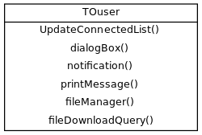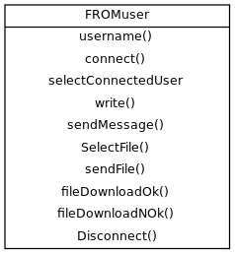

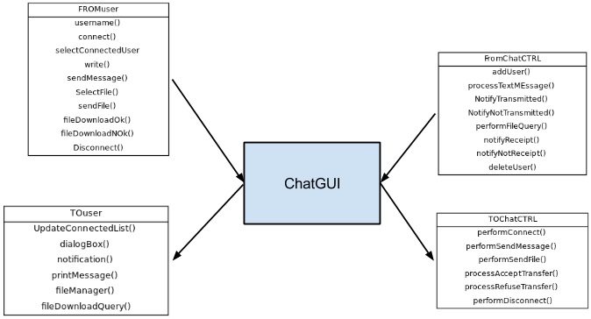

ChatCtrl

[TOChatNI | sendHello(); sendHelloOk(); processTextMessage() ; processSendFile() ; performRefusetransfer() ; performAcceptTransfer() ; sendGoodbye() ]

[FromChatNI | performHelloOk() ; performHello() ; performTextMessage() ; processTransmission() ; processFileQuery() ; processReceipt() ; performGoodbye()]

[ToChatGUI | addUser() ; processTextMEssage() ; NotifyTransmitted() ; NotifyNotTransmitted() ; performFileQuery() ; notifyReceipt() ; notifyNotReceipt() ; deleteUser(); ]

[FromChatGUI | performConnect() ; performSendMessage() ; performSendFile(); processAcceptTransfer() ; processRefuseTransfer() ; performDisconnect() ]

