Individual Coding Exercise

A Thread-Safe Banking System:
Design, Trade-offs, and Three Approaches to Deadlock Prevention

[1] Introduction

Banking systems suit concurrency: many users touch the same account at once, and a synchronisation mistake costs real money, not just a wrong number on screen. This report explains a thread-safe banking system: an account class with a genuinely protected balance, operations built as Command objects, and three ways to move money between two accounts, each with a different trade-off.

The system rests on three ideas:
- a balance must never be corrupted by two threads acting on it at once;
- moving money between accounts must not deadlock;
- and every operation should be visible in an audit trail, whether it succeeds or fails.

Each section explains a design choice, its trade-off, and what testing showed.

[2] Object-Oriented Design

[2.1] BankAccount and Encapsulation
BankAccount stores its balance as a name-mangled attribute, __balance, which Python rewrites so it cannot be reached as account.balance from outside the class (Sridhar, Indumathi and Hariharan, 2023). Without this, external code could set the balance directly, skipping every check the class performs. The only way in is deposit(), withdraw(), and get_balance() (Figure 1).
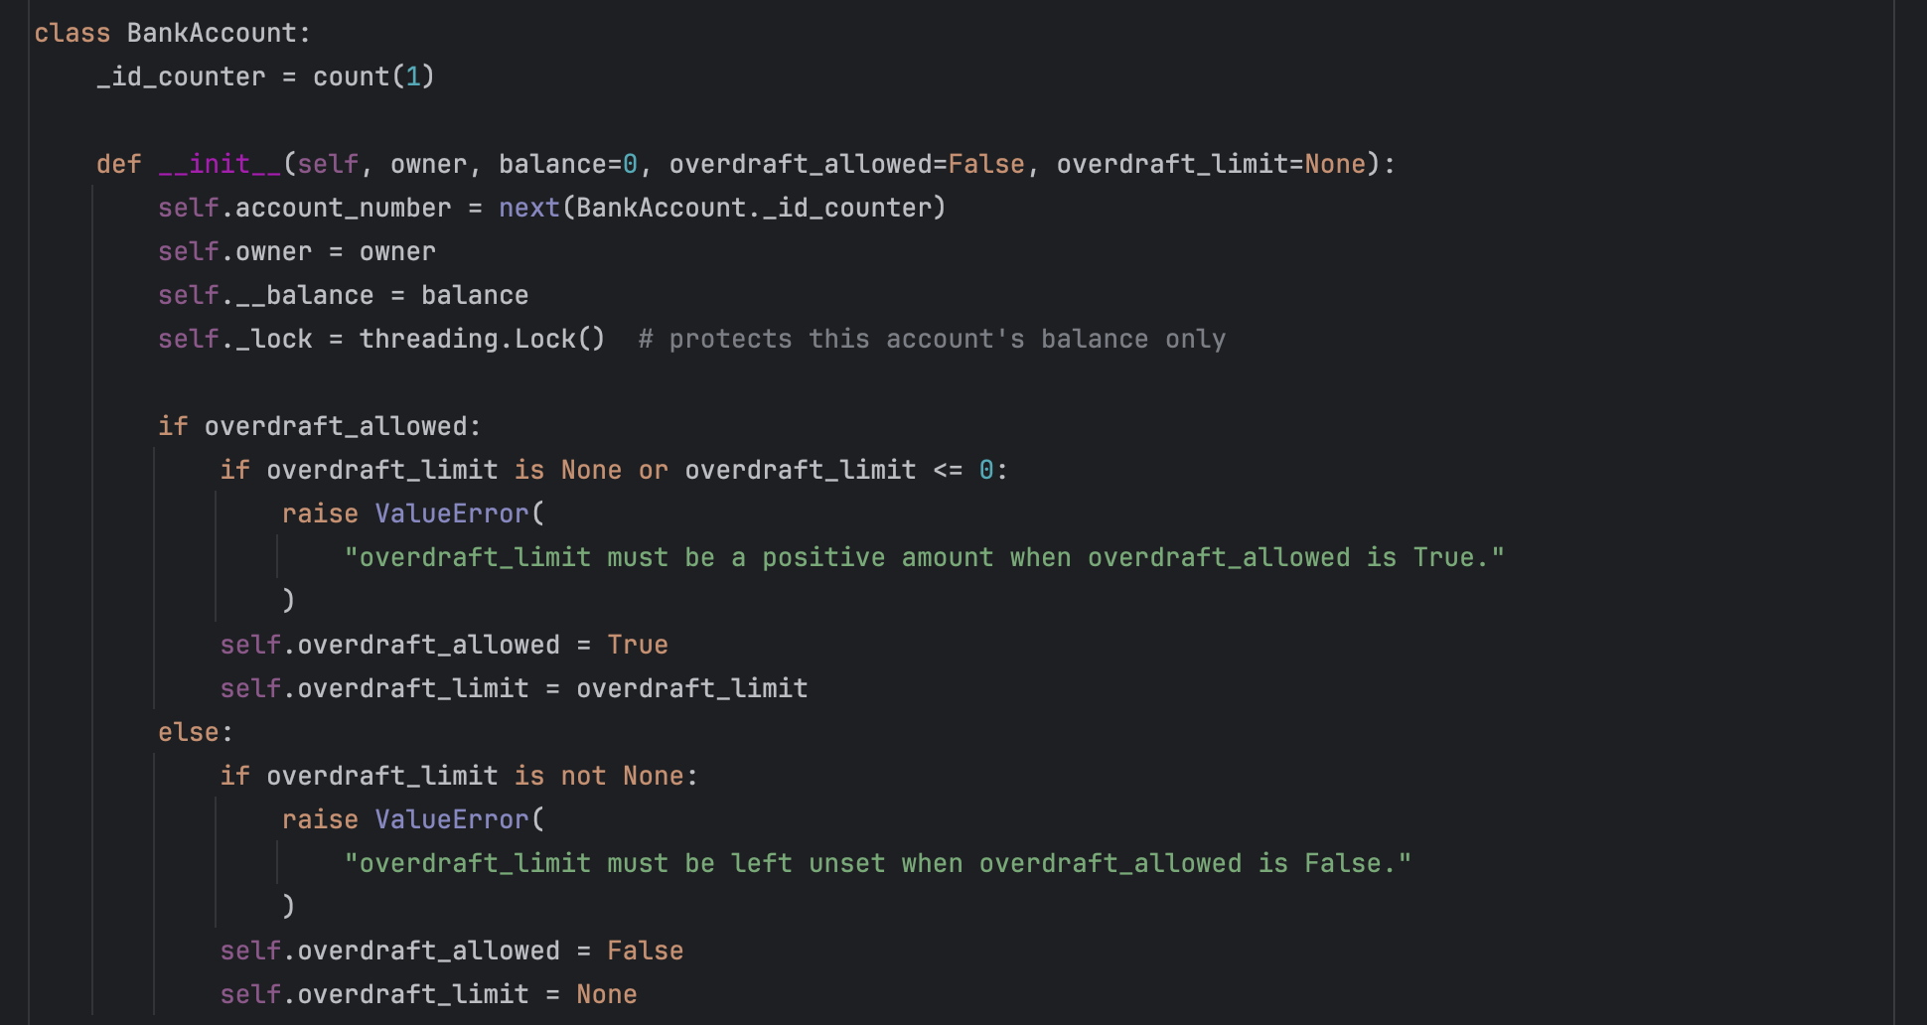
Figure 1 BankAccount construction, including overdraft validation.

Overdraft is off by default. An account can only allow it by setting overdraft_allowed=True together with a positive overdraft_limit; asking for one without the other raises an error immediately. This mirrors a real account, which either has no overdraft facility or an explicit, agreed limit, never an implicit, unlimited one.

No inheritance hierarchy of account types was built, since nothing here varies by account type; what varies is the transaction performed, handled separately in the Command layer below.

[2.2] The Command Pattern
Each operation, deposit, withdrawal, or transfer, is an object with one execute() method, not a direct method call (Sarcar, 2022). TransactionProcessor is the invoker: it runs whichever transaction it is given and logs the outcome, successful or not, protected by its own lock, separate from any account's lock (Figure 2, Figure 3). TransactionSimulator runs several users' transactions concurrently, one thread per user (Figure 4). This decouples issuing a transaction from the account itself: a new kind of transaction later just means a new class with an execute() method; BankAccount does not change.

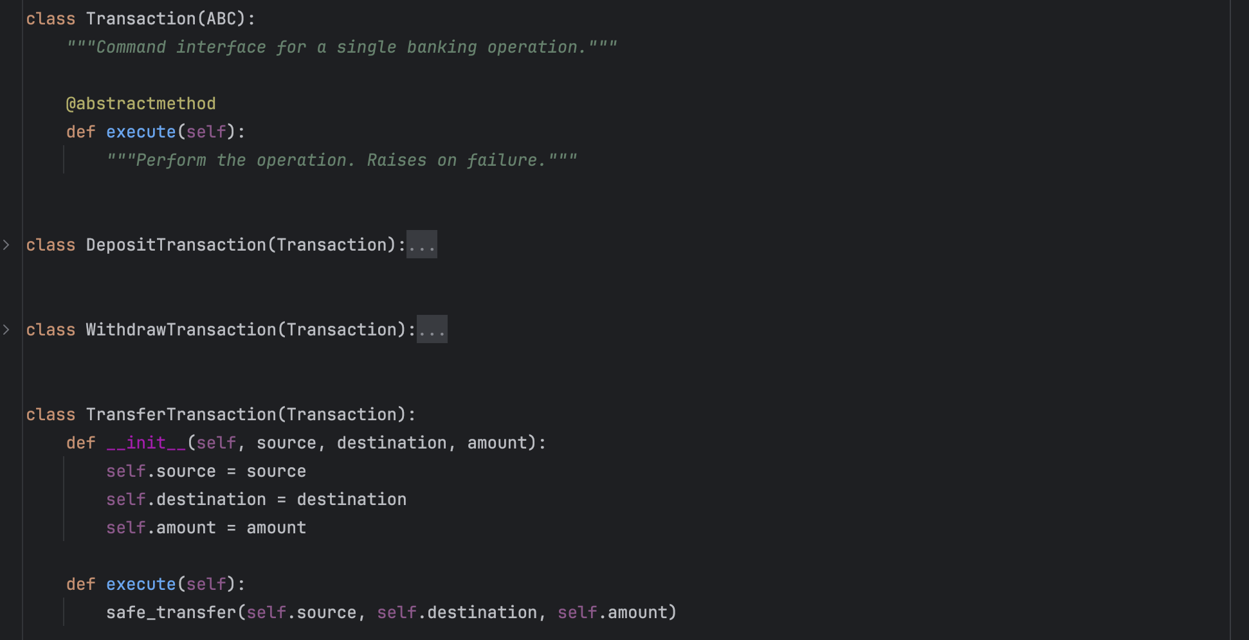
Figure 2 The Command interface and the transfer command.

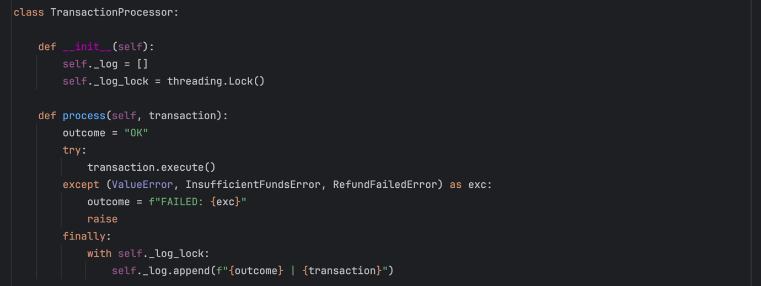
Figure 3 TransactionProcessor, the invoker, showing how the audit log is stored.

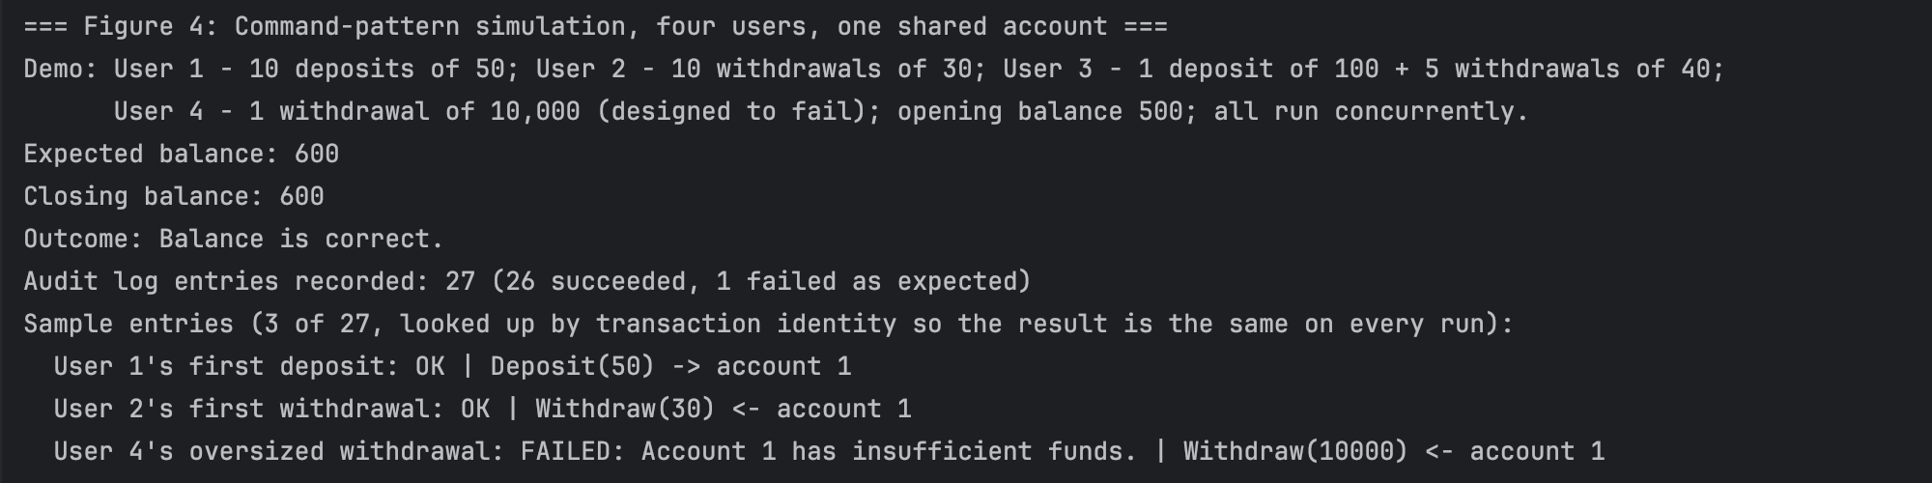
Figure 4 Sample output from three simulated users acting concurrently on one shared account (captured console output)

[2.3] The Cost of the Command Pattern
This is not free. Sarcar (2022) notes that command objects create real difficulty in a multithreaded setting, since an invoker on one thread must decide what to do with a failure raised on another; UoEO (n. d.) adds that using the Command pattern for operations this simple can add structure the problem does not need. Three operation types do not strictly need an invoker and command hierarchy. The justification is the audit trail: a banking system needs a durable record of every attempt, which the Command pattern gives by construction.

[3] Thread Safety

[3.1] Per-Account Locking
Each BankAccount owns one threading.Lock, held for the length of any read-modify-write on its balance (Nguyen, 2022; McDonald, 2022). The lock is scoped per account, not shared globally, since one lock across every account would force unrelated transactions to wait behind each other, removing the benefit of concurrency. Nguyen (2022) shows a sequential and a lock-protected counter taking the same time once one contended lock dominates the critical path; a lock per account avoids that.

[3.2] Evidence the Lock Is Necessary
To check the lock does real work, an unsynchronised deposit() was run under load: eight threads, each making 200 deposits of one unit, with a short pause between read and write to widen the interleaving window, McDonald's (2022) technique for making a race condition reliably visible (Figure 5). It lost 1,398 of the 1,600 expected updates. The real, locked BankAccount (Figure 6), under heavier load in the test suite, matched the expected balance every run (Figure 7).

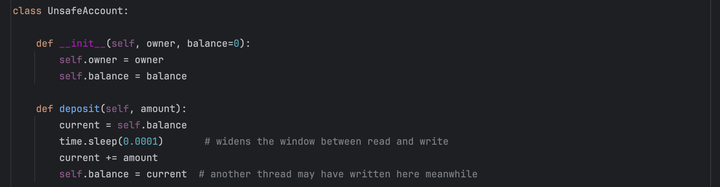
Figure 5 The unsynchronised control class used only to produce the lost-update evidence (not part of the submitted system).

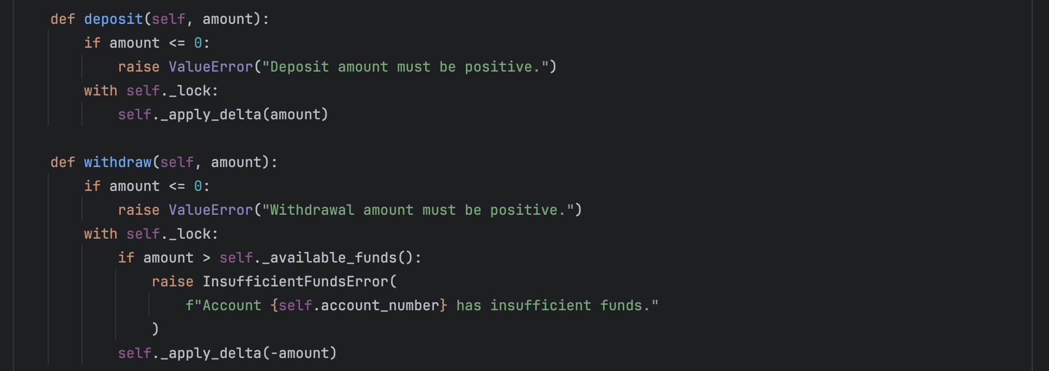
Figure 6 The real, locked deposit()/withdraw() used by the system.

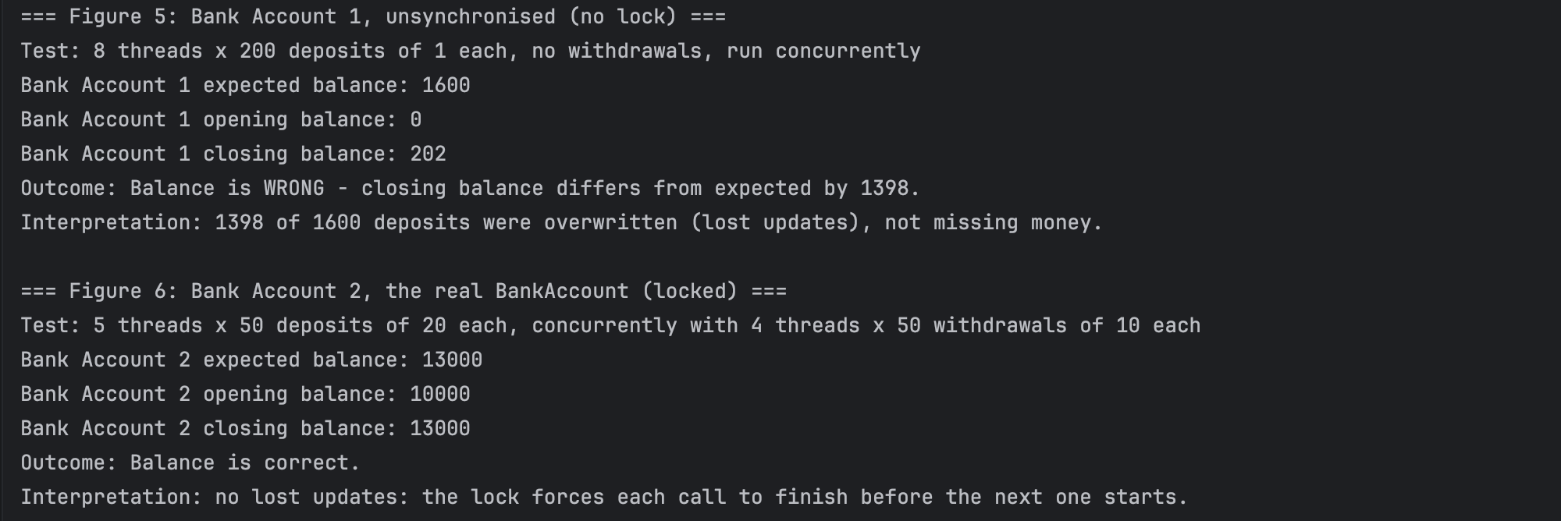
Figure 7 Lost-update count from Figure 5 versus the locked BankAccount under load from Figure 6 (captured console output).

[3.3] Lock Choice and the GIL
A plain Lock, not an RLock, was chosen since no method calls another locking method on the same account from the same thread; unneeded re-entrancy would make a real deadlock harder to break, since only the owning thread may release an RLock (McDonald, 2022). Threading, not multiprocessing, fits this workload, since the locked sections are short arithmetic updates, not CPU-heavy work. Python's GIL stops true parallel bytecode execution across threads (Nguyen, 2022), but that costs nothing here: contention is over shared state, not CPU time.

[4] Deadlock Prevention

[4.1] The Hazard: naive_transfer
A transfer between two accounts must hold both locks for the whole update, so no other thread can see or change either balance mid-transfer. Locking in call order, source then destination, reproduces the circular wait Nguyen (2022) shows with two locks and two threads: if one thread transfers A to B while another transfers B to A at once, each can end up holding one lock while waiting on the other, indefinitely. This is built as naive_transfer (Figure 8), kept only to show the hazard; the system never calls it. Running two threads against it in opposite directions reproduces the deadlock reliably, matching Nguyen's (2022) own example (Figure 10).

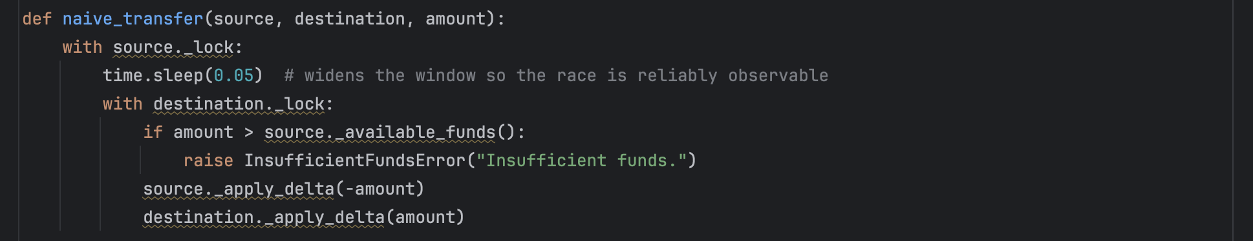
Figure 8 naive_transfer, kept only to demonstrate the hazard; locks are acquired in call order.

[4.2] The Fix: safe_transfer
safe_transfer is the transfer the system actually uses (Figure 9). It acquires both locks together, always in ascending account-number order, regardless of which account is the source for a given call. Nguyen (2022) ranks locks the same way using Python's id() function; this implementation ranks by account_number instead, since it is already a required, human-meaningful identifier, while id() is only unique for an object's lifetime and means nothing in an audit log. Under the identical opposing load that deadlocked naive_transfer, safe_transfer finishes without hanging and keeps the combined balance exact (Figure 10).

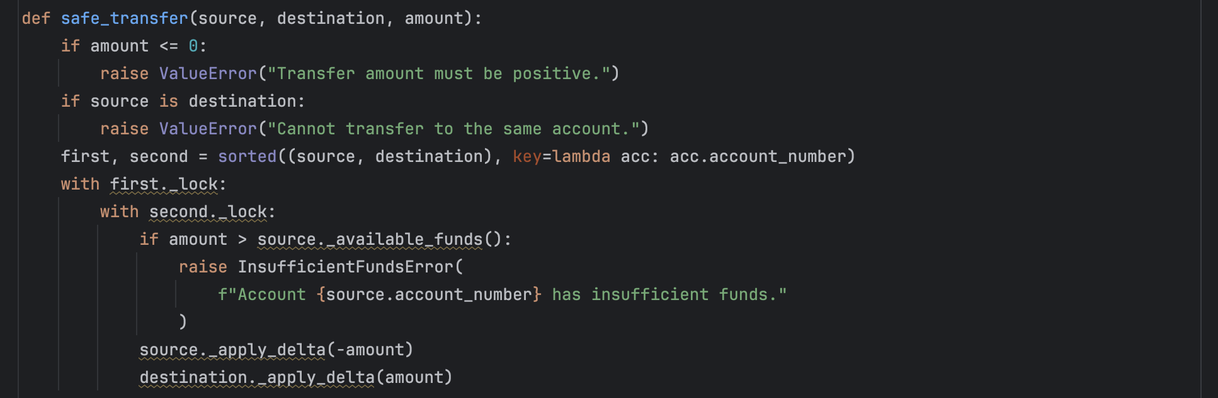
Figure 9 safe_transfer, used by the system; locks are acquired in a fixed order regardless of call order.

Testing also surfaced a second way to deadlock: calling safe_transfer with the same account as both source and destination makes sorted() return that account twice, so the same plain Lock is acquired a second time by the thread that already holds it, and a non-reentrant Lock then waits forever. This is now checked explicitly, raising a clear error instead of hanging; the same case for all three transfer designs is shown in Annex A.

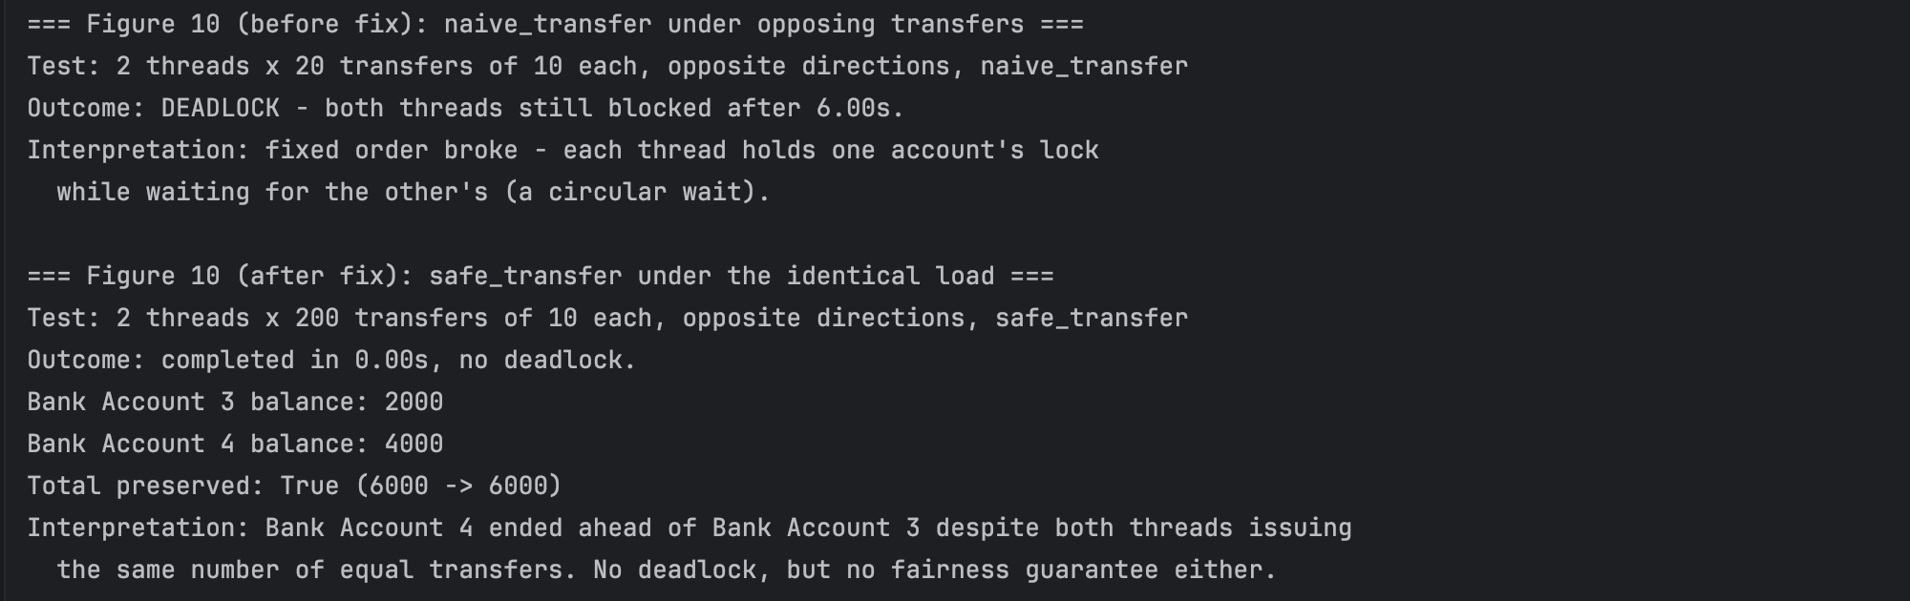
Figure 10 naive_transfer deadlocking, then safe_transfer resolving the identical opposing load (captured console output).

[4.3] Further Findings
Two further findings extend beyond preventing deadlock itself, and are examined in full in Annex A rather than here: a residual fairness limitation in safe_transfer, where a short burst of contention can still favour one thread completely, and a structurally deadlock-free alternative, sequential_transfer, modelled on how a real payment is processed sequentially with a compensating refund. Both are tested and costed in the annex, alongside the trade-offs each one carries.

[5] Testing and Validation

Thirty-three automated tests, written with Python's unittest module, cover nine areas: account creation and balance access; single-threaded deposit/withdrawal correctness; overdraft rules; sequential_transfer and its refund path; transfer behaviour across overdraft combinations; self-transfer; correctness under concurrent load; deadlock prevention across all three designs; and audit log completeness (Table 1). All thirty-three pass.

No account registry exists: the test suite and simulator construct BankAccount and TransactionProcessor instances directly, as local objects, discarding them afterwards. Opening balances are just a constructor argument, so each test controls its own starting state without a shared fixture or database.

One test is worth noting: test_naive_transfer_deadlocks_under_opposing_load asserts the unsafe function is still blocked after a timeout, built to fail informatively rather than just pass: if a lucky interleaving let naive_transfer finish anyway, the test would flag that the hazard was not reproduced, not pass silently. This reflects a real limit of testing concurrent code: a race condition is non-deterministic, so its absence on one run is evidence, not proof (McDonald, 2022). The matching safety tests run under the identical load, so a pass shows the fix holds under the exact conditions that broke the naive version.

Category | Tests | What is validated
Account creation and balance access | 5 | Owner and opening balance stored correctly; account_number assigned and unique; default balance is zero; get_balance() reflects state.
Single-threaded correctness | 5 | Deposit, withdrawal, and input-validation behaviour in isolation.
Overdraft rules | 5 | Overdraft off by default; allowed/limit must be set together; withdrawals within and beyond the limit.
Sequential transfer and refund | 4 | Successful transfer; clean abort on withdrawal failure; refund on deposit failure; RefundFailedError when the refund also fails.
Transfer overdraft combinations | 4 | safe_transfer across both-overdraft, neither, and both mixed cases; only the source account's settings govern the outcome.
Self-transfer | 3 | safe_transfer rejects source equal to destination explicitly; naive_transfer self-deadlocks on it (left unguarded on purpose); sequential_transfer completes it as a no-op.
Concurrent correctness | 2 | Final balance is exact after mixed concurrent deposits/withdrawals; total funds are conserved across concurrent transfers.
Deadlock prevention | 3 | naive_transfer deadlocks under opposing load; safe_transfer and sequential_transfer both complete under the identical load.
Command-pattern audit log | 2 | Successful and failed transactions are both logged; concurrent users produce exactly one log entry per transaction attempted.
Table 1 Automated test suite (33/33 passed).

[6] Critical Evaluation

No Singleton was used for "the bank" as a global registry, despite the pull to reach for one when a system has one conceptual owner of shared state. A Singleton's global mutable state, and its known testability problems since tests cannot swap in a fresh instance between runs, outweigh the convenience here. Passing instances explicitly keeps dependencies visible and tests isolated.

The Command pattern's audit log is a genuine step toward secure, accountable transaction handling (UoEO, 2026), but should not be overstated: it records only a description and outcome, with no caller identity, timestamp, or tamper-evidence, closer to a debugging aid than a compliance-grade trail. A production system would typically close this gap and the fairness limitation together, moving processing onto a first-in-first-out queue that stores each transaction as a durable event, giving an ordering guarantee and persistent history at once (Marcotte and Zebdi, 2022). This is not free: it brings eventual consistency and infrastructure complexity. sequential_transfer's refund step, discussed in Annex A, is a small version of the same compensating-action idea.

[7] Conclusion

This system demonstrates a thread-safe BankAccount with a genuinely private balance, validated against a reproducible race condition, and a Command-pattern layer that separates issuing a transaction from the account itself while logging every attempt. The core deadlock problem is reproduced and then fixed within this scope: naive_transfer deadlocks reliably under opposing concurrent load, while safe_transfer, locking both accounts in a fixed order rather than call order, resolves the identical load without hanging.

Every decision carries a cost. Per-account locking trades a global view of consistency for throughput. The Command pattern trades structure three simple operation types do not strictly need for a durable record of every attempt, successful or not. Fixed lock ordering removes the circular wait behind deadlock; it says nothing, though, about which waiting thread runs next under contention, a further trade-off examined alongside a second transfer design in Annex A. None of this is free: the system is limited to a single process and an in-memory log, and the tests validate correctness under load, not production readiness.

------ End -----

Word count: 1,544 (main content excluding titles, tables, table’s caption, figure’s caption, annex and references)

References

Marcotte, C-H. and Zebdi, A. (2022) An Atypical ASP.NET Core 6 Design Patterns Guide: A SOLID Adventure into Architectural Principles and Design Patterns Using .NET 6 and C# 10. 2nd edn. Birmingham: Packt Publishing.

McDonald, J.C. (2022) Dead Simple Python: Idiomatic Python for the Impatient Programmer. San Francisco, CA: No Starch Press.

Nguyen, Q. (2022) Advanced Python Programming: Accelerate Your Python Programs Using Proven Techniques and Design Patterns. 2nd edn. Birmingham: Packt Publishing.

Sarcar, V. (2022) Java Design Patterns: A Hands-On Experience with Real-World Examples. 3rd edn. New York: Apress. Available at: https://doi.org/10.1007/978-1-4842-7971-7.

Sridhar, S., Indumathi, J. and Hariharan, V.M. (2023) Python Programming. Delhi: Pearson India.

UoEO / University of Essex Online (2026) Advanced Object-Oriented Design and Programming: Unit 6 assignment brief. Colchester: University of Essex Online. Unpublished module material.

UoEO / University of Essex Online (no date) Drawbacks of Behavioural Design Patterns. Unit 5 lecturecast transcript, Advanced Object-Oriented Design and Programming module.

Annex A
Fairness Under Load and an Alternative Transfer Design (excluded from the word count)
This annex extends beyond deadlock prevention itself, referenced from Section 4.3. It covers a residual fairness limitation in safe_transfer, and sequential_transfer, an alternative transfer design built and tested in full but not adopted for the live system.

Annex A.1 Residual Trade-off: Fairness

Fixing the deadlock did not remove every problem. In one run, one account ended with the full combined balance and the other with none, even though both threads issued the same number of equal transfers. This is starvation, the third classic concurrency hazard alongside deadlock and livelock: a plain Lock gives no guarantee about which waiting thread is served next under contention (McDonald, 2022).

At small scale, this is not really a race at all: the whole job finishes in under a millisecond, faster than any scheduling interruption, so one thread completes its entire loop before the other gets a real turn. The size of the resulting skew is predictable, not random: cutting the transfer count from 200 to 105 against the same opening balance produced a skew of exactly 50 on every one of fifty trials; changing it again to 110 produced a skew of exactly 100, matching a prediction made before that test was run. Raising the opening balance so it could absorb the full transfer volume changed the picture entirely: the same test, now long enough to span many scheduling windows, balanced exactly every time. What decides the outcome is not how many transfers are attempted, but whether the contested balance runs out before the scheduler can hand control between threads, and a real account has a finite balance too, so this is not just an artefact of a small test.

Annex A.2 An Alternative Considered: sequential_transfer

Both designs above assume a transfer must be atomic: it either has not happened or has fully happened, with no moment where the money is nowhere. That assumption is why a transfer needs two locks at once, and holding two locks at once is what makes deadlock possible. A third design gives up atomicity instead. sequential_transfer mirrors how a payment is often processed: the debit is confirmed first; the credit is attempted afterward; if the debit fails, nothing happens; if the credit then fails, the debit is refunded (Figure 11). This is a small compensating-action pattern, the idea behind the Saga pattern for coordinating multi-step operations across services (Marcotte and Zebdi, 2022). If the refund also fails, a RefundFailedError names both accounts and the exact amount so a person can reconcile it (Sridhar, Indumathi and Hariharan, 2023).

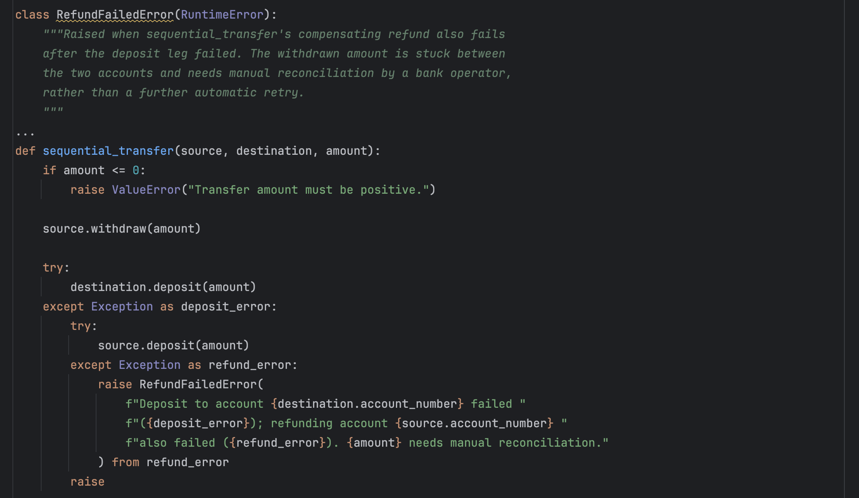
Figure 11 sequential_transfer and RefundFailedError.

sequential_transfer never holds two accounts' locks at once: withdraw() acquires and releases its own lock, then deposit() does the same, separately. No thread ever holds a second lock while waiting, so the circular wait behind deadlock cannot arise, not by discipline, but structurally. Testing confirms this: opposing sequential transfers under the load that deadlocks naive_transfer complete in milliseconds, every time (Figure 13). This also brings a genuine encapsulation benefit: safe_transfer needs an internal, non-public route into each account's balance, since calling deposit()/withdraw() would try to reacquire a lock it already holds; sequential_transfer only calls the same public methods any caller uses, so nothing needs privileged access to an account's private state.

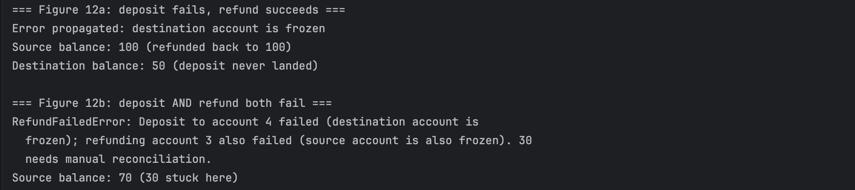
Figure 12 The refund path, and the manual-reconciliation error when the refund also fails (captured console output).

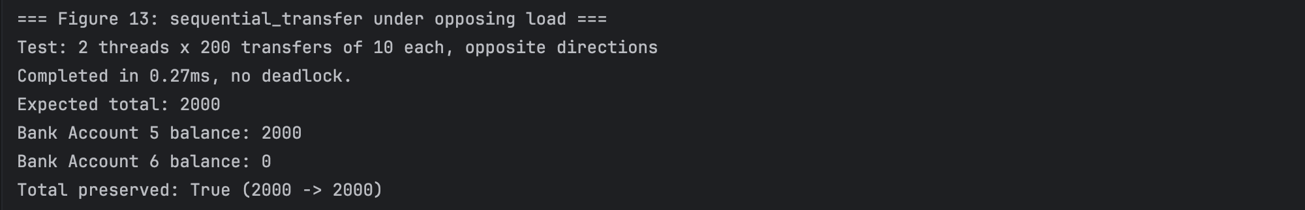
Figure 13 sequential_transfer under the identical opposing load that deadlocks naive_transfer (captured console output).

The trade-off is atomicity itself. Because the two steps happen separately, there is a real window, confirmed by widening it artificially, where a concurrent observer could see the combined total short by the transferred amount - the money is genuinely in transit, not missing by mistake. Under a short burst of contention, sequential_transfer shows the same complete-sweep skew as safe_transfer, for the same reason: the exchange finishes faster than the scheduler can intervene.

safe_transfer was adopted for the live system because it demonstrates deadlock prevention directly, through lock ordering. sequential_transfer was built and tested in full regardless, since it reflects a genuine alternative used in real payment systems, and comparing the two makes the cost of atomicity, and of avoiding it, visible. The self-transfer case in Section 4.2 makes the same contrast concretely: safe_transfer must reject it explicitly, while sequential_transfer passes through unharmed as a side effect of never nesting locks (Figure 14).

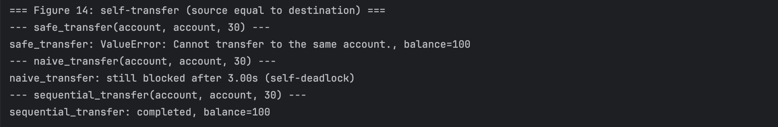
Figure 14 Self-transfer (source equal to destination) across all three transfer designs (captured console output).

