Secure E-Learning Platform: Case Study Report
Case Study Activity, Tasks 1 to 3. Unit 10: Test-Driven Development and BDD. Advanced Object-Oriented Design and Programming.

Introduction
This report covers the Unit 10 case study activity in full. Task 1 sets out the architecture of a secure, scalable e-learning platform. Task 2 implements one of its five services, User Management, in Python, using Test-Driven Development. Task 3 covers the tests written for that service, the refactors made as a result, and this documentation. Course Management, Enrolment Management, Payment and Assessment are specified at the design level in Task 1 only; User Management is the sole service built and tested in code.

[Task 1] Software Architecture Design

1.1 Architecture Style: Microservices
The platform adopts a microservices architecture, decomposing the system into five independently deployable services aligned to distinct business capabilities: User Management, Course Management, Enrolment Management, Payment, and Assessment. A layered monolith was considered as a lower-overhead alternative but rejected, because it would force whole-system scaling in response to demand concentrated in specific capabilities, which does not align with the requirement that the platform be scalable. Enrolment and Payment traffic is expected to peak sharply around registration and fee-payment periods, while Course Management and Assessment experience comparatively steady, lower-volume access outside those windows. Garcia and Telang (2023) describe this as a fine-grained approach to non-functional requirements, in which each service is scaled according to its own demand profile rather than replicating capacity across parts of the system that do not need it.
This benefit carries a cost. Chow (2024) notes that decomposing a system into services introduces distributed data management, since each service maintains its own store and consistency across services must be handled explicitly rather than assumed, together with network latency between calls that would otherwise be in-process. Chow further cautions that the overhead of a microservices topology can outweigh its benefits for small-scale or infrequently used components, a concern directly relevant here because the case study requires only one service, User Management, to be built and tested; the remaining four services are specified at the design level rather than implemented.
The security implication of this choice follows the same logic as the scalability argument and is developed further in Section 1.4: a microservices topology multiplies the number of trust boundaries in the system, from one in a monolith to one per service plus the gateway, which raises the operational cost of consistent enforcement even as it improves fault isolation, since a fault confined to Assessment need not affect Payment. Weighed against the stated requirement for scalability, this trade-off is accepted for the design as a whole, while the implementation in Tasks 2 and 3 is deliberately scoped to a single service so that the trade-off does not need to be defended at the level of a fully operating distributed system.

1.2 High-Level Architecture Diagram
Web / Mobile Client
API Gateway
TLS termination, authentication token validation, rate limiting
User  Management  (own data store) | Course  Management  (own data store) | Enrolment  Management  (own data store) | Payment  (own data store) | Assessment  (own data store)
Event Bus (asynchronous integration)
Enrolment Management to Payment: enrolment created
Enrolment Management to Assessment: enrolment confirmed
Shared platform services: secrets store, centralised logging and monitoring, service discovery
Figure 1: High-level microservices topology for the secure e-learning platform.
Client requests enter through a single API Gateway, which enforces authentication and rate limiting before routing a request to the relevant service. Each service maintains its own data store, consistent with the decentralised data ownership principle of microservices architecture (Chow, 2024). Enrolment Management communicates asynchronously with Payment and Assessment via an event bus, decoupling the enrolment workflow from downstream processing rather than calling those services synchronously.

1.3 Core Modules
Module | Core responsibility | Data ownership and notes
User Management | Registration, authentication, authorisation and profile management for learners and staff. | Owns the identity and credential store. Issues role-based tokens consumed by every other service.
Course Management | Creation, editing and publishing of course structure and content. | Owns the course catalogue and content metadata. Read-heavy, comparatively steady load.
Enrolment Management | Managing a learner's enrolment onto a course, prerequisite checks and enrolment status. | Publishes enrolment events consumed by Payment and Assessment via the event bus.
Payment | Processing course fees, refunds and payment status. | Owns transaction records. Highest-sensitivity data in the system; encrypted at rest and in transit.
Assessment | Managing assignments, submissions, grading and feedback. | Owns assessment and grade data, subject to academic record-keeping obligations.

1.4 Security Considerations
Security is enforced at two levels. The API Gateway forms the outer perimeter, terminating TLS, validating authentication tokens and applying rate limiting before a request reaches any service, which centralises the controls a client-facing boundary must provide. Shah (2023) frames this as one instance of defence in depth, the principle that a system should rely on multiple layers of control so that a failure in one layer does not expose the whole system, alongside the complementary principle of least privilege, under which each service is granted only the access it needs to perform its function.
Because each service is independently deployable, authentication cannot stop at the gateway. Baker (2022) distinguishes authentication, verifying who a caller is, from authorisation, determining what that caller may do, and this distinction is applied per service: User Management issues role-based tokens on login, and each downstream service is responsible for verifying a token's validity and scope before acting on a request, rather than trusting that the gateway has already done so. Input validation and sanitisation are applied at every service boundary rather than once at the edge, consistent with the entry-point-level control Shah (2023) recommends for microservices, since a service that trusts input forwarded internally is as exposed to injection attacks as one exposed directly to the internet.
Payment and User Management hold the platform's most sensitive data, transaction records and credentials respectively, and both are encrypted at rest and in transit rather than relying on network-level protection alone. Secrets such as database credentials and API keys are held in a dedicated secrets store rather than in configuration files or source code, following the secrets-management practice Shah (2023) sets out for cloud-native systems. Because Payment and User Management process personal and financial data, the design also needs to satisfy the UK data protection principles set out in Article 5 of the UK GDPR and supplemented by the Data Protection Act 2018 (Data Protection Act 2018; UK GDPR, 2016), in particular that personal data be processed lawfully, fairly and transparently, and be adequate, relevant and limited to what is necessary for the stated purpose.
The cost of this approach mirrors the one identified for the architecture as a whole: distributing enforcement across five services means five places where a misconfiguration could leave a gap, rather than one. This is treated as an accepted trade-off rather than a limitation to be designed away, on the basis that the alternative, a single enforcement point in a monolith, would not support the independent scaling the brief requires.

[Task 2] Implementation (User Management, TDD)

2.1 Design Decisions
UserService receives a UserRepository through its constructor rather than creating its own storage, so tests supply InMemoryUserRepository as a test double instead of a real database (Tibi, 2022).
Failures use a small exception hierarchy rather than a single generic exception or a boolean return. WeakPasswordError covers password-policy failures generally; PasswordSimilarToUsernameError and CommonPasswordError subclass it for the two most specific reasons, so a caller can catch either the general or the specific case.
Passwords are hashed with bcrypt, using bcrypt.gensalt() to generate a fresh salt on every call, per Baker (2022) on never storing or comparing passwords as plain text. The password-policy rules enforced on registration and password change are:
Password rule | Exception raised | Basis
At least 8 characters, one letter, one digit | WeakPasswordError | Baseline complexity
Not the same as, or containing, the username | PasswordSimilarToUsernameError | Baker (2022), 9.2
Not a common or previously breached password, including with digits appended | CommonPasswordError | Baker (2022), 9.2
No more than 72 bytes | WeakPasswordError | bcrypt algorithm limit

2.2 Implementation Details
The module is organised as one class or small set of functions per concern, so each can be tested and reasoned about on its own:
Module / class | Responsibility | Key public members
models.User | Holds one registered user's data | username, email, password_hash, role, to_public_dict()
repository.UserRepository / InMemoryUserRepository | Storage abstraction and its in-memory implementation | add, get_by_username, get_by_email
security | Wraps bcrypt for password storage and verification | hash_password, verify_password, MAX_PASSWORD_BYTES
exceptions | Hierarchy of module-specific failure types | UserManagementError and its subclasses
service.UserService | Orchestrates registration, authentication, password change and role checks | register, authenticate, change_password, has_role
audit_log | Security audit logging through a dedicated logger | log_authentication_success/failure, log_password_change_success/failure

2.3 Security Audit Logging
The authenticate and change_password methods log every outcome through a dedicated logger, user_management.audit: success at INFO, failure at WARNING with a specific reason (unknown username, incorrect password, incorrect current password). Passwords are never logged, following Shah (2023) on keeping sensitive data out of logs and error messages. The reason is recorded for monitoring even though it is not exposed to the caller, who still receives only a generic failure or a boolean result.
The audit_log module itself attaches only a NullHandler, so importing it does not start writing files; the hosting application decides where records go. M4_U10_CaseStudyActivity_demo_audit_log.py attaches a FileHandler and exercises all four outcomes:
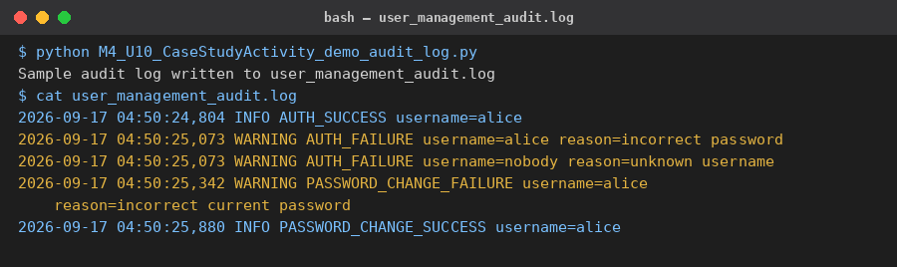
Figure 2: sample audit log produced by the demo script.
Reproduce: python M4_U10_CaseStudyActivity_demo_audit_log.py, then read user_management_audit.log in the same directory.
Four tests exercise the logging functions directly (M4_U10_CaseStudyActivity_test_audit_log.py) and four more confirm UserService actually calls them at the right points (M4_U10_CaseStudyActivity_test_service.py); the tests themselves are discussed in Task 3.

[Task 3] Testing and validation

3.1 Testing Approach
Tests use unittest and follow the Arrange, Act, Assert structure (Tibi, 2022). Each was written before the behaviour it checks existed, run to confirm it failed for the expected reason, then made to pass. For example, the length and character-class check was removed from UserService.register and the two affected tests run directly:
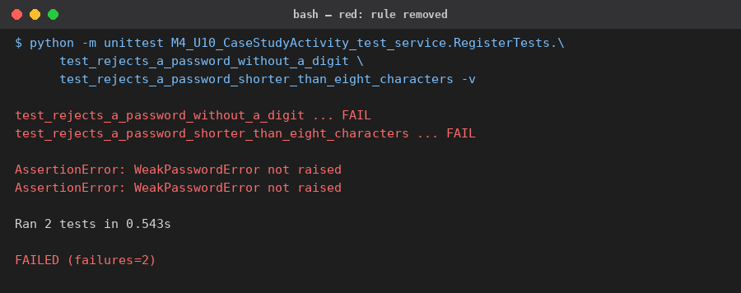
Figure 3: the two tests fail for the expected reason once the rule is removed.
Reproduce: in M4_U10_CaseStudyActivity_service.py, delete the "if _fails_strength_rule(password): raise WeakPasswordError(...)" block inside the _validate_new_password function then run python -m unittest M4_U10_CaseStudyActivity_test_service.RegisterTests.test_rejects_a_password_without_a_digit M4_U10_CaseStudyActivity_test_service.RegisterTests.test_rejects_a_password_shorter_than_eight_characters -v
Restoring the check and running the full suite gives:
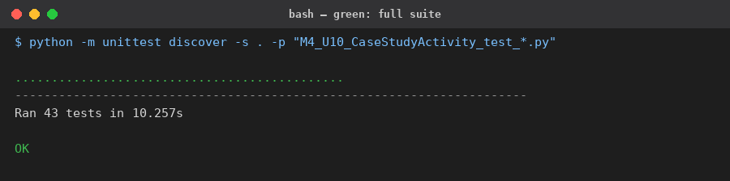
Figure 4: full suite passing after the check is restored.
Reproduce: python -m unittest discover -s . -p "M4_U10_CaseStudyActivity_test_*.py" -v
Forty-three tests across four modules cover every public method: register, authenticate, change_password and has_role on UserService; add, get_by_username and get_by_email on InMemoryUserRepository; hash_password and verify_password in security; and the four logging functions in audit_log described in Section 2.3.

3.2 Refactoring
The password-policy checks (length and character class, username similarity, the common-password list, the 72-byte limit) would otherwise be duplicated between register and change_password. Both methods call a single helper, _validate_new_password, instead; the full suite was re-run after the change and remained green, confirming behaviour was unaffected (Tibi, 2022).

3.3 Performance Review
InMemoryUserRepository.get_by_email originally scanned every registered user linearly to find a match. It now maintains a second dictionary, indexed by email alongside the existing one indexed by username, so both lookups are O(1) regardless of how many users are registered. No test was failing beforehand, since the previous version was correct and only slow at scale; the existing tests covering get_by_email were the safety net for this change, and remained green afterwards, the same full run shown in Figure 4.
Bcrypt's hashing cost was also reviewed and deliberately left unchanged. bcrypt.gensalt() applies a work factor chosen to make each hash slow enough to resist brute-force guessing; lowering it would improve throughput at the direct expense of the security property Section 2.1 relies on. Performance and security compete here, and security was prioritised for credential storage specifically, while performance was prioritised for repository lookups, which held no such trade-off to protect.

Accompanying Files
The Task 1 diagram and tables above are embedded directly in this document. The Task 2 and 3 implementation is provided separately as M4_U10_CaseStudyActivity.zip, following the M4_U10_CaseStudyActivity_ naming convention: exceptions.py, security.py, models.py, repository.py, service.py, audit_log.py, demo_audit_log.py, test_security.py, test_repository.py, test_service.py and test_audit_log.py, plus requirements.txt (bcrypt). Install once with pip install -r requirements.txt, then run the suite with python -m unittest discover -s . -p "M4_U10_CaseStudyActivity_test_*.py".

References
Baker, M. (2022) Secure Web Application Development: A Hands-On Guide with Python and Django. 1st edn. Berkeley, CA: Apress.
Chow, J. (2024) Software Architecture with Kotlin: Combine Various Architectural Styles to Create Sustainable and Scalable Software Solutions. 1st edn. Birmingham: Packt Publishing.
Garcia, M.M. and Telang, T. (2023) Learn Microservices with Spring Boot 3: A Practical Approach Using Event-Driven Architecture, Cloud-Native Patterns, and Containerization. 3rd edn. Berkeley, CA: Apress.
Provos, N. and Mazieres, D. (1999) 'A future-adaptable password scheme', in Proceedings of the 1999 USENIX Annual Technical Conference, FREENIX Track. Monterey, CA, 6-11 June. Berkeley, CA: USENIX Association. Available at: https://www.usenix.org/legacy/event/usenix99/provos/provos.pdf (Accessed: 15 September 2026).
Shah, M. (2023) Cloud Native Software Security Handbook: Unleash the Power of Cloud Native Tools for Robust Security in Modern Applications. 1st edn. Birmingham: Packt Publishing.
Tibi, A. (2022) Pragmatic Test-Driven Development in C# and .NET: Write Loosely Coupled, Documented, and High-Quality Code with DDD Using Familiar Tools and Libraries. 1st edn. Birmingham: Packt Publishing.

Legislation
Data Protection Act 2018, c. 12. Available at: https://www.legislation.gov.uk/ukpga/2018/12/contents (Accessed: 15 September 2026).
UK General Data Protection Regulation (2016) Regulation (EU) 2016/679 of the European Parliament and of the Council of 27 April 2016 on the protection of natural persons with regard to the processing of personal data and on the free movement of such data (General Data Protection Regulation), as it forms part of the law of England and Wales, Scotland and Northern Ireland by virtue of the European Union (Withdrawal) Act 2018. Available at: https://www.legislation.gov.uk/eur/2016/679/contents (Accessed: 15 September 2026).

