Unit 11 Case Study Activity
Refactoring UserManager for Dependency Injection

1. Scope
This piece addresses the Unit 11 case study activity: the original UserManager and EmailService are refactored to remove tight coupling and to make UserManager testable in isolation, followed by the further improvements listed in the activity brief.

2. Problem in the Original Design
In the original code, UserManager creates its own EmailService inside the constructor. Laigner et al. (2022) name this pattern Control Freak: a class obtains a dependency through direct instantiation, which raises coupling to one concrete implementation and cannot be changed through the class's public contract. A direct consequence is that any unit test written against UserManager also exercises EmailService, so the test cannot run without a working notification channel.

3. Step 1: Introducing the Interface
class NotificationService(ABC):
@abstractmethod
def send_notification(self, user, message):
pass

Taelman et al. (2023) describe dependency injection as tying objects together through a lightweight interface, so different implementations can be substituted without changing the class that depends on the interface. Python has no interface keyword, so an abstract base class is used to express the same contract. NotificationService declares one method, which keeps the abstraction narrow enough that an email channel and an SMS channel can both satisfy it without being forced to implement anything they do not need.

4. Step 2: Implementing the Interface
class EmailService(NotificationService):
def send_notification(self, user, message):
print(f"Sending email to {user}: {message}")

EmailService is kept close to the version given in the activity brief; only the base class changes. The print statement stands in for a real email API call, which keeps the exercise runnable without external credentials while still demonstrating the contract.

5. Step 3: Injecting the Dependency into UserManager
class UserManager:
def __init__(self, notifier):
self.notifier = notifier
def register_user(self, user):
self.notifier.send_notification(user, "Welcome!")

UserManager now receives a NotificationService through its constructor instead of building one. Constructor injection is the form used because, of the three forms of injection described by Taelman et al. (2023), constructor injection is the simplest and produces an object that is fully wired at the moment it is created, avoiding a partially configured UserManager being used before a setter is called.

6. Testing the Refactored Code
mock_notifier = Mock(spec=NotificationService)
manager = UserManager(mock_notifier)
manager.register_user("alice@example.com")
mock_notifier.send_notification.assert_called_once_with(
"alice@example.com", "Welcome!"
)

A Mock object built with spec=NotificationService replaces the real channel in the unit tests, so register_user is checked without printing to the console or depending on any channel implementation. This mirrors the point made in the unit's lecturecast material, that mock injection isolates a test from side effects and lets a suite run without touching production systems (University of Essex Online, n.d.). One integration test is kept separate and is the only test permitted to instantiate the real EmailService, following the third further-improvement step in the activity brief.

7. Further Improvements
SMSService is added as a second channel. Because both channels satisfy NotificationService, UserManager requires no change to accept it, which is the direct benefit of depending on an abstraction rather than a class. Wiring is placed in a small composition root function, build_user_manager, rather than inside UserManager itself. A class that asks a central registry for its own dependency is the Service Locator anti-pattern criticised by Laigner et al. (2022), because it reintroduces the coupling that dependency injection is meant to remove; the composition root avoids this by keeping the decision about which concrete class to use outside the classes that use it. A production system of realistic size would normally automate this wiring with a container, for example a Python library such as dependency-injector, or Spring and Guice in Java (Tuğan, Arslan and Tiryaki, 2024). A hand-written factory function is used here instead so the exercise carries no external dependency and stays reproducible on any machine with a plain Python interpreter.

8. Trade-offs
The refactoring adds one abstract class that the original code did not need, and a reader must now follow one extra level of indirection to see which class sends a notification at runtime. This cost is accepted because it buys what the activity sets out to demonstrate: a channel can be swapped by changing the composition root alone, and UserManager can be tested without a working channel. Constructor injection carries its own cost: because wiring is fixed at construction, changing the channel after the object exists requires building a new UserManager rather than calling a setter. Setter injection would remove that limitation at the cost of allowing a UserManager to exist briefly without a channel at all (Taelman et al., 2023), which is a worse trade-off for this exercise.

9. Learning Outcomes Addressed
LO2 is addressed by restructuring a concrete design problem around constructor injection and abstraction. LO3 is addressed by using an interface-based design to make the notification channel reusable and swappable between two independent implementations without modifying the class that depends on it.

10. Test Evidence
Figure 1 shows the composition root demonstration printing to the console for both channels, followed by the three-test suite (two unit tests and one integration test) running and passing.

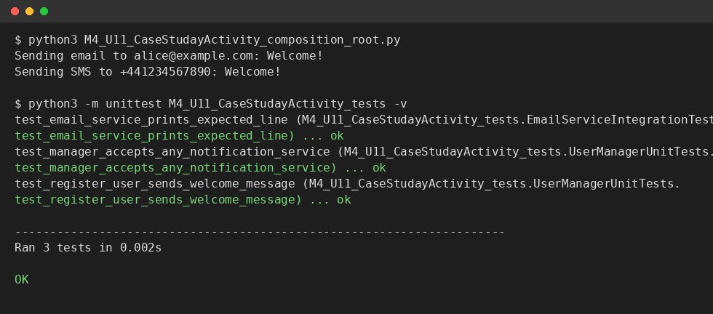
Figure 1. Console output: channel swap demonstration and full test run, all three tests passing.

References

Laigner, R., Mendonça, D., Garcia, A. and Kalinowski, M. (2022) 'Cataloging dependency injection anti-patterns in software systems', The Journal of Systems & Software, 184, p. 111125. Available at: https://doi.org/10.1016/j.jss.2021.111125.

Taelman, R., Van Herwegen, J., Vander Sande, M. and Verborgh, R. (2023) 'Components.js: Semantic dependency injection', Semantic Web, 14(1), pp. 135-153. Available at: https://doi.org/10.3233/SW-222945.

Tuğan, S., Arslan, E. and Tiryaki, A.M. (2024) 'Developing a web framework based on Inversion of Control', The European Journal of Research and Development, 4(2), pp. 96-109. Available at: https://doi.org/10.56038/ejrnd.v4i2.441.

University of Essex Online (n.d.) 'How Do DI Frameworks Enhance Flexibility and Testability?' [Lecturecast transcript]. Unit 11: Dependency Injection and Inversion of Control. Colchester: University of Essex Online.

