ATM Software System

CSC 340 – Design specification report

Blankenship, Sean A.

2022

Table of Contents

Table of Figures 2

I. Introduction 3

A. Problem Statement 3

B. Proposal 3

II. System Description 3

III. System Requirements 3

A. Functional Requirements 3

B. Non-functional Requirements 11

IV. Use Case Diagram 12

V. Class Diagram 13

VI. Sequence Diagrams 14

A. Log In 14

B. Log Out 15

C. Check Balance 16

D. Deposit Money 17

E. Withdraw Money 18

F. Transfer Money 19

VII. State Diagram 20

VIII. Activity Diagrams 21

A. Log In 21

B. Log Out 22

C. Check Balance 23

D. Deposit Money 24

E. Withdraw Money 25

F. Transfer Money 26

IX. Database Design 27

A. ER Diagram 27

B. Table Schema 28

X. Conclusion 28

XI. Data Dictionary 29

# Table of Figures

Figure 1 ATM Use Case Diagram 12

Figure 2 ATM Class Diagram 13

Figure 3 Log In Sequence Diagram 14

Figure 4 Log Out Sequence Diagram 15

Figure 5 Check Balance Sequence Diagram 16

Figure 6 Deposit Money Sequence Diagram 17

Figure 7 Withdraw Money Sequence Diagram 18

Figure 8 Transfer Money Sequence Diagram 19

Figure 9 ATM State Diagram 20

Figure 10 Log In Activity Diagram 21

Figure 11 Log Out Activity Diagram 22

Figure 12 Check Balance Activity Diagram 23

Figure 13 Deposit Money Activity Diagram 24

Figure 14 Withdraw Money Activity Diagram 25

Figure 15 Transfer Money Activity Diagram 26

Figure 16 ATM Entity Relationship Diagram 27

Figure 17 ATM Table Schema 28

# Introduction

## Problem Statement

ZZZ bank has no ATMs currently. They are seeking assistance in creating a software system for the machines.

## Proposal

We propose an ATM software system to help their customers use their ATMs effortlessly.

# System Description

This ATM Software System is for a new local bank known as ZZZ Bank. The system will be used across various ATMs. The machines will provide basic operations to their customers, including depositing money, withdrawing money, checking balances, and transferring money from one account to another. Each machine will be refilled to hold $100,000 cash daily for possible withdrawals. For security reasons, each account can have at most $3000 in total for all the transactions (except for checking balance) through ATMs each day. Effectiveness and efficiency are ZZZ Bank’s primary requirements.

# System Requirements

## Functional Requirements

1. The system shall allow a user to log in to the ATM.
   1. The user shall insert their card and enter their PIN.

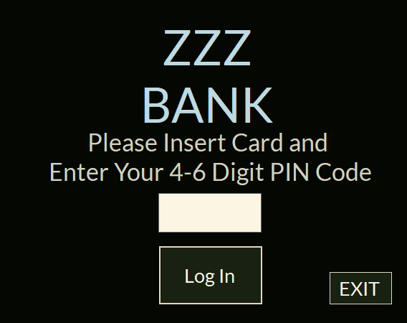

* 1. The user shall press the “Log In” button.
     1. If the PIN is invalid, the system shall display an error message and let the user try again.

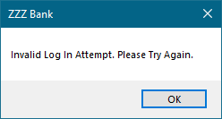

* + 1. If the PIN is valid, The system shall take the user, who is now a customer, to the primary screen where they can now select what they wish to do.

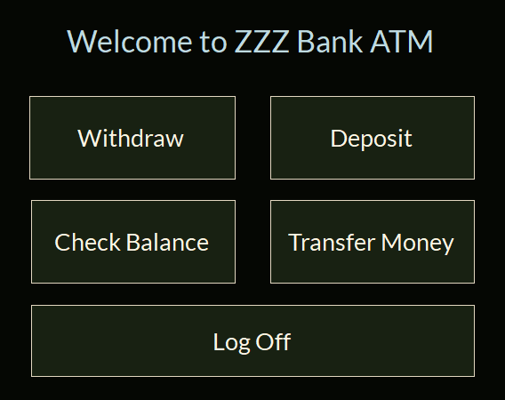

1. The system shall allow a customer to log out of the ATM.
   1. The customer shall select the “Log Off” button from the main menu.

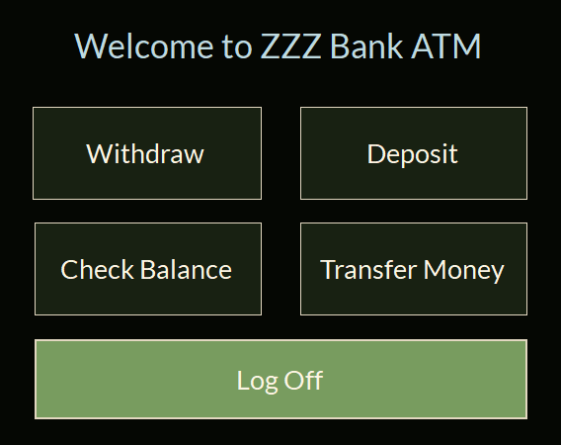

* 1. The system shall ask the user if they are sure they wish to exit.

* + 1. If yes, the system shall prompt the customer to remove their card.
       1. Once the card is removed the system shall return to the card prompt screen.
    2. If no, the system shall return to the main menu.

1. The system shall allow a customer to check their balance.
   1. The customer shall select the “Check Balance” button from the main menu.

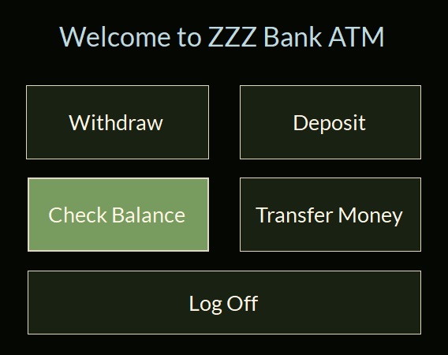

* 1. The system shall display a list of accounts that belong to the customer.

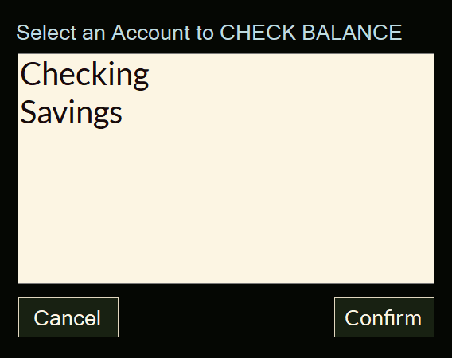

* 1. The customer shall select the account they wish to check.
  2. The system shall display the balance of the selected account.

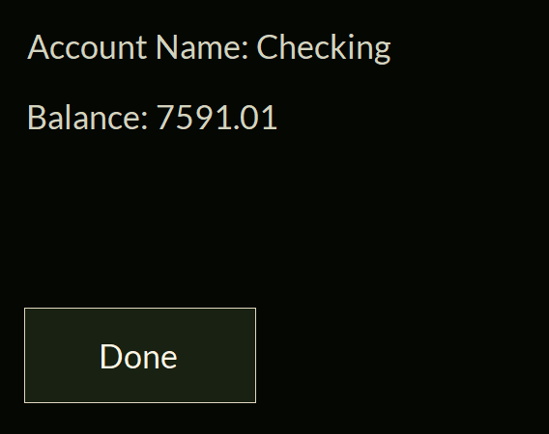

* 1. The customer shall select “Continue”
  2. The system shall return to the main menu

1. The system shall allow a customer to deposit money into their account
   1. The customer shall select the “Deposit Money” button from the main menu.

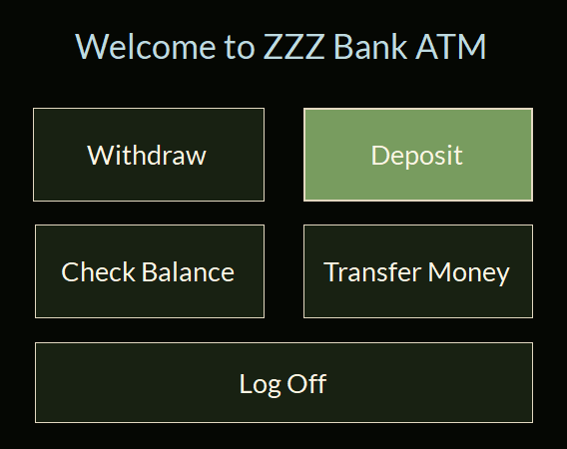

* 1. The system shall display a list of accounts that belong to the customer.

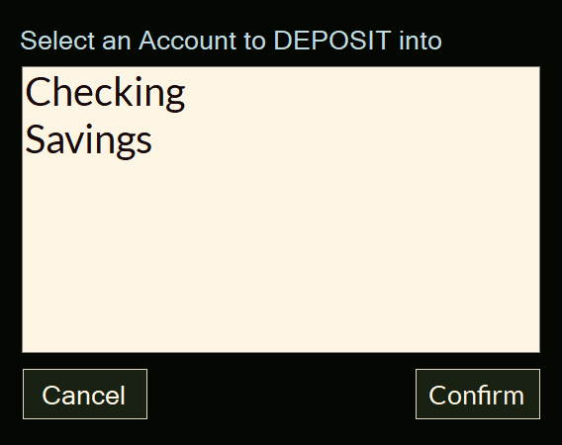

* 1. The customer shall select the account to deposit money.
  2. The system shall display the balance of the selected account.
  3. The customer shall enter the amount they plan to deposit.

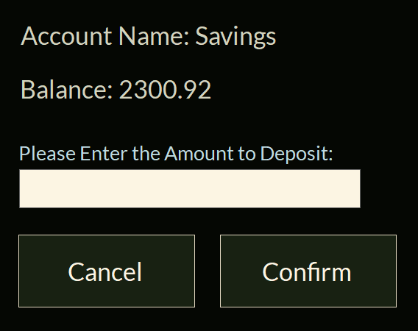

* 1. The system shall validate the amount.
     1. If the amount violates the non-functional requirement NR1, the system shall display an error message and return to the previous screen in step 4.4.

* + 1. If the amount is valid, the system shall go to step 4.7.
  1. The system shall request for the user to deposit the envelope enclosed with money.
  2. The customer shall deposit the funds.
  3. The system shall add the amount to the daily transaction amount (NR1).
  4. The system shall report to the user that the transaction will be processed.

* 1. The system shall return to the main menu.

1. The system shall allow a customer to withdraw money from their account.
   1. The customer shall select the “Withdraw Money” button from the main menu.

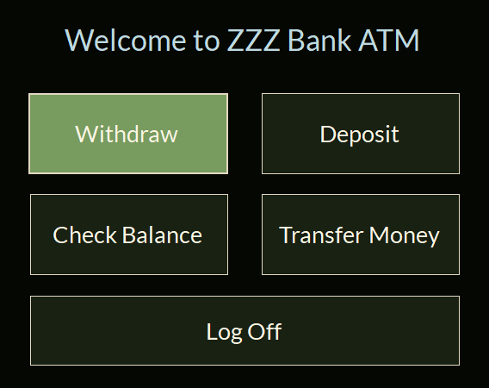

* 1. The system shall display a list of accounts that belong to the customer.

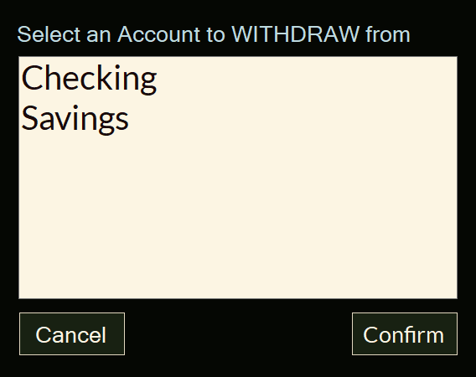

* 1. The customer shall select the account to withdraw money.
  2. The system shall display the balance of the selected account.
  3. The customer shall enter the amount for withdrawal.

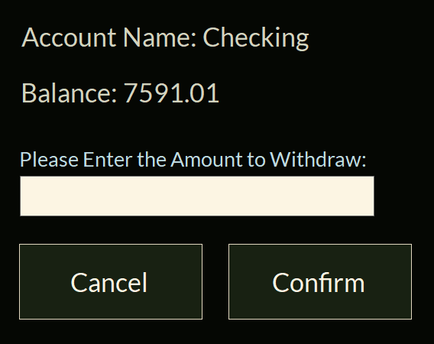

* 1. The system shall validate the amount.
     1. If the amount is greater than the balance, the system shall display an error message and return to the previous screen in step 5.4.

* + 1. If the amount violates the non-functional requirement NR1, the system shall display an error message and return to the previous screen in step 5.4.

* + 1. If the amount is valid, the system shall go to step 5.7.
  1. The system shall dispense the money.

* 1. The system shall add the amount to the daily transaction amount (NR1).
  2. The system shall deduct the amount from the balance
  3. The system shall return to the main menu.

1. The system shall allow a customer to transfer money from one account to another.
   1. The customer shall select the “Transfer Money” button from the main menu.

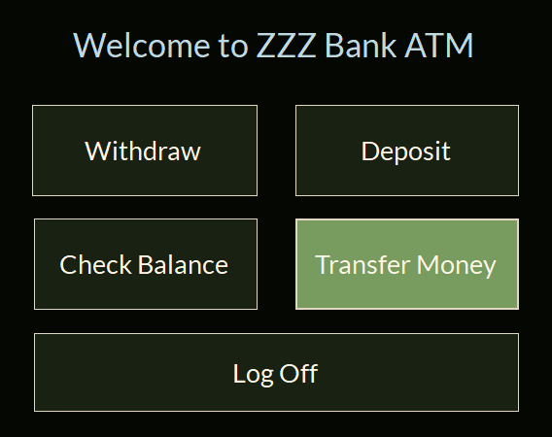

* 1. The system shall display a list of accounts that belong to the customer.

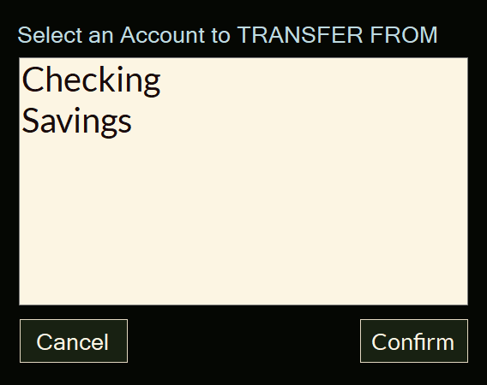

* 1. The customer shall select the account to transfer money from.
  2. The system shall once again display a list of accounts that belong to the customer (excluding the one already selected).

* 1. The customer shall select the account to transfer money to.
  2. The system shall display the balance of the selected accounts.
  3. The customer shall enter the amount to transfer.

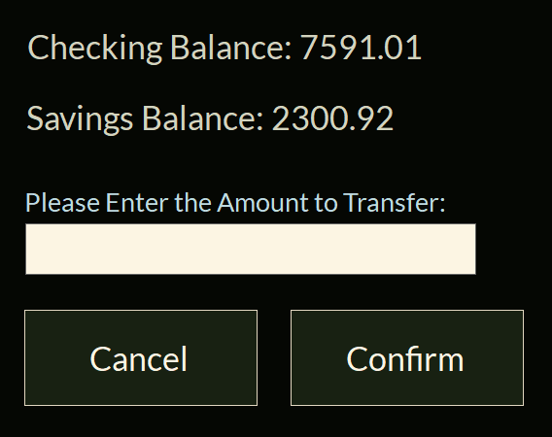

* 1. The system shall validate the amount.
     1. If the amount is greater than the balance of the first account, the system shall display an error message and return to the previous screen in step 6.6.

* + 1. If the amount violates the non-functional requirement NR1, the system shall display an error message and return to the previous screen in step 6.6.

* + 1. If the amount is valid, the system shall go to step 6.9.
  1. The system shall deduct the amount from the balance of the first account.
  2. The system shall add the amount to the balance of the second account.
  3. The system shall add the amount to the daily transaction amount (NR1).
  4. The system shall return to the main menu.

## Non-functional Requirements

1. For security reasons, each account can have at most $3000 in total for all the transactions (except for checking balance) through ATMs each day.
2. If the machine’s daily withdrawals across all accounts exceed $100,000 then the ATM will not process any further transactions until the next day, as the machine only holds $100,000 each day.
3. Customer PINs can only be 4-6 numbers. No letters, no symbols, no shorter, no longer.
4. Balances for withdrawal, deposit, and transfer can not be over 7 characters long (1234.67 is an example of the longest transaction that the system will handle due to the $3000.00 limit as seen in non-functional requirement NR1.

# Use Case Diagram



Figure ATM Use Case Diagram

Figure 1 provides an explanation of who can use what features of the ATM software system.

Users can log into the machine but do not have access to any other features.

Once a user logs in and becomes a customer, they gain access to all the other features that the system offers. These features include depositing money into the customer’s accounts, withdrawing money from the customer’s accounts, transferring money from one of the customer’s accounts to another, checking the balance of the customer’s accounts, and logging out of the system.

# Class Diagram



Figure ATM Class Diagram

Figure 2 shows the entire process of the ATM software system. The single customer uses the machine to process transactions that modify the state of the accounts that the user owns. Put simply, the customers will use the ATM to make changes to their accounts.

These transactions vary in nature but the user is able to check their balance, deposit money, withdraw money, and transfer money.

# Sequence Diagrams

## Log In



Figure Log In Sequence Diagram

Figure 3 provides an explanation of the simple process of logging out.

First the user inserts their card, which is processed then validated by the system. Then the user inserts their PIN number, which is validated by the system. After the card and PIN are validated, the system logs the customer into the system.

## Log Out



Figure Log Out Sequence Diagram

Figure 4 provides an explanation of the simplest process of the system, logging out.

All the customer needs to do is select the log out button, which will be accompanied by a popup ensuring the customer wishes to do so (both contained in logOut()), once finished the system will log out the user and take them back to the main menu.

## Check Balance



Figure Check Balance Sequence Diagram

Figure 5 provides an explanation of the simple process of checking the balance.

The customer selects the “check balance” button on the main menu which will then begin the transaction. First, a list of the customer’s accounts will be provided and then they must select the account they wish to view the balance of and is shown that balance by the system.

All the system needs to do is show the customer the balance of the account they selected.

## Deposit Money



Figure Deposit Money Sequence Diagram

Figure 6 provides an explanation of the process of depositing cash.

The customer selects the “deposit money” button on the main menu which will then begin the transaction. First, a list of the customer’s accounts will be provided and then they must select the account they wish to deposit cash into, then they provide the amount they wish to deposit.

The system, in turn, will validate the amount with the daily transaction limit then receive the money and begin processing the transaction.

## Withdraw Money



Figure Withdraw Money Sequence Diagram

Figure 7 provides an explanation of the process of withdrawing cash. This process is incredibly similar to that of depositing cash, however this time it is the balance will be deducted rather than added to.

The customer selects the “withdraw money” button on the main menu which will then begin the transaction. First, a list of the customer’s accounts will be provided and then they must select the account they wish to withdraw cash from, then they provide the amount they wish to withdraw.

The system, in turn, will validate the amount with the daily transaction limit and the accounts balance then dispense the money.

## Transfer Money



Figure Transfer Money Sequence Diagram

Figure 8 illustrates the most complex process of the system, transferring money. This is the process of transferring the funds from one account to another. All that is needed is the two accounts, the amount, and then the action of swapping them.

The customer selects the “transfer money” button on the main menu which will then begin the transaction. First, a list of the customer’s accounts will be provided and then they must select the account they wish to withdraw cash from, then the account they wish to deposit money into. After this they provide the amount they wish to transfer.

The system, in turn, will validate the amount with the daily transaction limit and the accounts balance then transfer the money by first withdrawing the funds from the first account and then depositing them into the second account.

# State Diagram



Figure ATM State Diagram

Figure 9 shows the entire process of the ATM software system in relative detail from the machines perspective. The machine is idle until a user approaches and inserts their card. After the card is validated, the same is done with the user’s PIN number. If either turn up invalid, an error is displayed and the card is ejected prompting the user to try again.

From the point after both are validated, the user is logged in and can perform as many transactions as wanted, once finished they will cancel out of the menu and the card will be ejected, returning the machine to an idle state.

# Activity Diagrams

## Log In



Figure Log In Activity Diagram

Figure 10 provides an explanation of the simple process of logging out.

First the user inserts their card, which is processed then validated by the system. Then the user inserts their PIN number, which is validated by the system. After the card and PIN are validated, the system logs the customer into the system.

## Log Out



Figure Log Out Activity Diagram

Figure 11 provides an explanation of the simplest process of the system, logging out.

All the customer needs to do is select the log out button, which will be accompanied by a popup ensuring the customer wishes to do so (both contained in logOut()), once finished the system will log out the user and take them back to the main menu.

## Check Balance



Figure Check Balance Activity Diagram

Figure 12 provides an explanation of the simple process of checking the balance in more detail.

The customer selects the “check balance” button on the main menu which will then begin the transaction. First, a list of the customer’s accounts will be provided through SQL statements and then the customer must select the account they wish to view the balance of and is shown that balance by the system.

All the system needs to do is show the customer the balance of the account they selected.

After this the user confirms they are finished and the process is over.

## Deposit Money



Figure Deposit Money Activity Diagram

Figure 13 provides an explanation of the process of depositing cash.

The customer selects the “deposit money” button on the main menu which will then begin the transaction. First, a list of the customer’s accounts will be provided through SQL statements and then the customer must select the account they wish to deposit cash into, then they provide the amount they wish to deposit.

The system, in turn, will validate the amount with the daily transaction limit then receive the money and add it to the user’s balance.

## Withdraw Money



Figure Withdraw Money Activity Diagram

Figure 14 provides an explanation of the process of withdrawing cash. This process is incredibly similar to that of depositing cash, however this time it is the balance will be deducted rather than added to.

The customer selects the “withdraw money” button on the main menu which will then begin the transaction. First, a list of the customer’s accounts will be provided through SQL statements and then the customer must select the account they wish to withdraw cash from, then they provide the amount they wish to withdraw.

The system, in turn, will validate the amount with the daily transaction limit and the accounts balance then dispense the money whilst also deducting it from the balance of the customer’s account.

## Transfer Money



Figure Transfer Money Activity Diagram

Figure 15 illustrates the most complex process of the system, transferring money. This is the process of transferring the funds from one account to another. All that is needed is the two accounts, the amount, and then the action of swapping them.

The customer selects the “transfer money” button on the main menu which will then begin the transaction. First, a list of the customer’s accounts will be provided through SQL statements and then the customer must select the account they wish to withdraw cash from, then the account they wish to deposit money into. After this they provide the amount, they wish to transfer.

The system, in turn, will validate the amount with the daily transaction limit and the accounts balance then transfer the money by first withdrawing the funds from the first account and then depositing them into the second account.

# Database Design

## ER Diagram

Figure ATM Entity Relationship Diagram

Figure 16 shows the entire process of the ATM software system. The single customer uses the machine to process transactions that modify the state of the accounts that the user owns. Put simply, the customers will use the ATM to make changes to their accounts.

These transactions vary in nature but the user is able to check their balance, deposit money, withdraw money, and transfer money.

All of these are tied together through their id’s as underlined in the diagram.

## Table Schema

Figure ATM Table Schema

Figure 17 is ultimately the same as figure 16 shows the entire process of the ATM software system. However more emphasis is placed onto how these would work in a table format, with the headings of the table being placed under the tables themselves.

# Conclusion

The proposed ATM software system will assist the new ZZZ bank in handling customer transactions. It offers a quick, efficient, and easy-to-understand user interface that will provide not only the customers with a convenient experience but will also provide ZZZ bank staff with an effective and efficient automated teller that will increase workplace productivity.

# Data Dictionary

Activity Diagram - An activity diagram is a graphical representation of the exact steps used in the process of what they represent for the ATM system.

Actors - Actors, seen in the diagrams, are the individuals or objects that take part in the ATM software system process.

Class Diagram - An ER diagram is a graphical representation that shows the general relationships between classes in the system with an emphasis on their variables and functions within the program.

Customer - Once a user logs in, they are officially a customer with ZZZ bank.

ER Diagram - An ER diagram is a graphical representation that shows the relationship between classes in the system with an emphasis on how they would work in a database.

Main Menu - The screen where all the primary functions of the program are located. Including deposit, withdraw, check balance, transfer, and log out.

Sequence Diagram - A Sequence diagram is a graphical representation that shows the functions that will be used to preform a certain process in the ATM system.

State Diagram - A State diagram is a graphical representation that shows the general process of the entire system.

Table Schema - A table schema is a graphical representation that shows the relationship between classes in the system with an emphasis on how they work together as tables within a database.

Use Case Diagram - A use case diagram is a graphical representation used to illustrate the functions that the ATM system can perform, and who/what can perform them.

User - A user is any individual who interacts with the machine, but has not logged in.