Component 2: Data Science
Patterns, correlations and trends in the Bangkok CCTV dataset
2190513 Data Science (ICE) · Data Science Project 2026/1 · Pipatpol Wongtharua (Tim)

1. What this component does
The project brief defines Component 2 as applying analytical methods to explore patterns, trends and insights in the prepared dataset, and defines the project objective as analysing meaningful spatial and/or temporal patterns. This document reports what was found.
The analysis takes the structured data produced by Component 1 and asks three questions: how traffic varies in time, how it varies in space, and which measured variables carry information about each other. It also audits the dataset itself, which turned up two collection faults that affect everything downstream.

2. The data analysed
100 traffic cameras across Bangkok. Each took a photograph roughly every 10 minutes between 06:00 and 21:00, over seven days from Tuesday 25 August to Monday 31 August 2026. That is 61,319 photographs, about 613 per camera.
Component 1 ran YOLO object detection on every photograph and counted four vehicle classes in each: cars, motorcycles, buses and trucks. One row of the dataset is therefore one photograph, with its camera, coordinates, timestamp and four counts.
For this component a further 23 columns were generated describing each camera's physical surroundings from OpenStreetMap: counts of shops, offices, bus stops, traffic signals, crossings, parking, green space and road classes within 100 m and 500 m.

What the detector found | Mean per photo | % of photos showing zero | Share of all vehicles
Cars | 7.94 | 6% | 74.9%
Trucks | 1.20 | 45% | 11.3%
Motorcycles | 1.06 | 62% | 10.0%
Buses | 0.40 | 74% | 3.8%
Cars dominate. The three other classes are zero in most photographs, so they behave more like presence/absence signals than like counts.

3. How the analysis was set up
One methodological decision shapes every number in this report, so it is stated up front. The dataset has one row per photograph, but the variables live at three different grains:

Level | Rows | What actually varies at this level
One photograph | 61,319 | vehicle counts, plus substantial detector noise
One camera-hour | 10,728 | averaged traffic for that camera in that hour
One camera | 100 | the camera's surroundings and its typical traffic

A camera's surroundings are identical across all 613 of its photographs. Testing a surroundings variable against 61,319 photograph rows therefore repeats each camera's single value 613 times and treats copies as evidence.
Measured directly: the strongest surroundings relationship carries p = 0.00097 when computed across 100 cameras and below 1e-300 when computed across 61,319 photographs. The coefficient barely moves. Only the pseudo-replication changed. Every result below states the level it was computed at.
Correlations use Spearman's rho because the counts are zero-inflated and skewed. Where many variables are tested at once, p-values are corrected for multiple comparisons using the Benjamini-Hochberg procedure at a false discovery rate of 5 percent. Confidence intervals for camera-level quantities come from a bootstrap that resamples whole cameras rather than rows.

4. Patterns

4.1 Location matters far more than time
This is the central finding. Of all the variation in camera-hour traffic, 56 percent is differences between cameras and only 44 percent is a single camera changing over time. Hour of day on its own explains just 11.5 percent of the variance.
The quietest camera averages 2.6 vehicles per photograph; the busiest averages 24.6. That 9.3-fold spread across locations dwarfs anything the clock does.
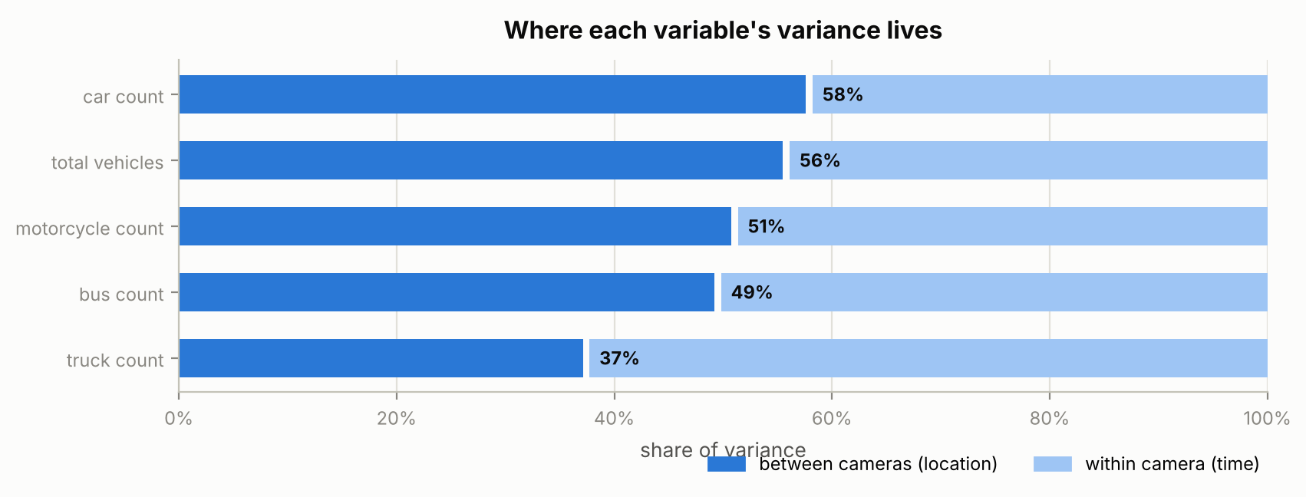
Figure 1. Share of variance that is between cameras (location) versus within a camera (time).

 | Camera | Location | Mean vehicles per photo
Busiest | 277 | Footbridge near Soi Rang Nam, Phayathai Road | 24.6
 | 112 | Police box on Thiam Ruam Mit Road | 23.0
 | 11 | Traffic lights near Soi Rajavithi 6 | 22.8
Quietest | 619 | Pathum Wan Intersection | 3.3
 | 370 | Thewet Intersection | 2.8
 | 170 | Footbridge near Nawati Somdet Ya Hospital | 2.7

Consequence: the default view of the dashboard should be a map. Feature engineering for any predictive model should concentrate on describing locations, with time of day as a correction term rather than the driver.

4.2 Nearby cameras are not alike
Spatial clustering was tested with Moran's I on a five-nearest-neighbour graph, using a permutation test for significance. Total traffic gives I = +0.10 with p = 0.054, which does not clear the 0.05 threshold. Cameras close together are not meaningfully more similar than cameras far apart.
Two individual classes do cluster weakly: bus counts (I = +0.25, p = 0.002) and motorcycle counts (I = +0.13, p = 0.024). One reading, which this data cannot confirm, is that buses and motorcycles follow fixed route structure that is geographically organised, whereas car counts are set mainly by what each camera happens to be pointed at.
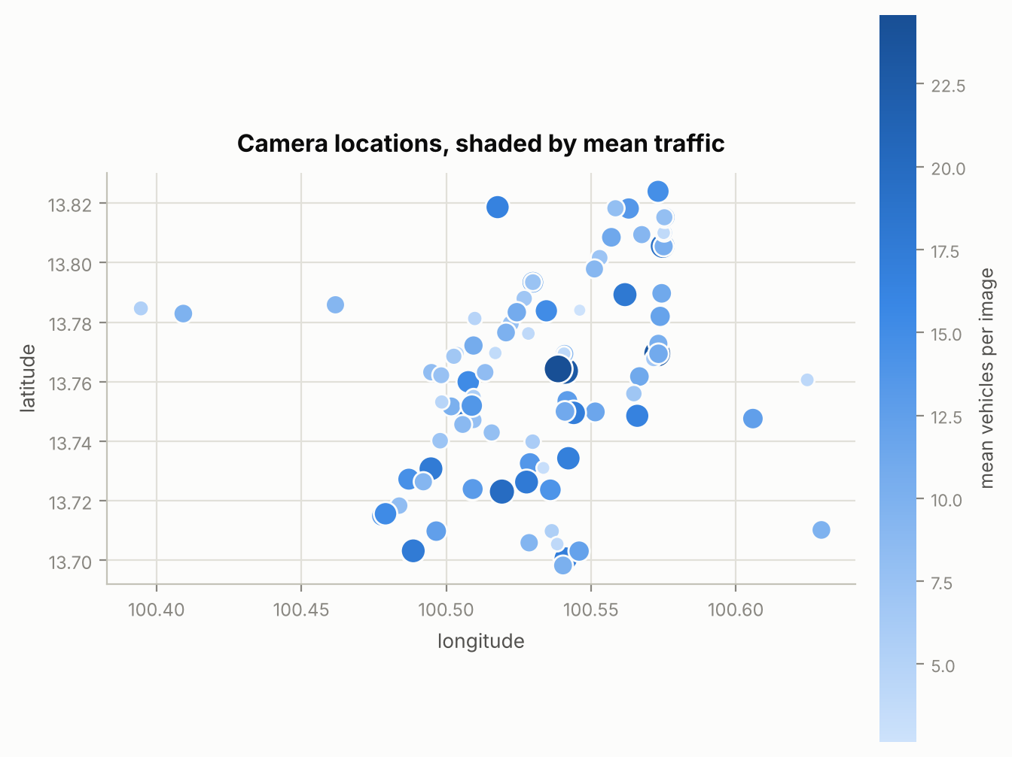
Figure 2. The 100 camera locations, shaded by mean traffic. Busy and quiet cameras sit next to each other throughout the city.
Consequence: a smoothed heatmap that interpolates between camera points is not supported by the data and would be inventing values. Show the cameras as discrete points. A higher-resolution map must be predicted at each location from that location's own features.

4.3 Cameras fall into two behavioural types
Cameras were clustered on the shape of their day rather than its height: each camera's hourly profile was divided by its own mean first, so a quiet street and a busy street with the same rhythm group together. The number of clusters was chosen by silhouette score across k = 2 to 6.
The best solution is two types, at a silhouette of 0.198. That is weak, and it is reported as such: these are two bands along a continuum rather than two distinct kinds of camera. The split is still usable as a coarse filter.
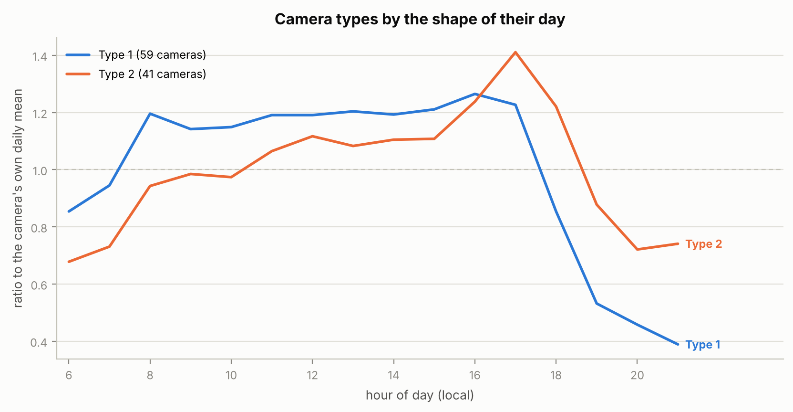
Figure 3. The two camera types, each indexed to its own daily mean. The difference is in the evening.

Type | Cameras | Peaks at | Peak height | Level at 21:00 | Mean vehicles
Type 1 | 59 | 16:00 | 1.26x | 0.39x | 9.5
Type 2 | 41 | 17:00 | 1.41x | 0.74x | 11.3

Type 1 collapses sharply after the evening peak, falling to 39 percent of its own daily average by 21:00. Type 2 peaks higher and later and is still at 74 percent at the same hour.
Worth noting: the type a camera belongs to correlates with how busy it is at only rho = +0.15. Shape of day and volume of traffic are close to independent, so the typology is a genuinely separate axis users can filter on rather than a restatement of which cameras are busy.

5. Correlations

5.1 The built environment barely explains traffic
All 23 OpenStreetMap surroundings features were tested against each camera's mean traffic, at camera level with n = 100, and corrected for multiple comparisons. Only two survive.

Feature | Spearman rho | 95% CI | Corrected p | Survives
Major roads within 100 m | +0.33 | +0.13 to +0.49 | 0.022 | Yes
Major roads within 500 m | +0.29 | +0.09 to +0.46 | 0.040 | Yes
Traffic signals within 100 m | +0.22 | +0.02 to +0.41 | 0.200 | No
Residential roads within 500 m | +0.20 | +0.00 to +0.39 | 0.228 | No
Pedestrian crossings within 100 m | +0.20 | -0.01 to +0.38 | 0.228 | No

Shops, offices, bus stops, parking, green space and rail stations all come back with nothing. Even the strongest feature explains only about 11 percent of the variation between cameras.
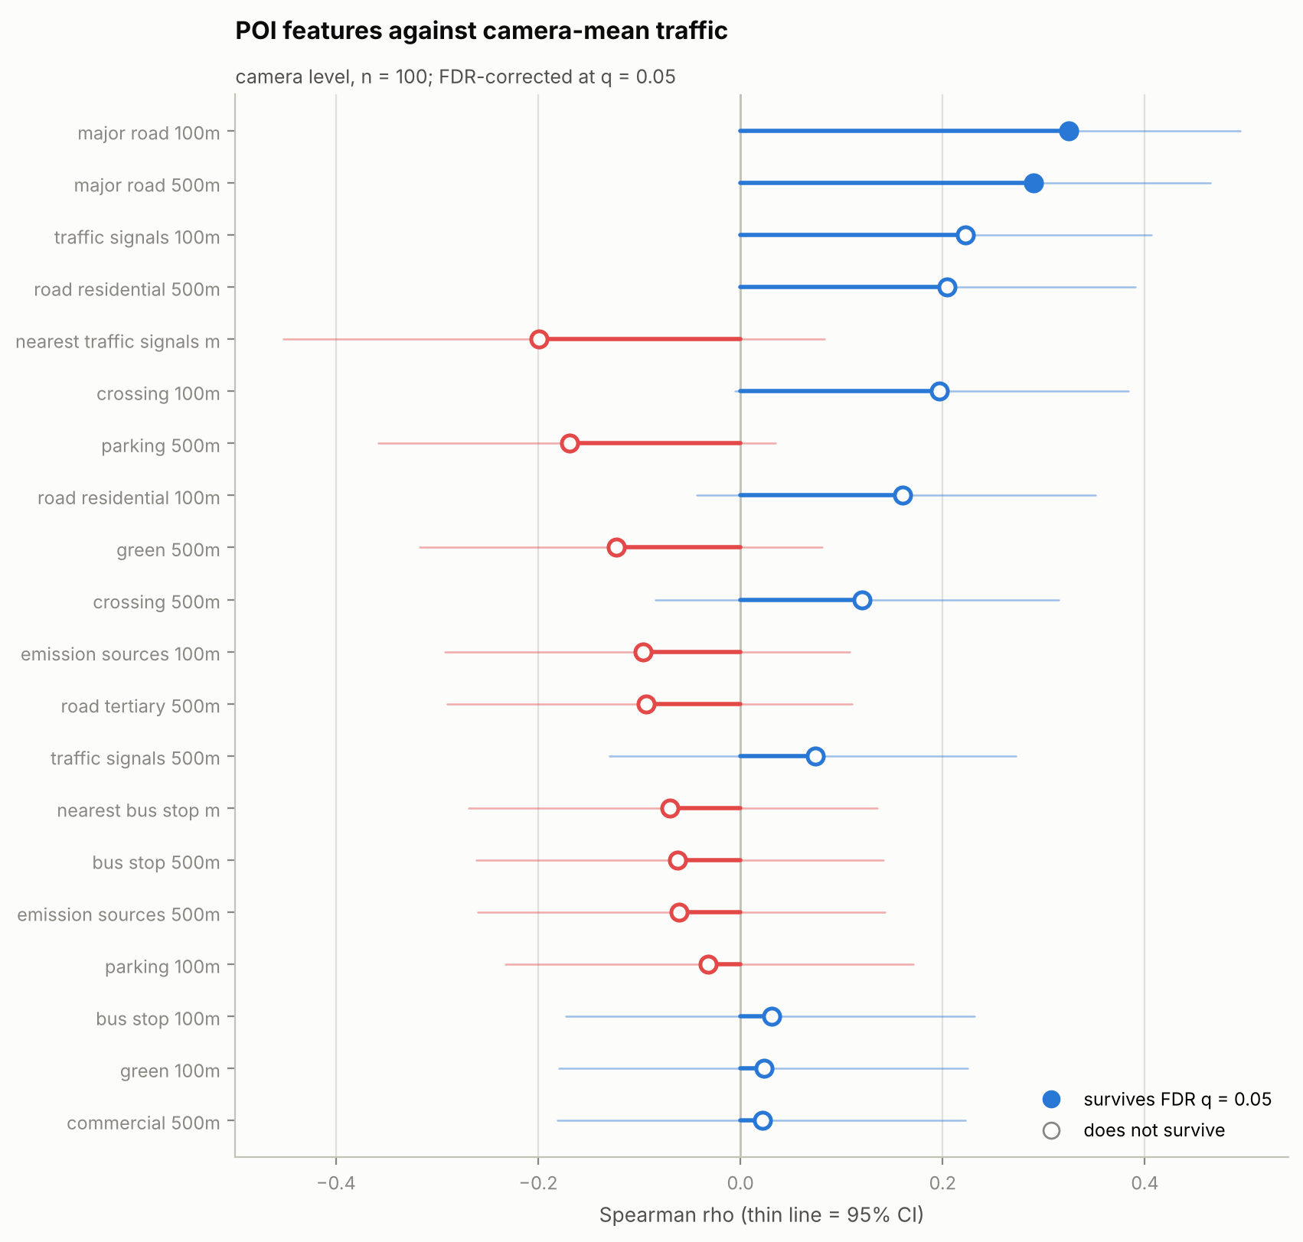
Figure 4. All 23 surroundings features ranked by correlation with camera-mean traffic. Filled dots survive correction for multiple comparisons; hollow dots do not. Thin lines are 95% confidence intervals.
Honest reading: a traffic camera points at a road. What governs its counts is the road itself, not the amenities near it. If more location signal is needed, it should come from road geometry such as lane count, carriageway width and junction type, not from adding more amenity categories.

5.2 Single photographs are noisy; camera averages are not
Across individual photographs the four vehicle classes barely move together, at a mean correlation of +0.21. Across camera averages the same four classes correlate at +0.39, roughly double.
The gap between those two numbers is the clearest available evidence that a single frame is a poor measurement. One parked truck, one shadow, one patch of glare, and the count for that frame is wrong. Averaging the five or six photographs in a camera-hour cancels most of that out.
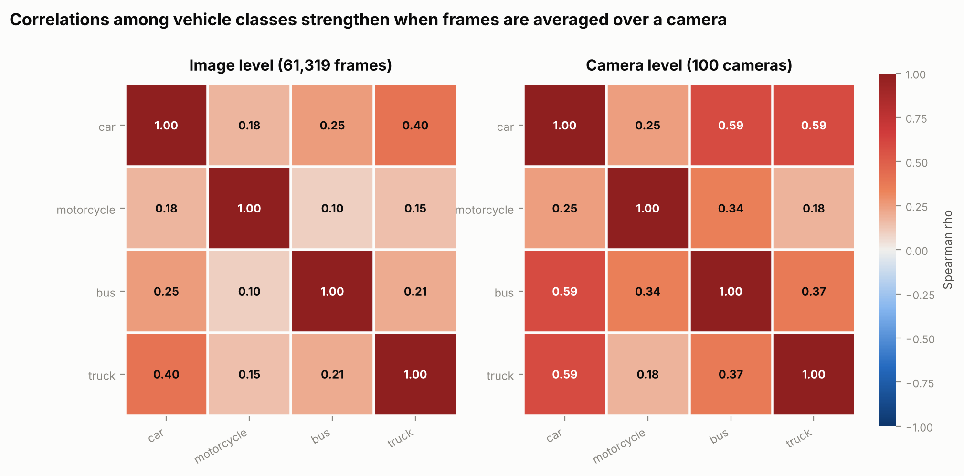
Figure 5. The same four vehicle classes correlated at photograph level and at camera level, on one shared colour scale.
A principal component analysis on the camera-level means puts 50 percent of the variance on the first component against 25 percent for four structureless channels. There is a common traffic-volume factor, but it is not dominant: collapsing the four classes into a single congestion index would discard about half the variation, and the second component (23 percent) is driven almost entirely by motorcycles.
Consequence: aggregate to camera-hour before modelling or charting. Never present a single photograph's count as a fact, and keep the class breakdown rather than replacing it with one number.

6. Trends

6.1 The daily cycle, and the trap inside it
Traffic peaks at 17:00 with a mean of 13.0 vehicles per photograph and bottoms out at 20:00 at 6.0. The cycle is real but shallow, since hour of day explains only 11.5 percent of the variance in camera-hour traffic.
The classes do not share a peak. Motorcycles peak at 08:00, trucks at 11:00, buses at 16:00 and cars at 17:00, a spread of nine hours. They are different traffic processes and should not be collapsed into a single congestion number without checking which class is driving the result.
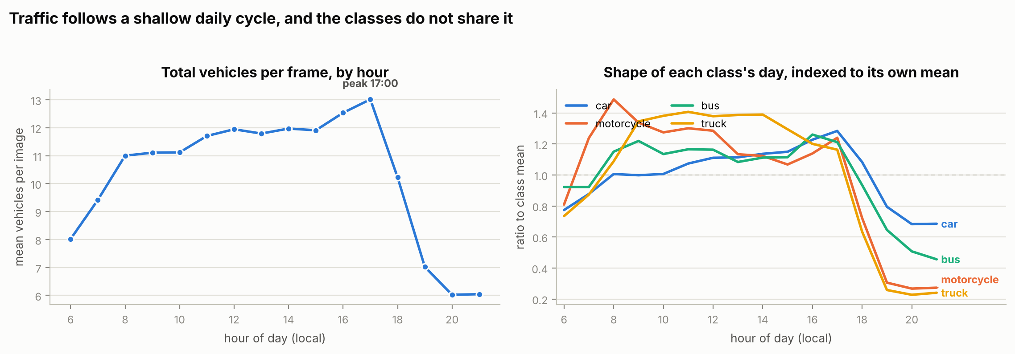
Figure 6. Total traffic by hour, and the shape of each class's day indexed to its own mean.
The trap: 17:00 is the tallest single hour, but traffic collapses immediately after 18:00. Summed across the day, the morning block from 06:00 to 11:00 carries more traffic than the evening block from 16:00 to 21:00 on every single day of the week, with the evening-to-morning ratio running between 0.75 and 1.00 and never reaching 1.
This means ranking locations by busiest hour and ranking them by daily total produce different orders. Both are defensible. Whichever the dashboard uses must be labelled, or the two views will appear to contradict each other.

6.2 The weekly rhythm
Wednesday is this week's busiest day at 11.53 vehicles per photograph and Sunday the quietest at 8.40. Weekday traffic exceeds weekend traffic by 2.33 vehicles per photograph, with a 95 percent confidence interval of 2.05 to 2.64 from a bootstrap that resamples whole cameras.
That interval excludes zero, so the weekday/weekend difference survives proper clustering. It should still be read with care: the window contains only one weekend, so the effect cannot be separated from whatever else happened on 29 and 30 August.
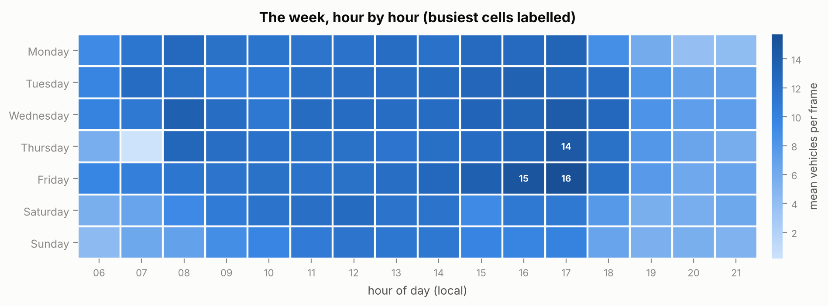
Figure 7. Mean vehicles per photograph for every day-of-week and hour combination. The pale Thursday morning cells are the collection outage described in section 7.

Camera type | Weekday mean | Weekend mean | Drop
Type 1 | 10.38 | 8.19 | 21.1%
Type 2 | 12.06 | 9.84 | 18.4%

The weekend drop is not uniform. Type 1 cameras lose 21 percent of their weekday traffic against 18 percent for Type 2, so commuter-driven locations and all-week locations are distinguishable from the vehicle counts alone.
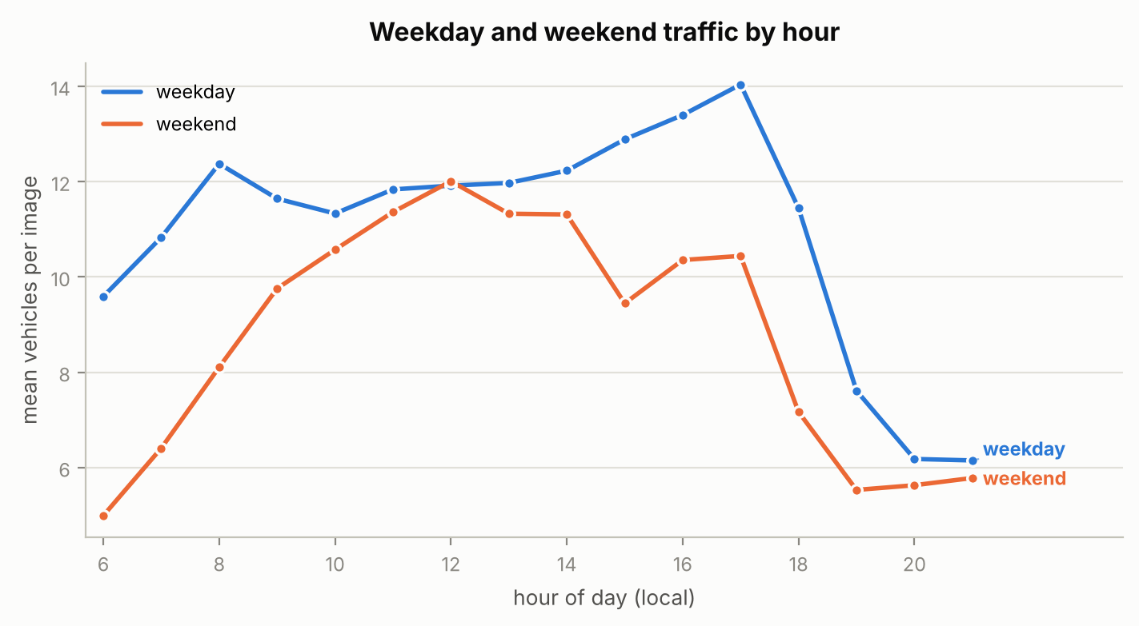
Figure 8. Weekday and weekend hourly profiles. The weekend has no morning ramp.

6.3 Camera-hours that depart from their own norm
An expected value was built for every camera at every hour, separately for weekdays and weekends, then every camera-hour was scored against it. Deviations were standardised using the median and median absolute deviation rather than the mean and standard deviation, so the outliers being searched for cannot inflate the scale used to detect them.
317 of 10,209 scored camera-hours, or 3.11 percent, deviate by more than 3.5 robust standard deviations. A normal distribution would produce well under 0.1 percent.
This was checked not to be an artefact of a collapsed scale. The median robust standard deviation is 1.48 vehicles, about 14 percent of the overall mean, and the residual distribution has an excess kurtosis of 4.6 against 0 for a normal. The counts genuinely have heavy tails, so these flags represent real structure: incidents, closures, weather, or detector failures.
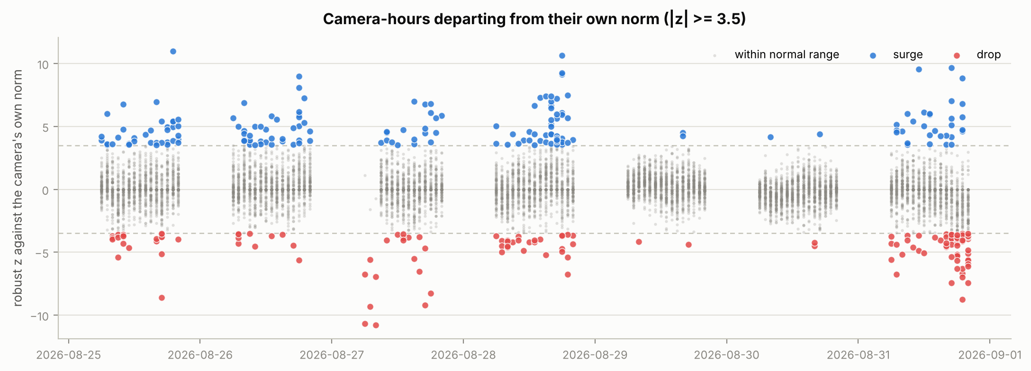
Figure 9. Every scored camera-hour by how far it departs from that camera's own norm for that hour and day type.
The flags are concentrated rather than spread evenly. Camera 196 alone accounts for 14 of them, and its imagery should be checked before its numbers are treated as traffic. Separately, the five cameras with the flattest counts across the whole week are worth a manual look: a traffic camera whose count barely moves is more likely to be mis-framed or obstructed than genuinely steady.

7. Two collection faults found
Both of these were found by the anomaly analysis and both must be excluded from any chart, average or model. They are stated here because they will produce visibly wrong results otherwise.

7.1 The scraper missed the morning of Thursday 27 August
At 07:00 and 08:00 that day, 165 camera-hours were built from under half the usual number of photographs. A further 472 camera-hours across the week produced no row at all because no photograph was captured. Thursday 27 August has 1,429 camera-hours against a median of 1,550 for the other days.
Why it matters: a simple average over whatever rows are present will report that morning as near-empty roads across the entire city. Traffic was normal. The cameras were not looking. Absent rows are the easy mistake here, because a groupby over what exists silently averages a smaller city instead of reporting a gap.

7.2 The 21:00 hour is incomplete on every date
Collection stops partway through 21:00, so that hour holds roughly 50 photographs instead of 600. This is the edge of the collection window, not a fault, and it is the same on all seven days.
Why it matters: including 21:00 in an hourly average produces a dramatic evening collapse that does not exist in the traffic. Any hourly chart must drop that hour or label it.

8. Insights and what follows from them

For the visualisation module (Component 3)
- Lead with a map. 56 percent of all variation is between locations, so that is where the story is.
- Use discrete camera points, not a smoothed surface. There is no significant spatial clustering, so interpolating between cameras would be inventing data.
- Offer the camera type as a filter. It is close to independent of traffic volume, so it adds an axis rather than repeating one.
- Show hourly profiles rather than daily averages. A single daily number hides both the evening peak and the morning weight.
- Label whichever ranking is used. Busiest hour and daily total give different orders, and both are correct.
- Exclude 21:00 and the Thursday 27 August morning from every average, or the dashboard will show faults as findings.
- Never display a single photograph's count. Use camera-hour averages.

For any predictive model
- Aggregate to camera-hour before fitting. Per-photograph counts add variance without adding signal.
- Prioritise location descriptors over temporal ones, and prefer road geometry over amenity counts.
- Split validation data by whole cameras and whole days. Two photographs ten minutes apart at one camera are nearly the same observation, so a random row split will report an accuracy the model does not have.
- Treat distance-to-nearest features as censored at 500 m. A missing value there means nothing of that kind is within range, which is information, not absence.

The highest-value next step
317 camera-hours behave abnormally and the flags cluster in particular cameras. Some of those are real traffic events and some are detector failures, and the two cannot be separated from the counts alone. Opening the underlying images for the most-flagged cameras would resolve it, and would also settle whether the flattest cameras are obstructed.

What this dataset cannot answer
Stated plainly so that nothing is built on a wrong assumption. There is no PM2.5 and no weather data in what was analysed. Nothing in the pipeline measures haze or image quality, so no claim about air quality can be made from these features. Coverage is seven days of daylight only, so nothing here speaks to night-time behaviour, to other seasons, or to any week but this one.

9. What is in this folder
Everything regenerates by running one command from the repository root:
python Component2_DataSci/main.py
File | What it is
main.py | Runs the whole analysis and writes the report, tables and figures
analysis.py | The thirteen analysis sections
stats_tools.py | The statistics: correlation with confidence intervals, false discovery rate correction, cluster bootstrap, partial correlation, intraclass correlation, Moran's I
features.py | Loading, feature engineering and the three aggregation levels
figures.py | All eleven charts
config.py | Paths, column groups and thresholds
make_camera_poi.py | Regenerates the OpenStreetMap surroundings features
smoke_test_pm25.py | Tests the air-quality code path, which runs only if that data is ever added
README.md | How to run everything

The output/ subfolder holds the generated results: the full technical report as markdown, eleven figures, twenty-four tables as CSV, and three tidy tables for the visualisation module.

Handoff file for Component 3 | One row per | Contains
output/dashboard/cameras.csv | camera (100) | location, profile type, mean counts, all 23 surroundings features
output/dashboard/camera_hours.csv | camera-hour (10,728) | counts, expected value, deviation score
output/dashboard/anomaly_flags.csv | flagged hour (317) | the abnormal camera-hours, marked surge or drop

