**Lab 11 Solutions**

**Problem1**

Answer questions about the G = (V,E) displayed below.

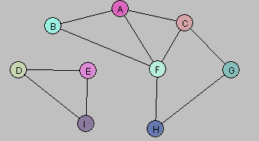

a. Let U = {A, B}. Draw G[U].

Solution:

b. Let W = {A, C, G, F}. Draw G[W].

Solution:

c. Let Y = {A, B, D, E}. Draw G[Y].

Solution:

d. Consider the following subgraph H of G:

Is there a subset X of the vertex set V so that H = G[X]? Explain.

Solution. Any such X would have to contain the vertices A, B, F, and no others. But the graph induced by A, B, F is the following, which is not the same as H.

**Problem2**



Ans.





**Problem3**

The following graph has a Hamiltonian cycle. Find it.





**Problem4**

Consider the problem of computing a *maximum* spanning tree, namely the spanning tree that maximizes the sum of edge costs. Do Prim and Kruskal’s algorithm work for this problem (assuming of course that we choose the crossing edge with maximum cost)?

Solution:

Yes, all the proofs are the same. Just flip the inequalities. Another way of seeing that there’s no difference in the problems is to just flip the sign on all the edges. Finding the maximum spanning tree is the same problem as finding the minimum spanning tree in a graph which had costs negated (relative to the originals). As we saw from the previous question, having negative costs doesn’t change the correctness of the MST algorithms.