**Lab 2 Solutions**

**Problem1: Solution**

First loop has a constant time statement inside it so its takes O(n).

Second loop has another loop(nested) inside it and in worst case it takes O(n2).

So, total asymptotic running time of given algorithm = O(n) + O(n2) = O(n2).

**Problem2: Solution**

**a) Algorithm(pseudo-code)**

Algorithm merge(Arr1, Arr2)

Input: Two sorted arrays Arr1 and Arr2 of integers

Output: An array integers after merging these arrays in sorted order

resultArray <-- new Array() of size of sum of lengths of both arrays Arr1 and Arr2

Arr1Index = 0

Arr2Index = 0

resultArrayIndex = 0

while Arr1Index < Arr1.length and Arr2Index < Arr2.length

if Arr1[Arr1Index] <= Arr2[Arr2Index] then

resultArray[resultArrayIndex] <-- Arr1[Arr1Index]

resultArrayIndex = resultArrayIndex+1

Arr1Index = Arr1Index+1

else

resultArray[resultArrayIndex] = Arr2[Arr2Index]

resultArrayIndex = resultArrayIndex+1

Arr2Index = Arr2Index+1

While Arr1Index < Arr1.length

resultArray[resultArrayIndex] <-- Arr1[Arr1Index]

resultArrayIndex = resultArrayIndex+1

Arr1Index = Arr1Index+1

While Arr2Index < Arr2.length

resultArray[resultArrayIndex] <-- Arr2[Arr2Index]

resultArrayIndex = resultArrayIndex+1

Arr2Index = Arr2Index+1

return resultArray

**b) Calculation of asymptotic running time:**

Suppose n is the length of larger aray, then first loop taks 2n times at max so complexity is O(n).

Second Loop takes O(n) time.

Third loop takes O(n) time.

So, overall complexity of the algorith is O(n) + O(n) + O(n) = O(n)

**c) Java solution of above problem has been stored in folder “problem2c”.**

**Problem3: Solution**

1. **1 + 4n2 is O(n2)**

Solution: This statement is true

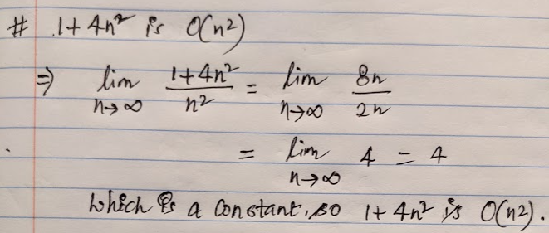

1. **n2 - 2n is not O(n)**

Solution: This statement is true.

1. **log(n) is o(n) –** This statement is true.

1. **n is not o(n)**

**Solution:** This statement is true

**Problem4: Solution**

Java solution for problem4 is in folder folder “problem4”