**Lab 3 Solutions**

**Problem1: Solution**

a)

­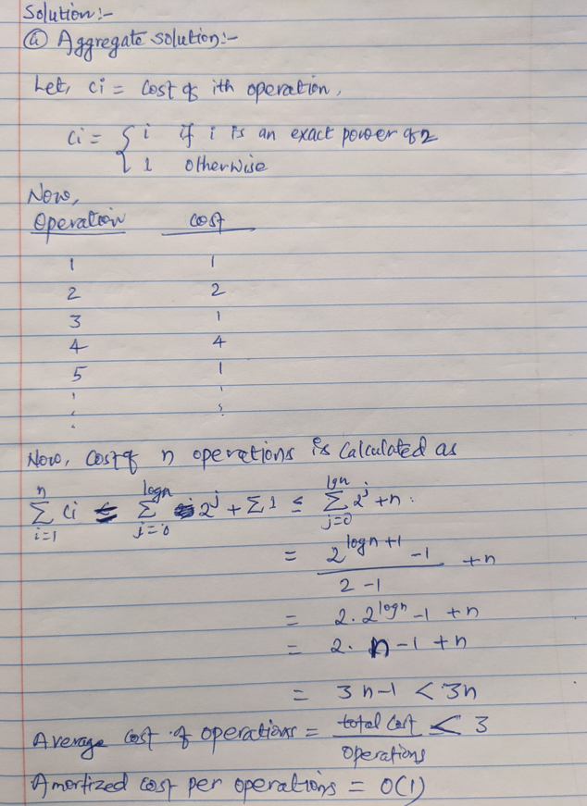

b)

**Problem2, 3 and 4: Solutions have separate files with explanation of how they work.**