|  |  |
| --- | --- |
| UX(mV) | UY(mV) |
| 150.00 | 86.00 |
| 98.00 | 81.00 |
| 67.00 | 75.00 |
| 26.00 | 65.00 |
| 0.00 | 52.00 |
| -22.00 | 36.00 |
| -32.00 | 18.00 |
| -44.00 | 0.00 |
| -54.00 | -19.00 |
| -75.00 | -51.00 |
| -103.00 | -63.00 |
| -160.00 | -80.00 |
| -93.00 | -68.00 |
| -42.00 | -58.00 |
| -16.00 | -49.00 |
| 0.00 | -52.00 |
| 18.00 | -27.00 |
| 29.00 | -15.00 |
| 37.00 | 0.00 |
| 47.00 | 22.00 |
| 53.00 | 36.00 |
| 63.00 | 52.00 |
| 81.00 | 68.00 |
| 96.00 | 76.00 |
| 110.00 | 80.00 |

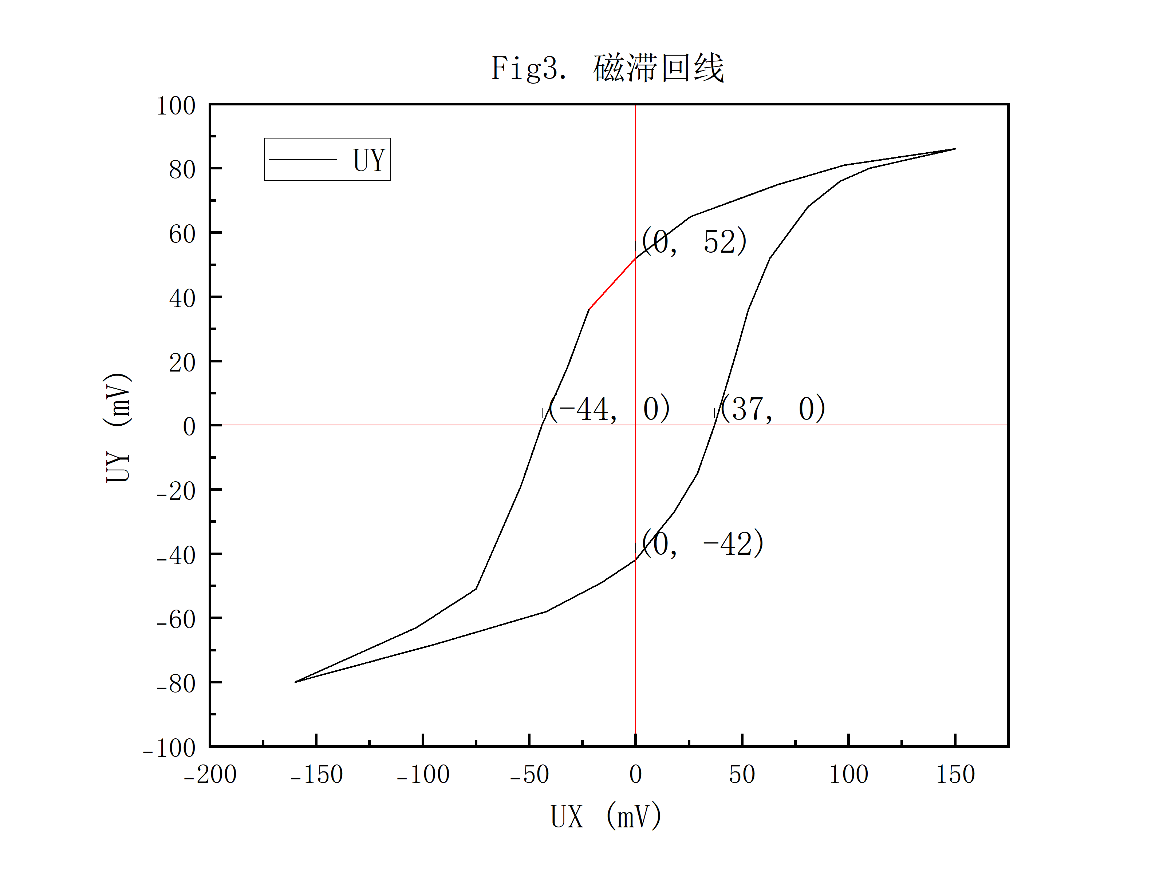表3. 磁滞回线

|  |  |
| --- | --- |
| U(mV) | T(℃) |
| 24 | 24.78 |
| 29.2 | 24.78 |
| 33.4 | 24.77 |
| 37.2 | 24.75 |
| 42.1 | 24.73 |
| 47.3 | 24.73 |
| 52.1 | 24.74 |
| 57.3 | 24.77 |
| 62.3 | 24.79 |
| 67.3 | 24.84 |
| 72.3 | 24.89 |
| 77.2 | 24.92 |
| 82.1 | 24.96 |
| 84.2 | 24.98 |
| 89.4 | 24.18 |
| 90.3 | 23.28 |
| 91 | 22.34 |
| 91.7 | 21.18 |
| 92.2 | 20.23 |
| 92.7 | 19.19 |
| 93.1 | 18.42 |
| 93.7 | 17.21 |
| 95 | 14.83 |
| 95.4 | 13.87 |
| 95.6 | 13.18 |
| 97.4 | 10.92 |
| 98.1 | 10.17 |
| 100.9 | 6.38 |
| 101.8 | 5.56 |
| 103.2 | 4.73 |
| 104.5 | 4.23 |
| 105.7 | 4.05 |
| 106.8 | 3.91 |
| 107.8 | 3.87 |
| 108.7 | 3.81 |
| 109.4 | 3.81 |

表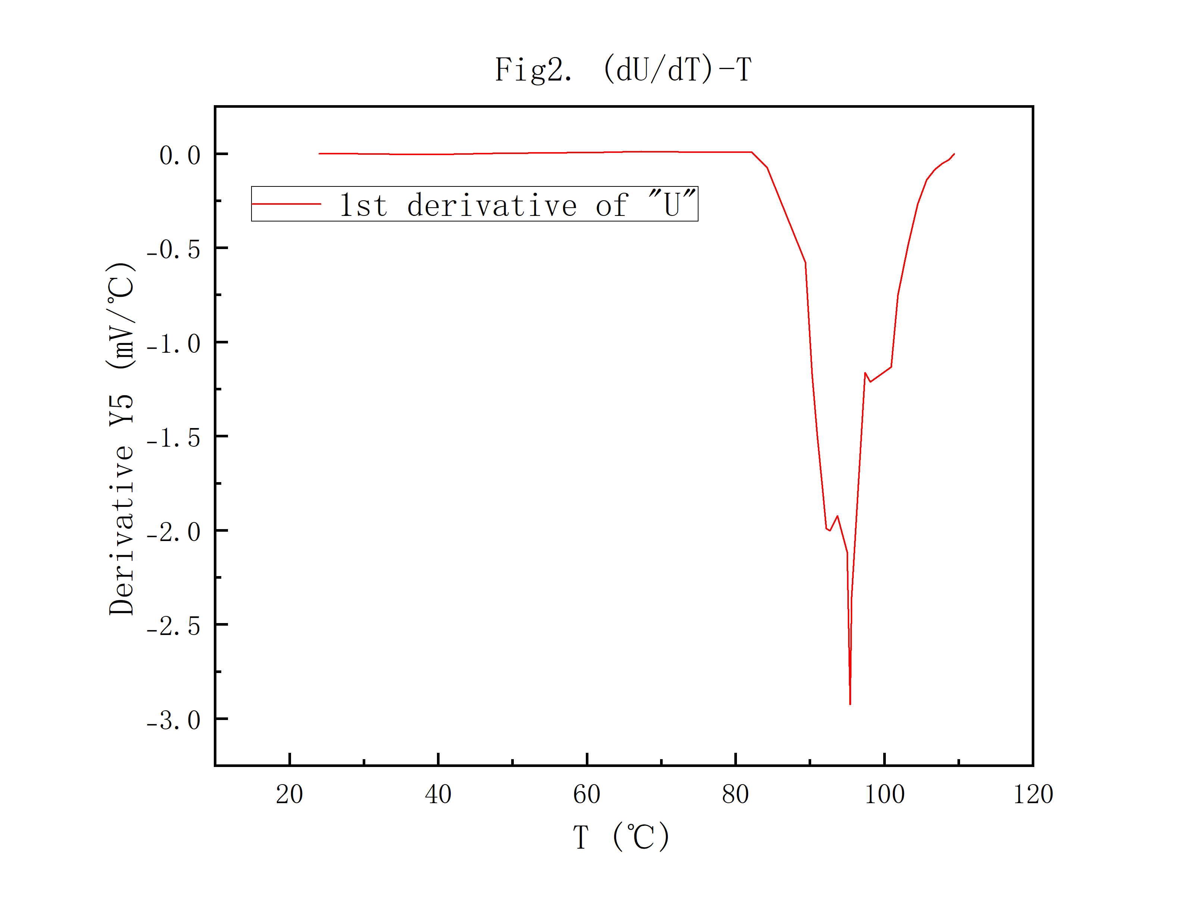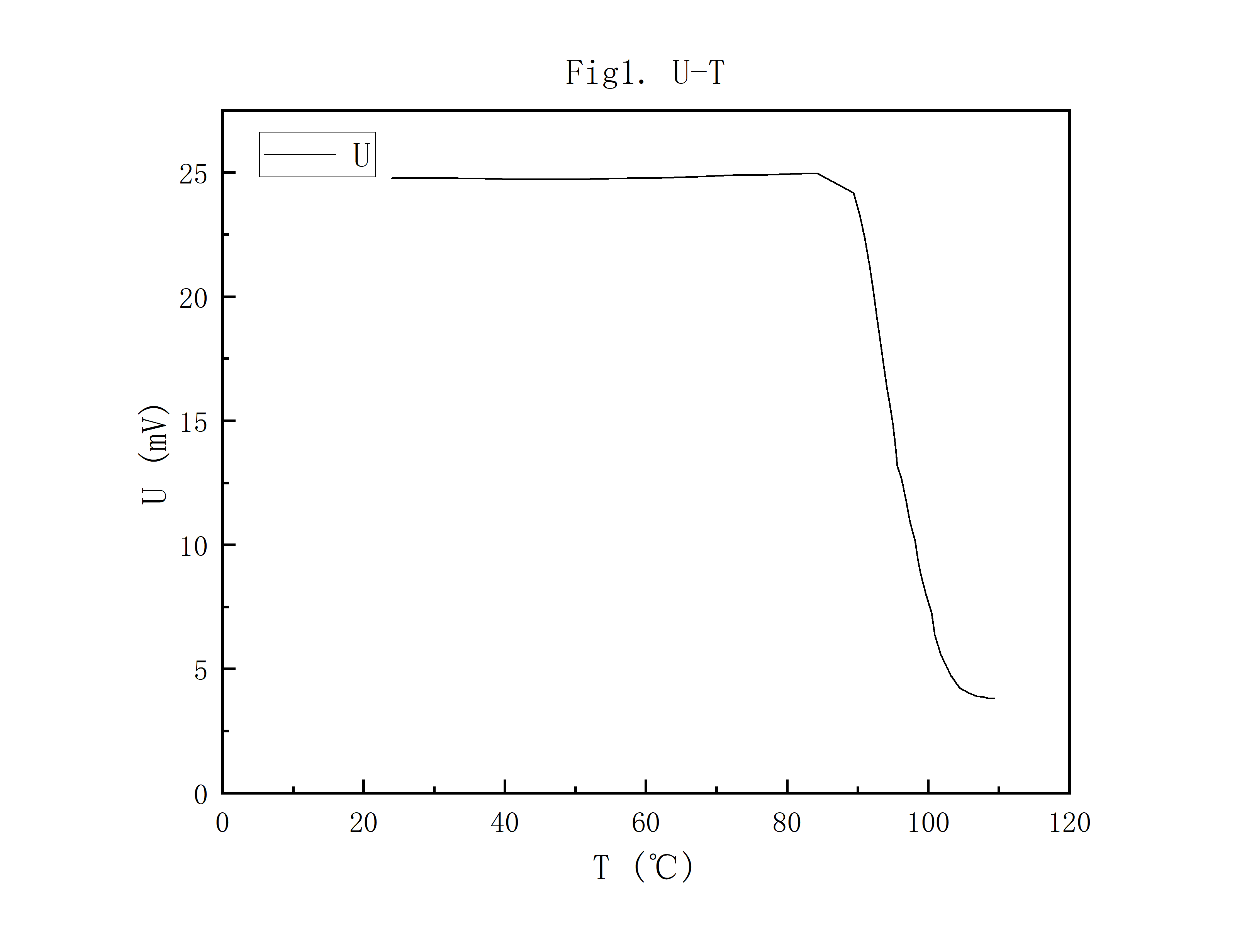2. 居里温度