1. 热敏电阻

|  |  |  |  |  |
| --- | --- | --- | --- | --- |
| T(K) | U(V) | 1/T | R(Ω) | lnR |
| 273.15 | 0 | 0.003661 | 30714.7 | 10.3325 |
| 301.15 | 0.05704 | 0.003321 | 9184.035 | 9.125222 |
| 318.45 | 0.07825 | 0.00314 | 4488.277 | 8.409224 |
| 327.15 | 0.08481 | 0.003057 | 3241.908 | 8.083917 |
| 337.15 | 0.09063 | 0.002966 | 2204.029 | 7.698042 |
| 347.15 | 0.09476 | 0.002881 | 1503.143 | 7.315314 |
| 357.15 | 0.09756 | 0.0028 | 1043.755 | 6.95058 |
| 367.15 | 0.09953 | 0.002724 | 727.8659 | 6.590117 |
| 373.15 | 0.1006 | 0.00268 | 558.7565 | 6.325714 |

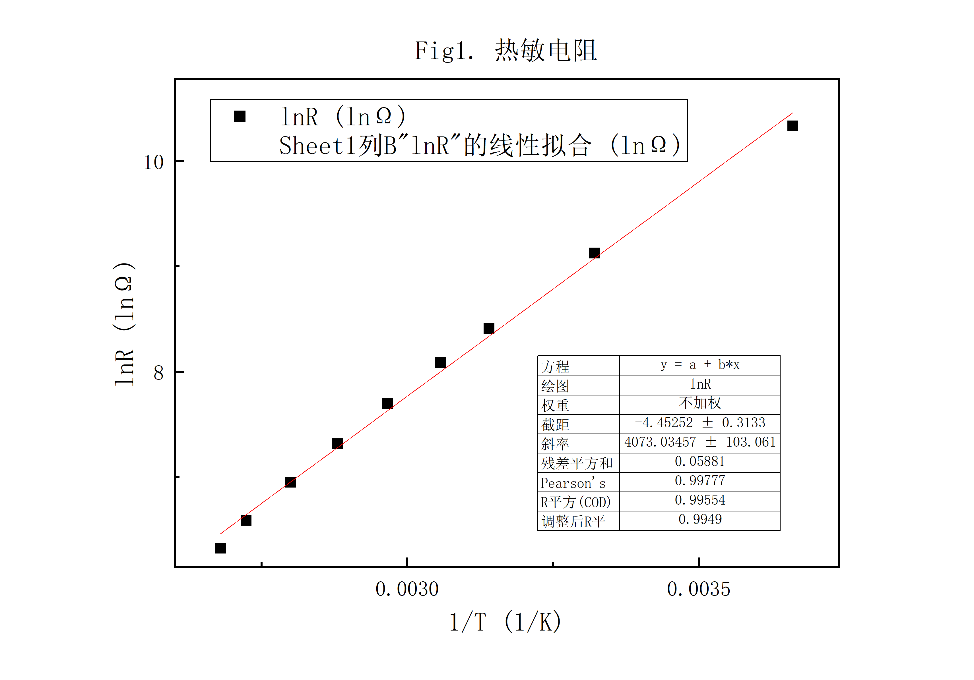

1. 铂电阻

|  |  |  |
| --- | --- | --- |
| t (℃) | U(mV) | R(Ω) |
| 0 | 0 | 102.4 |
| 32.7 | 16.47 | 113.8864 |
| 42 | 21.43 | 117.4744 |
| 50 | 24.16 | 119.4758 |
| 60 | 28.62 | 122.7867 |
| 70 | 34.94 | 127.5685 |
| 80 | 39.81 | 131.3273 |
| 90 | 44.83 | 135.2712 |
| 100 | 50.18 | 139.5541 |

