# Multiple Linear Regression. In-class Exercise 2

EL-GY 6143 Intro Machine Learning. Prof. Sundeep Rangan

## Question

From the lecture slides.

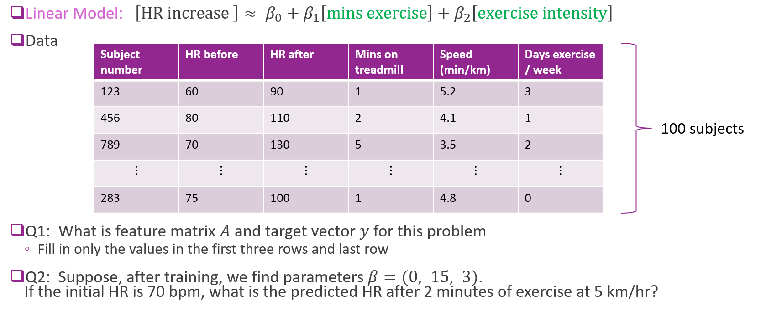

## Solution

