## Lab Assigment 7

Student: Manuel Diaz  
ID: f99543083

We performed the finite element analysis in for the 1, 4, 16 and 64 element discretization models show below,

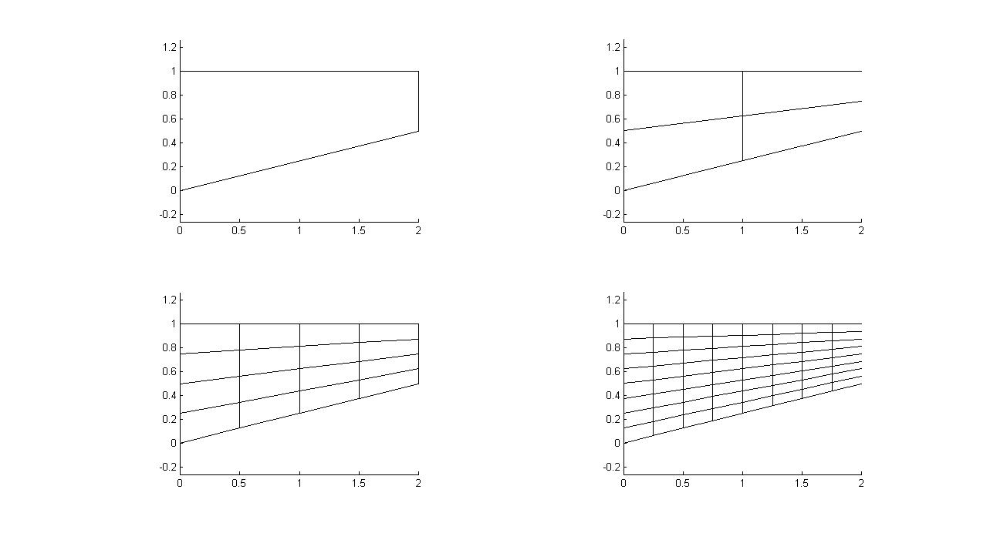

The plots of the displacements $U_{y}$ ­ at the top and bottom tips, (2,1) and (2,0.5) respectively, using the above models are show in the plots below,

